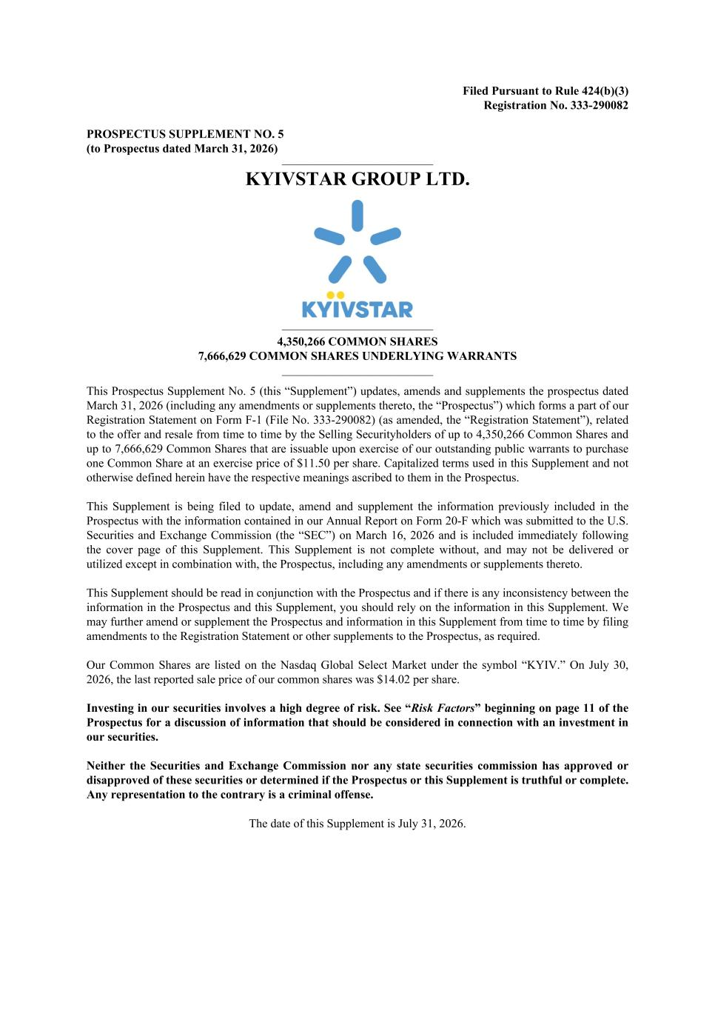
Filed Pursuant to Rule 424(b)(3) Registration No. 333-290082 PROSPECTUS SUPPLEMENT NO. 5 (to Prospectus dated March 31, 2026) __________________________________________ KYIVSTAR GROUP LTD. __________________________________________ 4,350,266 COMMON SHARES 7,666,629 COMMON SHARES UNDERLYING WARRANTS __________________________________________ This Prospectus Supplement No. 5 (this “Supplement”) updates, amends and supplements the prospectus dated March 31, 2026 (including any amendments or supplements thereto, the “Prospectus”) which forms a part of our Registration Statement on Form F-1 (File No. 333-290082) (as amended, the “Registration Statement”), related to the offer and resale from time to time by the Selling Securityholders of up to 4,350,266 Common Shares and up to 7,666,629 Common Shares that are issuable upon exercise of our outstanding public warrants to purchase one Common Share at an exercise price of $11.50 per share. Capitalized terms used in this Supplement and not otherwise defined herein have the respective meanings ascribed to them in the Prospectus. This Supplement is being filed to update, amend and supplement the information previously included in the Prospectus with the information contained in our Annual Report on Form 20-F which was submitted to the U.S. Securities and Exchange Commission (the “SEC”) on March 16, 2026 and is included immediately following the cover page of this Supplement. This Supplement is not complete without, and may not be delivered or utilized except in combination with, the Prospectus, including any amendments or supplements thereto. This Supplement should be read in conjunction with the Prospectus and if there is any inconsistency between the information in the Prospectus and this Supplement, you should rely on the information in this Supplement. We may further amend or supplement the Prospectus and information in this Supplement from time to time by filing amendments to the Registration Statement or other supplements to the Prospectus, as required. Our Common Shares are listed on the Nasdaq Global Select Market under the symbol “KYIV.” On July 30, 2026, the last reported sale price of our common shares was $14.02 per share. Investing in our securities involves a high degree of risk. See “Risk Factors” beginning on page 11 of the Prospectus for a discussion of information that should be considered in connection with an investment in our securities. Neither the Securities and Exchange Commission nor any state securities commission has approved or disapproved of these securities or determined if the Prospectus or this Supplement is truthful or complete. Any representation to the contrary is a criminal offense. The date of this Supplement is July 31, 2026.

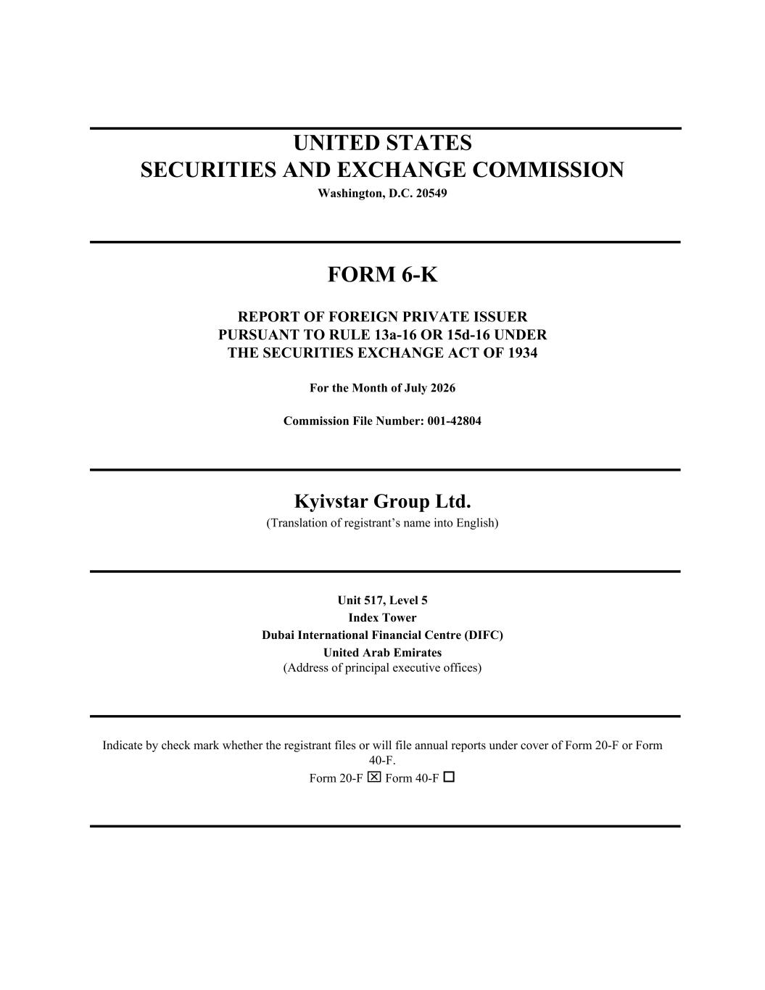
UNITED STATES SECURITIES AND EXCHANGE COMMISSION Washington, D.C. 20549 FORM 6-K REPORT OF FOREIGN PRIVATE ISSUER PURSUANT TO RULE 13a-16 OR 15d-16 UNDER THE SECURITIES EXCHANGE ACT OF 1934 For the Month of July 2026 Commission File Number: 001-42804 Kyivstar Group Ltd. (Translation of registrant’s name into English) Unit 517, Level 5 Index Tower Dubai International Financial Centre (DIFC) United Arab Emirates (Address of principal executive offices) Indicate by check mark whether the registrant files or will file annual reports under cover of Form 20-F or Form 40-F. Form 20-F x Form 40-F o

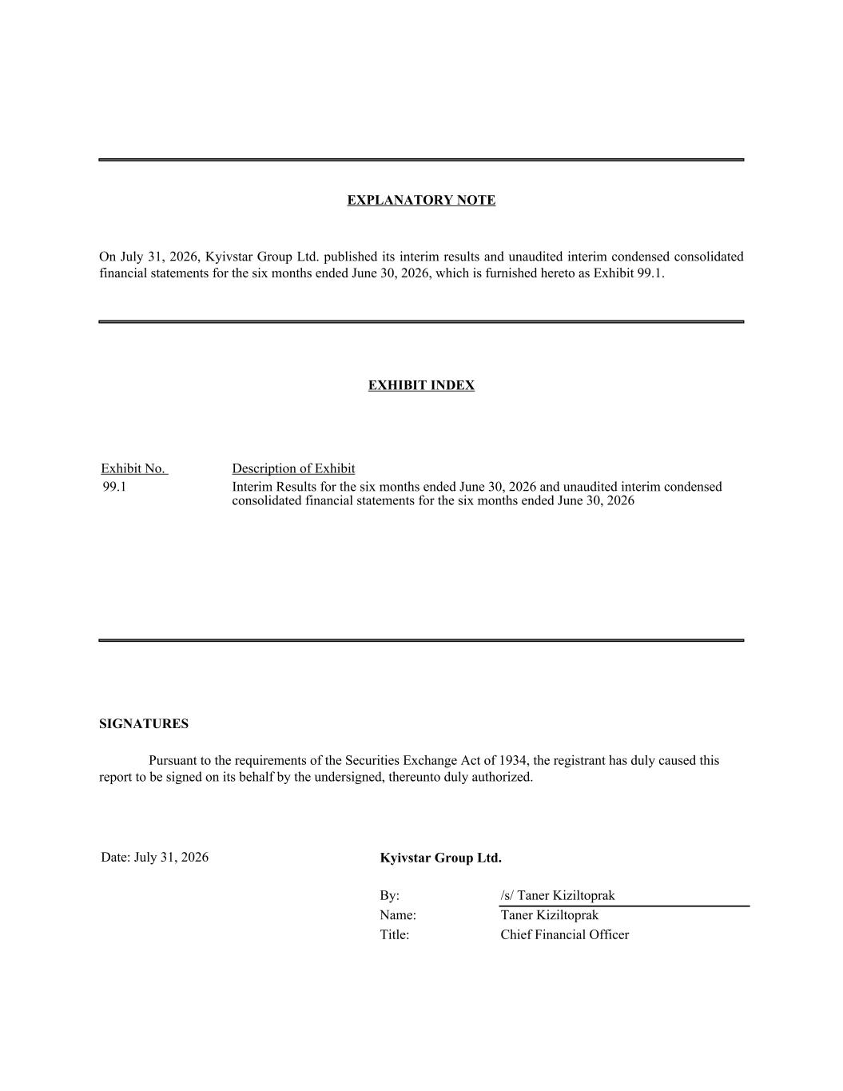
EXPLANATORY NOTE On July 31, 2026, Kyivstar Group Ltd. published its interim results and unaudited interim condensed consolidated financial statements for the six months ended June 30, 2026, which is furnished hereto as Exhibit 99.1. EXHIBIT INDEX Exhibit No. Description of Exhibit 99.1 Interim Results for the six months ended June 30, 2026 and unaudited interim condensed consolidated financial statements for the six months ended June 30, 2026 SIGNATURES Pursuant to the requirements of the Securities Exchange Act of 1934, the registrant has duly caused this report to be signed on its behalf by the undersigned, thereunto duly authorized. Date: July 31, 2026 Kyivstar Group Ltd. By: /s/ Taner Kiziltoprak Name: Taner Kiziltoprak Title: Chief Financial Officer

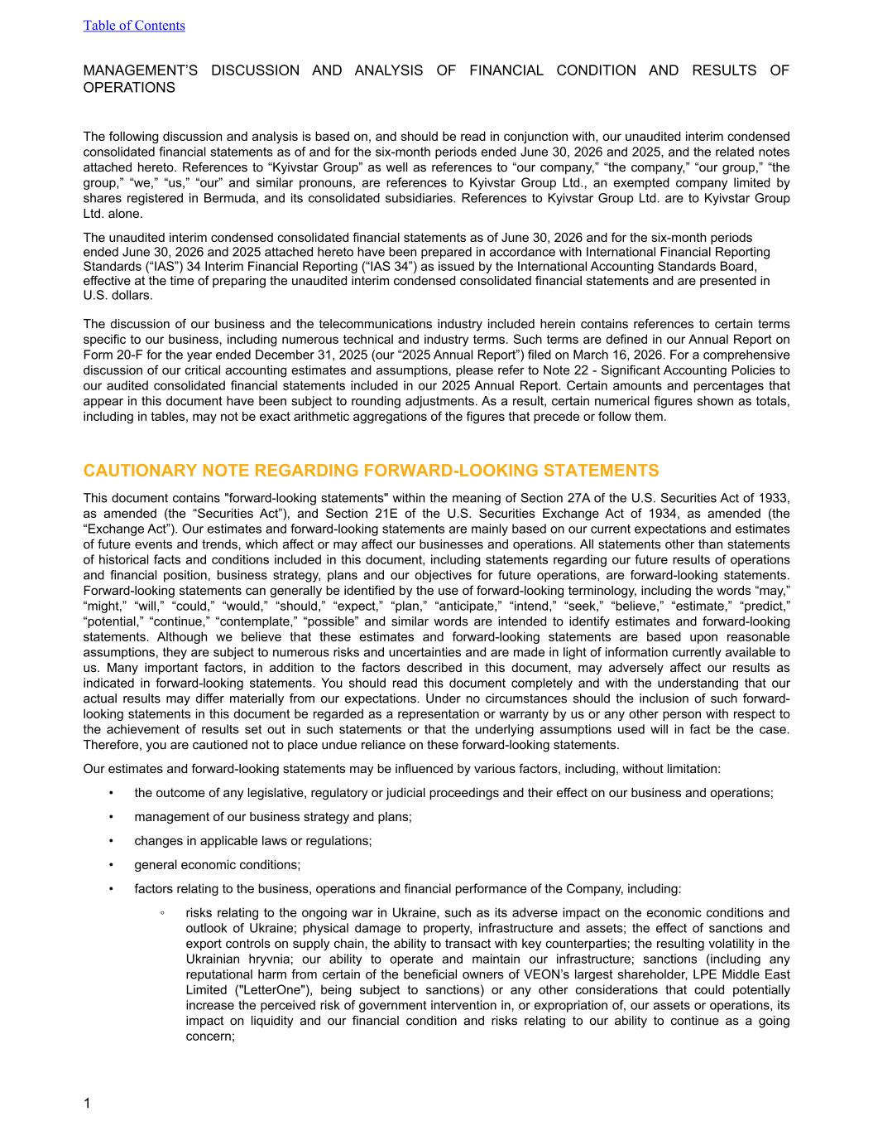
MANAGEMENT’S DISCUSSION AND ANALYSIS OF FINANCIAL CONDITION AND RESULTS OF OPERATIONS The following discussion and analysis is based on, and should be read in conjunction with, our unaudited interim condensed consolidated financial statements as of and for the six-month periods ended June 30, 2026 and 2025, and the related notes attached hereto. References to “Kyivstar Group” as well as references to “our company,” “the company,” “our group,” “the group,” “we,” “us,” “our” and similar pronouns, are references to Kyivstar Group Ltd., an exempted company limited by shares registered in Bermuda, and its consolidated subsidiaries. References to Kyivstar Group Ltd. are to Kyivstar Group Ltd. alone. The unaudited interim condensed consolidated financial statements as of June 30, 2026 and for the six-month periods ended June 30, 2026 and 2025 attached hereto have been prepared in accordance with International Financial Reporting Standards (“IAS”) 34 Interim Financial Reporting (“IAS 34”) as issued by the International Accounting Standards Board, effective at the time of preparing the unaudited interim condensed consolidated financial statements and are presented in U.S. dollars. The discussion of our business and the telecommunications industry included herein contains references to certain terms specific to our business, including numerous technical and industry terms. Such terms are defined in our Annual Report on Form 20-F for the year ended December 31, 2025 (our “2025 Annual Report”) filed on March 16, 2026. For a comprehensive discussion of our critical accounting estimates and assumptions, please refer to Note 22 - Significant Accounting Policies to our audited consolidated financial statements included in our 2025 Annual Report. Certain amounts and percentages that appear in this document have been subject to rounding adjustments. As a result, certain numerical figures shown as totals, including in tables, may not be exact arithmetic aggregations of the figures that precede or follow them. CAUTIONARY NOTE REGARDING FORWARD-LOOKING STATEMENTS This document contains "forward-looking statements" within the meaning of Section 27A of the U.S. Securities Act of 1933, as amended (the “Securities Act”), and Section 21E of the U.S. Securities Exchange Act of 1934, as amended (the “Exchange Act”). Our estimates and forward-looking statements are mainly based on our current expectations and estimates of future events and trends, which affect or may affect our businesses and operations. All statements other than statements of historical facts and conditions included in this document, including statements regarding our future results of operations and financial position, business strategy, plans and our objectives for future operations, are forward-looking statements. Forward-looking statements can generally be identified by the use of forward-looking terminology, including the words “may,” “might,” “will,” “could,” “would,” “should,” “expect,” “plan,” “anticipate,” “intend,” “seek,” “believe,” “estimate,” “predict,” “potential,” “continue,” “contemplate,” “possible” and similar words are intended to identify estimates and forward-looking statements. Although we believe that these estimates and forward-looking statements are based upon reasonable assumptions, they are subject to numerous risks and uncertainties and are made in light of information currently available to us. Many important factors, in addition to the factors described in this document, may adversely affect our results as indicated in forward-looking statements. You should read this document completely and with the understanding that our actual results may differ materially from our expectations. Under no circumstances should the inclusion of such forward- looking statements in this document be regarded as a representation or warranty by us or any other person with respect to the achievement of results set out in such statements or that the underlying assumptions used will in fact be the case. Therefore, you are cautioned not to place undue reliance on these forward-looking statements. Our estimates and forward-looking statements may be influenced by various factors, including, without limitation: • the outcome of any legislative, regulatory or judicial proceedings and their effect on our business and operations; • management of our business strategy and plans; • changes in applicable laws or regulations; • general economic conditions; • factors relating to the business, operations and financial performance of the Company, including: ◦ risks relating to the ongoing war in Ukraine, such as its adverse impact on the economic conditions and outlook of Ukraine; physical damage to property, infrastructure and assets; the effect of sanctions and export controls on supply chain, the ability to transact with key counterparties; the resulting volatility in the Ukrainian hryvnia; our ability to operate and maintain our infrastructure; sanctions (including any reputational harm from certain of the beneficial owners of VEON’s largest shareholder, LPE Middle East Limited ("LetterOne"), being subject to sanctions) or any other considerations that could potentially increase the perceived risk of government intervention in, or expropriation of, our assets or operations, its impact on liquidity and our financial condition and risks relating to our ability to continue as a going concern; Table of Contents 1

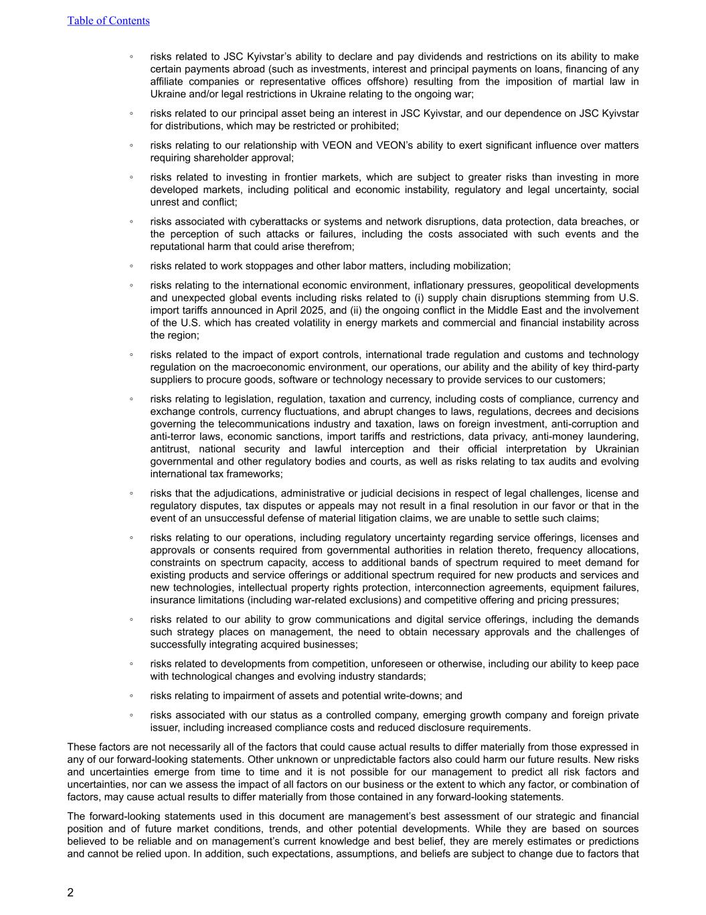
◦ risks related to JSC Kyivstar’s ability to declare and pay dividends and restrictions on its ability to make certain payments abroad (such as investments, interest and principal payments on loans, financing of any affiliate companies or representative offices offshore) resulting from the imposition of martial law in Ukraine and/or legal restrictions in Ukraine relating to the ongoing war; ◦ risks related to our principal asset being an interest in JSC Kyivstar, and our dependence on JSC Kyivstar for distributions, which may be restricted or prohibited; ◦ risks relating to our relationship with VEON and VEON’s ability to exert significant influence over matters requiring shareholder approval; ◦ risks related to investing in frontier markets, which are subject to greater risks than investing in more developed markets, including political and economic instability, regulatory and legal uncertainty, social unrest and conflict; ◦ risks associated with cyberattacks or systems and network disruptions, data protection, data breaches, or the perception of such attacks or failures, including the costs associated with such events and the reputational harm that could arise therefrom; ◦ risks related to work stoppages and other labor matters, including mobilization; ◦ risks relating to the international economic environment, inflationary pressures, geopolitical developments and unexpected global events including risks related to (i) supply chain disruptions stemming from U.S. import tariffs announced in April 2025, and (ii) the ongoing conflict in the Middle East and the involvement of the U.S. which has created volatility in energy markets and commercial and financial instability across the region; ◦ risks related to the impact of export controls, international trade regulation and customs and technology regulation on the macroeconomic environment, our operations, our ability and the ability of key third-party suppliers to procure goods, software or technology necessary to provide services to our customers; ◦ risks relating to legislation, regulation, taxation and currency, including costs of compliance, currency and exchange controls, currency fluctuations, and abrupt changes to laws, regulations, decrees and decisions governing the telecommunications industry and taxation, laws on foreign investment, anti-corruption and anti-terror laws, economic sanctions, import tariffs and restrictions, data privacy, anti-money laundering, antitrust, national security and lawful interception and their official interpretation by Ukrainian governmental and other regulatory bodies and courts, as well as risks relating to tax audits and evolving international tax frameworks; ◦ risks that the adjudications, administrative or judicial decisions in respect of legal challenges, license and regulatory disputes, tax disputes or appeals may not result in a final resolution in our favor or that in the event of an unsuccessful defense of material litigation claims, we are unable to settle such claims; ◦ risks relating to our operations, including regulatory uncertainty regarding service offerings, licenses and approvals or consents required from governmental authorities in relation thereto, frequency allocations, constraints on spectrum capacity, access to additional bands of spectrum required to meet demand for existing products and service offerings or additional spectrum required for new products and services and new technologies, intellectual property rights protection, interconnection agreements, equipment failures, insurance limitations (including war-related exclusions) and competitive offering and pricing pressures; ◦ risks related to our ability to grow communications and digital service offerings, including the demands such strategy places on management, the need to obtain necessary approvals and the challenges of successfully integrating acquired businesses; ◦ risks related to developments from competition, unforeseen or otherwise, including our ability to keep pace with technological changes and evolving industry standards; ◦ risks relating to impairment of assets and potential write-downs; and ◦ risks associated with our status as a controlled company, emerging growth company and foreign private issuer, including increased compliance costs and reduced disclosure requirements. These factors are not necessarily all of the factors that could cause actual results to differ materially from those expressed in any of our forward-looking statements. Other unknown or unpredictable factors also could harm our future results. New risks and uncertainties emerge from time to time and it is not possible for our management to predict all risk factors and uncertainties, nor can we assess the impact of all factors on our business or the extent to which any factor, or combination of factors, may cause actual results to differ materially from those contained in any forward-looking statements. The forward-looking statements used in this document are management’s best assessment of our strategic and financial position and of future market conditions, trends, and other potential developments. While they are based on sources believed to be reliable and on management’s current knowledge and best belief, they are merely estimates or predictions and cannot be relied upon. In addition, such expectations, assumptions, and beliefs are subject to change due to factors that Table of Contents 2


are often beyond our control. As a result, the inclusion of the estimates or other forecast information in this document should not be relied on as "guidance" or otherwise predictive of actual future events, and actual results may differ materially from the forecasts. Forward-looking statements speak only as of the date of the filing of this document. Except to the extent required by law, we disclaim any obligation to update or revise any of these forward-looking statements, whether as a result of new information, future events or otherwise, after the date on which the statements are made or to reflect the occurrence of unanticipated events. You should refer to our periodic and current reports filed or furnished, as applicable, with the SEC for specific risks which could cause actual results to be significantly different from those expressed or implied by these forward-looking statements. Table of Contents 3

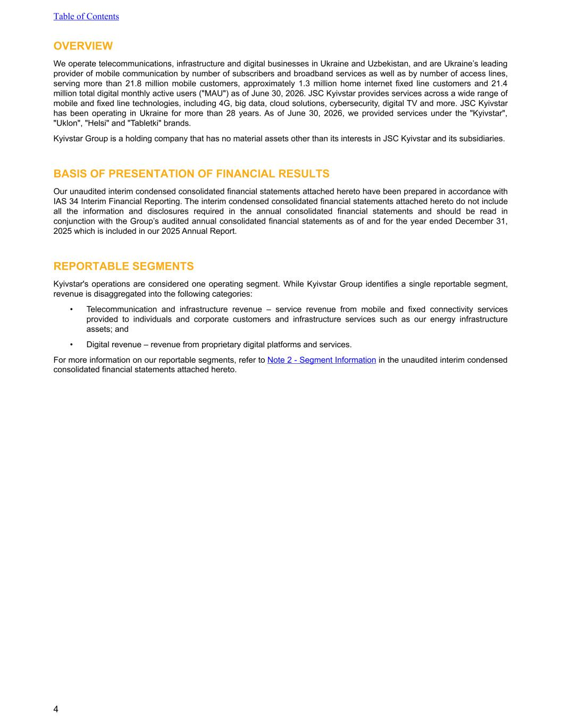
OVERVIEW We operate telecommunications, infrastructure and digital businesses in Ukraine and Uzbekistan, and are Ukraine’s leading provider of mobile communication by number of subscribers and broadband services as well as by number of access lines, serving more than 21.8 million mobile customers, approximately 1.3 million home internet fixed line customers and 21.4 million total digital monthly active users ("MAU") as of June 30, 2026. JSC Kyivstar provides services across a wide range of mobile and fixed line technologies, including 4G, big data, cloud solutions, cybersecurity, digital TV and more. JSC Kyivstar has been operating in Ukraine for more than 28 years. As of June 30, 2026, we provided services under the "Kyivstar", "Uklon", "Helsi" and "Tabletki" brands. Kyivstar Group is a holding company that has no material assets other than its interests in JSC Kyivstar and its subsidiaries. BASIS OF PRESENTATION OF FINANCIAL RESULTS Our unaudited interim condensed consolidated financial statements attached hereto have been prepared in accordance with IAS 34 Interim Financial Reporting. The interim condensed consolidated financial statements attached hereto do not include all the information and disclosures required in the annual consolidated financial statements and should be read in conjunction with the Group’s audited annual consolidated financial statements as of and for the year ended December 31, 2025 which is included in our 2025 Annual Report. REPORTABLE SEGMENTS Kyivstar's operations are considered one operating segment. While Kyivstar Group identifies a single reportable segment, revenue is disaggregated into the following categories: • Telecommunication and infrastructure revenue – service revenue from mobile and fixed connectivity services provided to individuals and corporate customers and infrastructure services such as our energy infrastructure assets; and • Digital revenue – revenue from proprietary digital platforms and services. For more information on our reportable segments, refer to Note 2 - Segment Information in the unaudited interim condensed consolidated financial statements attached hereto. Table of Contents 4

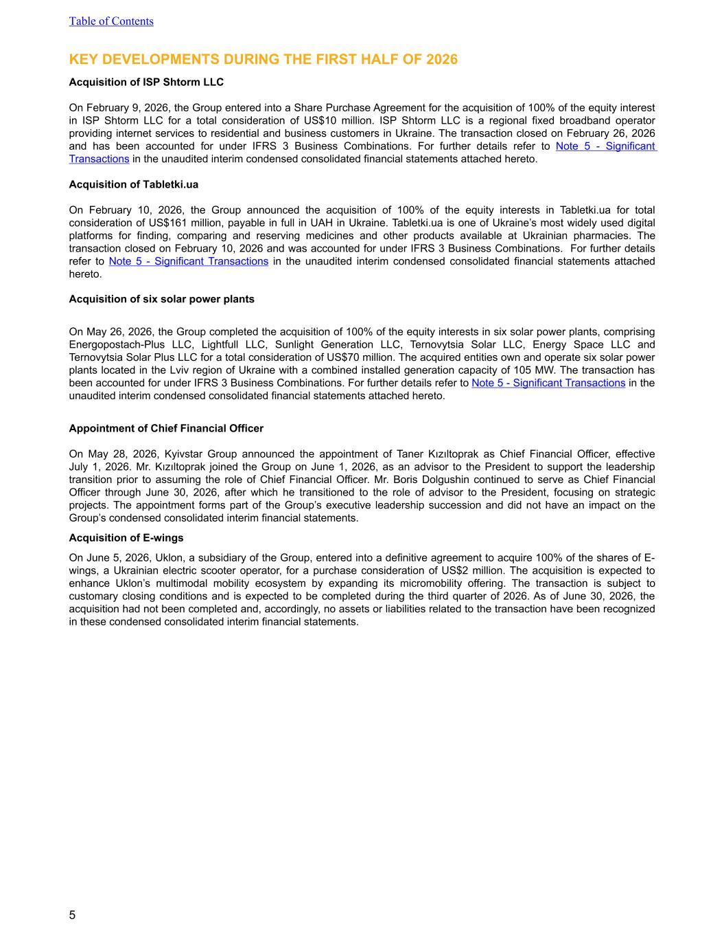
KEY DEVELOPMENTS DURING THE FIRST HALF OF 2026 Acquisition of ISP Shtorm LLC On February 9, 2026, the Group entered into a Share Purchase Agreement for the acquisition of 100% of the equity interest in ISP Shtorm LLC for a total consideration of US$10 million. ISP Shtorm LLC is a regional fixed broadband operator providing internet services to residential and business customers in Ukraine. The transaction closed on February 26, 2026 and has been accounted for under IFRS 3 Business Combinations. For further details refer to Note 5 - Significant Transactions in the unaudited interim condensed consolidated financial statements attached hereto. Acquisition of Tabletki.ua On February 10, 2026, the Group announced the acquisition of 100% of the equity interests in Tabletki.ua for total consideration of US$161 million, payable in full in UAH in Ukraine. Tabletki.ua is one of Ukraine’s most widely used digital platforms for finding, comparing and reserving medicines and other products available at Ukrainian pharmacies. The transaction closed on February 10, 2026 and was accounted for under IFRS 3 Business Combinations. For further details refer to Note 5 - Significant Transactions in the unaudited interim condensed consolidated financial statements attached hereto. Acquisition of six solar power plants On May 26, 2026, the Group completed the acquisition of 100% of the equity interests in six solar power plants, comprising Energopostach-Plus LLC, Lightfull LLC, Sunlight Generation LLC, Ternovytsia Solar LLC, Energy Space LLC and Ternovytsia Solar Plus LLC for a total consideration of US$70 million. The acquired entities own and operate six solar power plants located in the Lviv region of Ukraine with a combined installed generation capacity of 105 MW. The transaction has been accounted for under IFRS 3 Business Combinations. For further details refer to Note 5 - Significant Transactions in the unaudited interim condensed consolidated financial statements attached hereto. Appointment of Chief Financial Officer On May 28, 2026, Kyivstar Group announced the appointment of Taner Kızıltoprak as Chief Financial Officer, effective July 1, 2026. Mr. Kızıltoprak joined the Group on June 1, 2026, as an advisor to the President to support the leadership transition prior to assuming the role of Chief Financial Officer. Mr. Boris Dolgushin continued to serve as Chief Financial Officer through June 30, 2026, after which he transitioned to the role of advisor to the President, focusing on strategic projects. The appointment forms part of the Group’s executive leadership succession and did not have an impact on the Group’s condensed consolidated interim financial statements. Acquisition of E-wings On June 5, 2026, Uklon, a subsidiary of the Group, entered into a definitive agreement to acquire 100% of the shares of E- wings, a Ukrainian electric scooter operator, for a purchase consideration of US$2 million. The acquisition is expected to enhance Uklon’s multimodal mobility ecosystem by expanding its micromobility offering. The transaction is subject to customary closing conditions and is expected to be completed during the third quarter of 2026. As of June 30, 2026, the acquisition had not been completed and, accordingly, no assets or liabilities related to the transaction have been recognized in these condensed consolidated interim financial statements. Table of Contents 5


KEY DEVELOPMENTS AFTER THE REPORTING PERIOD There were no material developments subsequent to June 30, 2026 through the date of this report. Table of Contents 6

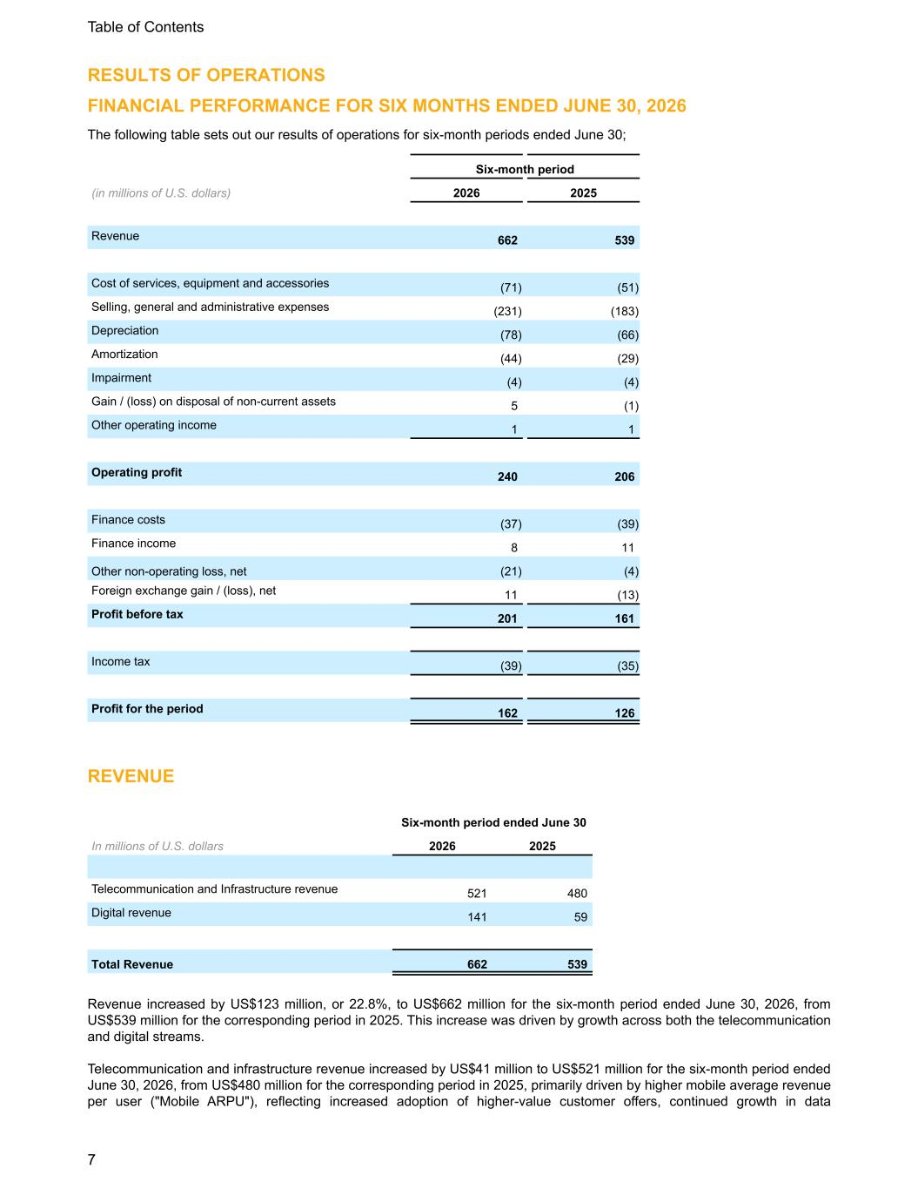
RESULTS OF OPERATIONS FINANCIAL PERFORMANCE FOR SIX MONTHS ENDED JUNE 30, 2026 The following table sets out our results of operations for six-month periods ended June 30; Six-month period (in millions of U.S. dollars) 2026 2025 Revenue 662 539 Cost of services, equipment and accessories (71) (51) Selling, general and administrative expenses (231) (183) Depreciation (78) (66) Amortization (44) (29) Impairment (4) (4) Gain / (loss) on disposal of non-current assets 5 (1) Other operating income 1 1 Operating profit 240 206 Finance costs (37) (39) Finance income 8 11 Other non-operating loss, net (21) (4) Foreign exchange gain / (loss), net 11 (13) Profit before tax 201 161 Income tax (39) (35) Profit for the period 162 126 REVENUE Six-month period ended June 30 In millions of U.S. dollars 2026 2025 Telecommunication and Infrastructure revenue 521 480 Digital revenue 141 59 Total Revenue 662 539 Revenue increased by US$123 million, or 22.8%, to US$662 million for the six-month period ended June 30, 2026, from US$539 million for the corresponding period in 2025. This increase was driven by growth across both the telecommunication and digital streams. Telecommunication and infrastructure revenue increased by US$41 million to US$521 million for the six-month period ended June 30, 2026, from US$480 million for the corresponding period in 2025, primarily driven by higher mobile average revenue per user ("Mobile ARPU"), reflecting increased adoption of higher-value customer offers, continued growth in data Table of Contents 7

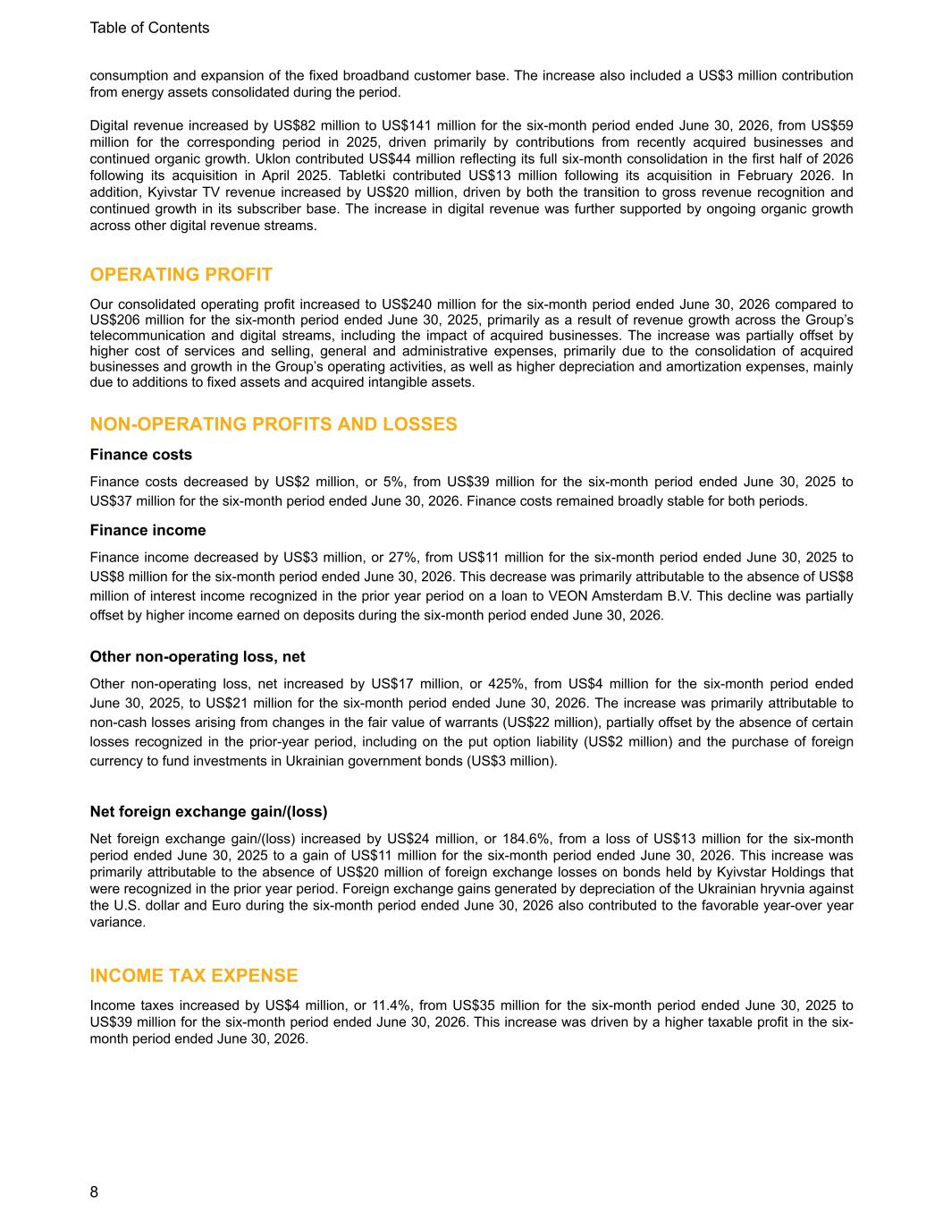
consumption and expansion of the fixed broadband customer base. The increase also included a US$3 million contribution from energy assets consolidated during the period. Digital revenue increased by US$82 million to US$141 million for the six-month period ended June 30, 2026, from US$59 million for the corresponding period in 2025, driven primarily by contributions from recently acquired businesses and continued organic growth. Uklon contributed US$44 million reflecting its full six-month consolidation in the first half of 2026 following its acquisition in April 2025. Tabletki contributed US$13 million following its acquisition in February 2026. In addition, Kyivstar TV revenue increased by US$20 million, driven by both the transition to gross revenue recognition and continued growth in its subscriber base. The increase in digital revenue was further supported by ongoing organic growth across other digital revenue streams. OPERATING PROFIT Our consolidated operating profit increased to US$240 million for the six-month period ended June 30, 2026 compared to US$206 million for the six-month period ended June 30, 2025, primarily as a result of revenue growth across the Group’s telecommunication and digital streams, including the impact of acquired businesses. The increase was partially offset by higher cost of services and selling, general and administrative expenses, primarily due to the consolidation of acquired businesses and growth in the Group’s operating activities, as well as higher depreciation and amortization expenses, mainly due to additions to fixed assets and acquired intangible assets. NON-OPERATING PROFITS AND LOSSES Finance costs Finance costs decreased by US$2 million, or 5%, from US$39 million for the six-month period ended June 30, 2025 to US$37 million for the six-month period ended June 30, 2026. Finance costs remained broadly stable for both periods. Finance income Finance income decreased by US$3 million, or 27%, from US$11 million for the six-month period ended June 30, 2025 to US$8 million for the six-month period ended June 30, 2026. This decrease was primarily attributable to the absence of US$8 million of interest income recognized in the prior year period on a loan to VEON Amsterdam B.V. This decline was partially offset by higher income earned on deposits during the six-month period ended June 30, 2026. Other non-operating loss, net Other non-operating loss, net increased by US$17 million, or 425%, from US$4 million for the six-month period ended June 30, 2025, to US$21 million for the six-month period ended June 30, 2026. The increase was primarily attributable to non-cash losses arising from changes in the fair value of warrants (US$22 million), partially offset by the absence of certain losses recognized in the prior-year period, including on the put option liability (US$2 million) and the purchase of foreign currency to fund investments in Ukrainian government bonds (US$3 million). Net foreign exchange gain/(loss) Net foreign exchange gain/(loss) increased by US$24 million, or 184.6%, from a loss of US$13 million for the six-month period ended June 30, 2025 to a gain of US$11 million for the six-month period ended June 30, 2026. This increase was primarily attributable to the absence of US$20 million of foreign exchange losses on bonds held by Kyivstar Holdings that were recognized in the prior year period. Foreign exchange gains generated by depreciation of the Ukrainian hryvnia against the U.S. dollar and Euro during the six-month period ended June 30, 2026 also contributed to the favorable year-over year variance. INCOME TAX EXPENSE Income taxes increased by US$4 million, or 11.4%, from US$35 million for the six-month period ended June 30, 2025 to US$39 million for the six-month period ended June 30, 2026. This increase was driven by a higher taxable profit in the six- month period ended June 30, 2026. Table of Contents 8

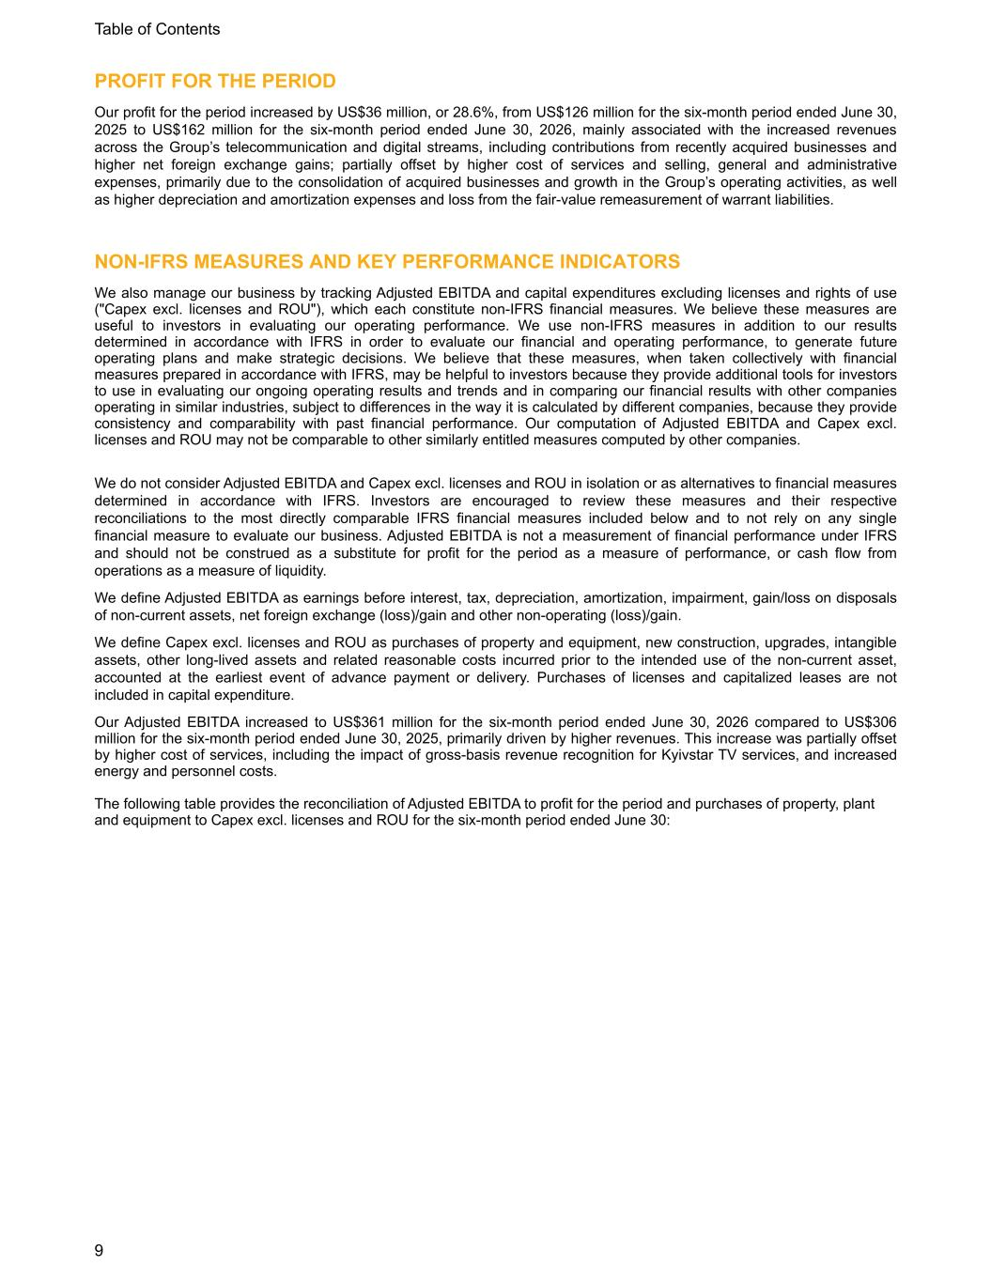
PROFIT FOR THE PERIOD Our profit for the period increased by US$36 million, or 28.6%, from US$126 million for the six-month period ended June 30, 2025 to US$162 million for the six-month period ended June 30, 2026, mainly associated with the increased revenues across the Group’s telecommunication and digital streams, including contributions from recently acquired businesses and higher net foreign exchange gains; partially offset by higher cost of services and selling, general and administrative expenses, primarily due to the consolidation of acquired businesses and growth in the Group’s operating activities, as well as higher depreciation and amortization expenses and loss from the fair-value remeasurement of warrant liabilities. NON-IFRS MEASURES AND KEY PERFORMANCE INDICATORS We also manage our business by tracking Adjusted EBITDA and capital expenditures excluding licenses and rights of use ("Capex excl. licenses and ROU"), which each constitute non-IFRS financial measures. We believe these measures are useful to investors in evaluating our operating performance. We use non-IFRS measures in addition to our results determined in accordance with IFRS in order to evaluate our financial and operating performance, to generate future operating plans and make strategic decisions. We believe that these measures, when taken collectively with financial measures prepared in accordance with IFRS, may be helpful to investors because they provide additional tools for investors to use in evaluating our ongoing operating results and trends and in comparing our financial results with other companies operating in similar industries, subject to differences in the way it is calculated by different companies, because they provide consistency and comparability with past financial performance. Our computation of Adjusted EBITDA and Capex excl. licenses and ROU may not be comparable to other similarly entitled measures computed by other companies. We do not consider Adjusted EBITDA and Capex excl. licenses and ROU in isolation or as alternatives to financial measures determined in accordance with IFRS. Investors are encouraged to review these measures and their respective reconciliations to the most directly comparable IFRS financial measures included below and to not rely on any single financial measure to evaluate our business. Adjusted EBITDA is not a measurement of financial performance under IFRS and should not be construed as a substitute for profit for the period as a measure of performance, or cash flow from operations as a measure of liquidity. We define Adjusted EBITDA as earnings before interest, tax, depreciation, amortization, impairment, gain/loss on disposals of non-current assets, net foreign exchange (loss)/gain and other non-operating (loss)/gain. We define Capex excl. licenses and ROU as purchases of property and equipment, new construction, upgrades, intangible assets, other long-lived assets and related reasonable costs incurred prior to the intended use of the non-current asset, accounted at the earliest event of advance payment or delivery. Purchases of licenses and capitalized leases are not included in capital expenditure. Our Adjusted EBITDA increased to US$361 million for the six-month period ended June 30, 2026 compared to US$306 million for the six-month period ended June 30, 2025, primarily driven by higher revenues. This increase was partially offset by higher cost of services, including the impact of gross-basis revenue recognition for Kyivstar TV services, and increased energy and personnel costs. The following table provides the reconciliation of Adjusted EBITDA to profit for the period and purchases of property, plant and equipment to Capex excl. licenses and ROU for the six-month period ended June 30: Table of Contents 9

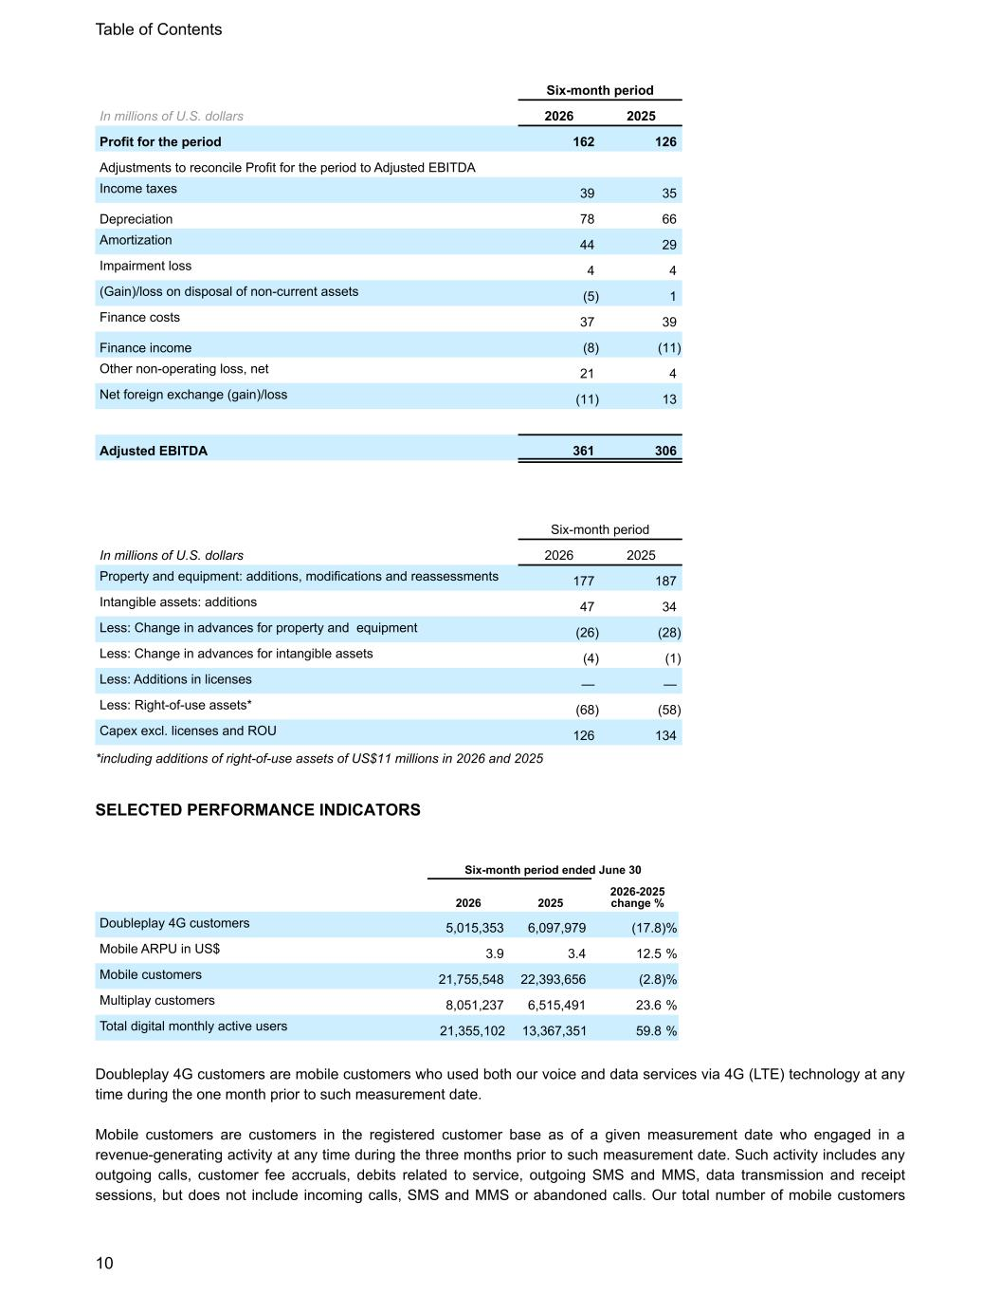
Six-month period In millions of U.S. dollars 2026 2025 Profit for the period 162 126 Adjustments to reconcile Profit for the period to Adjusted EBITDA Income taxes 39 35 Depreciation 78 66 Amortization 44 29 Impairment loss 4 4 (Gain)/loss on disposal of non-current assets (5) 1 Finance costs 37 39 Finance income (8) (11) Other non-operating loss, net 21 4 Net foreign exchange (gain)/loss (11) 13 Adjusted EBITDA 361 306 Six-month period In millions of U.S. dollars 2026 2025 Property and equipment: additions, modifications and reassessments 177 187 Intangible assets: additions 47 34 Less: Change in advances for property and equipment (26) (28) Less: Change in advances for intangible assets (4) (1) Less: Additions in licenses — — Less: Right-of-use assets* (68) (58) Capex excl. licenses and ROU 126 134 *including additions of right-of-use assets of US$11 millions in 2026 and 2025 SELECTED PERFORMANCE INDICATORS Six-month period ended June 30 2026 2025 2026-2025 change % Doubleplay 4G customers 5,015,353 6,097,979 (17.8) % Mobile ARPU in US$ 3.9 3.4 12.5 % Mobile customers 21,755,548 22,393,656 (2.8) % Multiplay customers 8,051,237 6,515,491 23.6 % Total digital monthly active users 21,355,102 13,367,351 59.8 % Doubleplay 4G customers are mobile customers who used both our voice and data services via 4G (LTE) technology at any time during the one month prior to such measurement date. Mobile customers are customers in the registered customer base as of a given measurement date who engaged in a revenue-generating activity at any time during the three months prior to such measurement date. Such activity includes any outgoing calls, customer fee accruals, debits related to service, outgoing SMS and MMS, data transmission and receipt sessions, but does not include incoming calls, SMS and MMS or abandoned calls. Our total number of mobile customers Table of Contents 10

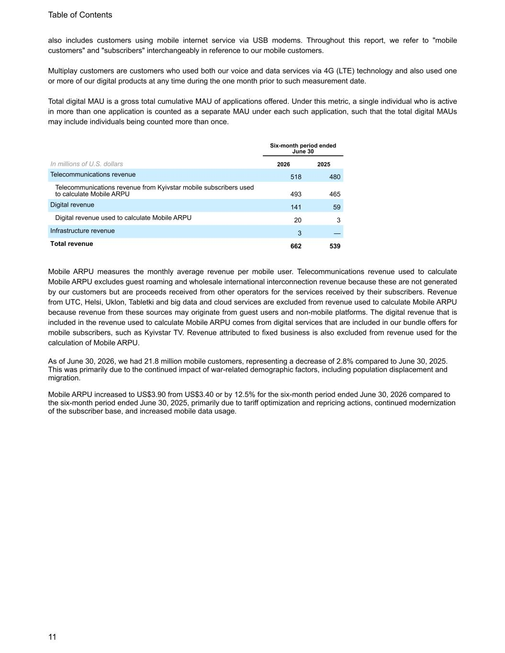
also includes customers using mobile internet service via USB modems. Throughout this report, we refer to "mobile customers" and "subscribers" interchangeably in reference to our mobile customers. Multiplay customers are customers who used both our voice and data services via 4G (LTE) technology and also used one or more of our digital products at any time during the one month prior to such measurement date. Total digital MAU is a gross total cumulative MAU of applications offered. Under this metric, a single individual who is active in more than one application is counted as a separate MAU under each such application, such that the total digital MAUs may include individuals being counted more than once. Six-month period ended June 30 In millions of U.S. dollars 2026 2025 Telecommunications revenue 518 480 Telecommunications revenue from Kyivstar mobile subscribers used to calculate Mobile ARPU 493 465 Digital revenue 141 59 Digital revenue used to calculate Mobile ARPU 20 3 Infrastructure revenue 3 — Total revenue 662 539 Mobile ARPU measures the monthly average revenue per mobile user. Telecommunications revenue used to calculate Mobile ARPU excludes guest roaming and wholesale international interconnection revenue because these are not generated by our customers but are proceeds received from other operators for the services received by their subscribers. Revenue from UTC, Helsi, Uklon, Tabletki and big data and cloud services are excluded from revenue used to calculate Mobile ARPU because revenue from these sources may originate from guest users and non-mobile platforms. The digital revenue that is included in the revenue used to calculate Mobile ARPU comes from digital services that are included in our bundle offers for mobile subscribers, such as Kyivstar TV. Revenue attributed to fixed business is also excluded from revenue used for the calculation of Mobile ARPU. As of June 30, 2026, we had 21.8 million mobile customers, representing a decrease of 2.8% compared to June 30, 2025. This was primarily due to the continued impact of war-related demographic factors, including population displacement and migration. Mobile ARPU increased to US$3.90 from US$3.40 or by 12.5% for the six-month period ended June 30, 2026 compared to the six-month period ended June 30, 2025, primarily due to tariff optimization and repricing actions, continued modernization of the subscriber base, and increased mobile data usage. Table of Contents 11

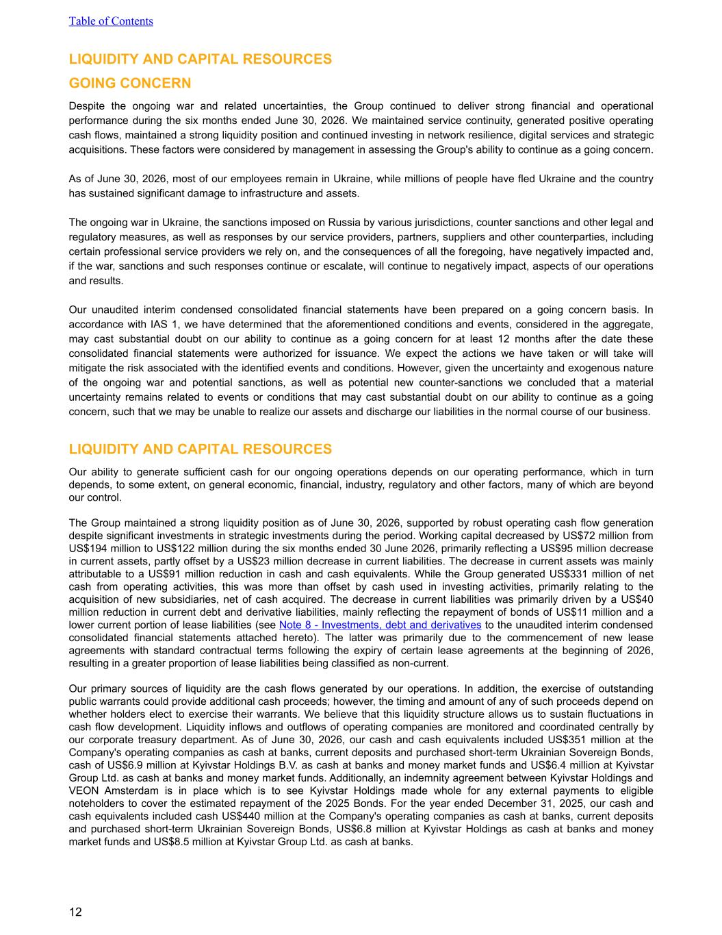
LIQUIDITY AND CAPITAL RESOURCES GOING CONCERN Despite the ongoing war and related uncertainties, the Group continued to deliver strong financial and operational performance during the six months ended June 30, 2026. We maintained service continuity, generated positive operating cash flows, maintained a strong liquidity position and continued investing in network resilience, digital services and strategic acquisitions. These factors were considered by management in assessing the Group's ability to continue as a going concern. As of June 30, 2026, most of our employees remain in Ukraine, while millions of people have fled Ukraine and the country has sustained significant damage to infrastructure and assets. The ongoing war in Ukraine, the sanctions imposed on Russia by various jurisdictions, counter sanctions and other legal and regulatory measures, as well as responses by our service providers, partners, suppliers and other counterparties, including certain professional service providers we rely on, and the consequences of all the foregoing, have negatively impacted and, if the war, sanctions and such responses continue or escalate, will continue to negatively impact, aspects of our operations and results. Our unaudited interim condensed consolidated financial statements have been prepared on a going concern basis. In accordance with IAS 1, we have determined that the aforementioned conditions and events, considered in the aggregate, may cast substantial doubt on our ability to continue as a going concern for at least 12 months after the date these consolidated financial statements were authorized for issuance. We expect the actions we have taken or will take will mitigate the risk associated with the identified events and conditions. However, given the uncertainty and exogenous nature of the ongoing war and potential sanctions, as well as potential new counter-sanctions we concluded that a material uncertainty remains related to events or conditions that may cast substantial doubt on our ability to continue as a going concern, such that we may be unable to realize our assets and discharge our liabilities in the normal course of our business. LIQUIDITY AND CAPITAL RESOURCES Our ability to generate sufficient cash for our ongoing operations depends on our operating performance, which in turn depends, to some extent, on general economic, financial, industry, regulatory and other factors, many of which are beyond our control. The Group maintained a strong liquidity position as of June 30, 2026, supported by robust operating cash flow generation despite significant investments in strategic investments during the period. Working capital decreased by US$72 million from US$194 million to US$122 million during the six months ended 30 June 2026, primarily reflecting a US$95 million decrease in current assets, partly offset by a US$23 million decrease in current liabilities. The decrease in current assets was mainly attributable to a US$91 million reduction in cash and cash equivalents. While the Group generated US$331 million of net cash from operating activities, this was more than offset by cash used in investing activities, primarily relating to the acquisition of new subsidiaries, net of cash acquired. The decrease in current liabilities was primarily driven by a US$40 million reduction in current debt and derivative liabilities, mainly reflecting the repayment of bonds of US$11 million and a lower current portion of lease liabilities (see Note 8 - Investments, debt and derivatives to the unaudited interim condensed consolidated financial statements attached hereto). The latter was primarily due to the commencement of new lease agreements with standard contractual terms following the expiry of certain lease agreements at the beginning of 2026, resulting in a greater proportion of lease liabilities being classified as non-current. Our primary sources of liquidity are the cash flows generated by our operations. In addition, the exercise of outstanding public warrants could provide additional cash proceeds; however, the timing and amount of any of such proceeds depend on whether holders elect to exercise their warrants. We believe that this liquidity structure allows us to sustain fluctuations in cash flow development. Liquidity inflows and outflows of operating companies are monitored and coordinated centrally by our corporate treasury department. As of June 30, 2026, our cash and cash equivalents included US$351 million at the Company's operating companies as cash at banks, current deposits and purchased short-term Ukrainian Sovereign Bonds, cash of US$6.9 million at Kyivstar Holdings B.V. as cash at banks and money market funds and US$6.4 million at Kyivstar Group Ltd. as cash at banks and money market funds. Additionally, an indemnity agreement between Kyivstar Holdings and VEON Amsterdam is in place which is to see Kyivstar Holdings made whole for any external payments to eligible noteholders to cover the estimated repayment of the 2025 Bonds. For the year ended December 31, 2025, our cash and cash equivalents included cash US$440 million at the Company's operating companies as cash at banks, current deposits and purchased short-term Ukrainian Sovereign Bonds, US$6.8 million at Kyivstar Holdings as cash at banks and money market funds and US$8.5 million at Kyivstar Group Ltd. as cash at banks. Table of Contents 12

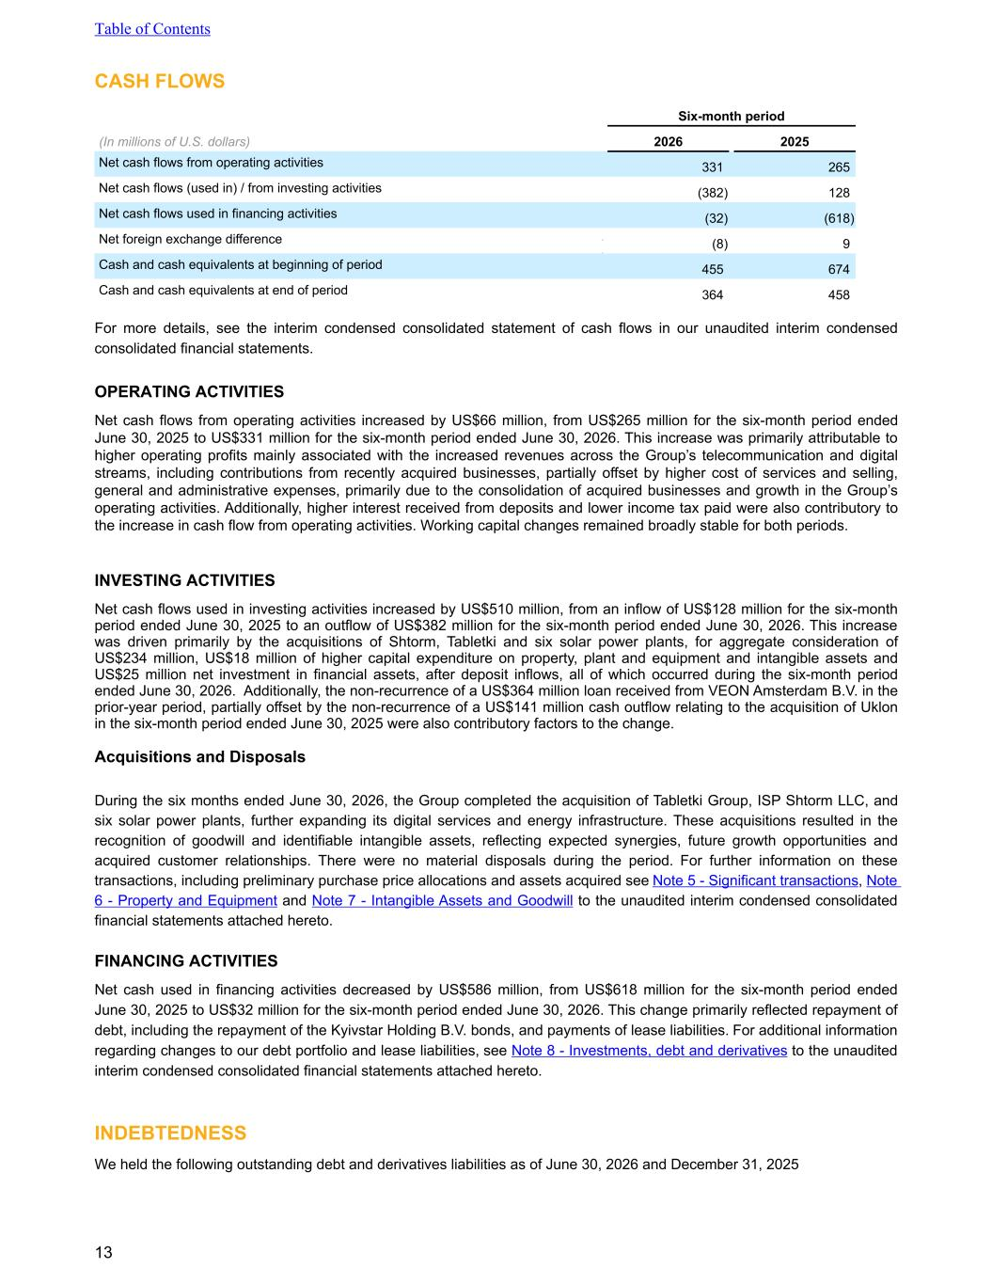
CASH FLOWS Six-month period (In millions of U.S. dollars) 2026 2025 Net cash flows from operating activities 331 265 Net cash flows (used in) / from investing activities (382) 128 Net cash flows used in financing activities (32) (618) Net foreign exchange difference - 5 (8) 9 Cash and cash equivalents at beginning of period 455 674 Cash and cash equivalents at end of period 364 458 For more details, see the interim condensed consolidated statement of cash flows in our unaudited interim condensed consolidated financial statements. OPERATING ACTIVITIES Net cash flows from operating activities increased by US$66 million, from US$265 million for the six-month period ended June 30, 2025 to US$331 million for the six-month period ended June 30, 2026. This increase was primarily attributable to higher operating profits mainly associated with the increased revenues across the Group’s telecommunication and digital streams, including contributions from recently acquired businesses, partially offset by higher cost of services and selling, general and administrative expenses, primarily due to the consolidation of acquired businesses and growth in the Group’s operating activities. Additionally, higher interest received from deposits and lower income tax paid were also contributory to the increase in cash flow from operating activities. Working capital changes remained broadly stable for both periods. INVESTING ACTIVITIES Net cash flows used in investing activities increased by US$510 million, from an inflow of US$128 million for the six-month period ended June 30, 2025 to an outflow of US$382 million for the six-month period ended June 30, 2026. This increase was driven primarily by the acquisitions of Shtorm, Tabletki and six solar power plants, for aggregate consideration of US$234 million, US$18 million of higher capital expenditure on property, plant and equipment and intangible assets and US$25 million net investment in financial assets, after deposit inflows, all of which occurred during the six-month period ended June 30, 2026. Additionally, the non-recurrence of a US$364 million loan received from VEON Amsterdam B.V. in the prior-year period, partially offset by the non-recurrence of a US$141 million cash outflow relating to the acquisition of Uklon in the six-month period ended June 30, 2025 were also contributory factors to the change. Acquisitions and Disposals During the six months ended June 30, 2026, the Group completed the acquisition of Tabletki Group, ISP Shtorm LLC, and six solar power plants, further expanding its digital services and energy infrastructure. These acquisitions resulted in the recognition of goodwill and identifiable intangible assets, reflecting expected synergies, future growth opportunities and acquired customer relationships. There were no material disposals during the period. For further information on these transactions, including preliminary purchase price allocations and assets acquired see Note 5 - Significant transactions, Note 6 - Property and Equipment and Note 7 - Intangible Assets and Goodwill to the unaudited interim condensed consolidated financial statements attached hereto. FINANCING ACTIVITIES Net cash used in financing activities decreased by US$586 million, from US$618 million for the six-month period ended June 30, 2025 to US$32 million for the six-month period ended June 30, 2026. This change primarily reflected repayment of debt, including the repayment of the Kyivstar Holding B.V. bonds, and payments of lease liabilities. For additional information regarding changes to our debt portfolio and lease liabilities, see Note 8 - Investments, debt and derivatives to the unaudited interim condensed consolidated financial statements attached hereto. INDEBTEDNESS We held the following outstanding debt and derivatives liabilities as of June 30, 2026 and December 31, 2025 Table of Contents 13

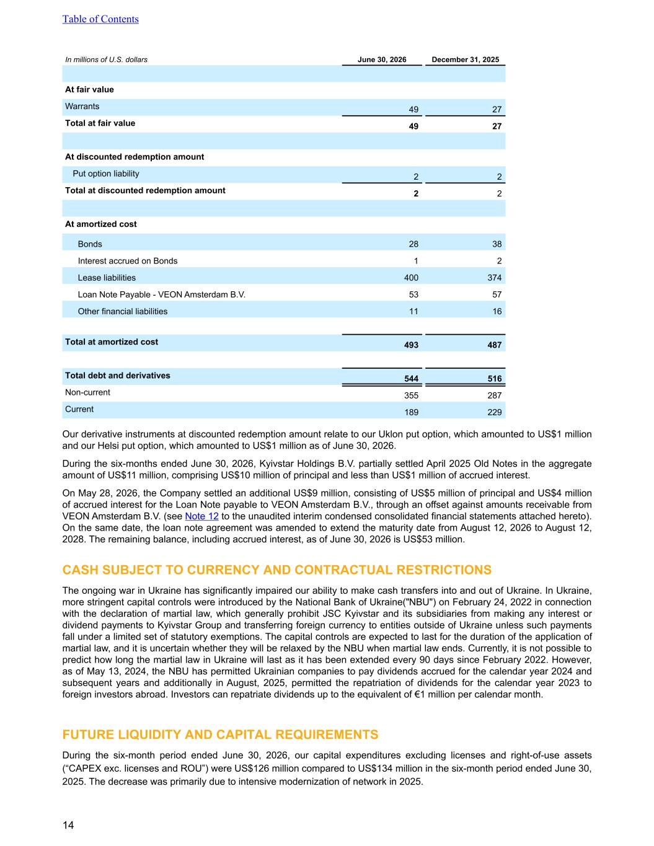
In millions of U.S. dollars June 30, 2026 December 31, 2025 At fair value Warrants 49 27 Total at fair value 49 27 At discounted redemption amount Put option liability 2 2 Total at discounted redemption amount 2 2 At amortized cost Bonds 28 38 Interest accrued on Bonds 1 2 Lease liabilities 400 374 Loan Note Payable - VEON Amsterdam B.V. 53 57 Other financial liabilities 11 16 Total at amortized cost 493 487 Total debt and derivatives 544 516 Non-current 355 287 Current 189 229 Our derivative instruments at discounted redemption amount relate to our Uklon put option, which amounted to US$1 million and our Helsi put option, which amounted to US$1 million as of June 30, 2026. During the six-months ended June 30, 2026, Kyivstar Holdings B.V. partially settled April 2025 Old Notes in the aggregate amount of US$11 million, comprising US$10 million of principal and less than US$1 million of accrued interest. On May 28, 2026, the Company settled an additional US$9 million, consisting of US$5 million of principal and US$4 million of accrued interest for the Loan Note payable to VEON Amsterdam B.V., through an offset against amounts receivable from VEON Amsterdam B.V. (see Note 12 to the unaudited interim condensed consolidated financial statements attached hereto). On the same date, the loan note agreement was amended to extend the maturity date from August 12, 2026 to August 12, 2028. The remaining balance, including accrued interest, as of June 30, 2026 is US$53 million. CASH SUBJECT TO CURRENCY AND CONTRACTUAL RESTRICTIONS The ongoing war in Ukraine has significantly impaired our ability to make cash transfers into and out of Ukraine. In Ukraine, more stringent capital controls were introduced by the National Bank of Ukraine("NBU") on February 24, 2022 in connection with the declaration of martial law, which generally prohibit JSC Kyivstar and its subsidiaries from making any interest or dividend payments to Kyivstar Group and transferring foreign currency to entities outside of Ukraine unless such payments fall under a limited set of statutory exemptions. The capital controls are expected to last for the duration of the application of martial law, and it is uncertain whether they will be relaxed by the NBU when martial law ends. Currently, it is not possible to predict how long the martial law in Ukraine will last as it has been extended every 90 days since February 2022. However, as of May 13, 2024, the NBU has permitted Ukrainian companies to pay dividends accrued for the calendar year 2024 and subsequent years and additionally in August, 2025, permitted the repatriation of dividends for the calendar year 2023 to foreign investors abroad. Investors can repatriate dividends up to the equivalent of €1 million per calendar month. FUTURE LIQUIDITY AND CAPITAL REQUIREMENTS During the six-month period ended June 30, 2026, our capital expenditures excluding licenses and right-of-use assets (“CAPEX exc. licenses and ROU”) were US$126 million compared to US$134 million in the six-month period ended June 30, 2025. The decrease was primarily due to intensive modernization of network in 2025. Table of Contents 14

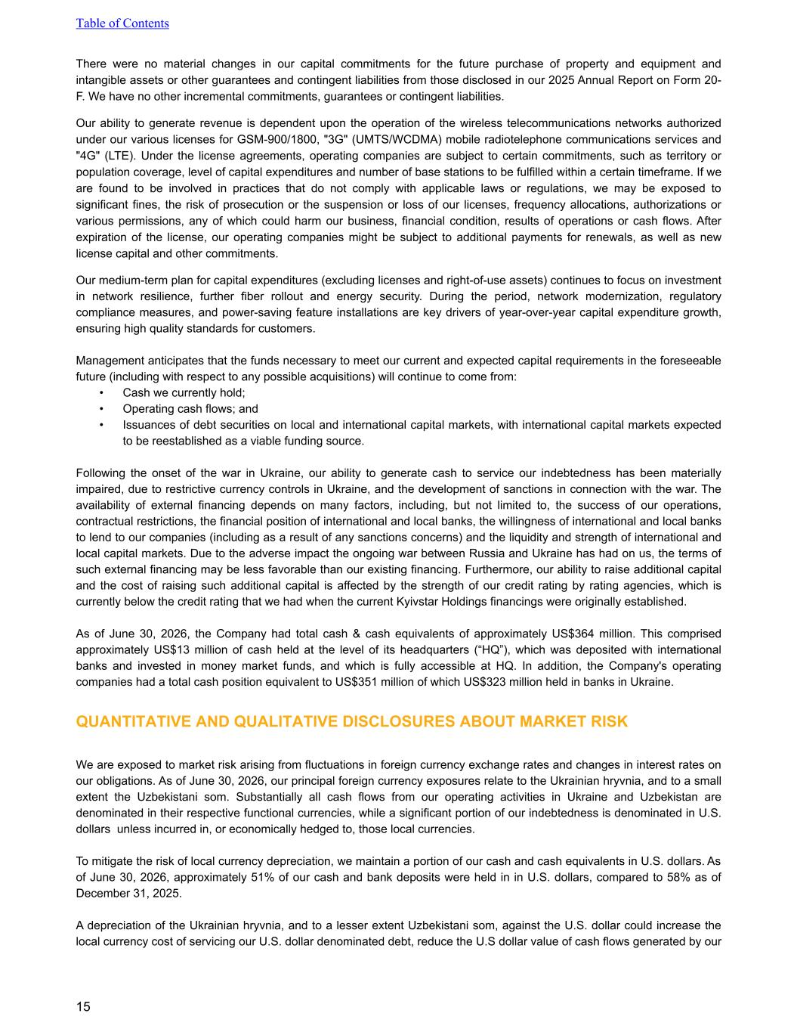
There were no material changes in our capital commitments for the future purchase of property and equipment and intangible assets or other guarantees and contingent liabilities from those disclosed in our 2025 Annual Report on Form 20- F. We have no other incremental commitments, guarantees or contingent liabilities. Our ability to generate revenue is dependent upon the operation of the wireless telecommunications networks authorized under our various licenses for GSM-900/1800, "3G" (UMTS/WCDMA) mobile radiotelephone communications services and "4G" (LTE). Under the license agreements, operating companies are subject to certain commitments, such as territory or population coverage, level of capital expenditures and number of base stations to be fulfilled within a certain timeframe. If we are found to be involved in practices that do not comply with applicable laws or regulations, we may be exposed to significant fines, the risk of prosecution or the suspension or loss of our licenses, frequency allocations, authorizations or various permissions, any of which could harm our business, financial condition, results of operations or cash flows. After expiration of the license, our operating companies might be subject to additional payments for renewals, as well as new license capital and other commitments. Our medium-term plan for capital expenditures (excluding licenses and right-of-use assets) continues to focus on investment in network resilience, further fiber rollout and energy security. During the period, network modernization, regulatory compliance measures, and power-saving feature installations are key drivers of year-over-year capital expenditure growth, ensuring high quality standards for customers. Management anticipates that the funds necessary to meet our current and expected capital requirements in the foreseeable future (including with respect to any possible acquisitions) will continue to come from: • Cash we currently hold; • Operating cash flows; and • Issuances of debt securities on local and international capital markets, with international capital markets expected to be reestablished as a viable funding source. Following the onset of the war in Ukraine, our ability to generate cash to service our indebtedness has been materially impaired, due to restrictive currency controls in Ukraine, and the development of sanctions in connection with the war. The availability of external financing depends on many factors, including, but not limited to, the success of our operations, contractual restrictions, the financial position of international and local banks, the willingness of international and local banks to lend to our companies (including as a result of any sanctions concerns) and the liquidity and strength of international and local capital markets. Due to the adverse impact the ongoing war between Russia and Ukraine has had on us, the terms of such external financing may be less favorable than our existing financing. Furthermore, our ability to raise additional capital and the cost of raising such additional capital is affected by the strength of our credit rating by rating agencies, which is currently below the credit rating that we had when the current Kyivstar Holdings financings were originally established. As of June 30, 2026, the Company had total cash & cash equivalents of approximately US$364 million. This comprised approximately US$13 million of cash held at the level of its headquarters (“HQ”), which was deposited with international banks and invested in money market funds, and which is fully accessible at HQ. In addition, the Company's operating companies had a total cash position equivalent to US$351 million of which US$323 million held in banks in Ukraine. QUANTITATIVE AND QUALITATIVE DISCLOSURES ABOUT MARKET RISK We are exposed to market risk arising from fluctuations in foreign currency exchange rates and changes in interest rates on our obligations. As of June 30, 2026, our principal foreign currency exposures relate to the Ukrainian hryvnia, and to a small extent the Uzbekistani som. Substantially all cash flows from our operating activities in Ukraine and Uzbekistan are denominated in their respective functional currencies, while a significant portion of our indebtedness is denominated in U.S. dollars unless incurred in, or economically hedged to, those local currencies. To mitigate the risk of local currency depreciation, we maintain a portion of our cash and cash equivalents in U.S. dollars. As of June 30, 2026, approximately 51% of our cash and bank deposits were held in in U.S. dollars, compared to 58% as of December 31, 2025. A depreciation of the Ukrainian hryvnia, and to a lesser extent Uzbekistani som, against the U.S. dollar could increase the local currency cost of servicing our U.S. dollar denominated debt, reduce the U.S dollar value of cash flows generated by our Table of Contents 15


operations, and adversely affect our liquidity, financial condition, results of operations and ability to repay or refinance existing indebtedness. Consistent with our treasury policies, we do not engage in derivative or treasury transactions for speculative purposes. Our treasury function maintains risk management policies and procedures designed to monitor and manage foreign currency risk, including guidelines governing the management and mitigation of foreign exchange exposures. Table of Contents 16

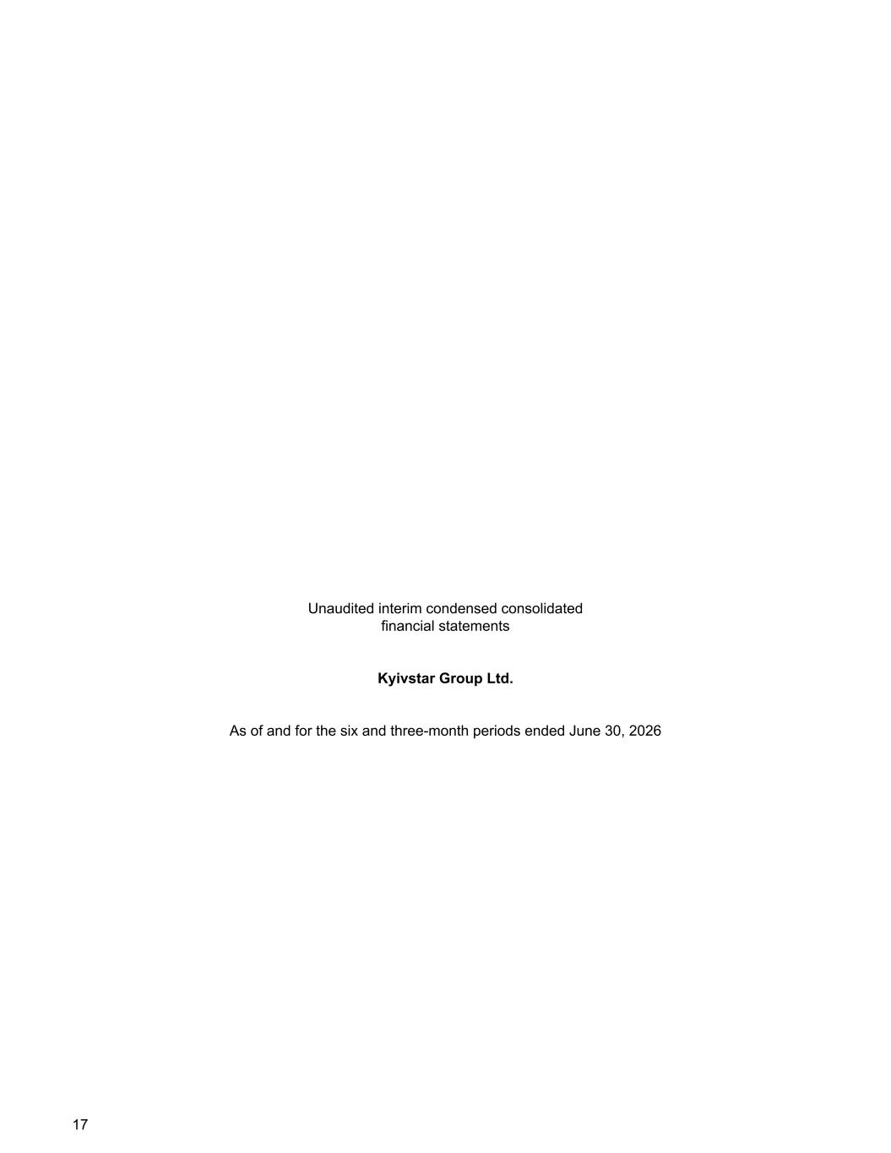
Unaudited interim condensed consolidated financial statements Kyivstar Group Ltd. As of and for the six and three-month periods ended June 30, 2026 17

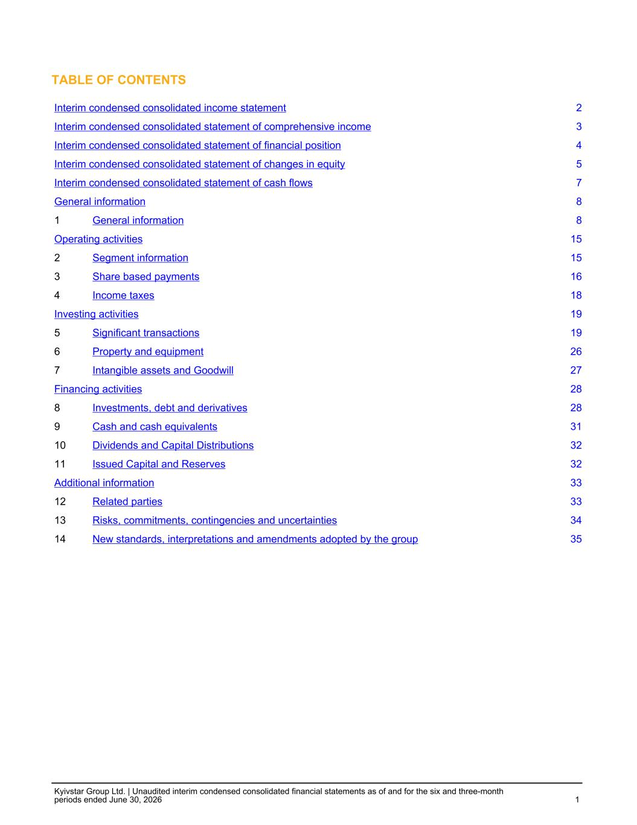
TABLE OF CONTENTS Interim condensed consolidated income statement 2 Interim condensed consolidated statement of comprehensive income 3 Interim condensed consolidated statement of financial position 4 Interim condensed consolidated statement of changes in equity 5 Interim condensed consolidated statement of cash flows 7 General information 8 1 General information 8 Operating activities 15 2 Segment information 15 3 Share based payments 16 4 Income taxes 18 Investing activities 19 5 Significant transactions 19 6 Property and equipment 26 7 Intangible assets and Goodwill 27 Financing activities 28 8 Investments, debt and derivatives 28 9 Cash and cash equivalents 31 10 Dividends and Capital Distributions 32 11 Issued Capital and Reserves 32 Additional information 33 12 Related parties 33 13 Risks, commitments, contingencies and uncertainties 34 14 New standards, interpretations and amendments adopted by the group 35 Kyivstar Group Ltd. | Unaudited interim condensed consolidated financial statements as of and for the six and three-month periods ended June 30, 2026 1

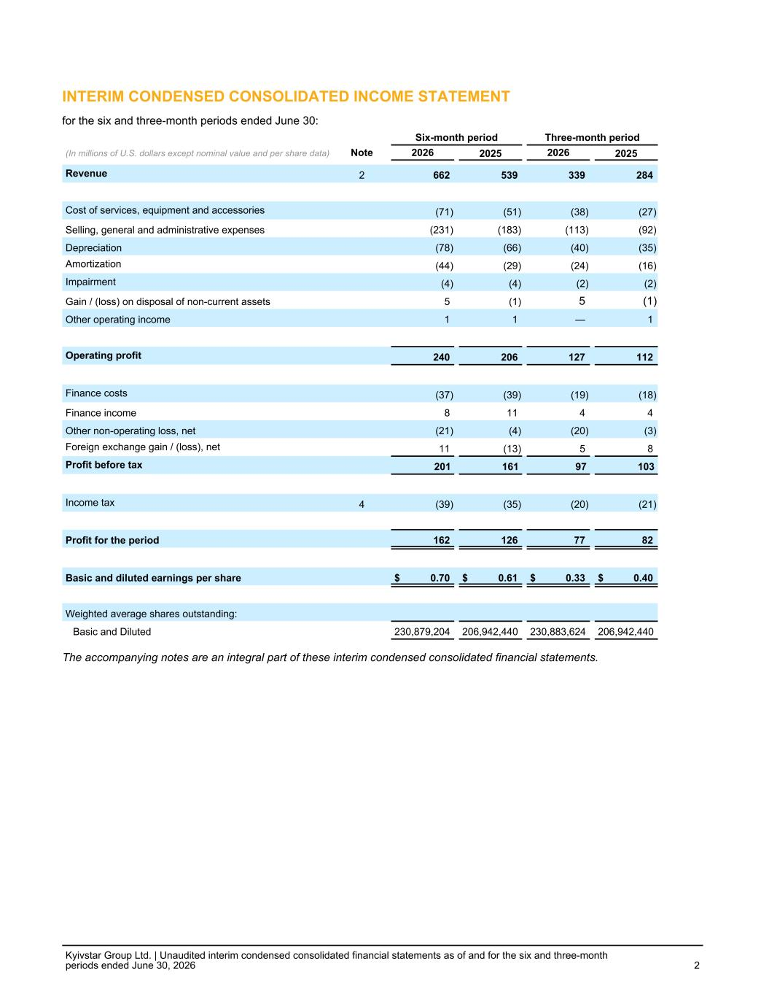
INTERIM CONDENSED CONSOLIDATED INCOME STATEMENT for the six and three-month periods ended June 30: Six-month period Three-month period (In millions of U.S. dollars except nominal value and per share data) Note 2026 2025 2026 2025 Revenue 2 662 539 339 284 Cost of services, equipment and accessories (71) (51) (38) (27) Selling, general and administrative expenses (231) (183) (113) (92) Depreciation (78) (66) (40) (35) Amortization (44) (29) (24) (16) Impairment (4) (4) (2) (2) Gain / (loss) on disposal of non-current assets 5 (1) 5 (1) Other operating income 1 1 — 1 Operating profit 240 206 127 112 Finance costs (37) (39) (19) (18) Finance income 8 11 4 4 Other non-operating loss, net (21) (4) (20) (3) Foreign exchange gain / (loss), net 11 (13) 5 8 Profit before tax 201 161 97 103 Income tax 4 (39) (35) (20) (21) Profit for the period 162 126 77 82 Basic and diluted earnings per share $ 0.70 $ 0.61 $ 0.33 $ 0.40 Weighted average shares outstanding: Basic and Diluted 230,879,204 206,942,440 230,883,624 206,942,440 The accompanying notes are an integral part of these interim condensed consolidated financial statements. Kyivstar Group Ltd. | Unaudited interim condensed consolidated financial statements as of and for the six and three-month periods ended June 30, 2026 2

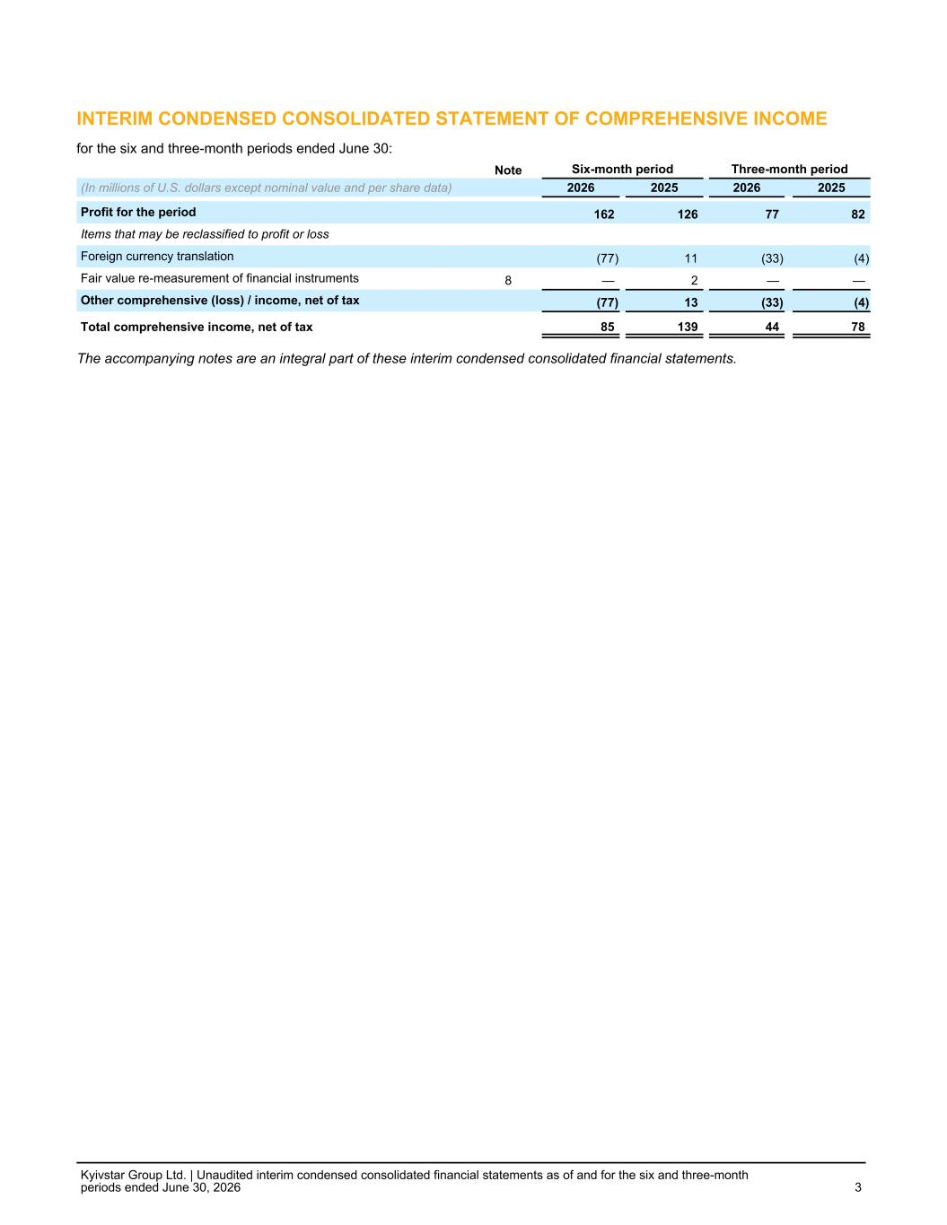
INTERIM CONDENSED CONSOLIDATED STATEMENT OF COMPREHENSIVE INCOME for the six and three-month periods ended June 30: Note Six-month period Three-month period (In millions of U.S. dollars except nominal value and per share data) 2026 2025 2026 2025 Profit for the period 162 126 77 82 Items that may be reclassified to profit or loss Foreign currency translation (77) 11 (33) (4) Fair value re-measurement of financial instruments 8 — 2 — — Other comprehensive (loss) / income, net of tax (77) 13 (33) (4) Total comprehensive income, net of tax 85 139 44 78 The accompanying notes are an integral part of these interim condensed consolidated financial statements. Kyivstar Group Ltd. | Unaudited interim condensed consolidated financial statements as of and for the six and three-month periods ended June 30, 2026 3

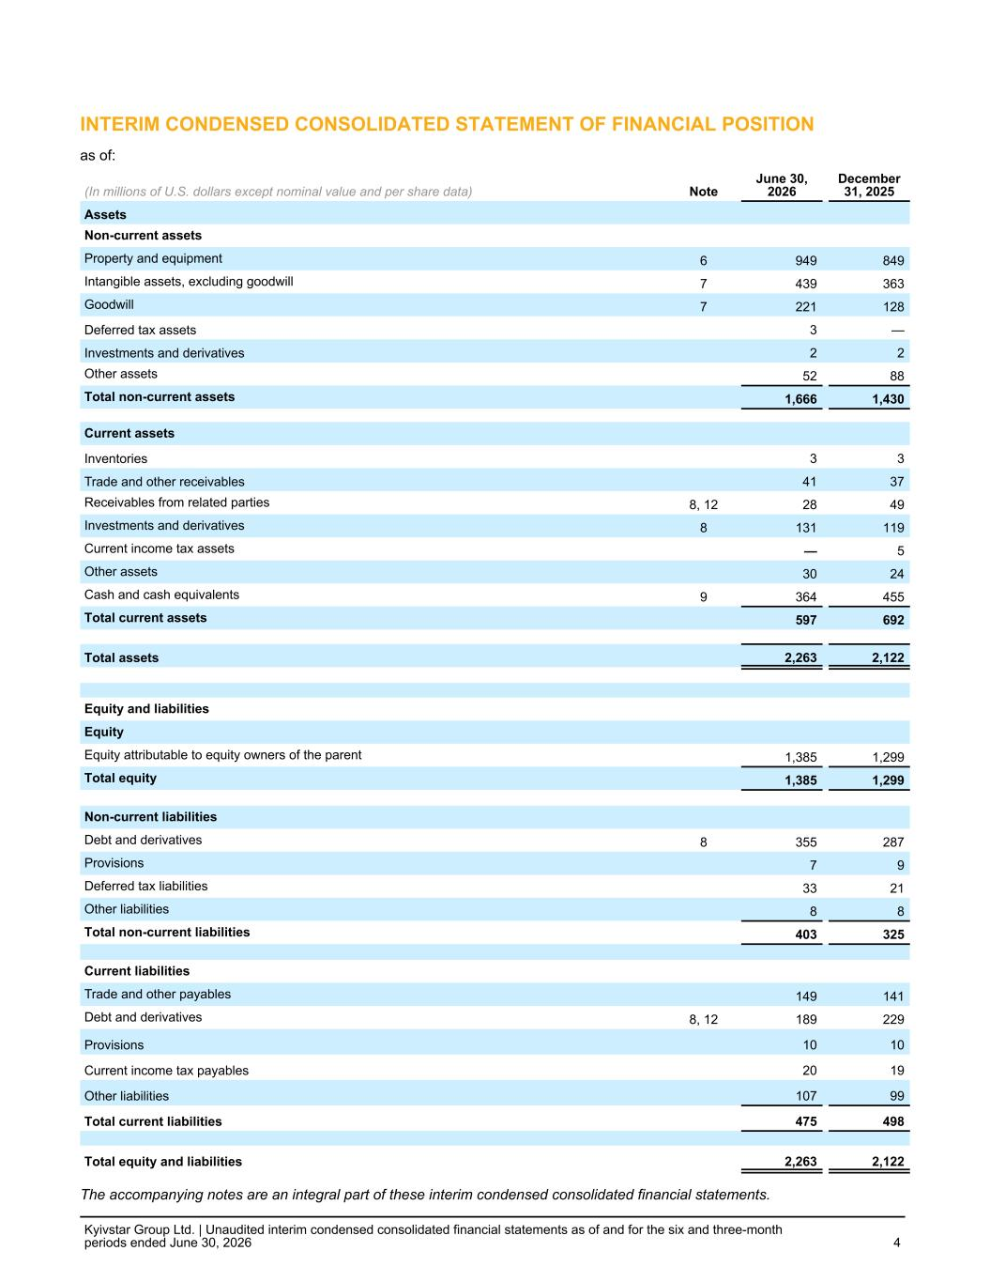
INTERIM CONDENSED CONSOLIDATED STATEMENT OF FINANCIAL POSITION as of: (In millions of U.S. dollars except nominal value and per share data) Note June 30, 2026 December 31, 2025 Assets Non-current assets Property and equipment 6 949 849 Intangible assets, excluding goodwill 7 439 363 Goodwill 7 221 128 Deferred tax assets 3 — Investments and derivatives 2 2 Other assets 52 88 Total non-current assets 1,666 1,430 Current assets Inventories 3 3 Trade and other receivables 41 37 Receivables from related parties 8, 12 28 49 Investments and derivatives 8 131 119 Current income tax assets — 5 Other assets 30 24 Cash and cash equivalents 9 364 455 Total current assets 597 692 Total assets 2,263 2,122 Equity and liabilities Equity Equity attributable to equity owners of the parent 1,385 1,299 Total equity 1,385 1,299 Non-current liabilities Debt and derivatives 8 355 287 Provisions 7 9 Deferred tax liabilities 33 21 Other liabilities 8 8 Total non-current liabilities 403 325 Current liabilities Trade and other payables 149 141 Debt and derivatives 8, 12 189 229 Provisions 10 10 Current income tax payables 20 19 Other liabilities 107 99 Total current liabilities 475 498 Total equity and liabilities 2,263 2,122 The accompanying notes are an integral part of these interim condensed consolidated financial statements. Kyivstar Group Ltd. | Unaudited interim condensed consolidated financial statements as of and for the six and three-month periods ended June 30, 2026 4

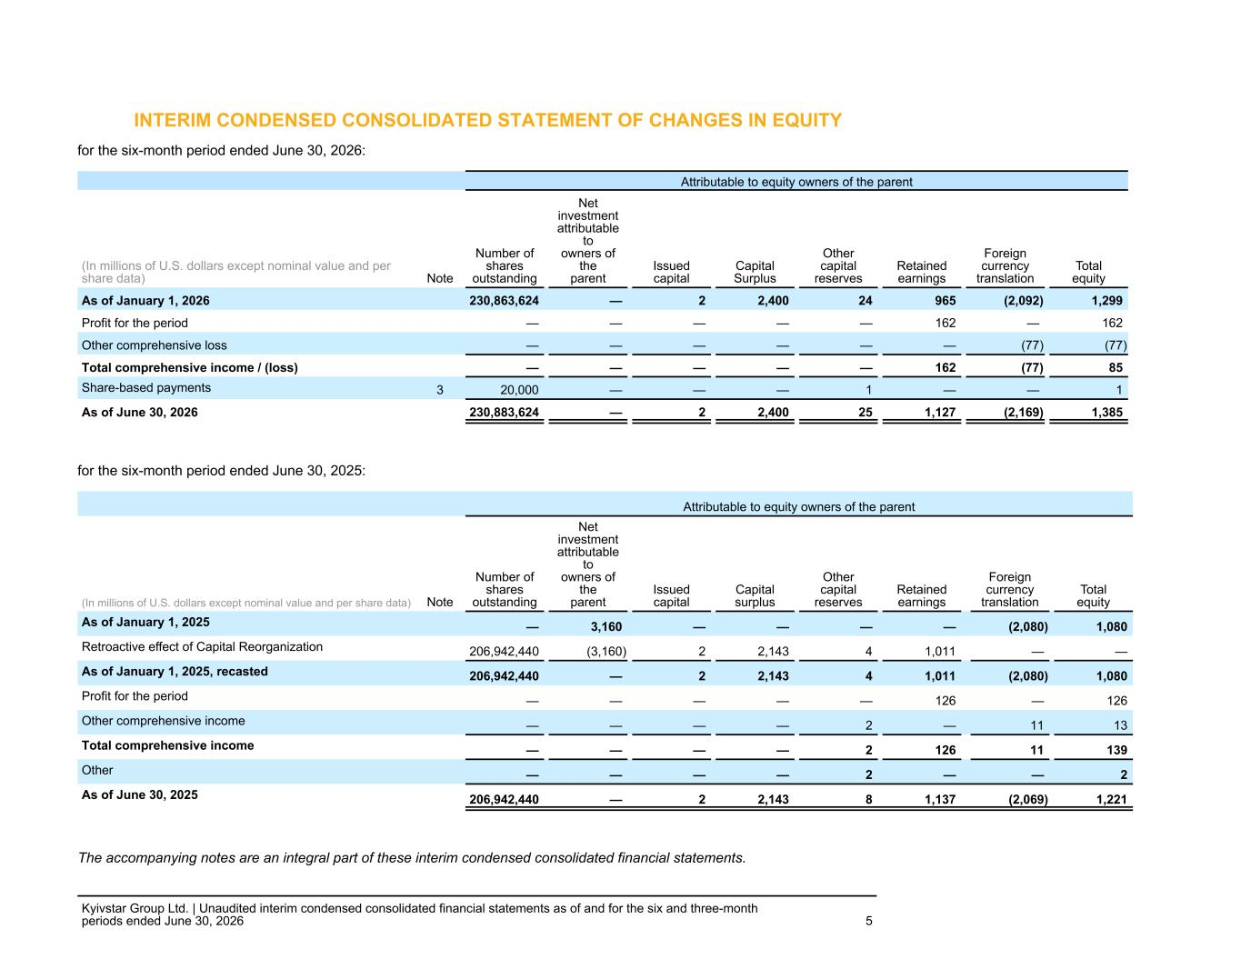
INTERIM CONDENSED CONSOLIDATED STATEMENT OF CHANGES IN EQUITY for the six-month period ended June 30, 2026: Attributable to equity owners of the parent (In millions of U.S. dollars except nominal value and per share data) Note Number of shares outstanding Net investment attributable to owners of the parent Issued capital Capital Surplus Other capital reserves Retained earnings Foreign currency translation Total equity As of January 1, 2026 230,863,624 — 2 2,400 24 965 (2,092) 1,299 Profit for the period — — — — — 162 — 162 Other comprehensive loss — — — — — — (77) (77) Total comprehensive income / (loss) — — — — — 162 (77) 85 Share-based payments 3 20,000 — — — 1 — — 1 As of June 30, 2026 230,883,624 — 2 2,400 25 1,127 (2,169) 1,385 for the six-month period ended June 30, 2025: Attributable to equity owners of the parent (In millions of U.S. dollars except nominal value and per share data) Note Number of shares outstanding Net investment attributable to owners of the parent Issued capital Capital surplus Other capital reserves Retained earnings Foreign currency translation Total equity As of January 1, 2025 — 3,160 — — — — (2,080) 1,080 Retroactive effect of Capital Reorganization 206,942,440 (3,160) 2 2,143 4 1,011 — — As of January 1, 2025, recasted 206,942,440 — 2 2,143 4 1,011 (2,080) 1,080 Profit for the period — — — — — 126 — 126 Other comprehensive income — — — — 2 — 11 13 Total comprehensive income — — — — 2 126 11 139 Other — — — — 2 — — 2 As of June 30, 2025 206,942,440 — 2 2,143 8 1,137 (2,069) 1,221 The accompanying notes are an integral part of these interim condensed consolidated financial statements. Kyivstar Group Ltd. | Unaudited interim condensed consolidated financial statements as of and for the six and three-month periods ended June 30, 2026 5

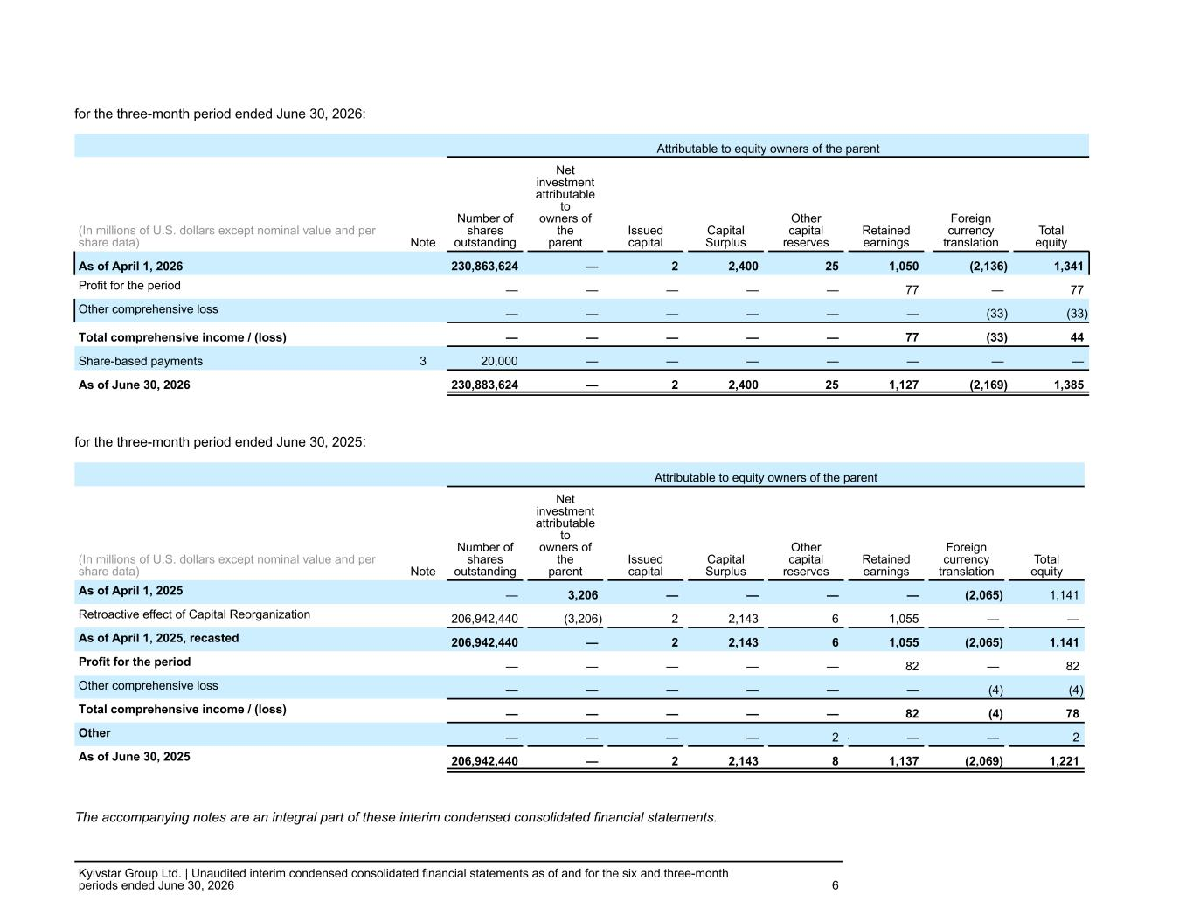
for the three-month period ended June 30, 2026: Attributable to equity owners of the parent (In millions of U.S. dollars except nominal value and per share data) Note Number of shares outstanding Net investment attributable to owners of the parent Issued capital Capital Surplus Other capital reserves Retained earnings Foreign currency translation Total equity As of April 1, 2026 230,863,624 — 2 2,400 25 1,050 (2,136) 1,341 Profit for the period 4 — — — — — 77 — 77 Other comprehensive loss — — — — — — (33) (33) Total comprehensive income / (loss) — — — — — 77 (33) 44 Share-based payments 3 20,000 — — — — — — — As of June 30, 2026 230,883,624 — 2 2,400 25 1,127 (2,169) 1,385 for the three-month period ended June 30, 2025: Attributable to equity owners of the parent (In millions of U.S. dollars except nominal value and per share data) Note Number of shares outstanding Net investment attributable to owners of the parent Issued capital Capital Surplus Other capital reserves Retained earnings Foreign currency translation Total equity As of April 1, 2025 — 3,206 — — — — (2,065) 1,141 Retroactive effect of Capital Reorganization 206,942,440 (3,206) 2 2,143 6 1,055 — — As of April 1, 2025, recasted 206,942,440 — 2 2,143 6 1,055 (2,065) 1,141 Profit for the period — — — — — 82 — 82 Other comprehensive loss — — — — — — (4) (4) Total comprehensive income / (loss) — — — — — 82 (4) 78 Other — — — — 2 — — — 2 As of June 30, 2025 206,942,440 — 2 2,143 8 1,137 (2,069) 1,221 The accompanying notes are an integral part of these interim condensed consolidated financial statements. Kyivstar Group Ltd. | Unaudited interim condensed consolidated financial statements as of and for the six and three-month periods ended June 30, 2026 6

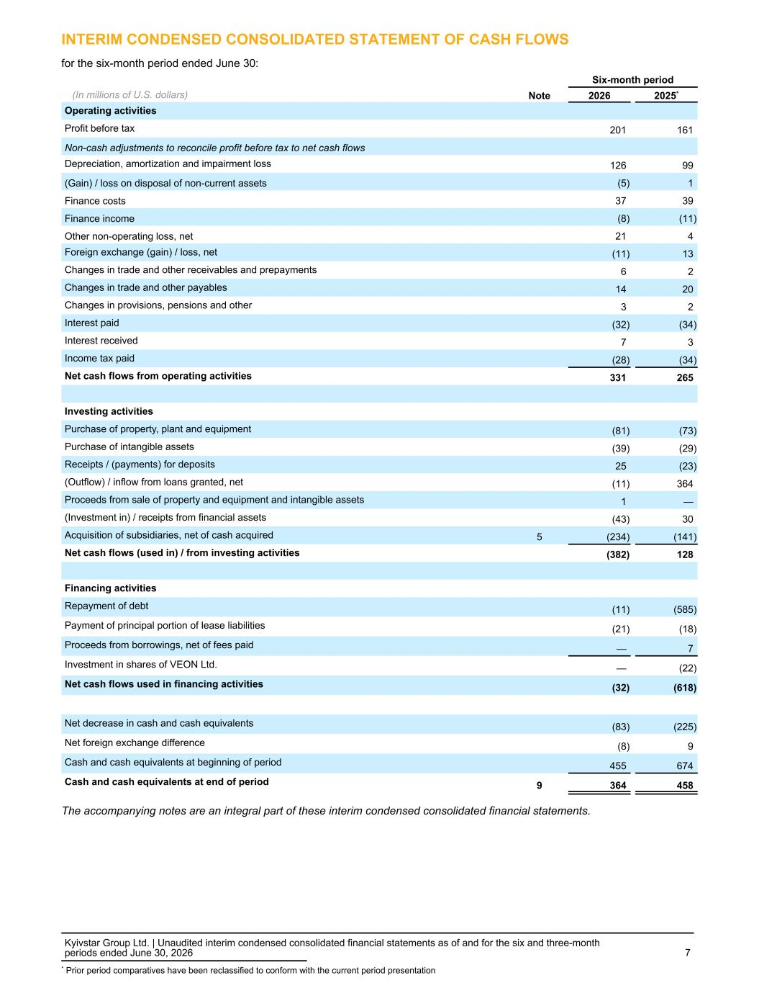
INTERIM CONDENSED CONSOLIDATED STATEMENT OF CASH FLOWS for the six-month period ended June 30: Six-month period (In millions of U.S. dollars) Note 2026 2025* Operating activities Profit before tax 201 161 Non-cash adjustments to reconcile profit before tax to net cash flows Depreciation, amortization and impairment loss 126 99 (Gain) / loss on disposal of non-current assets (5) 1 Finance costs 37 39 Finance income (8) (11) Other non-operating loss, net 21 4 Foreign exchange (gain) / loss, net (11) 13 Changes in trade and other receivables and prepayments 6 2 Changes in trade and other payables 14 20 Changes in provisions, pensions and other 3 2 Interest paid (32) (34) Interest received 7 3 Income tax paid (28) (34) Net cash flows from operating activities 331 265 Investing activities Purchase of property, plant and equipment (81) (73) Purchase of intangible assets (39) (29) Receipts / (payments) for deposits 25 (23) (Outflow) / inflow from loans granted, net (11) 364 Proceeds from sale of property and equipment and intangible assets 1 — (Investment in) / receipts from financial assets (43) 30 Acquisition of subsidiaries, net of cash acquired 5 (234) (141) Net cash flows (used in) / from investing activities (382) 128 Financing activities Repayment of debt (11) (585) Payment of principal portion of lease liabilities (21) (18) Proceeds from borrowings, net of fees paid — 7 Investment in shares of VEON Ltd. — (22) Net cash flows used in financing activities (32) (618) Net decrease in cash and cash equivalents (83) (225) Net foreign exchange difference (8) 9 Cash and cash equivalents at beginning of period 455 674 Cash and cash equivalents at end of period 9 364 458 The accompanying notes are an integral part of these interim condensed consolidated financial statements. Kyivstar Group Ltd. | Unaudited interim condensed consolidated financial statements as of and for the six and three-month periods ended June 30, 2026 7 * Prior period comparatives have been reclassified to conform with the current period presentation

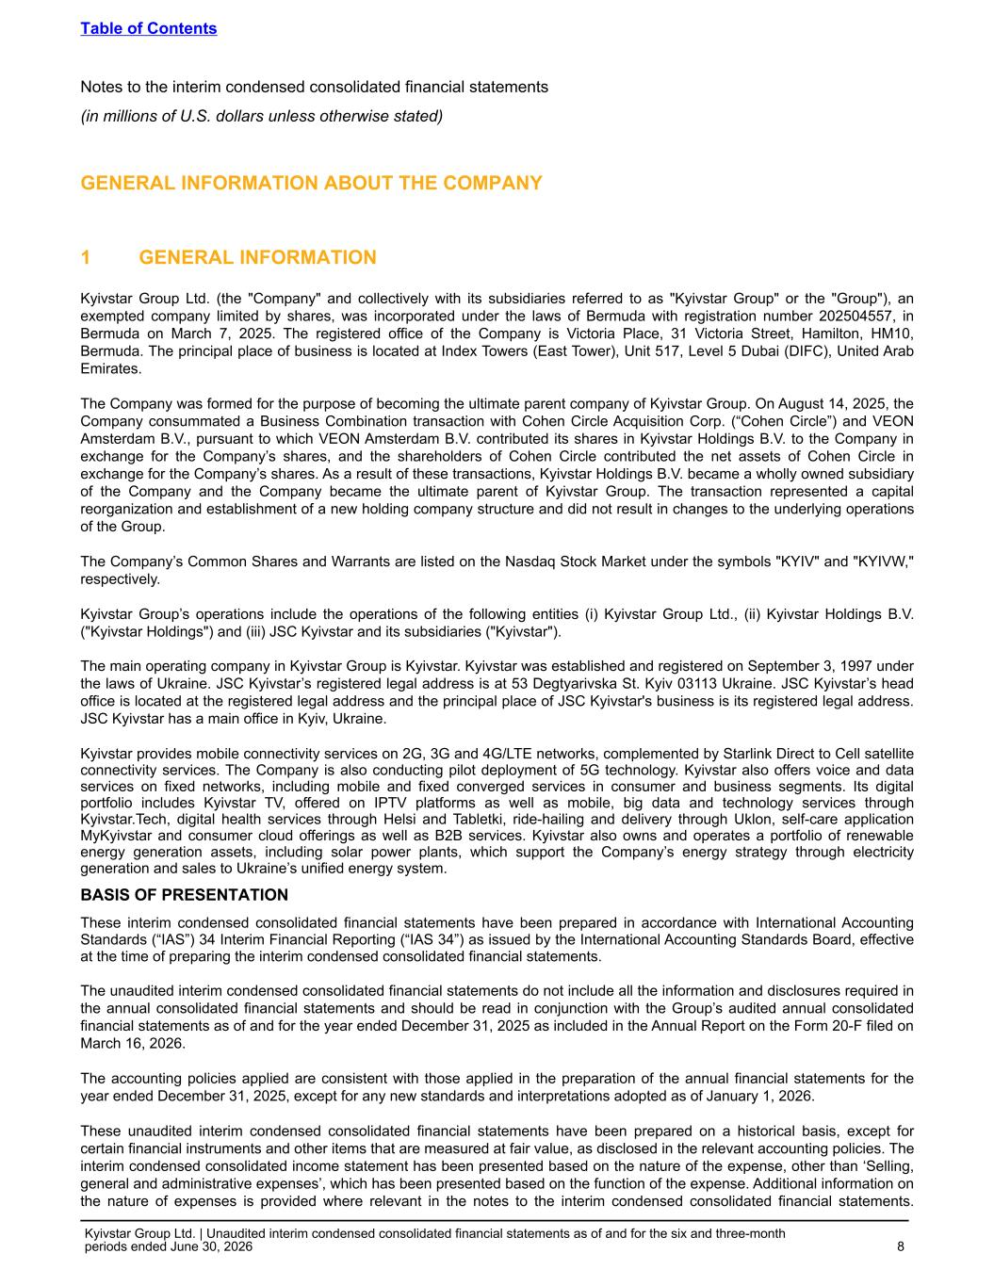
GENERAL INFORMATION ABOUT THE COMPANY 1 GENERAL INFORMATION Kyivstar Group Ltd. (the "Company" and collectively with its subsidiaries referred to as "Kyivstar Group" or the "Group"), an exempted company limited by shares, was incorporated under the laws of Bermuda with registration number 202504557, in Bermuda on March 7, 2025. The registered office of the Company is Victoria Place, 31 Victoria Street, Hamilton, HM10, Bermuda. The principal place of business is located at Index Towers (East Tower), Unit 517, Level 5 Dubai (DIFC), United Arab Emirates. The Company was formed for the purpose of becoming the ultimate parent company of Kyivstar Group. On August 14, 2025, the Company consummated a Business Combination transaction with Cohen Circle Acquisition Corp. (“Cohen Circle”) and VEON Amsterdam B.V., pursuant to which VEON Amsterdam B.V. contributed its shares in Kyivstar Holdings B.V. to the Company in exchange for the Company’s shares, and the shareholders of Cohen Circle contributed the net assets of Cohen Circle in exchange for the Company’s shares. As a result of these transactions, Kyivstar Holdings B.V. became a wholly owned subsidiary of the Company and the Company became the ultimate parent of Kyivstar Group. The transaction represented a capital reorganization and establishment of a new holding company structure and did not result in changes to the underlying operations of the Group. The Company’s Common Shares and Warrants are listed on the Nasdaq Stock Market under the symbols "KYIV" and "KYIVW," respectively. Kyivstar Group’s operations include the operations of the following entities (i) Kyivstar Group Ltd., (ii) Kyivstar Holdings B.V. ("Kyivstar Holdings") and (iii) JSC Kyivstar and its subsidiaries ("Kyivstar"). The main operating company in Kyivstar Group is Kyivstar. Kyivstar was established and registered on September 3, 1997 under the laws of Ukraine. JSC Kyivstar’s registered legal address is at 53 Degtyarivska St. Kyiv 03113 Ukraine. JSC Kyivstar’s head office is located at the registered legal address and the principal place of JSC Kyivstar's business is its registered legal address. JSC Kyivstar has a main office in Kyiv, Ukraine. Kyivstar provides mobile connectivity services on 2G, 3G and 4G/LTE networks, complemented by Starlink Direct to Cell satellite connectivity services. The Company is also conducting pilot deployment of 5G technology. Kyivstar also offers voice and data services on fixed networks, including mobile and fixed converged services in consumer and business segments. Its digital portfolio includes Kyivstar TV, offered on IPTV platforms as well as mobile, big data and technology services through Kyivstar.Tech, digital health services through Helsi and Tabletki, ride-hailing and delivery through Uklon, self-care application MyKyivstar and consumer cloud offerings as well as B2B services. Kyivstar also owns and operates a portfolio of renewable energy generation assets, including solar power plants, which support the Company’s energy strategy through electricity generation and sales to Ukraine’s unified energy system. BASIS OF PRESENTATION These interim condensed consolidated financial statements have been prepared in accordance with International Accounting Standards (“IAS”) 34 Interim Financial Reporting (“IAS 34”) as issued by the International Accounting Standards Board, effective at the time of preparing the interim condensed consolidated financial statements. The unaudited interim condensed consolidated financial statements do not include all the information and disclosures required in the annual consolidated financial statements and should be read in conjunction with the Group’s audited annual consolidated financial statements as of and for the year ended December 31, 2025 as included in the Annual Report on the Form 20-F filed on March 16, 2026. The accounting policies applied are consistent with those applied in the preparation of the annual financial statements for the year ended December 31, 2025, except for any new standards and interpretations adopted as of January 1, 2026. These unaudited interim condensed consolidated financial statements have been prepared on a historical basis, except for certain financial instruments and other items that are measured at fair value, as disclosed in the relevant accounting policies. The interim condensed consolidated income statement has been presented based on the nature of the expense, other than ‘Selling, general and administrative expenses’, which has been presented based on the function of the expense. Additional information on the nature of expenses is provided where relevant in the notes to the interim condensed consolidated financial statements. Table of Contents Notes to the interim condensed consolidated financial statements (in millions of U.S. dollars unless otherwise stated) Kyivstar Group Ltd. | Unaudited interim condensed consolidated financial statements as of and for the six and three-month periods ended June 30, 2026 8

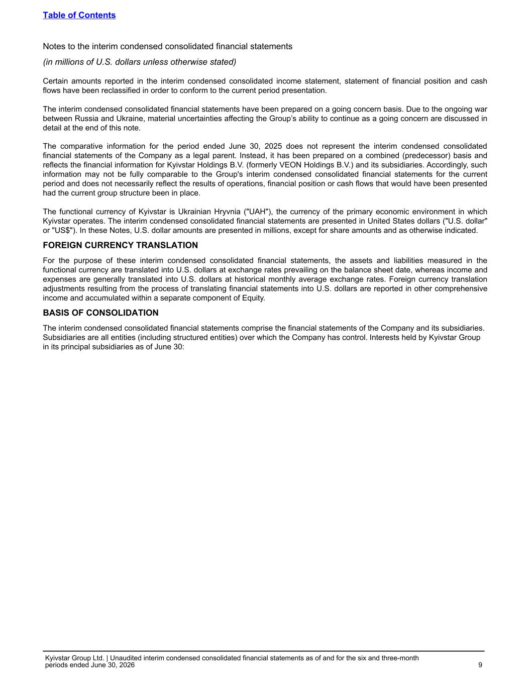
Certain amounts reported in the interim condensed consolidated income statement, statement of financial position and cash flows have been reclassified in order to conform to the current period presentation. The interim condensed consolidated financial statements have been prepared on a going concern basis. Due to the ongoing war between Russia and Ukraine, material uncertainties affecting the Group’s ability to continue as a going concern are discussed in detail at the end of this note. The comparative information for the period ended June 30, 2025 does not represent the interim condensed consolidated financial statements of the Company as a legal parent. Instead, it has been prepared on a combined (predecessor) basis and reflects the financial information for Kyivstar Holdings B.V. (formerly VEON Holdings B.V.) and its subsidiaries. Accordingly, such information may not be fully comparable to the Group's interim condensed consolidated financial statements for the current period and does not necessarily reflect the results of operations, financial position or cash flows that would have been presented had the current group structure been in place. The functional currency of Kyivstar is Ukrainian Hryvnia ("UAH"), the currency of the primary economic environment in which Kyivstar operates. The interim condensed consolidated financial statements are presented in United States dollars ("U.S. dollar" or "US$"). In these Notes, U.S. dollar amounts are presented in millions, except for share amounts and as otherwise indicated. FOREIGN CURRENCY TRANSLATION For the purpose of these interim condensed consolidated financial statements, the assets and liabilities measured in the functional currency are translated into U.S. dollars at exchange rates prevailing on the balance sheet date, whereas income and expenses are generally translated into U.S. dollars at historical monthly average exchange rates. Foreign currency translation adjustments resulting from the process of translating financial statements into U.S. dollars are reported in other comprehensive income and accumulated within a separate component of Equity. BASIS OF CONSOLIDATION The interim condensed consolidated financial statements comprise the financial statements of the Company and its subsidiaries. Subsidiaries are all entities (including structured entities) over which the Company has control. Interests held by Kyivstar Group in its principal subsidiaries as of June 30: Table of Contents Notes to the interim condensed consolidated financial statements (in millions of U.S. dollars unless otherwise stated) Kyivstar Group Ltd. | Unaudited interim condensed consolidated financial statements as of and for the six and three-month periods ended June 30, 2026 9

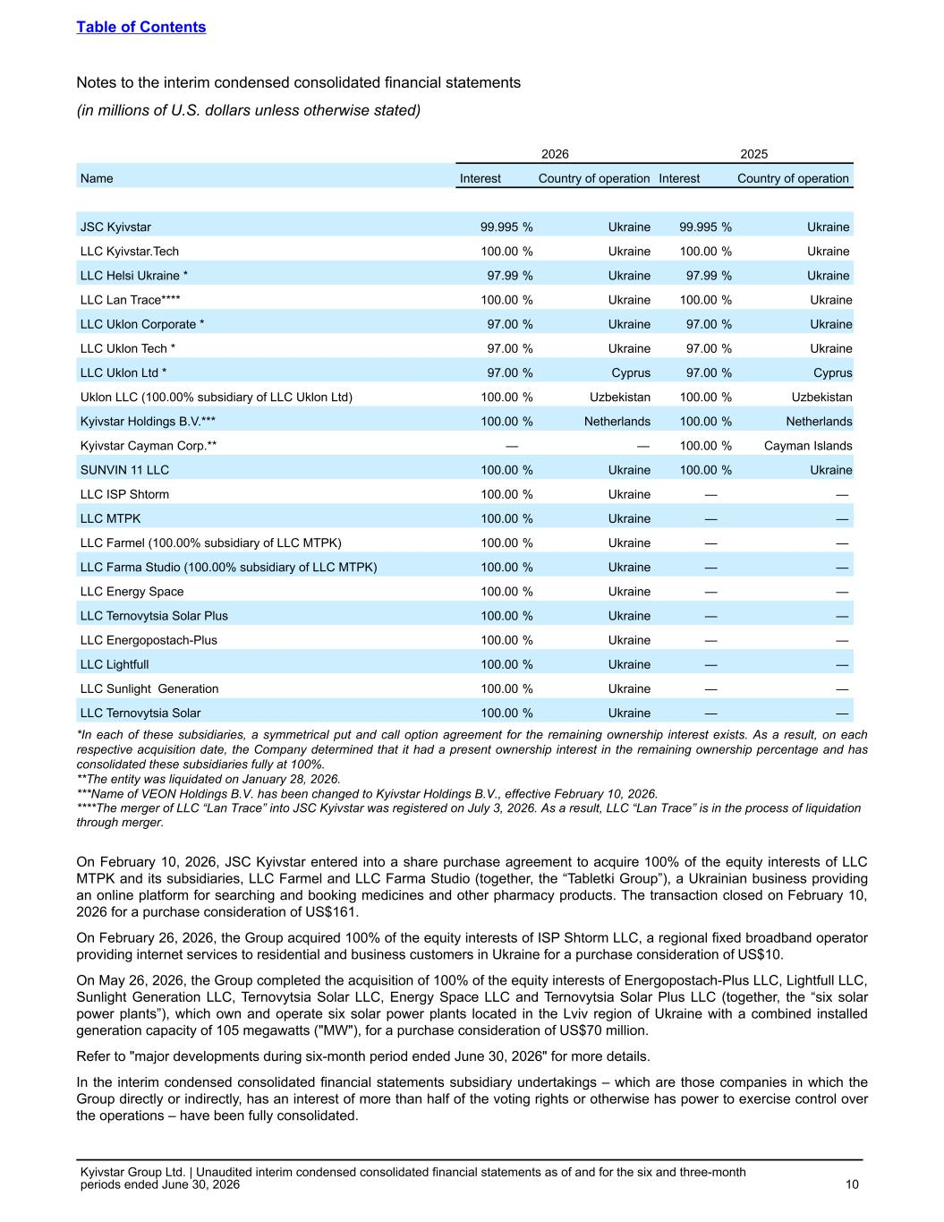
2026 2025 Name Interest Country of operation Interest Country of operation JSC Kyivstar 99.995 % Ukraine 99.995 % Ukraine LLC Kyivstar.Tech 100.00 % Ukraine 100.00 % Ukraine LLC Helsi Ukraine * 97.99 % Ukraine 97.99 % Ukraine LLC Lan Trace**** 100.00 % Ukraine 100.00 % Ukraine LLC Uklon Corporate * 97.00 % Ukraine 97.00 % Ukraine LLC Uklon Tech * 97.00 % Ukraine 97.00 % Ukraine LLC Uklon Ltd * 97.00 % Cyprus 97.00 % Cyprus Uklon LLC (100.00% subsidiary of LLC Uklon Ltd) 100.00 % Uzbekistan 100.00 % Uzbekistan Kyivstar Holdings B.V.*** 100.00 % Netherlands 100.00 % Netherlands Kyivstar Cayman Corp.** — — 100.00 % Cayman Islands SUNVIN 11 LLC 100.00 % Ukraine 100.00 % Ukraine LLC ISP Shtorm 100.00 % Ukraine — — LLC MTPK 100.00 % Ukraine — — LLC Farmel (100.00% subsidiary of LLC MTPK) 100.00 % Ukraine — — LLC Farma Studio (100.00% subsidiary of LLC MTPK) 100.00 % Ukraine — — LLC Energy Space 100.00 % Ukraine — — LLC Ternovytsia Solar Plus 100.00 % Ukraine — — LLC Energopostach-Plus 100.00 % Ukraine — — LLC Lightfull 100.00 % Ukraine — — LLC Sunlight Generation 100.00 % Ukraine — — LLC Ternovytsia Solar 100.00 % Ukraine — — *In each of these subsidiaries, a symmetrical put and call option agreement for the remaining ownership interest exists. As a result, on each respective acquisition date, the Company determined that it had a present ownership interest in the remaining ownership percentage and has consolidated these subsidiaries fully at 100%. **The entity was liquidated on January 28, 2026. ***Name of VEON Holdings B.V. has been changed to Kyivstar Holdings B.V., effective February 10, 2026. ****The merger of LLC “Lan Trace” into JSC Kyivstar was registered on July 3, 2026. As a result, LLC “Lan Trace” is in the process of liquidation through merger. On February 10, 2026, JSC Kyivstar entered into a share purchase agreement to acquire 100% of the equity interests of LLC MTPK and its subsidiaries, LLC Farmel and LLC Farma Studio (together, the “Tabletki Group”), a Ukrainian business providing an online platform for searching and booking medicines and other pharmacy products. The transaction closed on February 10, 2026 for a purchase consideration of US$161. On February 26, 2026, the Group acquired 100% of the equity interests of ISP Shtorm LLC, a regional fixed broadband operator providing internet services to residential and business customers in Ukraine for a purchase consideration of US$10. On May 26, 2026, the Group completed the acquisition of 100% of the equity interests of Energopostach-Plus LLC, Lightfull LLC, Sunlight Generation LLC, Ternovytsia Solar LLC, Energy Space LLC and Ternovytsia Solar Plus LLC (together, the “six solar power plants”), which own and operate six solar power plants located in the Lviv region of Ukraine with a combined installed generation capacity of 105 megawatts ("MW"), for a purchase consideration of US$70 million. Refer to "major developments during six-month period ended June 30, 2026" for more details. In the interim condensed consolidated financial statements subsidiary undertakings – which are those companies in which the Group directly or indirectly, has an interest of more than half of the voting rights or otherwise has power to exercise control over the operations – have been fully consolidated. Table of Contents Notes to the interim condensed consolidated financial statements (in millions of U.S. dollars unless otherwise stated) Kyivstar Group Ltd. | Unaudited interim condensed consolidated financial statements as of and for the six and three-month periods ended June 30, 2026 10

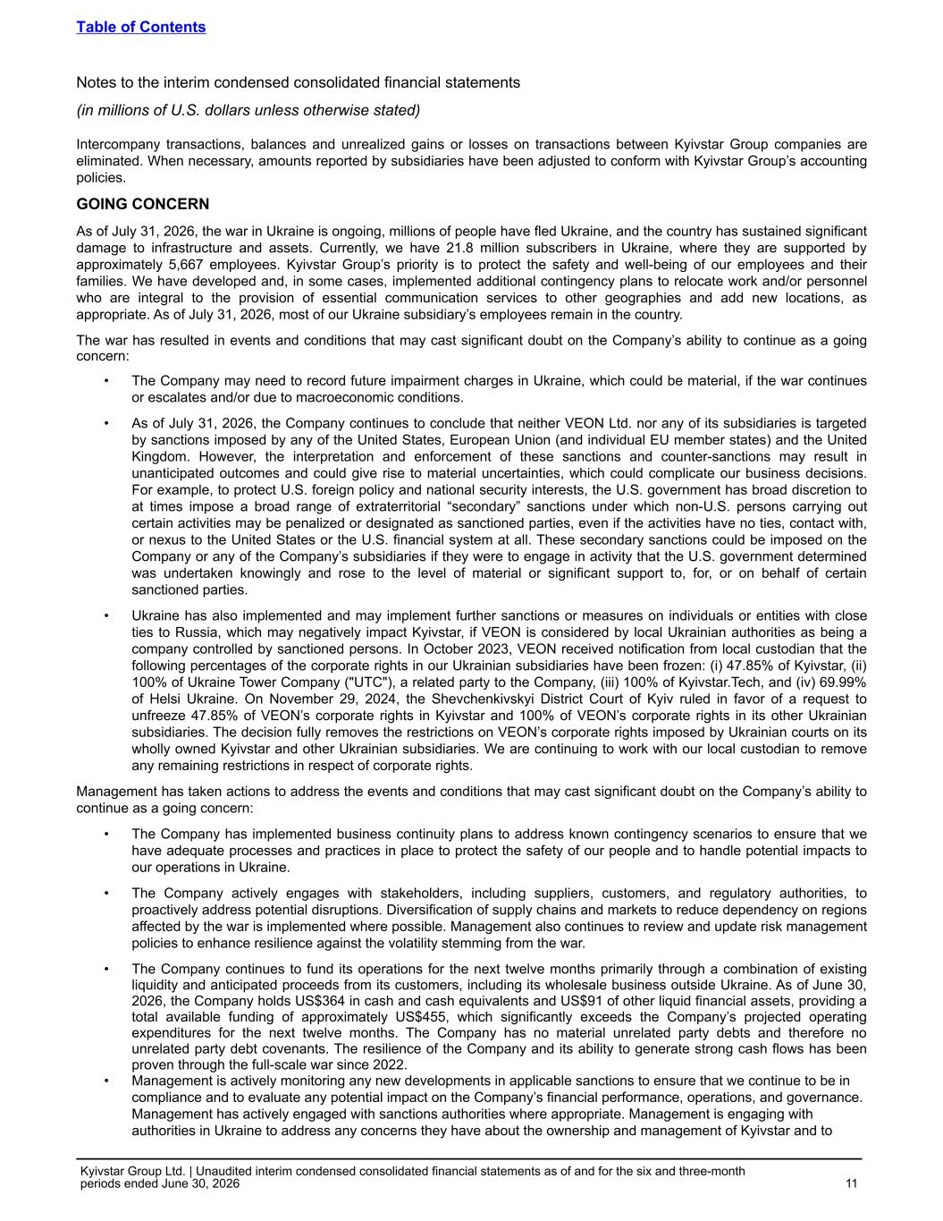
Intercompany transactions, balances and unrealized gains or losses on transactions between Kyivstar Group companies are eliminated. When necessary, amounts reported by subsidiaries have been adjusted to conform with Kyivstar Group’s accounting policies. GOING CONCERN As of July 31, 2026, the war in Ukraine is ongoing, millions of people have fled Ukraine, and the country has sustained significant damage to infrastructure and assets. Currently, we have 21.8 million subscribers in Ukraine, where they are supported by approximately 5,667 employees. Kyivstar Group’s priority is to protect the safety and well-being of our employees and their families. We have developed and, in some cases, implemented additional contingency plans to relocate work and/or personnel who are integral to the provision of essential communication services to other geographies and add new locations, as appropriate. As of July 31, 2026, most of our Ukraine subsidiary’s employees remain in the country. The war has resulted in events and conditions that may cast significant doubt on the Company’s ability to continue as a going concern: • The Company may need to record future impairment charges in Ukraine, which could be material, if the war continues or escalates and/or due to macroeconomic conditions. • As of July 31, 2026, the Company continues to conclude that neither VEON Ltd. nor any of its subsidiaries is targeted by sanctions imposed by any of the United States, European Union (and individual EU member states) and the United Kingdom. However, the interpretation and enforcement of these sanctions and counter-sanctions may result in unanticipated outcomes and could give rise to material uncertainties, which could complicate our business decisions. For example, to protect U.S. foreign policy and national security interests, the U.S. government has broad discretion to at times impose a broad range of extraterritorial “secondary” sanctions under which non-U.S. persons carrying out certain activities may be penalized or designated as sanctioned parties, even if the activities have no ties, contact with, or nexus to the United States or the U.S. financial system at all. These secondary sanctions could be imposed on the Company or any of the Company’s subsidiaries if they were to engage in activity that the U.S. government determined was undertaken knowingly and rose to the level of material or significant support to, for, or on behalf of certain sanctioned parties. • Ukraine has also implemented and may implement further sanctions or measures on individuals or entities with close ties to Russia, which may negatively impact Kyivstar, if VEON is considered by local Ukrainian authorities as being a company controlled by sanctioned persons. In October 2023, VEON received notification from local custodian that the following percentages of the corporate rights in our Ukrainian subsidiaries have been frozen: (i) 47.85% of Kyivstar, (ii) 100% of Ukraine Tower Company ("UTC"), a related party to the Company, (iii) 100% of Kyivstar.Tech, and (iv) 69.99% of Helsi Ukraine. On November 29, 2024, the Shevchenkivskyi District Court of Kyiv ruled in favor of a request to unfreeze 47.85% of VEON’s corporate rights in Kyivstar and 100% of VEON’s corporate rights in its other Ukrainian subsidiaries. The decision fully removes the restrictions on VEON’s corporate rights imposed by Ukrainian courts on its wholly owned Kyivstar and other Ukrainian subsidiaries. We are continuing to work with our local custodian to remove any remaining restrictions in respect of corporate rights. Management has taken actions to address the events and conditions that may cast significant doubt on the Company’s ability to continue as a going concern: • The Company has implemented business continuity plans to address known contingency scenarios to ensure that we have adequate processes and practices in place to protect the safety of our people and to handle potential impacts to our operations in Ukraine. • The Company actively engages with stakeholders, including suppliers, customers, and regulatory authorities, to proactively address potential disruptions. Diversification of supply chains and markets to reduce dependency on regions affected by the war is implemented where possible. Management also continues to review and update risk management policies to enhance resilience against the volatility stemming from the war. • The Company continues to fund its operations for the next twelve months primarily through a combination of existing liquidity and anticipated proceeds from its customers, including its wholesale business outside Ukraine. As of June 30, 2026, the Company holds US$364 in cash and cash equivalents and US$91 of other liquid financial assets, providing a total available funding of approximately US$455, which significantly exceeds the Company’s projected operating expenditures for the next twelve months. The Company has no material unrelated party debts and therefore no unrelated party debt covenants. The resilience of the Company and its ability to generate strong cash flows has been proven through the full-scale war since 2022. • Management is actively monitoring any new developments in applicable sanctions to ensure that we continue to be in compliance and to evaluate any potential impact on the Company’s financial performance, operations, and governance. Management has actively engaged with sanctions authorities where appropriate. Management is engaging with authorities in Ukraine to address any concerns they have about the ownership and management of Kyivstar and to Table of Contents Notes to the interim condensed consolidated financial statements (in millions of U.S. dollars unless otherwise stated) Kyivstar Group Ltd. | Unaudited interim condensed consolidated financial statements as of and for the six and three-month periods ended June 30, 2026 11

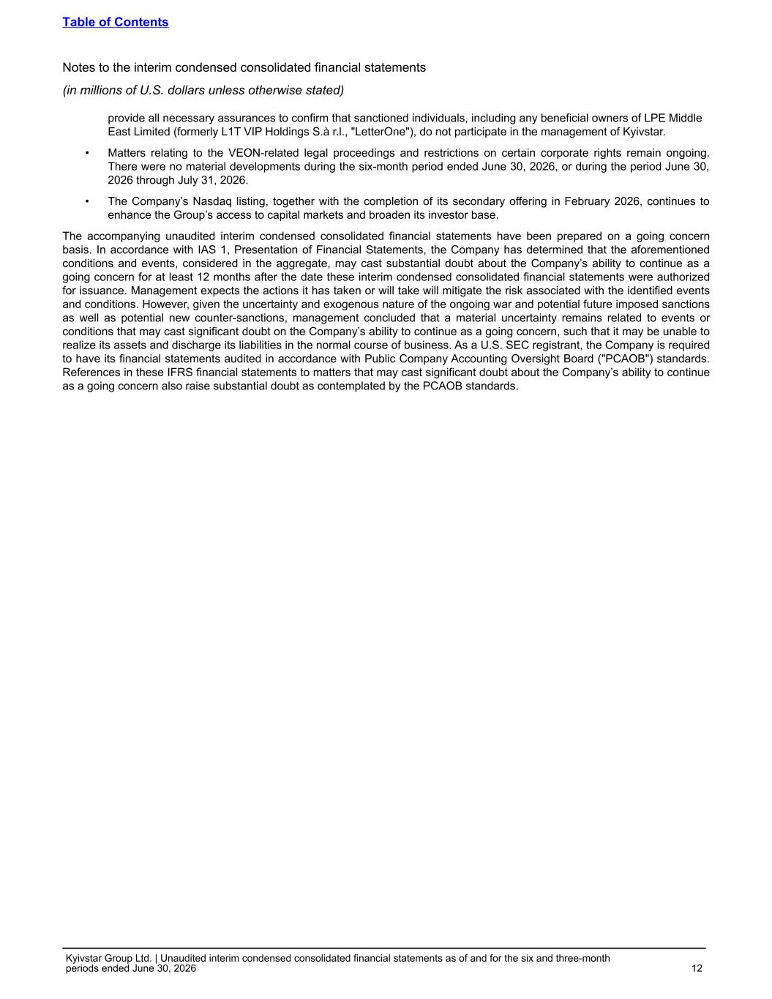
provide all necessary assurances to confirm that sanctioned individuals, including any beneficial owners of LPE Middle East Limited (formerly L1T VIP Holdings S.à r.l., "LetterOne"), do not participate in the management of Kyivstar. • Matters relating to the VEON-related legal proceedings and restrictions on certain corporate rights remain ongoing. There were no material developments during the six-month period ended June 30, 2026, or during the period June 30, 2026 through July 31, 2026. • The Company’s Nasdaq listing, together with the completion of its secondary offering in February 2026, continues to enhance the Group’s access to capital markets and broaden its investor base. The accompanying unaudited interim condensed consolidated financial statements have been prepared on a going concern basis. In accordance with IAS 1, Presentation of Financial Statements, the Company has determined that the aforementioned conditions and events, considered in the aggregate, may cast substantial doubt about the Company’s ability to continue as a going concern for at least 12 months after the date these interim condensed consolidated financial statements were authorized for issuance. Management expects the actions it has taken or will take will mitigate the risk associated with the identified events and conditions. However, given the uncertainty and exogenous nature of the ongoing war and potential future imposed sanctions as well as potential new counter-sanctions, management concluded that a material uncertainty remains related to events or conditions that may cast significant doubt on the Company’s ability to continue as a going concern, such that it may be unable to realize its assets and discharge its liabilities in the normal course of business. As a U.S. SEC registrant, the Company is required to have its financial statements audited in accordance with Public Company Accounting Oversight Board ("PCAOB") standards. References in these IFRS financial statements to matters that may cast significant doubt about the Company’s ability to continue as a going concern also raise substantial doubt as contemplated by the PCAOB standards. Table of Contents Notes to the interim condensed consolidated financial statements (in millions of U.S. dollars unless otherwise stated) Kyivstar Group Ltd. | Unaudited interim condensed consolidated financial statements as of and for the six and three-month periods ended June 30, 2026 12

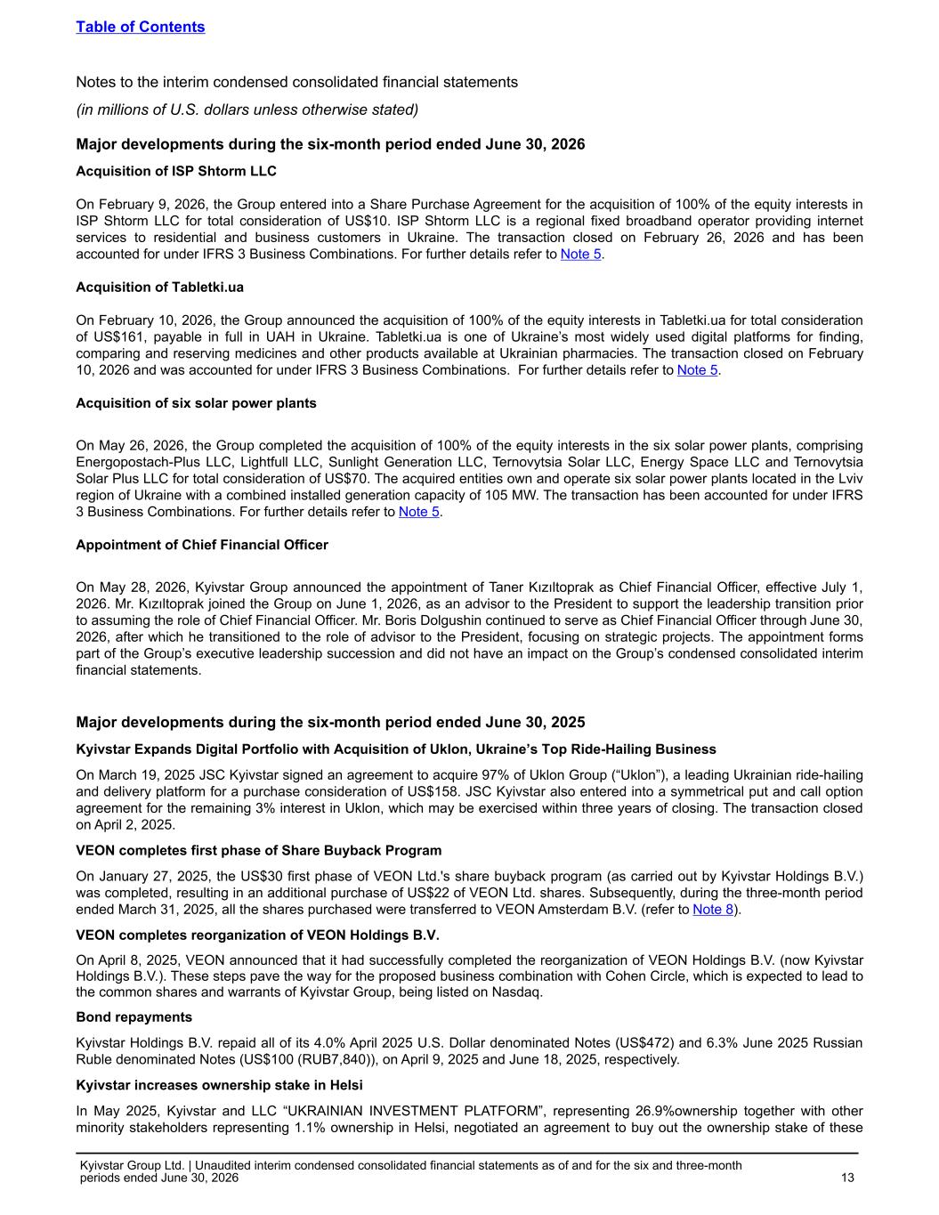
Major developments during the six-month period ended June 30, 2026 Acquisition of ISP Shtorm LLC On February 9, 2026, the Group entered into a Share Purchase Agreement for the acquisition of 100% of the equity interests in ISP Shtorm LLC for total consideration of US$10. ISP Shtorm LLC is a regional fixed broadband operator providing internet services to residential and business customers in Ukraine. The transaction closed on February 26, 2026 and has been accounted for under IFRS 3 Business Combinations. For further details refer to Note 5. Acquisition of Tabletki.ua On February 10, 2026, the Group announced the acquisition of 100% of the equity interests in Tabletki.ua for total consideration of US$161, payable in full in UAH in Ukraine. Tabletki.ua is one of Ukraine’s most widely used digital platforms for finding, comparing and reserving medicines and other products available at Ukrainian pharmacies. The transaction closed on February 10, 2026 and was accounted for under IFRS 3 Business Combinations. For further details refer to Note 5. Acquisition of six solar power plants On May 26, 2026, the Group completed the acquisition of 100% of the equity interests in the six solar power plants, comprising Energopostach-Plus LLC, Lightfull LLC, Sunlight Generation LLC, Ternovytsia Solar LLC, Energy Space LLC and Ternovytsia Solar Plus LLC for total consideration of US$70. The acquired entities own and operate six solar power plants located in the Lviv region of Ukraine with a combined installed generation capacity of 105 MW. The transaction has been accounted for under IFRS 3 Business Combinations. For further details refer to Note 5. Appointment of Chief Financial Officer On May 28, 2026, Kyivstar Group announced the appointment of Taner Kızıltoprak as Chief Financial Officer, effective July 1, 2026. Mr. Kızıltoprak joined the Group on June 1, 2026, as an advisor to the President to support the leadership transition prior to assuming the role of Chief Financial Officer. Mr. Boris Dolgushin continued to serve as Chief Financial Officer through June 30, 2026, after which he transitioned to the role of advisor to the President, focusing on strategic projects. The appointment forms part of the Group’s executive leadership succession and did not have an impact on the Group’s condensed consolidated interim financial statements. Major developments during the six-month period ended June 30, 2025 Kyivstar Expands Digital Portfolio with Acquisition of Uklon, Ukraine’s Top Ride-Hailing Business On March 19, 2025 JSC Kyivstar signed an agreement to acquire 97% of Uklon Group (“Uklon”), a leading Ukrainian ride-hailing and delivery platform for a purchase consideration of US$158. JSC Kyivstar also entered into a symmetrical put and call option agreement for the remaining 3% interest in Uklon, which may be exercised within three years of closing. The transaction closed on April 2, 2025. VEON completes first phase of Share Buyback Program On January 27, 2025, the US$30 first phase of VEON Ltd.'s share buyback program (as carried out by Kyivstar Holdings B.V.) was completed, resulting in an additional purchase of US$22 of VEON Ltd. shares. Subsequently, during the three-month period ended March 31, 2025, all the shares purchased were transferred to VEON Amsterdam B.V. (refer to Note 8). VEON completes reorganization of VEON Holdings B.V. On April 8, 2025, VEON announced that it had successfully completed the reorganization of VEON Holdings B.V. (now Kyivstar Holdings B.V.). These steps pave the way for the proposed business combination with Cohen Circle, which is expected to lead to the common shares and warrants of Kyivstar Group, being listed on Nasdaq. Bond repayments Kyivstar Holdings B.V. repaid all of its 4.0% April 2025 U.S. Dollar denominated Notes (US$472) and 6.3% June 2025 Russian Ruble denominated Notes (US$100 (RUB7,840)), on April 9, 2025 and June 18, 2025, respectively. Kyivstar increases ownership stake in Helsi In May 2025, Kyivstar and LLC “UKRAINIAN INVESTMENT PLATFORM”, representing 26.9%ownership together with other minority stakeholders representing 1.1% ownership in Helsi, negotiated an agreement to buy out the ownership stake of these Table of Contents Notes to the interim condensed consolidated financial statements (in millions of U.S. dollars unless otherwise stated) Kyivstar Group Ltd. | Unaudited interim condensed consolidated financial statements as of and for the six and three-month periods ended June 30, 2026 13


parties for US$11. Simultaneously the parties also terminated the existing put and call option agreements to the extent representing the stake of these parties, resulting in partial derecognition of the put option liability. At the same time Kyivstar agreed to terms with the remaining 2.01% shareholders based on the terms of the originally entered put and call option agreement. Table of Contents Notes to the interim condensed consolidated financial statements (in millions of U.S. dollars unless otherwise stated) Kyivstar Group Ltd. | Unaudited interim condensed consolidated financial statements as of and for the six and three-month periods ended June 30, 2026 14

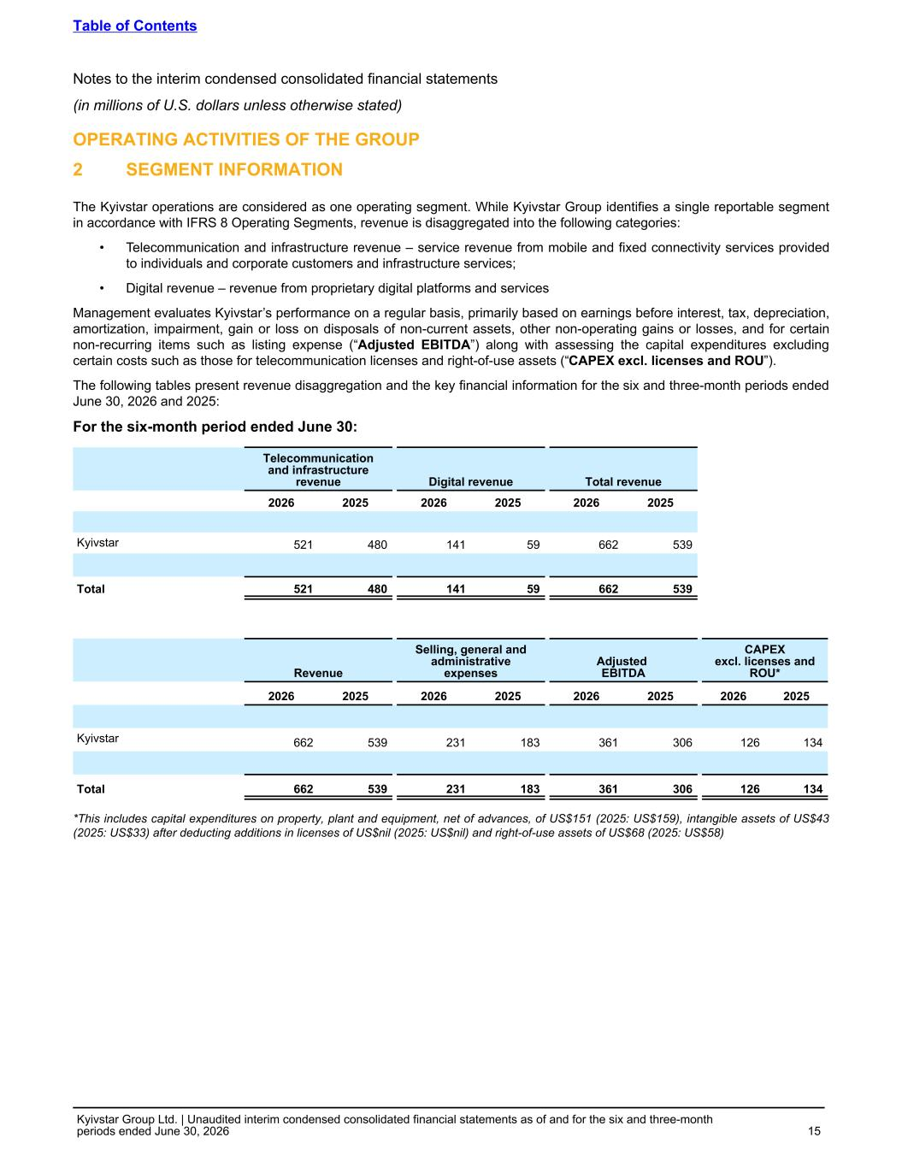
OPERATING ACTIVITIES OF THE GROUP 2 SEGMENT INFORMATION The Kyivstar operations are considered as one operating segment. While Kyivstar Group identifies a single reportable segment in accordance with IFRS 8 Operating Segments, revenue is disaggregated into the following categories: • Telecommunication and infrastructure revenue – service revenue from mobile and fixed connectivity services provided to individuals and corporate customers and infrastructure services; • Digital revenue – revenue from proprietary digital platforms and services Management evaluates Kyivstar’s performance on a regular basis, primarily based on earnings before interest, tax, depreciation, amortization, impairment, gain or loss on disposals of non-current assets, other non-operating gains or losses, and for certain non-recurring items such as listing expense (“Adjusted EBITDA”) along with assessing the capital expenditures excluding certain costs such as those for telecommunication licenses and right-of-use assets (“CAPEX excl. licenses and ROU”). The following tables present revenue disaggregation and the key financial information for the six and three-month periods ended June 30, 2026 and 2025: For the six-month period ended June 30: Telecommunication and infrastructure revenue Digital revenue Total revenue 2026 2025 2026 2025 2026 2025 Kyivstar 521 480 141 59 662 539 Total 521 480 141 59 662 539 Revenue Selling, general and administrative expenses Adjusted EBITDA CAPEX excl. licenses and ROU* 2026 2025 2026 2025 2026 2025 2026 2025 Kyivstar 662 539 231 183 361 306 126 134 Total 662 539 231 183 361 306 126 134 *This includes capital expenditures on property, plant and equipment, net of advances, of US$151 (2025: US$159), intangible assets of US$43 (2025: US$33) after deducting additions in licenses of US$nil (2025: US$nil) and right-of-use assets of US$68 (2025: US$58) Table of Contents Notes to the interim condensed consolidated financial statements (in millions of U.S. dollars unless otherwise stated) Kyivstar Group Ltd. | Unaudited interim condensed consolidated financial statements as of and for the six and three-month periods ended June 30, 2026 15

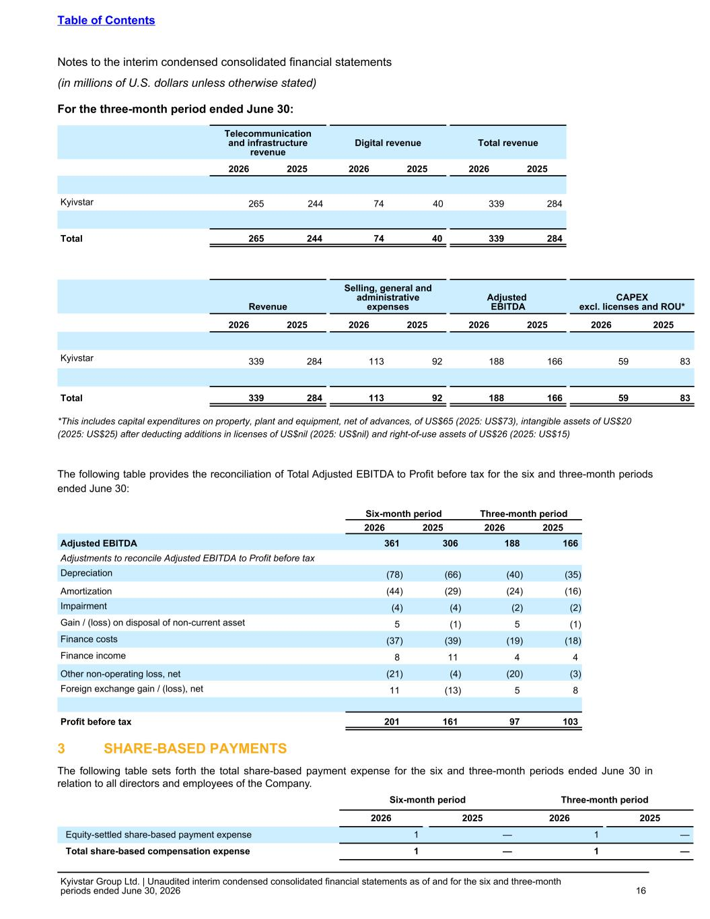
For the three-month period ended June 30: Telecommunication and infrastructure revenue Digital revenue Total revenue 2026 2025 2026 2025 2026 2025 Kyivstar 265 244 74 40 339 284 Total 265 244 74 40 339 284 Revenue Selling, general and administrative expenses Adjusted EBITDA CAPEX excl. licenses and ROU* 2026 2025 2026 2025 2026 2025 2026 2025 Kyivstar 339 284 113 92 188 166 59 83 Total 339 284 113 92 188 166 59 83 *This includes capital expenditures on property, plant and equipment, net of advances, of US$65 (2025: US$73), intangible assets of US$20 (2025: US$25) after deducting additions in licenses of US$nil (2025: US$nil) and right-of-use assets of US$26 (2025: US$15) The following table provides the reconciliation of Total Adjusted EBITDA to Profit before tax for the six and three-month periods ended June 30: Six-month period Three-month period 2026 2025 2026 2025 Adjusted EBITDA 361 306 188 166 Adjustments to reconcile Adjusted EBITDA to Profit before tax Depreciation (78) (66) (40) (35) Amortization (44) (29) (24) (16) Impairment (4) (4) (2) (2) Gain / (loss) on disposal of non-current asset 5 (1) 5 (1) Finance costs (37) (39) (19) (18) Finance income 8 11 4 4 Other non-operating loss, net (21) (4) (20) (3) Foreign exchange gain / (loss), net 11 (13) 5 8 Profit before tax 201 161 97 103 3 SHARE-BASED PAYMENTS The following table sets forth the total share-based payment expense for the six and three-month periods ended June 30 in relation to all directors and employees of the Company. Six-month period Three-month period 2026 2025 2026 2025 Equity-settled share-based payment expense 1 — 1 — Total share-based compensation expense 1 — 1 — Table of Contents Notes to the interim condensed consolidated financial statements (in millions of U.S. dollars unless otherwise stated) Kyivstar Group Ltd. | Unaudited interim condensed consolidated financial statements as of and for the six and three-month periods ended June 30, 2026 16

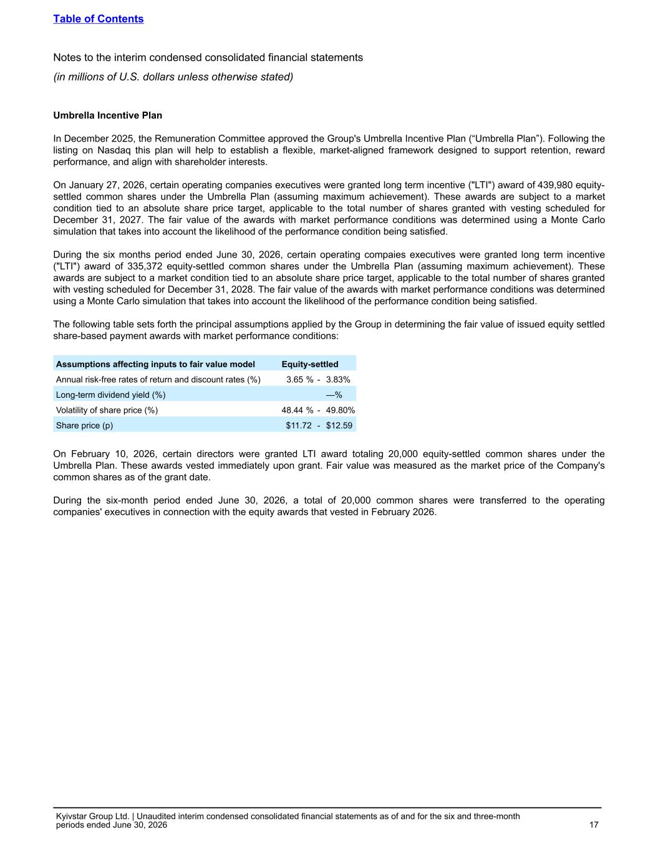
Umbrella Incentive Plan In December 2025, the Remuneration Committee approved the Group's Umbrella Incentive Plan (“Umbrella Plan”). Following the listing on Nasdaq this plan will help to establish a flexible, market-aligned framework designed to support retention, reward performance, and align with shareholder interests. On January 27, 2026, certain operating companies executives were granted long term incentive ("LTI") award of 439,980 equity- settled common shares under the Umbrella Plan (assuming maximum achievement). These awards are subject to a market condition tied to an absolute share price target, applicable to the total number of shares granted with vesting scheduled for December 31, 2027. The fair value of the awards with market performance conditions was determined using a Monte Carlo simulation that takes into account the likelihood of the performance condition being satisfied. During the six months period ended June 30, 2026, certain operating compaies executives were granted long term incentive ("LTI") award of 335,372 equity-settled common shares under the Umbrella Plan (assuming maximum achievement). These awards are subject to a market condition tied to an absolute share price target, applicable to the total number of shares granted with vesting scheduled for December 31, 2028. The fair value of the awards with market performance conditions was determined using a Monte Carlo simulation that takes into account the likelihood of the performance condition being satisfied. The following table sets forth the principal assumptions applied by the Group in determining the fair value of issued equity settled share-based payment awards with market performance conditions: Assumptions affecting inputs to fair value model Equity-settled Annual risk-free rates of return and discount rates (%) 3.65 % - 3.83% Long-term dividend yield (%) —% Volatility of share price (%) 48.44 % - 49.80% Share price (p) $11.72 - $12.59 On February 10, 2026, certain directors were granted LTI award totaling 20,000 equity-settled common shares under the Umbrella Plan. These awards vested immediately upon grant. Fair value was measured as the market price of the Company's common shares as of the grant date. During the six-month period ended June 30, 2026, a total of 20,000 common shares were transferred to the operating companies' executives in connection with the equity awards that vested in February 2026. Table of Contents Notes to the interim condensed consolidated financial statements (in millions of U.S. dollars unless otherwise stated) Kyivstar Group Ltd. | Unaudited interim condensed consolidated financial statements as of and for the six and three-month periods ended June 30, 2026 17

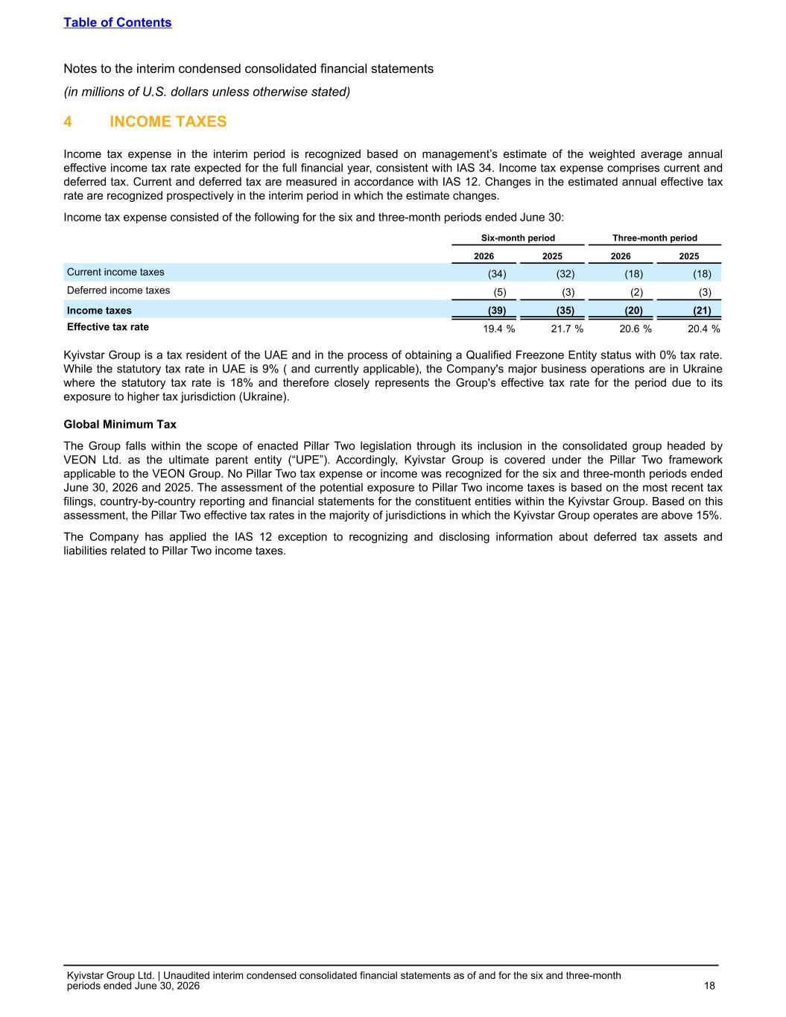
4 INCOME TAXES Income tax expense in the interim period is recognized based on management’s estimate of the weighted average annual effective income tax rate expected for the full financial year, consistent with IAS 34. Income tax expense comprises current and deferred tax. Current and deferred tax are measured in accordance with IAS 12. Changes in the estimated annual effective tax rate are recognized prospectively in the interim period in which the estimate changes. Income tax expense consisted of the following for the six and three-month periods ended June 30: Six-month period Three-month period 2026 2025 2026 2025 Current income taxes (34) (32) (18) (18) Deferred income taxes (5) (3) (2) (3) Income taxes (39) (35) (20) (21) Effective tax rate 19.4 % 21.7 % 20.6 % 20.4 % Kyivstar Group is a tax resident of the UAE and in the process of obtaining a Qualified Freezone Entity status with 0% tax rate. While the statutory tax rate in UAE is 9% ( and currently applicable), the Company's major business operations are in Ukraine where the statutory tax rate is 18% and therefore closely represents the Group's effective tax rate for the period due to its exposure to higher tax jurisdiction (Ukraine). Global Minimum Tax The Group falls within the scope of enacted Pillar Two legislation through its inclusion in the consolidated group headed by VEON Ltd. as the ultimate parent entity (“UPE”). Accordingly, Kyivstar Group is covered under the Pillar Two framework applicable to the VEON Group. No Pillar Two tax expense or income was recognized for the six and three-month periods ended June 30, 2026 and 2025. The assessment of the potential exposure to Pillar Two income taxes is based on the most recent tax filings, country-by-country reporting and financial statements for the constituent entities within the Kyivstar Group. Based on this assessment, the Pillar Two effective tax rates in the majority of jurisdictions in which the Kyivstar Group operates are above 15%. The Company has applied the IAS 12 exception to recognizing and disclosing information about deferred tax assets and liabilities related to Pillar Two income taxes. Table of Contents Notes to the interim condensed consolidated financial statements (in millions of U.S. dollars unless otherwise stated) Kyivstar Group Ltd. | Unaudited interim condensed consolidated financial statements as of and for the six and three-month periods ended June 30, 2026 18

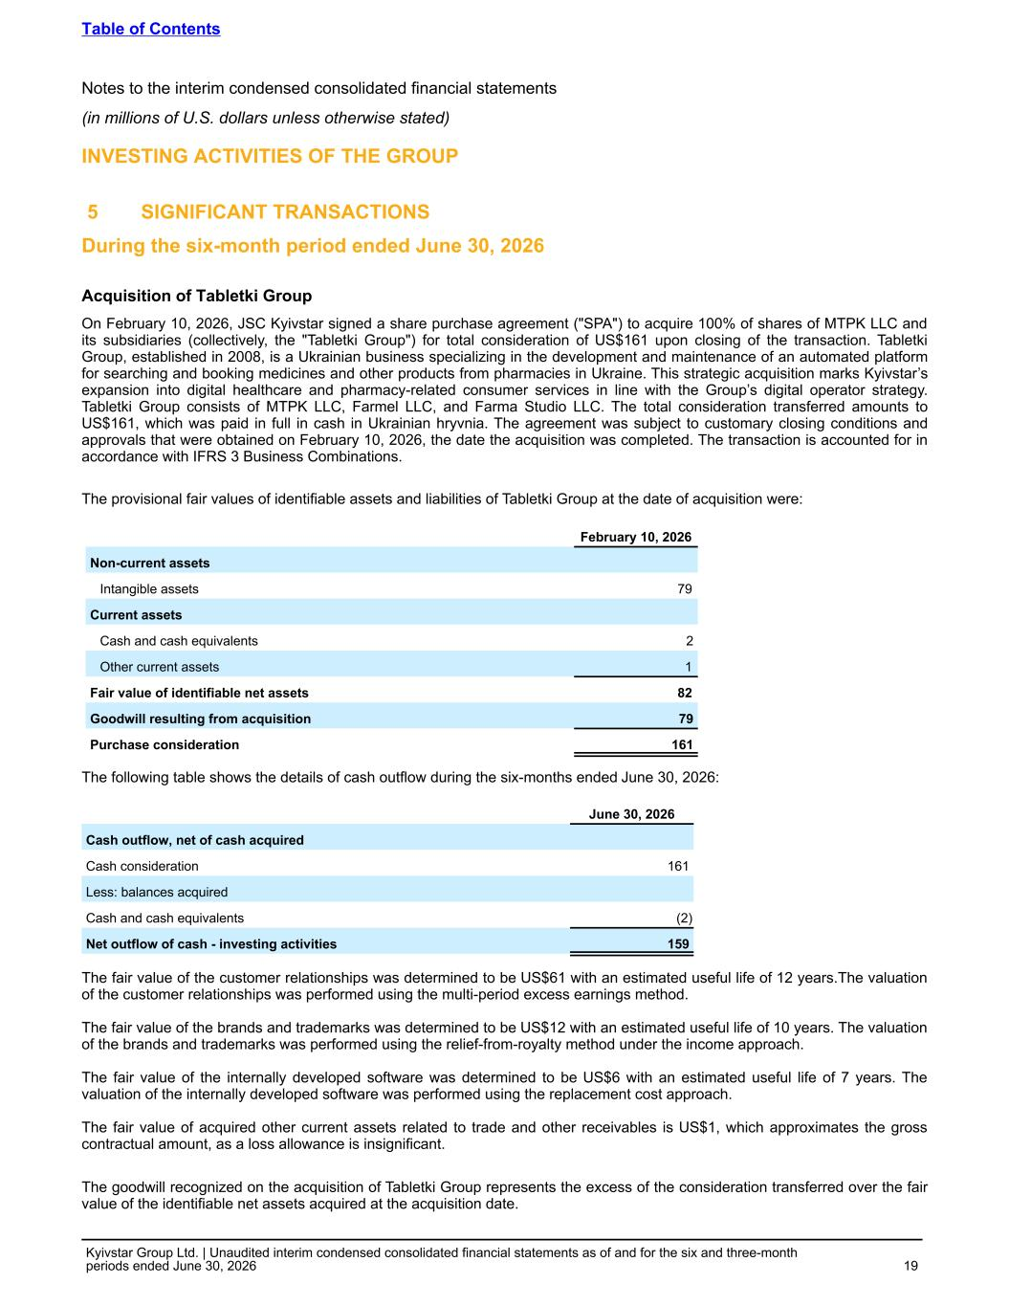
INVESTING ACTIVITIES OF THE GROUP 5 SIGNIFICANT TRANSACTIONS During the six-month period ended June 30, 2026 Acquisition of Tabletki Group On February 10, 2026, JSC Kyivstar signed a share purchase agreement ("SPA") to acquire 100% of shares of MTPK LLC and its subsidiaries (collectively, the "Tabletki Group") for total consideration of US$161 upon closing of the transaction. Tabletki Group, established in 2008, is a Ukrainian business specializing in the development and maintenance of an automated platform for searching and booking medicines and other products from pharmacies in Ukraine. This strategic acquisition marks Kyivstar’s expansion into digital healthcare and pharmacy-related consumer services in line with the Group’s digital operator strategy. Tabletki Group consists of MTPK LLC, Farmel LLC, and Farma Studio LLC. The total consideration transferred amounts to US$161, which was paid in full in cash in Ukrainian hryvnia. The agreement was subject to customary closing conditions and approvals that were obtained on February 10, 2026, the date the acquisition was completed. The transaction is accounted for in accordance with IFRS 3 Business Combinations. The provisional fair values of identifiable assets and liabilities of Tabletki Group at the date of acquisition were: February 10, 2026 Non-current assets Intangible assets 79 Current assets Cash and cash equivalents 2 Other current assets 1 Fair value of identifiable net assets 82 Goodwill resulting from acquisition 79 Purchase consideration 161 The following table shows the details of cash outflow during the six-months ended June 30, 2026: June 30, 2026 Cash outflow, net of cash acquired Cash consideration 161 Less: balances acquired Cash and cash equivalents (2) Net outflow of cash - investing activities 159 The fair value of the customer relationships was determined to be US$61 with an estimated useful life of 12 years.The valuation of the customer relationships was performed using the multi-period excess earnings method. The fair value of the brands and trademarks was determined to be US$12 with an estimated useful life of 10 years. The valuation of the brands and trademarks was performed using the relief-from-royalty method under the income approach. The fair value of the internally developed software was determined to be US$6 with an estimated useful life of 7 years. The valuation of the internally developed software was performed using the replacement cost approach. The fair value of acquired other current assets related to trade and other receivables is US$1, which approximates the gross contractual amount, as a loss allowance is insignificant. The goodwill recognized on the acquisition of Tabletkі Group represents the excess of the consideration transferred over the fair value of the identifiable net assets acquired at the acquisition date. Table of Contents Notes to the interim condensed consolidated financial statements (in millions of U.S. dollars unless otherwise stated) Kyivstar Group Ltd. | Unaudited interim condensed consolidated financial statements as of and for the six and three-month periods ended June 30, 2026 19

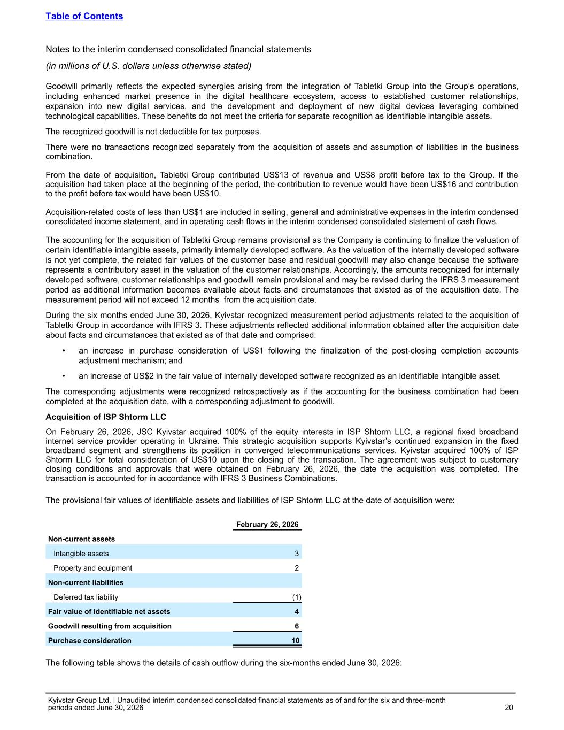
Goodwill primarily reflects the expected synergies arising from the integration of Tabletkі Group into the Group’s operations, including enhanced market presence in the digital healthcare ecosystem, access to established customer relationships, expansion into new digital services, and the development and deployment of new digital devices leveraging combined technological capabilities. These benefits do not meet the criteria for separate recognition as identifiable intangible assets. The recognized goodwill is not deductible for tax purposes. There were no transactions recognized separately from the acquisition of assets and assumption of liabilities in the business combination. From the date of acquisition, Tabletki Group contributed US$13 of revenue and US$8 profit before tax to the Group. If the acquisition had taken place at the beginning of the period, the contribution to revenue would have been US$16 and contribution to the profit before tax would have been US$10. Acquisition-related costs of less than US$1 are included in selling, general and administrative expenses in the interim condensed consolidated income statement, and in operating cash flows in the interim condensed consolidated statement of cash flows. The accounting for the acquisition of Tabletki Group remains provisional as the Company is continuing to finalize the valuation of certain identifiable intangible assets, primarily internally developed software. As the valuation of the internally developed software is not yet complete, the related fair values of the customer base and residual goodwill may also change because the software represents a contributory asset in the valuation of the customer relationships. Accordingly, the amounts recognized for internally developed software, customer relationships and goodwill remain provisional and may be revised during the IFRS 3 measurement period as additional information becomes available about facts and circumstances that existed as of the acquisition date. The measurement period will not exceed 12 months from the acquisition date. During the six months ended June 30, 2026, Kyivstar recognized measurement period adjustments related to the acquisition of Tabletki Group in accordance with IFRS 3. These adjustments reflected additional information obtained after the acquisition date about facts and circumstances that existed as of that date and comprised: • an increase in purchase consideration of US$1 following the finalization of the post-closing completion accounts adjustment mechanism; and • an increase of US$2 in the fair value of internally developed software recognized as an identifiable intangible asset. The corresponding adjustments were recognized retrospectively as if the accounting for the business combination had been completed at the acquisition date, with a corresponding adjustment to goodwill. Acquisition of ISP Shtorm LLC On February 26, 2026, JSC Kyivstar acquired 100% of the equity interests in ISP Shtorm LLC, a regional fixed broadband internet service provider operating in Ukraine. This strategic acquisition supports Kyivstar’s continued expansion in the fixed broadband segment and strengthens its position in converged telecommunications services. Kyivstar acquired 100% of ISP Shtorm LLC for total consideration of US$10 upon the closing of the transaction. The agreement was subject to customary closing conditions and approvals that were obtained on February 26, 2026, the date the acquisition was completed. The transaction is accounted for in accordance with IFRS 3 Business Combinations. The provisional fair values of identifiable assets and liabilities of ISP Shtorm LLC at the date of acquisition were: February 26, 2026 Non-current assets Intangible assets 3 Property and equipment 2 Non-current liabilities Deferred tax liability (1) Fair value of identifiable net assets 4 Goodwill resulting from acquisition 6 Purchase consideration 10 The following table shows the details of cash outflow during the six-months ended June 30, 2026: Table of Contents Notes to the interim condensed consolidated financial statements (in millions of U.S. dollars unless otherwise stated) Kyivstar Group Ltd. | Unaudited interim condensed consolidated financial statements as of and for the six and three-month periods ended June 30, 2026 20

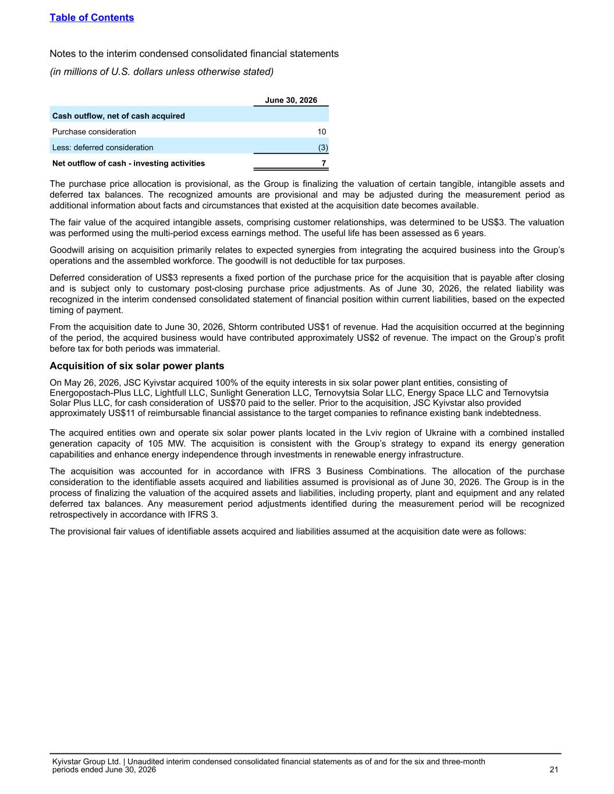
June 30, 2026 Cash outflow, net of cash acquired Purchase consideration 10 Less: deferred consideration (3) Net outflow of cash - investing activities 7 The purchase price allocation is provisional, as the Group is finalizing the valuation of certain tangible, intangible assets and deferred tax balances. The recognized amounts are provisional and may be adjusted during the measurement period as additional information about facts and circumstances that existed at the acquisition date becomes available. The fair value of the acquired intangible assets, comprising customer relationships, was determined to be US$3. The valuation was performed using the multi-period excess earnings method. The useful life has been assessed as 6 years. Goodwill arising on acquisition primarily relates to expected synergies from integrating the acquired business into the Group’s operations and the assembled workforce. The goodwill is not deductible for tax purposes. Deferred consideration of US$3 represents a fixed portion of the purchase price for the acquisition that is payable after closing and is subject only to customary post-closing purchase price adjustments. As of June 30, 2026, the related liability was recognized in the interim condensed consolidated statement of financial position within current liabilities, based on the expected timing of payment. From the acquisition date to June 30, 2026, Shtorm contributed US$1 of revenue. Had the acquisition occurred at the beginning of the period, the acquired business would have contributed approximately US$2 of revenue. The impact on the Group’s profit before tax for both periods was immaterial. Acquisition of six solar power plants On May 26, 2026, JSC Kyivstar acquired 100% of the equity interests in six solar power plant entities, consisting of Energopostach-Plus LLC, Lightfull LLC, Sunlight Generation LLC, Ternovytsia Solar LLC, Energy Space LLC and Ternovytsia Solar Plus LLC, for cash consideration of US$70 paid to the seller. Prior to the acquisition, JSC Kyivstar also provided approximately US$11 of reimbursable financial assistance to the target companies to refinance existing bank indebtedness. The acquired entities own and operate six solar power plants located in the Lviv region of Ukraine with a combined installed generation capacity of 105 MW. The acquisition is consistent with the Group’s strategy to expand its energy generation capabilities and enhance energy independence through investments in renewable energy infrastructure. The acquisition was accounted for in accordance with IFRS 3 Business Combinations. The allocation of the purchase consideration to the identifiable assets acquired and liabilities assumed is provisional as of June 30, 2026. The Group is in the process of finalizing the valuation of the acquired assets and liabilities, including property, plant and equipment and any related deferred tax balances. Any measurement period adjustments identified during the measurement period will be recognized retrospectively in accordance with IFRS 3. The provisional fair values of identifiable assets acquired and liabilities assumed at the acquisition date were as follows: Table of Contents Notes to the interim condensed consolidated financial statements (in millions of U.S. dollars unless otherwise stated) Kyivstar Group Ltd. | Unaudited interim condensed consolidated financial statements as of and for the six and three-month periods ended June 30, 2026 21

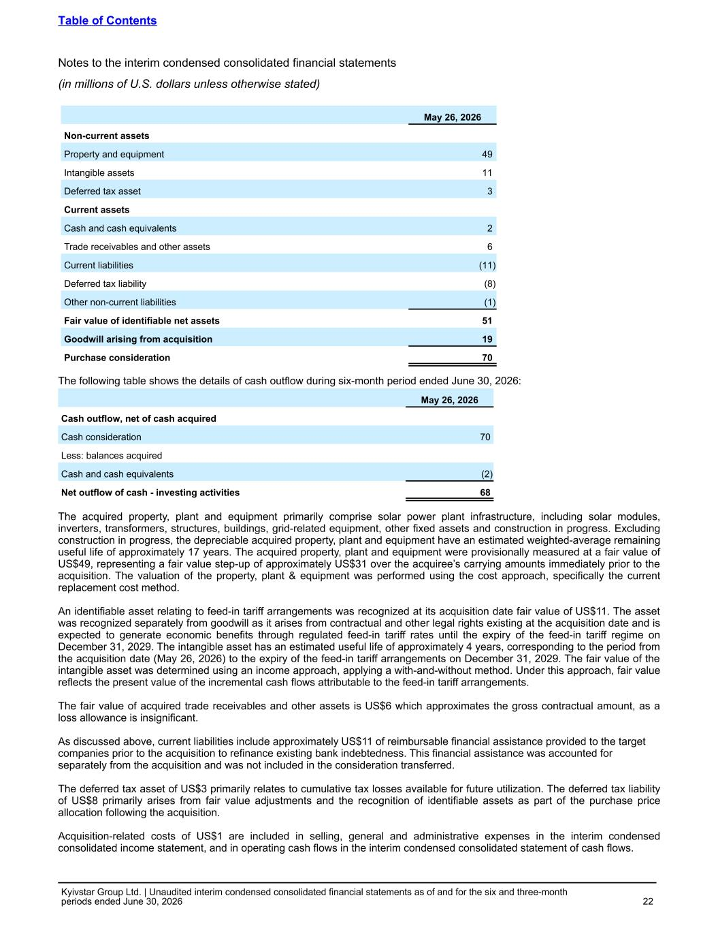
May 26, 2026 Non-current assets Property and equipment 49 Intangible assets 11 Deferred tax asset 3 Current assets Cash and cash equivalents 2 Trade receivables and other assets 6 Current liabilities (11) Deferred tax liability (8) Other non-current liabilities (1) Fair value of identifiable net assets 51 Goodwill arising from acquisition 19 Purchase consideration 70 The following table shows the details of cash outflow during six-month period ended June 30, 2026: May 26, 2026 Cash outflow, net of cash acquired Cash consideration 70 Less: balances acquired Cash and cash equivalents (2) Net outflow of cash - investing activities 68 The acquired property, plant and equipment primarily comprise solar power plant infrastructure, including solar modules, inverters, transformers, structures, buildings, grid-related equipment, other fixed assets and construction in progress. Excluding construction in progress, the depreciable acquired property, plant and equipment have an estimated weighted-average remaining useful life of approximately 17 years. The acquired property, plant and equipment were provisionally measured at a fair value of US$49, representing a fair value step-up of approximately US$31 over the acquiree’s carrying amounts immediately prior to the acquisition. The valuation of the property, plant & equipment was performed using the cost approach, specifically the current replacement cost method. An identifiable asset relating to feed-in tariff arrangements was recognized at its acquisition date fair value of US$11. The asset was recognized separately from goodwill as it arises from contractual and other legal rights existing at the acquisition date and is expected to generate economic benefits through regulated feed-in tariff rates until the expiry of the feed-in tariff regime on December 31, 2029. The intangible asset has an estimated useful life of approximately 4 years, corresponding to the period from the acquisition date (May 26, 2026) to the expiry of the feed-in tariff arrangements on December 31, 2029. The fair value of the intangible asset was determined using an income approach, applying a with-and-without method. Under this approach, fair value reflects the present value of the incremental cash flows attributable to the feed-in tariff arrangements. The fair value of acquired trade receivables and other assets is US$6 which approximates the gross contractual amount, as a loss allowance is insignificant. As discussed above, current liabilities include approximately US$11 of reimbursable financial assistance provided to the target companies prior to the acquisition to refinance existing bank indebtedness. This financial assistance was accounted for separately from the acquisition and was not included in the consideration transferred. The deferred tax asset of US$3 primarily relates to cumulative tax losses available for future utilization. The deferred tax liability of US$8 primarily arises from fair value adjustments and the recognition of identifiable assets as part of the purchase price allocation following the acquisition. Acquisition-related costs of US$1 are included in selling, general and administrative expenses in the interim condensed consolidated income statement, and in operating cash flows in the interim condensed consolidated statement of cash flows. Table of Contents Notes to the interim condensed consolidated financial statements (in millions of U.S. dollars unless otherwise stated) Kyivstar Group Ltd. | Unaudited interim condensed consolidated financial statements as of and for the six and three-month periods ended June 30, 2026 22

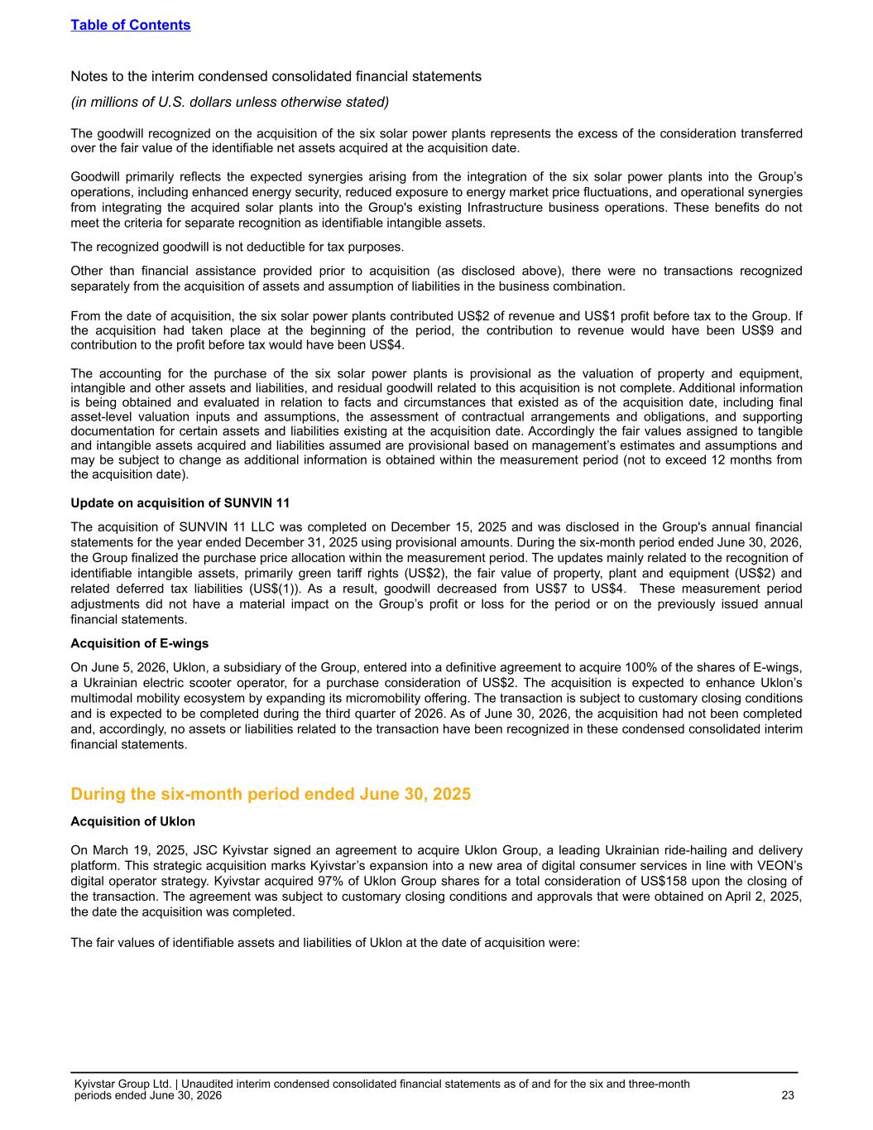
The goodwill recognized on the acquisition of the six solar power plants represents the excess of the consideration transferred over the fair value of the identifiable net assets acquired at the acquisition date. Goodwill primarily reflects the expected synergies arising from the integration of the six solar power plants into the Group’s operations, including enhanced energy security, reduced exposure to energy market price fluctuations, and operational synergies from integrating the acquired solar plants into the Group's existing Infrastructure business operations. These benefits do not meet the criteria for separate recognition as identifiable intangible assets. The recognized goodwill is not deductible for tax purposes. Other than financial assistance provided prior to acquisition (as disclosed above), there were no transactions recognized separately from the acquisition of assets and assumption of liabilities in the business combination. From the date of acquisition, the six solar power plants contributed US$2 of revenue and US$1 profit before tax to the Group. If the acquisition had taken place at the beginning of the period, the contribution to revenue would have been US$9 and contribution to the profit before tax would have been US$4. The accounting for the purchase of the six solar power plants is provisional as the valuation of property and equipment, intangible and other assets and liabilities, and residual goodwill related to this acquisition is not complete. Additional information is being obtained and evaluated in relation to facts and circumstances that existed as of the acquisition date, including final asset-level valuation inputs and assumptions, the assessment of contractual arrangements and obligations, and supporting documentation for certain assets and liabilities existing at the acquisition date. Accordingly the fair values assigned to tangible and intangible assets acquired and liabilities assumed are provisional based on management’s estimates and assumptions and may be subject to change as additional information is obtained within the measurement period (not to exceed 12 months from the acquisition date). Update on acquisition of SUNVIN 11 The acquisition of SUNVIN 11 LLC was completed on December 15, 2025 and was disclosed in the Group's annual financial statements for the year ended December 31, 2025 using provisional amounts. During the six-month period ended June 30, 2026, the Group finalized the purchase price allocation within the measurement period. The updates mainly related to the recognition of identifiable intangible assets, primarily green tariff rights (US$2), the fair value of property, plant and equipment (US$2) and related deferred tax liabilities (US$(1)). As a result, goodwill decreased from US$7 to US$4. These measurement period adjustments did not have a material impact on the Group’s profit or loss for the period or on the previously issued annual financial statements. Acquisition of E-wings On June 5, 2026, Uklon, a subsidiary of the Group, entered into a definitive agreement to acquire 100% of the shares of E-wings, a Ukrainian electric scooter operator, for a purchase consideration of US$2. The acquisition is expected to enhance Uklon’s multimodal mobility ecosystem by expanding its micromobility offering. The transaction is subject to customary closing conditions and is expected to be completed during the third quarter of 2026. As of June 30, 2026, the acquisition had not been completed and, accordingly, no assets or liabilities related to the transaction have been recognized in these condensed consolidated interim financial statements. During the six-month period ended June 30, 2025 Acquisition of Uklon On March 19, 2025, JSC Kyivstar signed an agreement to acquire Uklon Group, a leading Ukrainian ride-hailing and delivery platform. This strategic acquisition marks Kyivstar’s expansion into a new area of digital consumer services in line with VEON’s digital operator strategy. Kyivstar acquired 97% of Uklon Group shares for a total consideration of US$158 upon the closing of the transaction. The agreement was subject to customary closing conditions and approvals that were obtained on April 2, 2025, the date the acquisition was completed. The fair values of identifiable assets and liabilities of Uklon at the date of acquisition were: Table of Contents Notes to the interim condensed consolidated financial statements (in millions of U.S. dollars unless otherwise stated) Kyivstar Group Ltd. | Unaudited interim condensed consolidated financial statements as of and for the six and three-month periods ended June 30, 2026 23

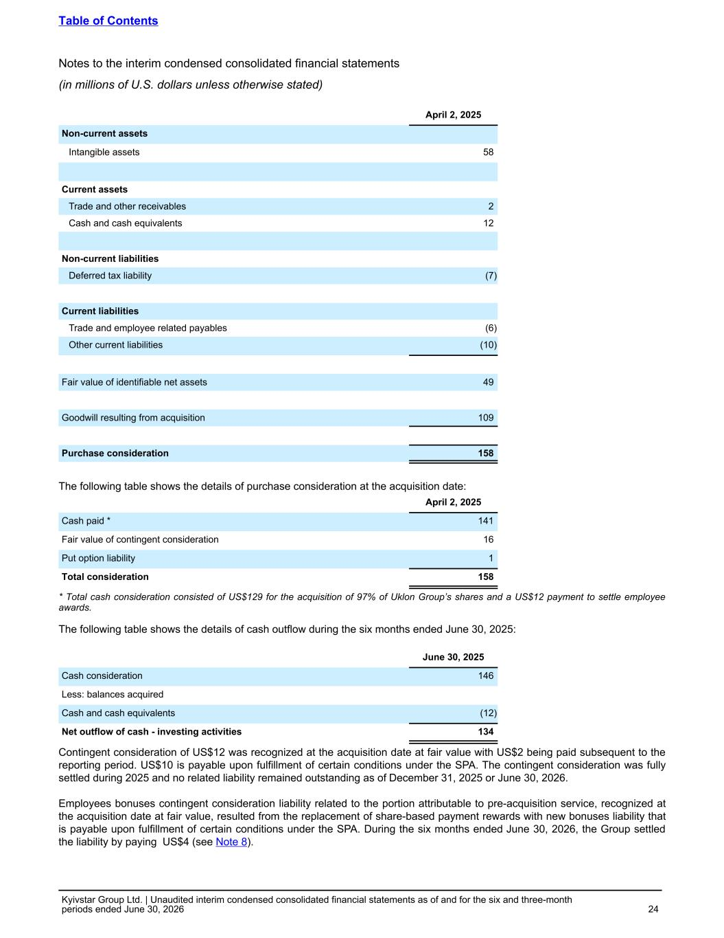
April 2, 2025 Non-current assets Intangible assets 58 Current assets Trade and other receivables 2 Cash and cash equivalents 12 Non-current liabilities Deferred tax liability (7) Current liabilities Trade and employee related payables (6) Other current liabilities (10) Fair value of identifiable net assets 49 Goodwill resulting from acquisition 109 Purchase consideration 158 The following table shows the details of purchase consideration at the acquisition date: April 2, 2025 Cash paid * 141 Fair value of contingent consideration 16 Put option liability 1 Total consideration 158 * Total cash consideration consisted of US$129 for the acquisition of 97% of Uklon Group’s shares and a US$12 payment to settle employee awards. The following table shows the details of cash outflow during the six months ended June 30, 2025: June 30, 2025 Cash consideration 146 Less: balances acquired Cash and cash equivalents (12) Net outflow of cash - investing activities 134 Contingent consideration of US$12 was recognized at the acquisition date at fair value with US$2 being paid subsequent to the reporting period. US$10 is payable upon fulfillment of certain conditions under the SPA. The contingent consideration was fully settled during 2025 and no related liability remained outstanding as of December 31, 2025 or June 30, 2026. Employees bonuses contingent consideration liability related to the portion attributable to pre-acquisition service, recognized at the acquisition date at fair value, resulted from the replacement of share-based payment rewards with new bonuses liability that is payable upon fulfillment of certain conditions under the SPA. During the six months ended June 30, 2026, the Group settled the liability by paying US$4 (see Note 8). Table of Contents Notes to the interim condensed consolidated financial statements (in millions of U.S. dollars unless otherwise stated) Kyivstar Group Ltd. | Unaudited interim condensed consolidated financial statements as of and for the six and three-month periods ended June 30, 2026 24

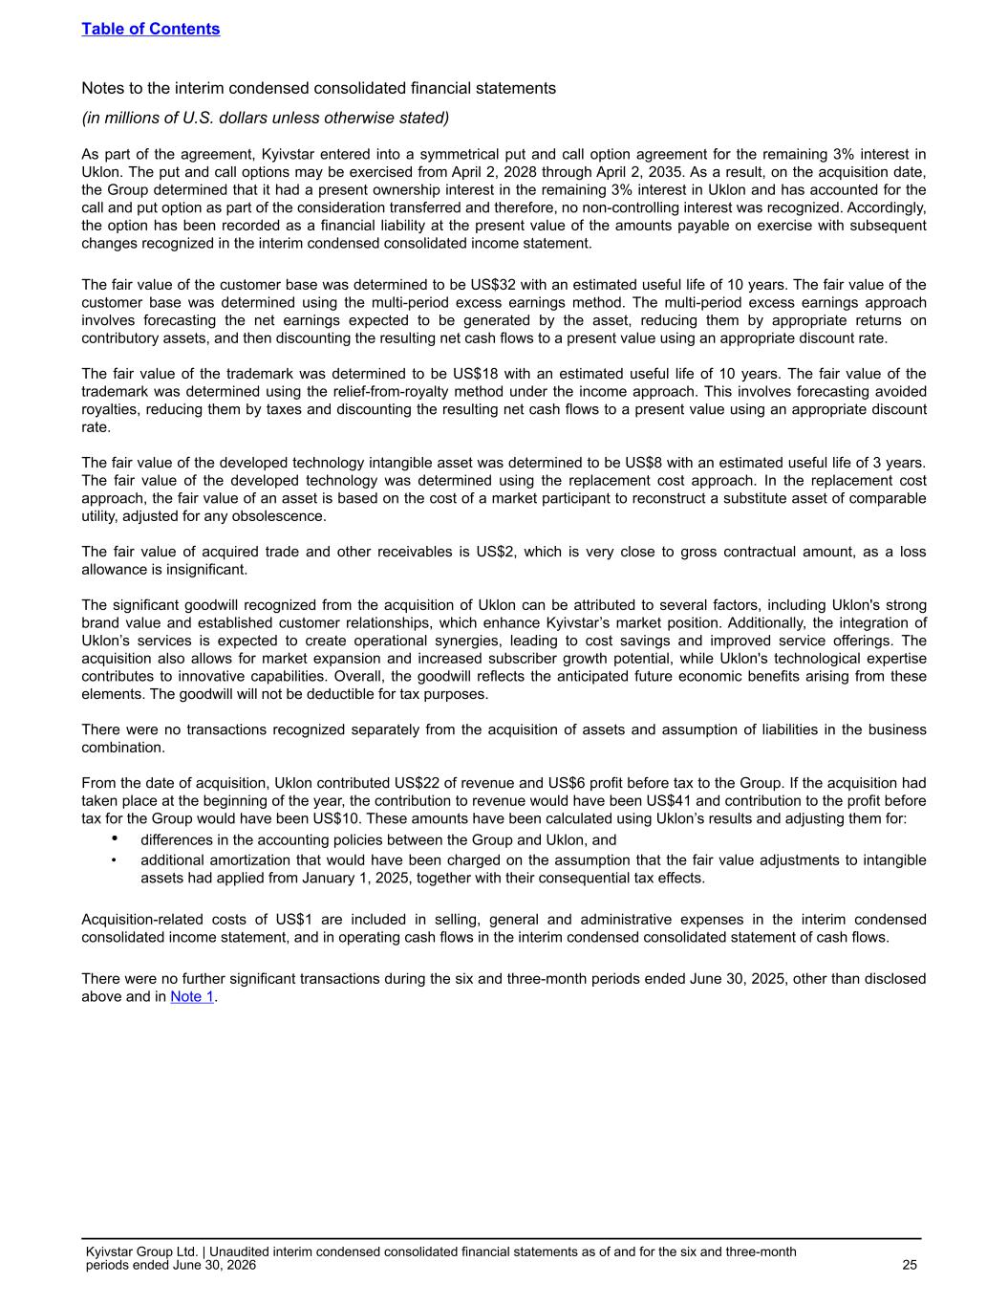
As part of the agreement, Kyivstar entered into a symmetrical put and call option agreement for the remaining 3% interest in Uklon. The put and call options may be exercised from April 2, 2028 through April 2, 2035. As a result, on the acquisition date, the Group determined that it had a present ownership interest in the remaining 3% interest in Uklon and has accounted for the call and put option as part of the consideration transferred and therefore, no non-controlling interest was recognized. Accordingly, the option has been recorded as a financial liability at the present value of the amounts payable on exercise with subsequent changes recognized in the interim condensed consolidated income statement. The fair value of the customer base was determined to be US$32 with an estimated useful life of 10 years. The fair value of the customer base was determined using the multi-period excess earnings method. The multi-period excess earnings approach involves forecasting the net earnings expected to be generated by the asset, reducing them by appropriate returns on contributory assets, and then discounting the resulting net cash flows to a present value using an appropriate discount rate. The fair value of the trademark was determined to be US$18 with an estimated useful life of 10 years. The fair value of the trademark was determined using the relief-from-royalty method under the income approach. This involves forecasting avoided royalties, reducing them by taxes and discounting the resulting net cash flows to a present value using an appropriate discount rate. The fair value of the developed technology intangible asset was determined to be US$8 with an estimated useful life of 3 years. The fair value of the developed technology was determined using the replacement cost approach. In the replacement cost approach, the fair value of an asset is based on the cost of a market participant to reconstruct a substitute asset of comparable utility, adjusted for any obsolescence. The fair value of acquired trade and other receivables is US$2, which is very close to gross contractual amount, as a loss allowance is insignificant. The significant goodwill recognized from the acquisition of Uklon can be attributed to several factors, including Uklon's strong brand value and established customer relationships, which enhance Kyivstar’s market position. Additionally, the integration of Uklon’s services is expected to create operational synergies, leading to cost savings and improved service offerings. The acquisition also allows for market expansion and increased subscriber growth potential, while Uklon's technological expertise contributes to innovative capabilities. Overall, the goodwill reflects the anticipated future economic benefits arising from these elements. The goodwill will not be deductible for tax purposes. There were no transactions recognized separately from the acquisition of assets and assumption of liabilities in the business combination. From the date of acquisition, Uklon contributed US$22 of revenue and US$6 profit before tax to the Group. If the acquisition had taken place at the beginning of the year, the contribution to revenue would have been US$41 and contribution to the profit before tax for the Group would have been US$10. These amounts have been calculated using Uklon’s results and adjusting them for: • differences in the accounting policies between the Group and Uklon, and • additional amortization that would have been charged on the assumption that the fair value adjustments to intangible assets had applied from January 1, 2025, together with their consequential tax effects. Acquisition-related costs of US$1 are included in selling, general and administrative expenses in the interim condensed consolidated income statement, and in operating cash flows in the interim condensed consolidated statement of cash flows. There were no further significant transactions during the six and three-month periods ended June 30, 2025, other than disclosed above and in Note 1. Table of Contents Notes to the interim condensed consolidated financial statements (in millions of U.S. dollars unless otherwise stated) Kyivstar Group Ltd. | Unaudited interim condensed consolidated financial statements as of and for the six and three-month periods ended June 30, 2026 25

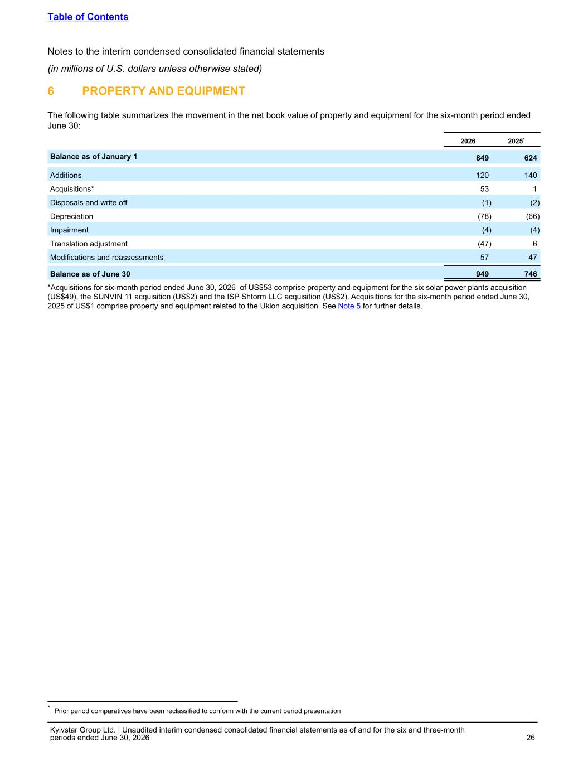
6 PROPERTY AND EQUIPMENT The following table summarizes the movement in the net book value of property and equipment for the six-month period ended June 30: 2026 2025* Balance as of January 1 849 624 Additions 120 140 Acquisitions* 53 1 Disposals and write off (1) (2) Depreciation (78) (66) Impairment (4) (4) Translation adjustment (47) 6 Modifications and reassessments 57 47 Balance as of June 30 949 746 *Acquisitions for six-month period ended June 30, 2026 of US$53 comprise property and equipment for the six solar power plants acquisition (US$49), the SUNVIN 11 acquisition (US$2) and the ISP Shtorm LLC acquisition (US$2). Acquisitions for the six-month period ended June 30, 2025 of US$1 comprise property and equipment related to the Uklon acquisition. See Note 5 for further details. Table of Contents Notes to the interim condensed consolidated financial statements (in millions of U.S. dollars unless otherwise stated) Kyivstar Group Ltd. | Unaudited interim condensed consolidated financial statements as of and for the six and three-month periods ended June 30, 2026 26 * Prior period comparatives have been reclassified to conform with the current period presentation

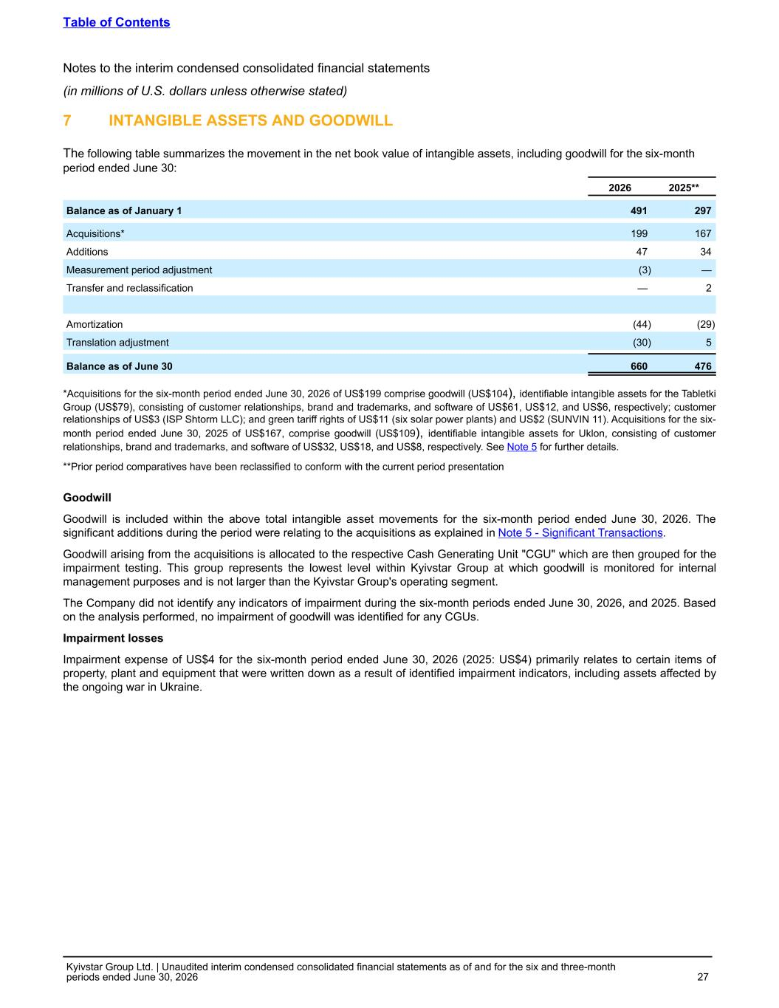
7 INTANGIBLE ASSETS AND GOODWILL The following table summarizes the movement in the net book value of intangible assets, including goodwill for the six-month period ended June 30: 2026 2025** Balance as of January 1 491 297 Acquisitions* 199 167 Additions 47 34 Measurement period adjustment (3) — Transfer and reclassification — 2 Amortization (44) (29) Translation adjustment (30) 5 Balance as of June 30 660 476 *Acquisitions for the six-month period ended June 30, 2026 of US$199 comprise goodwill (US$104), identifiable intangible assets for the Tabletki Group (US$79), consisting of customer relationships, brand and trademarks, and software of US$61, US$12, and US$6, respectively; customer relationships of US$3 (ISP Shtorm LLC); and green tariff rights of US$11 (six solar power plants) and US$2 (SUNVIN 11). Acquisitions for the six- month period ended June 30, 2025 of US$167, comprise goodwill (US$109), identifiable intangible assets for Uklon, consisting of customer relationships, brand and trademarks, and software of US$32, US$18, and US$8, respectively. See Note 5 for further details. **Prior period comparatives have been reclassified to conform with the current period presentation Goodwill Goodwill is included within the above total intangible asset movements for the six-month period ended June 30, 2026. The significant additions during the period were relating to the acquisitions as explained in Note 5 - Significant Transactions. Goodwill arising from the acquisitions is allocated to the respective Cash Generating Unit "CGU" which are then grouped for the impairment testing. This group represents the lowest level within Kyivstar Group at which goodwill is monitored for internal management purposes and is not larger than the Kyivstar Group's operating segment. The Company did not identify any indicators of impairment during the six-month periods ended June 30, 2026, and 2025. Based on the analysis performed, no impairment of goodwill was identified for any CGUs. Impairment losses Impairment expense of US$4 for the six-month period ended June 30, 2026 (2025: US$4) primarily relates to certain items of property, plant and equipment that were written down as a result of identified impairment indicators, including assets affected by the ongoing war in Ukraine. Table of Contents Notes to the interim condensed consolidated financial statements (in millions of U.S. dollars unless otherwise stated) Kyivstar Group Ltd. | Unaudited interim condensed consolidated financial statements as of and for the six and three-month periods ended June 30, 2026 27

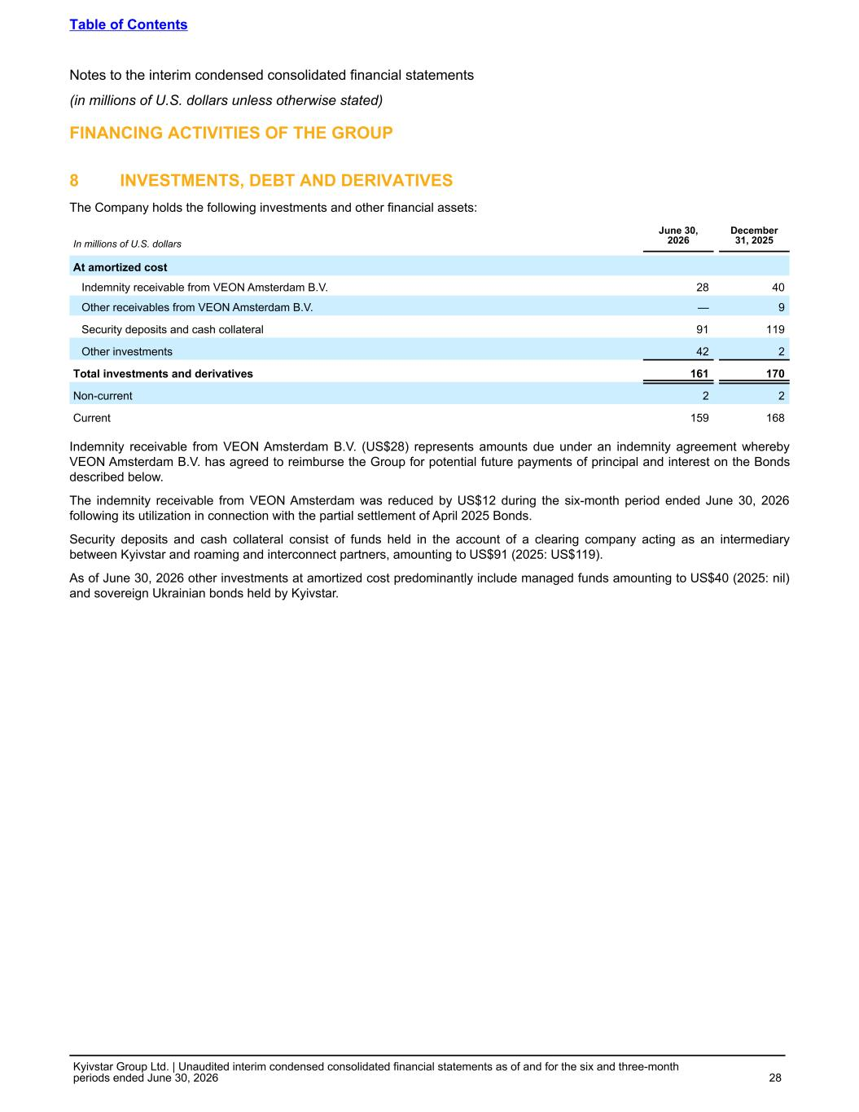
FINANCING ACTIVITIES OF THE GROUP 8 INVESTMENTS, DEBT AND DERIVATIVES The Company holds the following investments and other financial assets: In millions of U.S. dollars June 30, 2026 December 31, 2025 At amortized cost Indemnity receivable from VEON Amsterdam B.V. 28 40 Other receivables from VEON Amsterdam B.V. — 9 Security deposits and cash collateral 91 119 Other investments 42 2 Total investments and derivatives 161 170 Non-current 2 2 Current 159 168 Indemnity receivable from VEON Amsterdam B.V. (US$28) represents amounts due under an indemnity agreement whereby VEON Amsterdam B.V. has agreed to reimburse the Group for potential future payments of principal and interest on the Bonds described below. The indemnity receivable from VEON Amsterdam was reduced by US$12 during the six-month period ended June 30, 2026 following its utilization in connection with the partial settlement of April 2025 Bonds. Security deposits and cash collateral consist of funds held in the account of a clearing company acting as an intermediary between Kyivstar and roaming and interconnect partners, amounting to US$91 (2025: US$119). As of June 30, 2026 other investments at amortized cost predominantly include managed funds amounting to US$40 (2025: nil) and sovereign Ukrainian bonds held by Kyivstar. Table of Contents Notes to the interim condensed consolidated financial statements (in millions of U.S. dollars unless otherwise stated) Kyivstar Group Ltd. | Unaudited interim condensed consolidated financial statements as of and for the six and three-month periods ended June 30, 2026 28

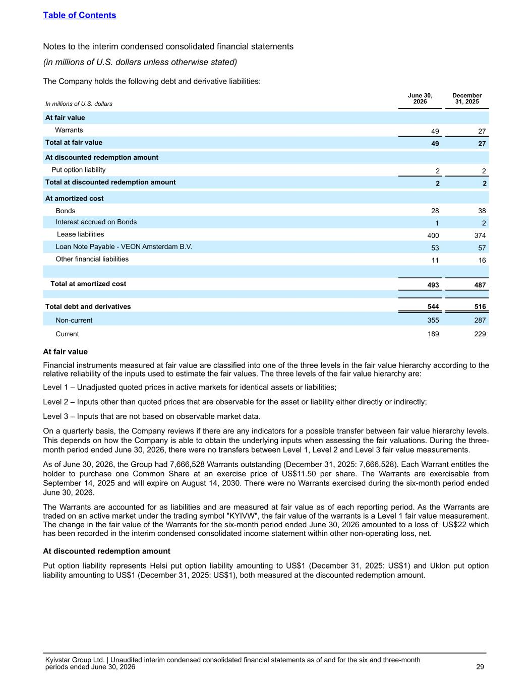
The Company holds the following debt and derivative liabilities: In millions of U.S. dollars June 30, 2026 December 31, 2025 At fair value Warrants 49 27 Total at fair value 49 27 At discounted redemption amount Put option liability 2 2 Total at discounted redemption amount 2 2 At amortized cost Bonds 28 38 Interest accrued on Bonds 1 2 Lease liabilities 400 374 Loan Note Payable - VEON Amsterdam B.V. 53 57 Other financial liabilities 11 16 Total at amortized cost 493 487 Total debt and derivatives 544 516 Non-current 355 287 Current 189 229 At fair value Financial instruments measured at fair value are classified into one of the three levels in the fair value hierarchy according to the relative reliability of the inputs used to estimate the fair values. The three levels of the fair value hierarchy are: Level 1 – Unadjusted quoted prices in active markets for identical assets or liabilities; Level 2 – Inputs other than quoted prices that are observable for the asset or liability either directly or indirectly; Level 3 – Inputs that are not based on observable market data. On a quarterly basis, the Company reviews if there are any indicators for a possible transfer between fair value hierarchy levels. This depends on how the Company is able to obtain the underlying inputs when assessing the fair valuations. During the three- month period ended June 30, 2026, there were no transfers between Level 1, Level 2 and Level 3 fair value measurements. As of June 30, 2026, the Group had 7,666,528 Warrants outstanding (December 31, 2025: 7,666,528). Each Warrant entitles the holder to purchase one Common Share at an exercise price of US$11.50 per share. The Warrants are exercisable from September 14, 2025 and will expire on August 14, 2030. There were no Warrants exercised during the six-month period ended June 30, 2026. The Warrants are accounted for as liabilities and are measured at fair value as of each reporting period. As the Warrants are traded on an active market under the trading symbol "KYIVW", the fair value of the warrants is a Level 1 fair value measurement. The change in the fair value of the Warrants for the six-month period ended June 30, 2026 amounted to a loss of US$22 which has been recorded in the interim condensed consolidated income statement within other non-operating loss, net. At discounted redemption amount Put option liability represents Helsi put option liability amounting to US$1 (December 31, 2025: US$1) and Uklon put option liability amounting to US$1 (December 31, 2025: US$1), both measured at the discounted redemption amount. Table of Contents Notes to the interim condensed consolidated financial statements (in millions of U.S. dollars unless otherwise stated) Kyivstar Group Ltd. | Unaudited interim condensed consolidated financial statements as of and for the six and three-month periods ended June 30, 2026 29

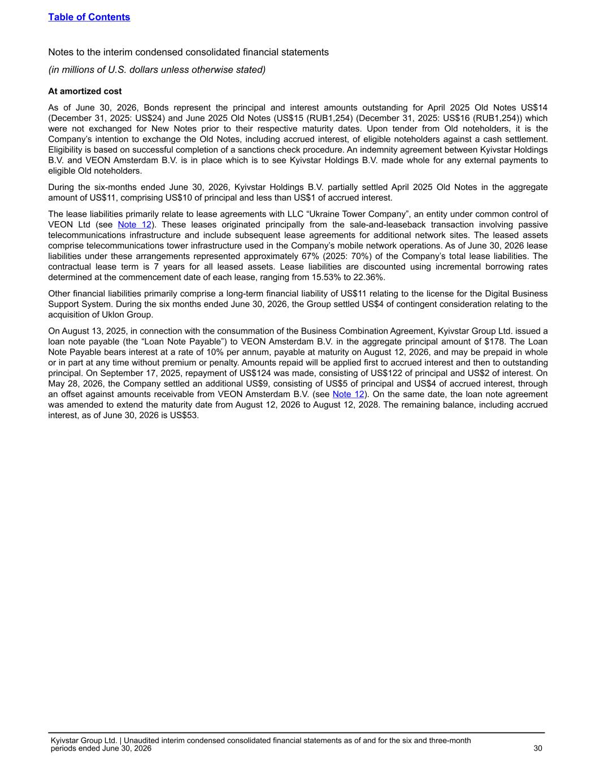
At amortized cost As of June 30, 2026, Bonds represent the principal and interest amounts outstanding for April 2025 Old Notes US$14 (December 31, 2025: US$24) and June 2025 Old Notes (US$15 (RUB1,254) (December 31, 2025: US$16 (RUB1,254)) which were not exchanged for New Notes prior to their respective maturity dates. Upon tender from Old noteholders, it is the Company’s intention to exchange the Old Notes, including accrued interest, of eligible noteholders against a cash settlement. Eligibility is based on successful completion of a sanctions check procedure. An indemnity agreement between Kyivstar Holdings B.V. and VEON Amsterdam B.V. is in place which is to see Kyivstar Holdings B.V. made whole for any external payments to eligible Old noteholders. During the six-months ended June 30, 2026, Kyivstar Holdings B.V. partially settled April 2025 Old Notes in the aggregate amount of US$11, comprising US$10 of principal and less than US$1 of accrued interest. The lease liabilities primarily relate to lease agreements with LLC “Ukraine Tower Company”, an entity under common control of VEON Ltd (see Note 12). These leases originated principally from the sale-and-leaseback transaction involving passive telecommunications infrastructure and include subsequent lease agreements for additional network sites. The leased assets comprise telecommunications tower infrastructure used in the Company’s mobile network operations. As of June 30, 2026 lease liabilities under these arrangements represented approximately 67% (2025: 70%) of the Company’s total lease liabilities. The contractual lease term is 7 years for all leased assets. Lease liabilities are discounted using incremental borrowing rates determined at the commencement date of each lease, ranging from 15.53% to 22.36%. Other financial liabilities primarily comprise a long-term financial liability of US$11 relating to the license for the Digital Business Support System. During the six months ended June 30, 2026, the Group settled US$4 of contingent consideration relating to the acquisition of Uklon Group. On August 13, 2025, in connection with the consummation of the Business Combination Agreement, Kyivstar Group Ltd. issued a loan note payable (the “Loan Note Payable”) to VEON Amsterdam B.V. in the aggregate principal amount of $178. The Loan Note Payable bears interest at a rate of 10% per annum, payable at maturity on August 12, 2026, and may be prepaid in whole or in part at any time without premium or penalty. Amounts repaid will be applied first to accrued interest and then to outstanding principal. On September 17, 2025, repayment of US$124 was made, consisting of US$122 of principal and US$2 of interest. On May 28, 2026, the Company settled an additional US$9, consisting of US$5 of principal and US$4 of accrued interest, through an offset against amounts receivable from VEON Amsterdam B.V. (see Note 12). On the same date, the loan note agreement was amended to extend the maturity date from August 12, 2026 to August 12, 2028. The remaining balance, including accrued interest, as of June 30, 2026 is US$53. Table of Contents Notes to the interim condensed consolidated financial statements (in millions of U.S. dollars unless otherwise stated) Kyivstar Group Ltd. | Unaudited interim condensed consolidated financial statements as of and for the six and three-month periods ended June 30, 2026 30

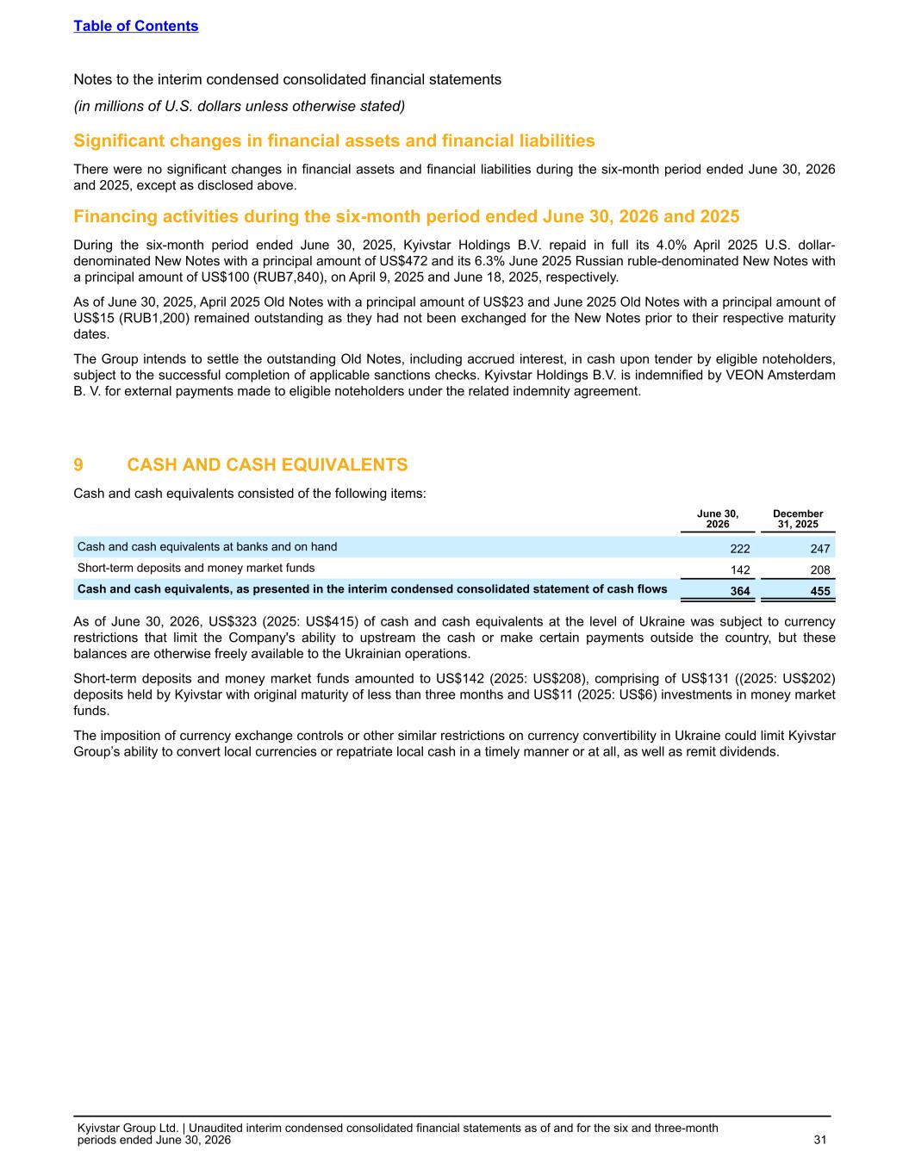
Significant changes in financial assets and financial liabilities There were no significant changes in financial assets and financial liabilities during the six-month period ended June 30, 2026 and 2025, except as disclosed above. Financing activities during the six-month period ended June 30, 2026 and 2025 During the six-month period ended June 30, 2025, Kyivstar Holdings B.V. repaid in full its 4.0% April 2025 U.S. dollar- denominated New Notes with a principal amount of US$472 and its 6.3% June 2025 Russian ruble-denominated New Notes with a principal amount of US$100 (RUB7,840), on April 9, 2025 and June 18, 2025, respectively. As of June 30, 2025, April 2025 Old Notes with a principal amount of US$23 and June 2025 Old Notes with a principal amount of US$15 (RUB1,200) remained outstanding as they had not been exchanged for the New Notes prior to their respective maturity dates. The Group intends to settle the outstanding Old Notes, including accrued interest, in cash upon tender by eligible noteholders, subject to the successful completion of applicable sanctions checks. Kyivstar Holdings B.V. is indemnified by VEON Amsterdam B. V. for external payments made to eligible noteholders under the related indemnity agreement. 9 CASH AND CASH EQUIVALENTS Cash and cash equivalents consisted of the following items: June 30, 2026 December 31, 2025 Cash and cash equivalents at banks and on hand 222 247 Short-term deposits and money market funds 142 208 Cash and cash equivalents, as presented in the interim condensed consolidated statement of cash flows 364 455 As of June 30, 2026, US$323 (2025: US$415) of cash and cash equivalents at the level of Ukraine was subject to currency restrictions that limit the Company's ability to upstream the cash or make certain payments outside the country, but these balances are otherwise freely available to the Ukrainian operations. Short-term deposits and money market funds amounted to US$142 (2025: US$208), comprising of US$131 ((2025: US$202) deposits held by Kyivstar with original maturity of less than three months and US$11 (2025: US$6) investments in money market funds. The imposition of currency exchange controls or other similar restrictions on currency convertibility in Ukraine could limit Kyivstar Group’s ability to convert local currencies or repatriate local cash in a timely manner or at all, as well as remit dividends. Table of Contents Notes to the interim condensed consolidated financial statements (in millions of U.S. dollars unless otherwise stated) Kyivstar Group Ltd. | Unaudited interim condensed consolidated financial statements as of and for the six and three-month periods ended June 30, 2026 31

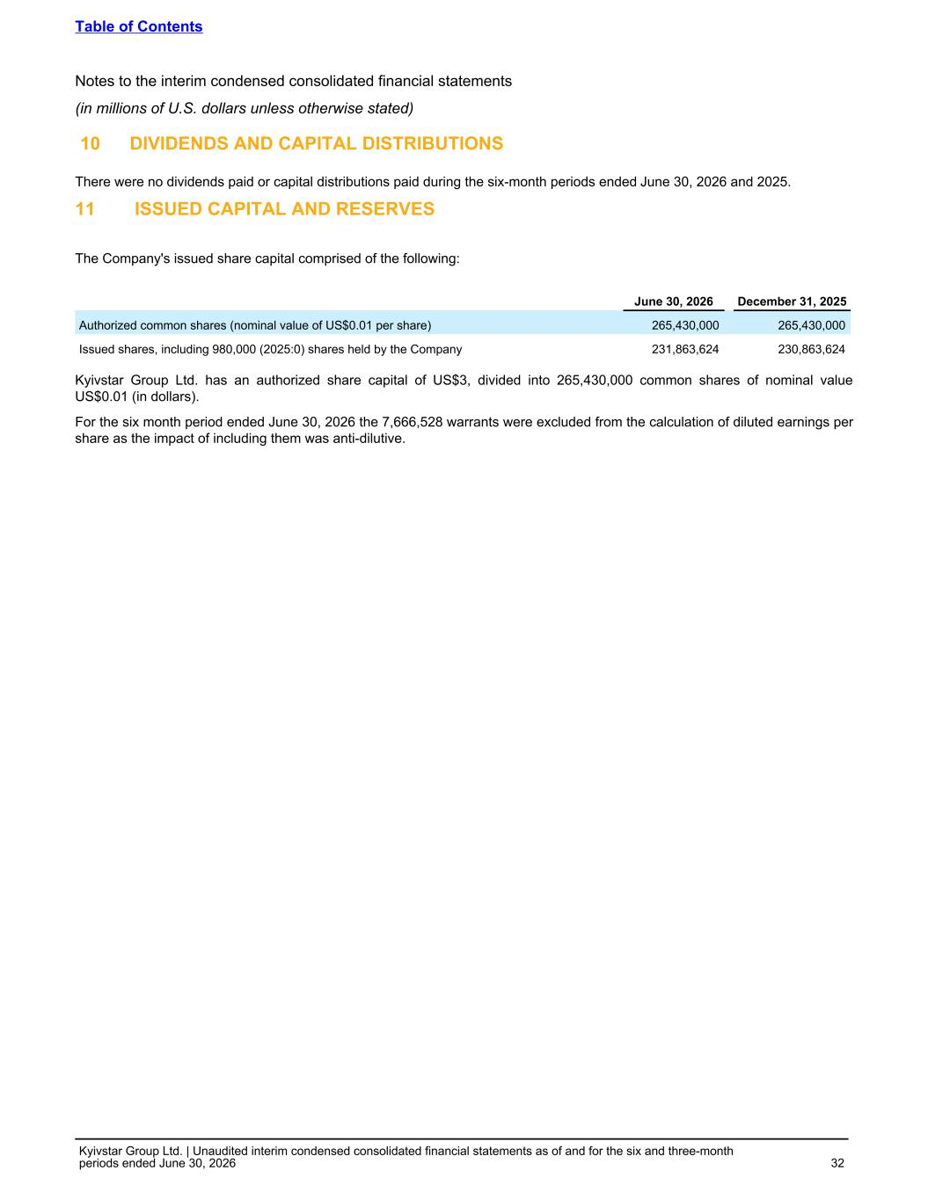
10 DIVIDENDS AND CAPITAL DISTRIBUTIONS There were no dividends paid or capital distributions paid during the six-month periods ended June 30, 2026 and 2025. 11 ISSUED CAPITAL AND RESERVES The Company's issued share capital comprised of the following: June 30, 2026 December 31, 2025 Authorized common shares (nominal value of US$0.01 per share) 265,430,000 265,430,000 Issued shares, including 980,000 (2025:0) shares held by the Company 231,863,624 230,863,624 Kyivstar Group Ltd. has an authorized share capital of US$3, divided into 265,430,000 common shares of nominal value US$0.01 (in dollars). For the six month period ended June 30, 2026 the 7,666,528 warrants were excluded from the calculation of diluted earnings per share as the impact of including them was anti-dilutive. Table of Contents Notes to the interim condensed consolidated financial statements (in millions of U.S. dollars unless otherwise stated) Kyivstar Group Ltd. | Unaudited interim condensed consolidated financial statements as of and for the six and three-month periods ended June 30, 2026 32

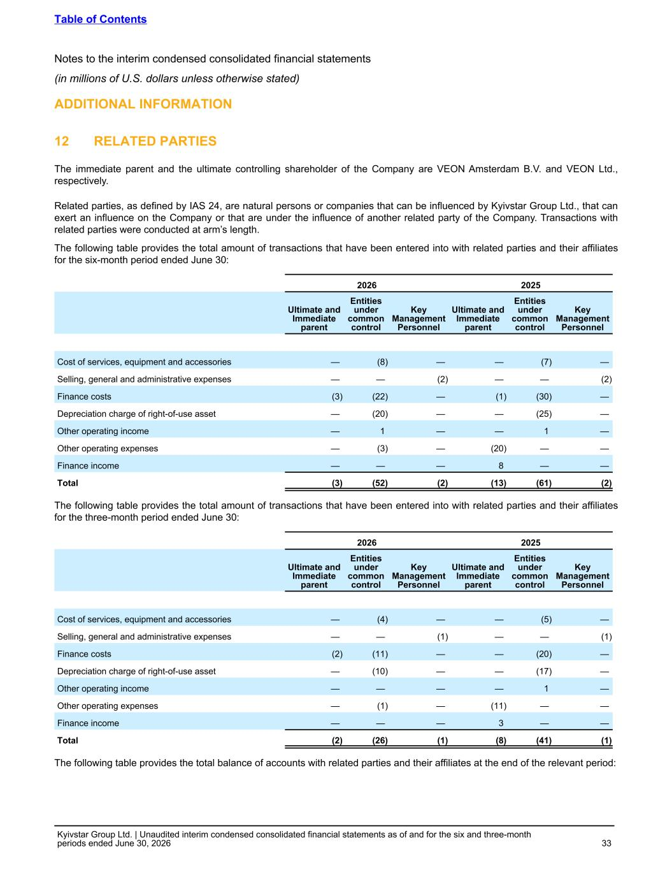
ADDITIONAL INFORMATION 12 RELATED PARTIES The immediate parent and the ultimate controlling shareholder of the Company are VEON Amsterdam B.V. and VEON Ltd., respectively. Related parties, as defined by IAS 24, are natural persons or companies that can be influenced by Kyivstar Group Ltd., that can exert an influence on the Company or that are under the influence of another related party of the Company. Transactions with related parties were conducted at arm’s length. The following table provides the total amount of transactions that have been entered into with related parties and their affiliates for the six-month period ended June 30: 2026 2025 Ultimate and Immediate parent Entities under common control Key Management Personnel Ultimate and Immediate parent Entities under common control Key Management Personnel Cost of services, equipment and accessories — (8) — — (7) — Selling, general and administrative expenses — — (2) — — (2) Finance costs (3) (22) — (1) (30) — Depreciation charge of right-of-use asset — (20) — — (25) — Other operating income — 1 — — 1 — Other operating expenses — (3) — (20) — — Finance income — — — 8 — — Total (3) (52) (2) (13) (61) (2) The following table provides the total amount of transactions that have been entered into with related parties and their affiliates for the three-month period ended June 30: 2026 2025 Ultimate and Immediate parent Entities under common control Key Management Personnel Ultimate and Immediate parent Entities under common control Key Management Personnel Cost of services, equipment and accessories — (4) — — (5) — Selling, general and administrative expenses — — (1) — — (1) Finance costs (2) (11) — — (20) — Depreciation charge of right-of-use asset — (10) — — (17) — Other operating income — — — — 1 — Other operating expenses — (1) — (11) — — Finance income — — — 3 — — Total (2) (26) (1) (8) (41) (1) The following table provides the total balance of accounts with related parties and their affiliates at the end of the relevant period: Table of Contents Notes to the interim condensed consolidated financial statements (in millions of U.S. dollars unless otherwise stated) Kyivstar Group Ltd. | Unaudited interim condensed consolidated financial statements as of and for the six and three-month periods ended June 30, 2026 33

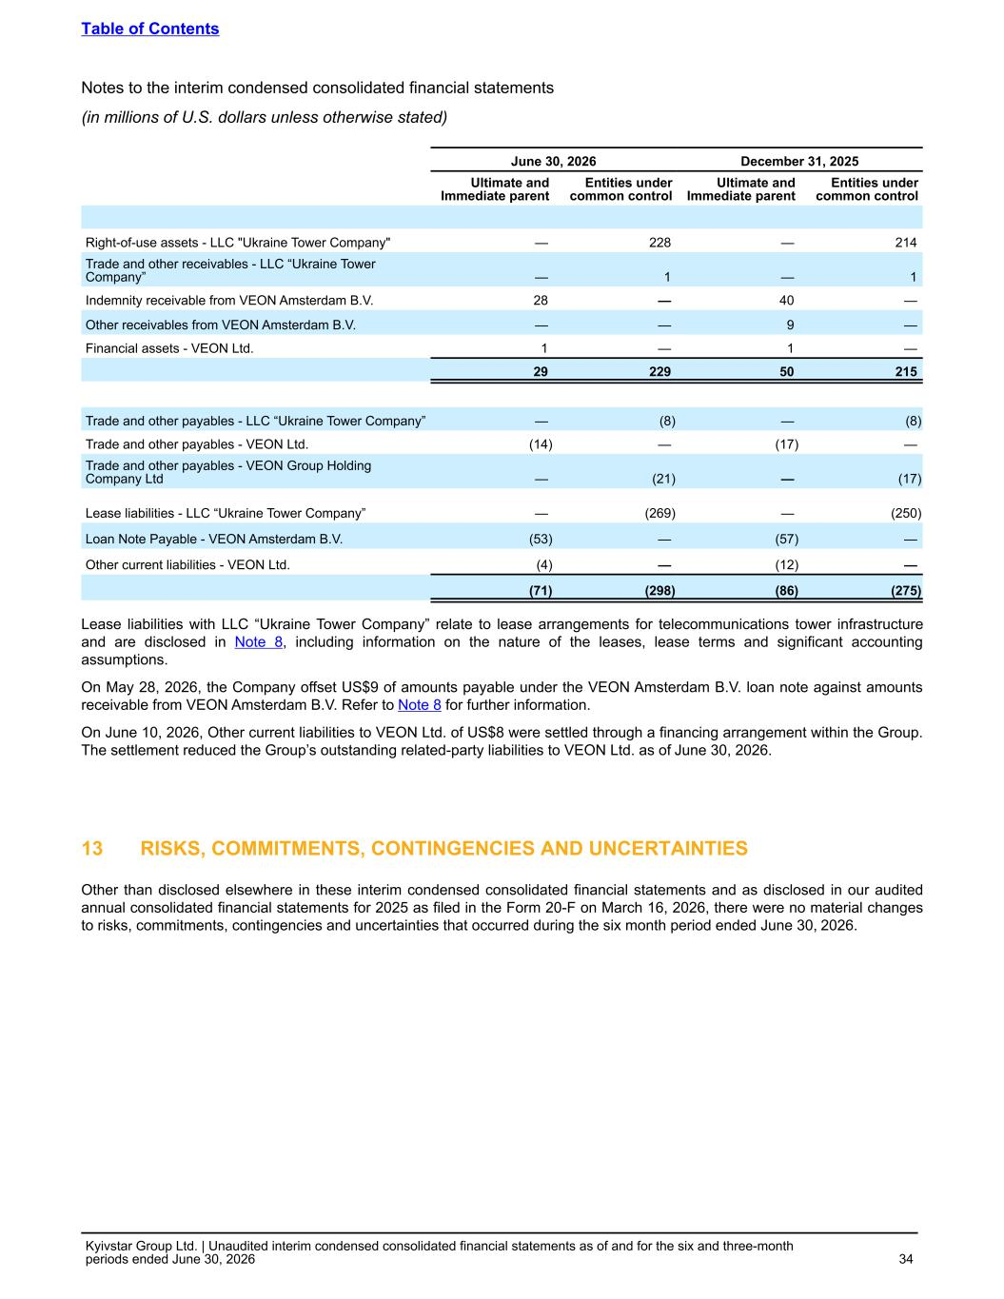
June 30, 2026 December 31, 2025 Ultimate and Immediate parent Entities under common control Ultimate and Immediate parent Entities under common control Right-of-use assets - LLC "Ukraine Tower Company" — 228 — 214 Trade and other receivables - LLC “Ukraine Tower Company” — 1 — 1 Indemnity receivable from VEON Amsterdam B.V. 28 — 40 — Other receivables from VEON Amsterdam B.V. — — 9 — Financial assets - VEON Ltd. 1 — 1 — 29 229 50 215 Trade and other payables - LLC “Ukraine Tower Company” — (8) — (8) Trade and other payables - VEON Ltd. (14) — (17) — Trade and other payables - VEON Group Holding Company Ltd — (21) — (17) Lease liabilities - LLC “Ukraine Tower Company” — (269) — (250) Loan Note Payable - VEON Amsterdam B.V. (53) — (57) — Other current liabilities - VEON Ltd. (4) — (12) — (71) (298) (86) (275) Lease liabilities with LLC “Ukraine Tower Company” relate to lease arrangements for telecommunications tower infrastructure and are disclosed in Note 8, including information on the nature of the leases, lease terms and significant accounting assumptions. On May 28, 2026, the Company offset US$9 of amounts payable under the VEON Amsterdam B.V. loan note against amounts receivable from VEON Amsterdam B.V. Refer to Note 8 for further information. On June 10, 2026, Other current liabilities to VEON Ltd. of US$8 were settled through a financing arrangement within the Group. The settlement reduced the Group’s outstanding related-party liabilities to VEON Ltd. as of June 30, 2026. 13 RISKS, COMMITMENTS, CONTINGENCIES AND UNCERTAINTIES Other than disclosed elsewhere in these interim condensed consolidated financial statements and as disclosed in our audited annual consolidated financial statements for 2025 as filed in the Form 20-F on March 16, 2026, there were no material changes to risks, commitments, contingencies and uncertainties that occurred during the six month period ended June 30, 2026. Table of Contents Notes to the interim condensed consolidated financial statements (in millions of U.S. dollars unless otherwise stated) Kyivstar Group Ltd. | Unaudited interim condensed consolidated financial statements as of and for the six and three-month periods ended June 30, 2026 34

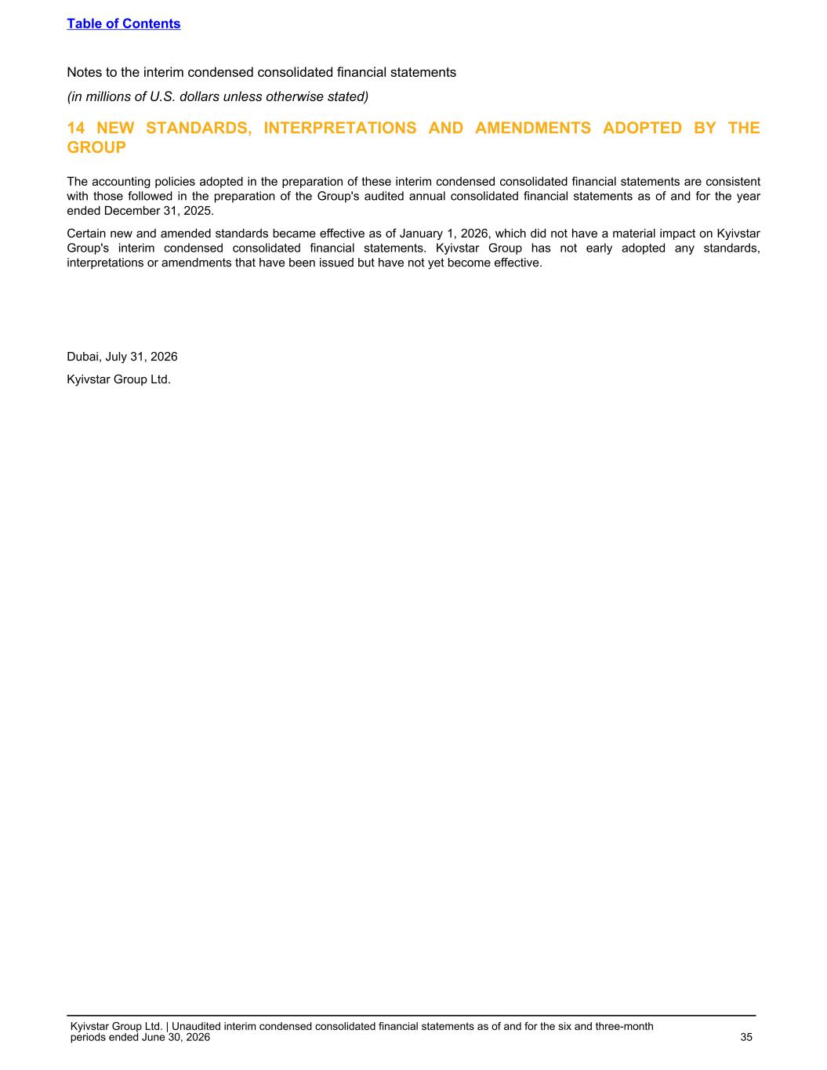
14 NEW STANDARDS, INTERPRETATIONS AND AMENDMENTS ADOPTED BY THE GROUP The accounting policies adopted in the preparation of these interim condensed consolidated financial statements are consistent with those followed in the preparation of the Group's audited annual consolidated financial statements as of and for the year ended December 31, 2025. Certain new and amended standards became effective as of January 1, 2026, which did not have a material impact on Kyivstar Group's interim condensed consolidated financial statements. Kyivstar Group has not early adopted any standards, interpretations or amendments that have been issued but have not yet become effective. Dubai, July 31, 2026 Kyivstar Group Ltd. Table of Contents Notes to the interim condensed consolidated financial statements (in millions of U.S. dollars unless otherwise stated) Kyivstar Group Ltd. | Unaudited interim condensed consolidated financial statements as of and for the six and three-month periods ended June 30, 2026 35

