UNITED STATES

SECURITIES AND EXCHANGE COMMISSION
Washington, D.C. 20549
FORM 6-K

REPORT OF FOREIGN PRIVATE ISSUER
PURSUANT TO RULE 13a-16 OR 15d-16 UNDER
THE SECURITIES EXCHANGE ACT OF 1934
For the Month of July 2026
Commission File Number: 001-42804
Kyivstar Group Ltd.

(Translation of registrant’s name into English)
Unit 517, Level 5

Index Tower
Dubai International Financial Centre (DIFC)
United Arab Emirates
(Address of principal executive offices)
Indicate by check mark whether the registrant files or will file annual reports under cover of Form 20-F or Form

40-F.
Form 20-F x Form 40-F o
EXPLANATORY NOTE

EXHIBIT INDEX
On July 31, 2026, Kyivstar Group Ltd. published an earnings release and investor presentation, copies of which are

furnished hereto as Exhibit 99.1 and 99.2 respectively.

SIGNATURES
Exhibit No.
99.1
99.2

Pursuant to the requirements of the Securities Exchange Act of 1934, the registrant has duly caused this
report to be signed on its behalf by the undersigned, thereunto duly authorized.
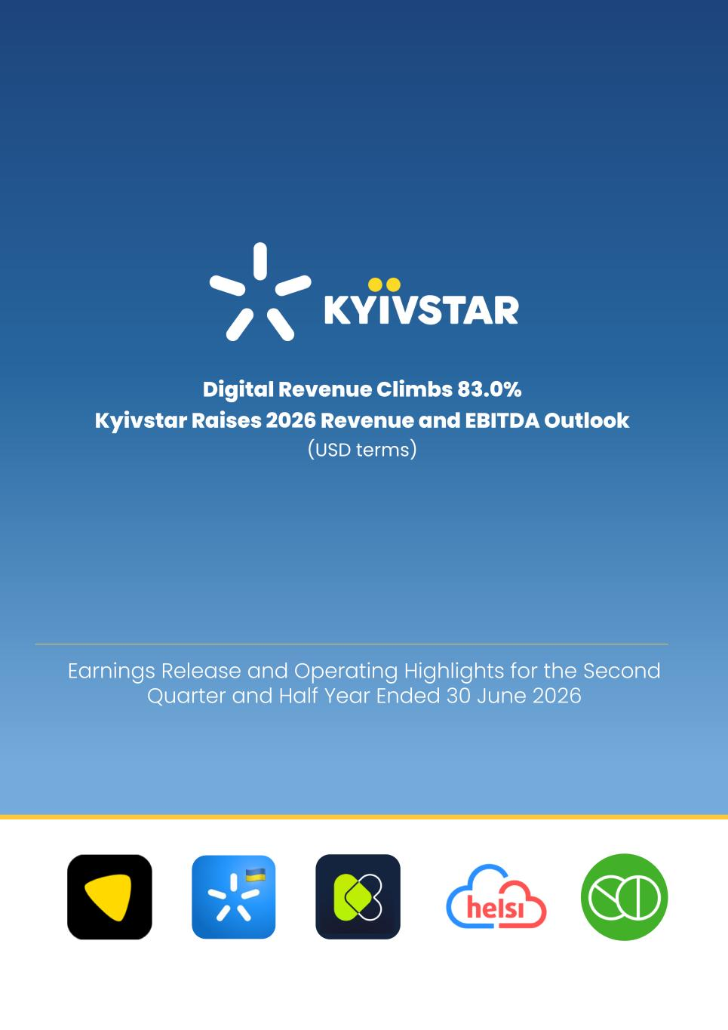
Date: July 31, 2026

Earnings Release and Operating Highlights for the Second Quarter and Half Year Ended 30 June 2026 Digital Revenue Climbs 83.0% Kyivstar Raises 2026 Revenue and EBITDA Outlook (USD terms)

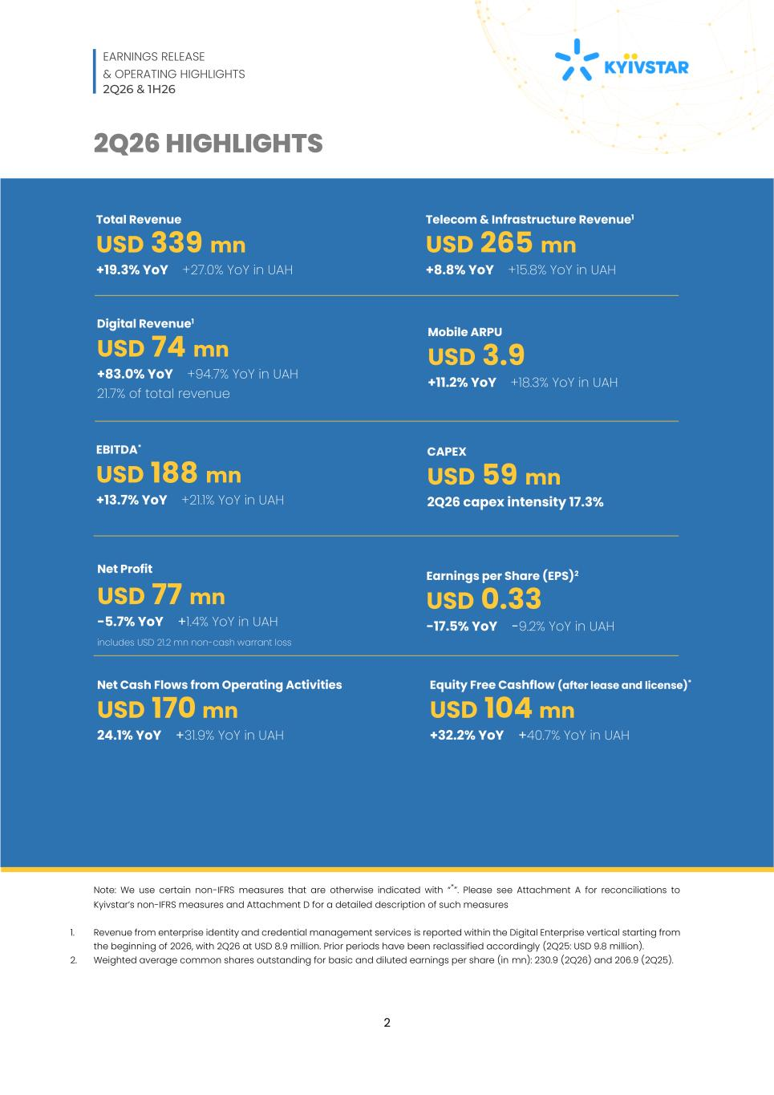
EARNINGS RELEASE & OPERATING HIGHLIGHTS 2Q26 & 1H26 2 2Q26 HIGHLIGHTS Note: We use certain non-IFRS measures that are otherwise indicated with “*”. Please see Attachment A for reconciliations to Kyivstar’s non-IFRS measures and Attachment D for a detailed description of such measures 1. Revenue from enterprise identity and credential management services is reported within the Digital Enterprise vertical starting from the beginning of 2026, with 2Q26 at USD 8.9 million. Prior periods have been reclassified accordingly (2Q25: USD 9.8 million). 2. Weighted average common shares outstanding for basic and diluted earnings per share (in mn): 230.9 (2Q26) and 206.9 (2Q25). Earnings per Share (EPS)2 USD 0.33 -17.5% YoY -9.2% YoY in UAH Total Revenue USD 339 mn +19.3% YoY +27.0% YoY in UAH Telecom & Infrastructure Revenue1 USD 265 mn +8.8% YoY +15.8% YoY in UAH Digital Revenue1 USD 74 mn +83.0% YoY +94.7% YoY in UAH 21.7% of total revenue Mobile ARPU USD 3.9 +11.2% YoY +18.3% YoY in UAH EBITDA* USD 188 mn +13.7% YoY +21.1% YoY in UAH Net Cash Flows from Operating Activities USD 170 mn 24.1% YoY +31.9% YoY in UAH CAPEX USD 59 mn 2Q26 capex intensity 17.3% Net Profit USD 77 mn -5.7% YoY +1.4% YoY in UAH includes USD 21.2 mn non-cash warrant loss Equity Free Cashflow (after lease and license)* USD 104 mn +32.2% YoY +40.7% YoY in UAH

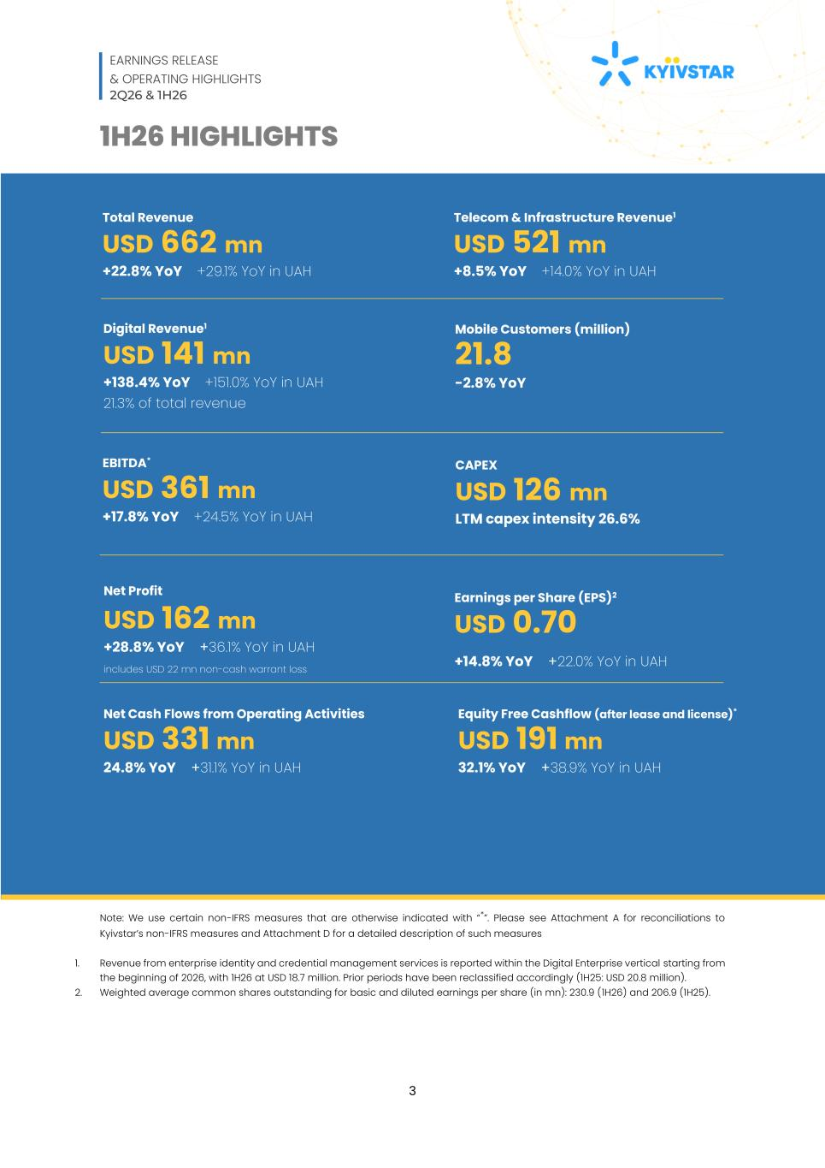
EARNINGS RELEASE & OPERATING HIGHLIGHTS 2Q26 & 1H26 3 1H26 HIGHLIGHTS Note: We use certain non-IFRS measures that are otherwise indicated with “*”. Please see Attachment A for reconciliations to Kyivstar’s non-IFRS measures and Attachment D for a detailed description of such measures 1. Revenue from enterprise identity and credential management services is reported within the Digital Enterprise vertical starting from the beginning of 2026, with 1H26 at USD 18.7 million. Prior periods have been reclassified accordingly (1H25: USD 20.8 million). 2. Weighted average common shares outstanding for basic and diluted earnings per share (in mn): 230.9 (1H26) and 206.9 (1H25). Earnings per Share (EPS)2 USD 0.70 +14.8% YoY +22.0% YoY in UAH Total Revenue USD 662 mn +22.8% YoY +29.1% YoY in UAH Telecom & Infrastructure Revenue1 USD 521 mn +8.5% YoY +14.0% YoY in UAH Digital Revenue1 USD 141 mn +138.4% YoY +151.0% YoY in UAH 21.3% of total revenue Mobile Customers (million) 21.8 -2.8% YoY EBITDA* USD 361 mn +17.8% YoY +24.5% YoY in UAH Net Cash Flows from Operating Activities USD 331 mn 24.8% YoY +31.1% YoY in UAH CAPEX USD 126 mn LTM capex intensity 26.6% Net Profit USD 162 mn +28.8% YoY +36.1% YoY in UAH includes USD 22 mn non-cash warrant loss 28.8% YoY +36.1% YoY in UAH Equity Free Cashflow (after lease and license)* USD 191 mn 32.1% YoY +38.9% YoY in UAH

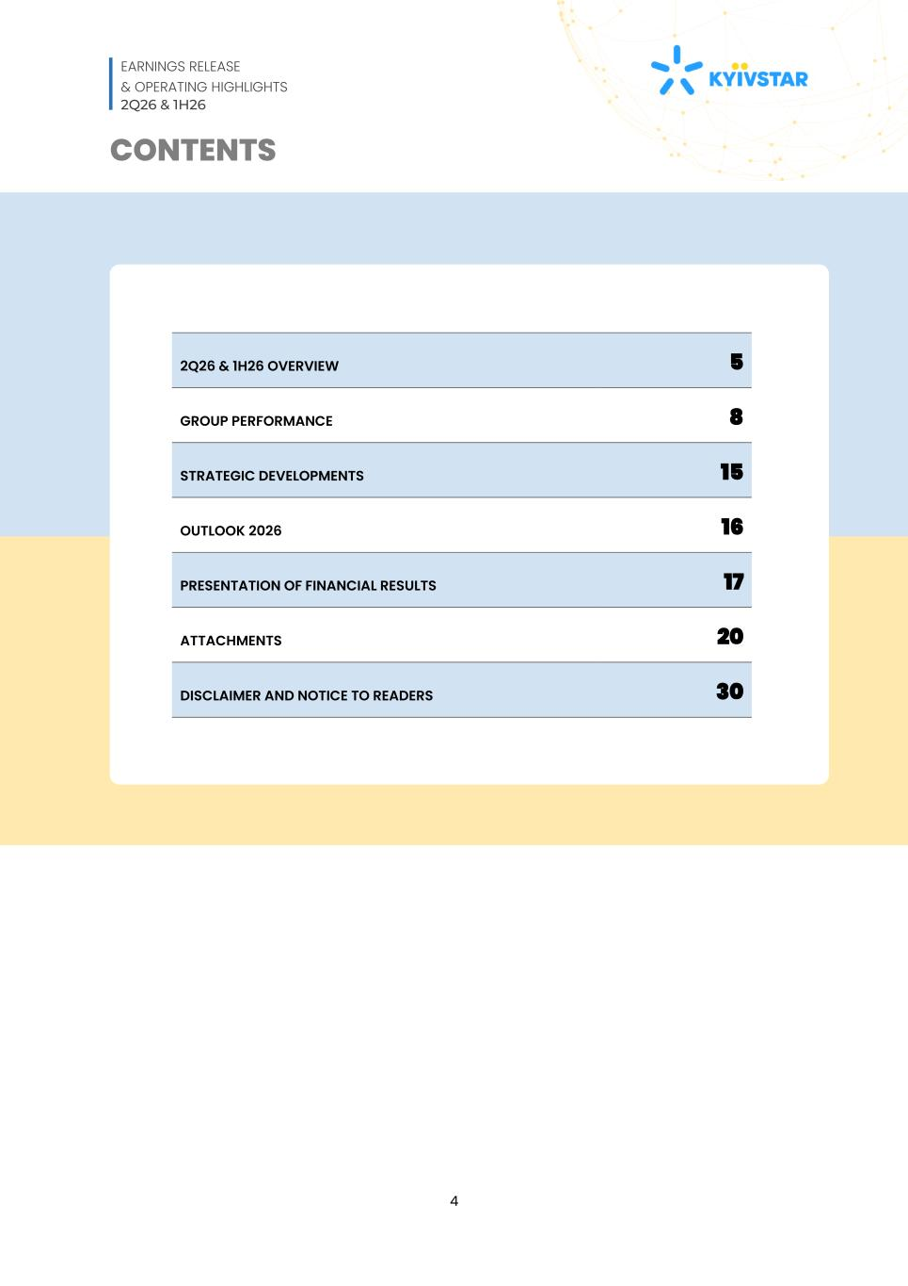
EARNINGS RELEASE & OPERATING HIGHLIGHTS 2Q26 & 1H26 4 CONTENTS 2Q26 & 1H26 OVERVIEW 5 GROUP PERFORMANCE 8 STRATEGIC DEVELOPMENTS 15 OUTLOOK 2026 16 PRESENTATION OF FINANCIAL RESULTS 17 ATTACHMENTS 20 DISCLAIMER AND NOTICE TO READERS 30

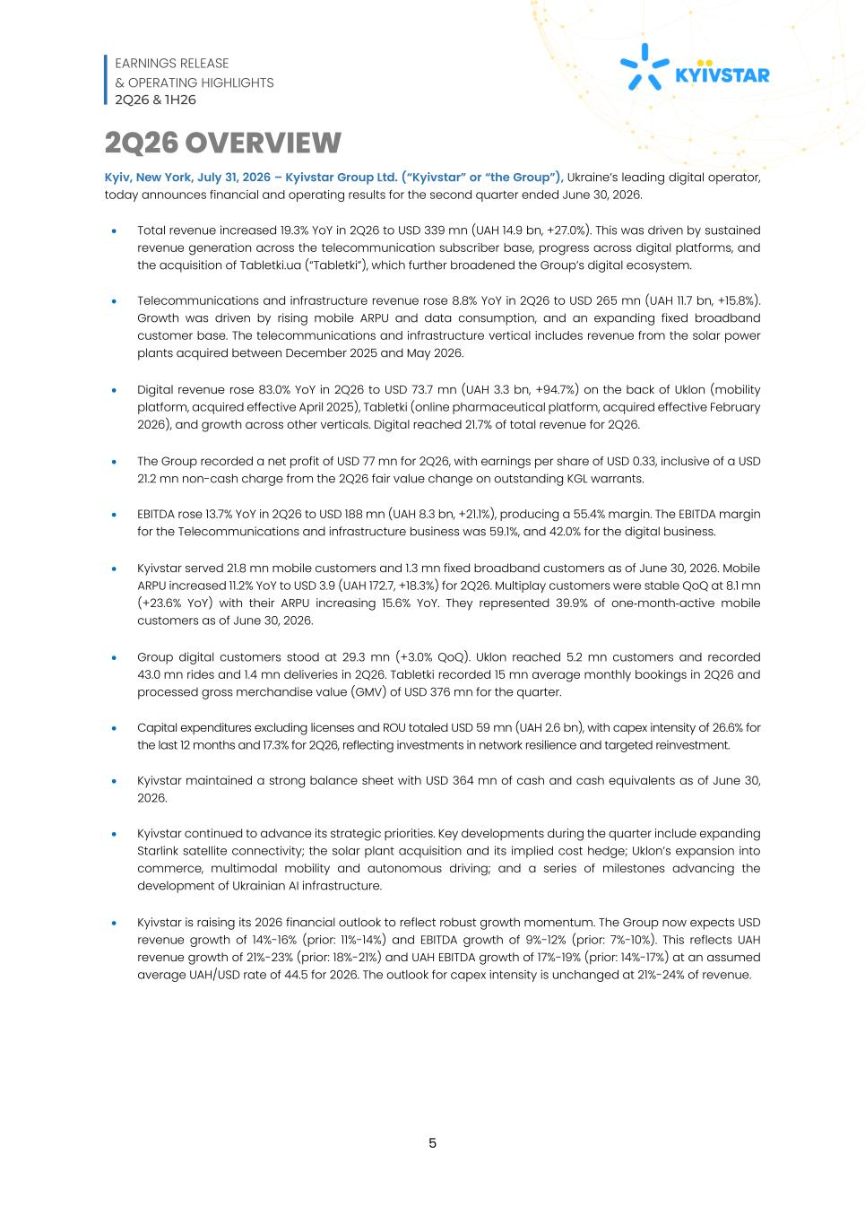
EARNINGS RELEASE & OPERATING HIGHLIGHTS 2Q26 & 1H26 5 2Q26 OVERVIEW Kyiv, New York, July 31, 2026 – Kyivstar Group Ltd. (“Kyivstar” or “the Group”), Ukraine’s leading digital operator, today announces financial and operating results for the second quarter ended June 30, 2026. • Total revenue increased 19.3% YoY in 2Q26 to USD 339 mn (UAH 14.9 bn, +27.0%). This was driven by sustained revenue generation across the telecommunication subscriber base, progress across digital platforms, and the acquisition of Tabletki.ua (“Tabletki”), which further broadened the Group’s digital ecosystem. • Telecommunications and infrastructure revenue rose 8.8% YoY in 2Q26 to USD 265 mn (UAH 11.7 bn, +15.8%). Growth was driven by rising mobile ARPU and data consumption, and an expanding fixed broadband customer base. The telecommunications and infrastructure vertical includes revenue from the solar power plants acquired between December 2025 and May 2026. • Digital revenue rose 83.0% YoY in 2Q26 to USD 73.7 mn (UAH 3.3 bn, +94.7%) on the back of Uklon (mobility platform, acquired effective April 2025), Tabletki (online pharmaceutical platform, acquired effective February 2026), and growth across other verticals. Digital reached 21.7% of total revenue for 2Q26. • The Group recorded a net profit of USD 77 mn for 2Q26, with earnings per share of USD 0.33, inclusive of a USD 21.2 mn non-cash charge from the 2Q26 fair value change on outstanding KGL warrants. • EBITDA rose 13.7% YoY in 2Q26 to USD 188 mn (UAH 8.3 bn, +21.1%), producing a 55.4% margin. The EBITDA margin for the Telecommunications and infrastructure business was 59.1%, and 42.0% for the digital business. • Kyivstar served 21.8 mn mobile customers and 1.3 mn fixed broadband customers as of June 30, 2026. Mobile ARPU increased 11.2% YoY to USD 3.9 (UAH 172.7, +18.3%) for 2Q26. Multiplay customers were stable QoQ at 8.1 mn (+23.6% YoY) with their ARPU increasing 15.6% YoY. They represented 39.9% of one-month-active mobile customers as of June 30, 2026. • Group digital customers stood at 29.3 mn (+3.0% QoQ). Uklon reached 5.2 mn customers and recorded 43.0 mn rides and 1.4 mn deliveries in 2Q26. Tabletki recorded 15 mn average monthly bookings in 2Q26 and processed gross merchandise value (GMV) of USD 376 mn for the quarter. • Capital expenditures excluding licenses and ROU totaled USD 59 mn (UAH 2.6 bn), with capex intensity of 26.6% for the last 12 months and 17.3% for 2Q26, reflecting investments in network resilience and targeted reinvestment. • Kyivstar maintained a strong balance sheet with USD 364 mn of cash and cash equivalents as of June 30, 2026. • Kyivstar continued to advance its strategic priorities. Key developments during the quarter include expanding Starlink satellite connectivity; the solar plant acquisition and its implied cost hedge; Uklon’s expansion into commerce, multimodal mobility and autonomous driving; and a series of milestones advancing the development of Ukrainian AI infrastructure. • Kyivstar is raising its 2026 financial outlook to reflect robust growth momentum. The Group now expects USD revenue growth of 14%-16% (prior: 11%-14%) and EBITDA growth of 9%-12% (prior: 7%-10%). This reflects UAH revenue growth of 21%-23% (prior: 18%-21%) and UAH EBITDA growth of 17%-19% (prior: 14%-17%) at an assumed average UAH/USD rate of 44.5 for 2026. The outlook for capex intensity is unchanged at 21%-24% of revenue.

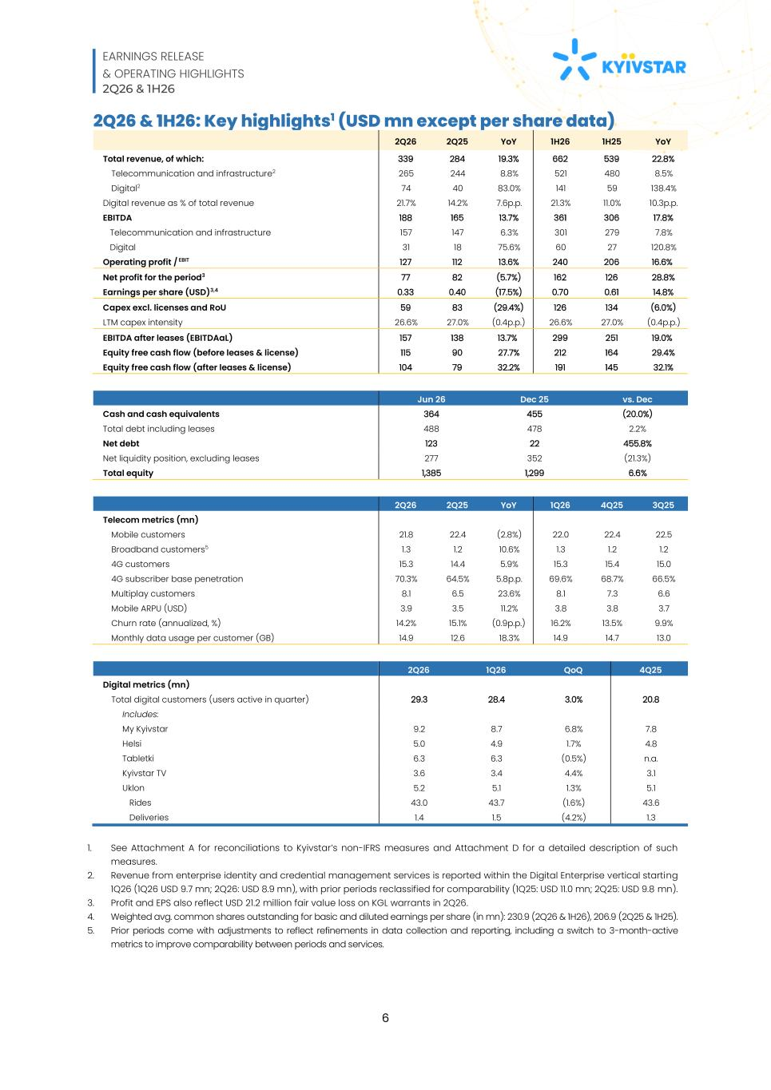
EARNINGS RELEASE & OPERATING HIGHLIGHTS 2Q26 & 1H26 6 2Q26 & 1H26: Key highlights1 (USD mn except per share data) 2Q26 2Q25 YoY 1H26 1H25 YoY Total revenue, of which: 339 284 19.3% 662 539 22.8% Telecommunication and infrastructure2 265 244 8.8% 521 480 8.5% Digital2 74 40 83.0% 141 59 138.4% Digital revenue as % of total revenue 21.7% 14.2% 7.6p.p. 21.3% 11.0% 10.3p.p. EBITDA 188 165 13.7% 361 306 17.8% Telecommunication and infrastructure 157 147 6.3% 301 279 7.8% Digital 31 18 75.6% 60 27 120.8% Operating profit / EBIT 127 112 13.6% 240 206 16.6% Net profit for the period3 77 82 (5.7%) 162 126 28.8% Earnings per share (USD)3,4 0.33 0.40 (17.5%) 0.70 0.61 14.8% Capex excl. licenses and RoU 59 83 (29.4%) 126 134 (6.0%) LTM capex intensity 26.6% 27.0% (0.4p.p.) 26.6% 27.0% (0.4p.p.) EBITDA after leases (EBITDAaL) 157 138 13.7% 299 251 19.0% Equity free cash flow (before leases & license) 115 90 27.7% 212 164 29.4% Equity free cash flow (after leases & license) 104 79 32.2% 191 145 32.1% Jun 26 Dec 25 vs. Dec Cash and cash equivalents 364 455 (20.0%) Total debt including leases 488 478 2.2% Net debt 123 22 455.8% Net liquidity position, excluding leases 277 352 (21.3%) Total equity 1,385 1,299 6.6% 2Q26 2Q25 YoY 1Q26 4Q25 3Q25 Telecom metrics (mn) Mobile customers 21.8 22.4 (2.8%) 22.0 22.4 22.5 Broadband customers5 1.3 1.2 10.6% 1.3 1.2 1.2 4G customers 15.3 14.4 5.9% 15.3 15.4 15.0 4G subscriber base penetration 70.3% 64.5% 5.8p.p. 69.6% 68.7% 66.5% Multiplay customers 8.1 6.5 23.6% 8.1 7.3 6.6 Mobile ARPU (USD) 3.9 3.5 11.2% 3.8 3.8 3.7 Churn rate (annualized, %) 14.2% 15.1% (0.9p.p.) 16.2% 13.5% 9.9% Monthly data usage per customer (GB) 14.9 12.6 18.3% 14.9 14.7 13.0 2Q26 1Q26 QoQ 4Q25 Digital metrics (mn) Total digital customers (users active in quarter) 29.3 28.4 3.0% 20.8 Includes: My Kyivstar 9.2 8.7 6.8% 7.8 Helsi 5.0 4.9 1.7% 4.8 Tabletki 6.3 6.3 (0.5%) n.a. Kyivstar TV 3.6 3.4 4.4% 3.1 Uklon 5.2 5.1 1.3% 5.1 Rides 43.0 43.7 (1.6%) 43.6 Deliveries 1.4 1.5 (4.2%) 1.3 1. See Attachment A for reconciliations to Kyivstar’s non-IFRS measures and Attachment D for a detailed description of such measures. 2. Revenue from enterprise identity and credential management services is reported within the Digital Enterprise vertical starting 1Q26 (1Q26 USD 9.7 mn; 2Q26: USD 8.9 mn), with prior periods reclassified for comparability (1Q25: USD 11.0 mn; 2Q25: USD 9.8 mn). 3. Profit and EPS also reflect USD 21.2 million fair value loss on KGL warrants in 2Q26. 4. Weighted avg. common shares outstanding for basic and diluted earnings per share (in mn): 230.9 (2Q26 & 1H26), 206.9 (2Q25 & 1H25). 5. Prior periods come with adjustments to reflect refinements in data collection and reporting, including a switch to 3-month-active metrics to improve comparability between periods and services.

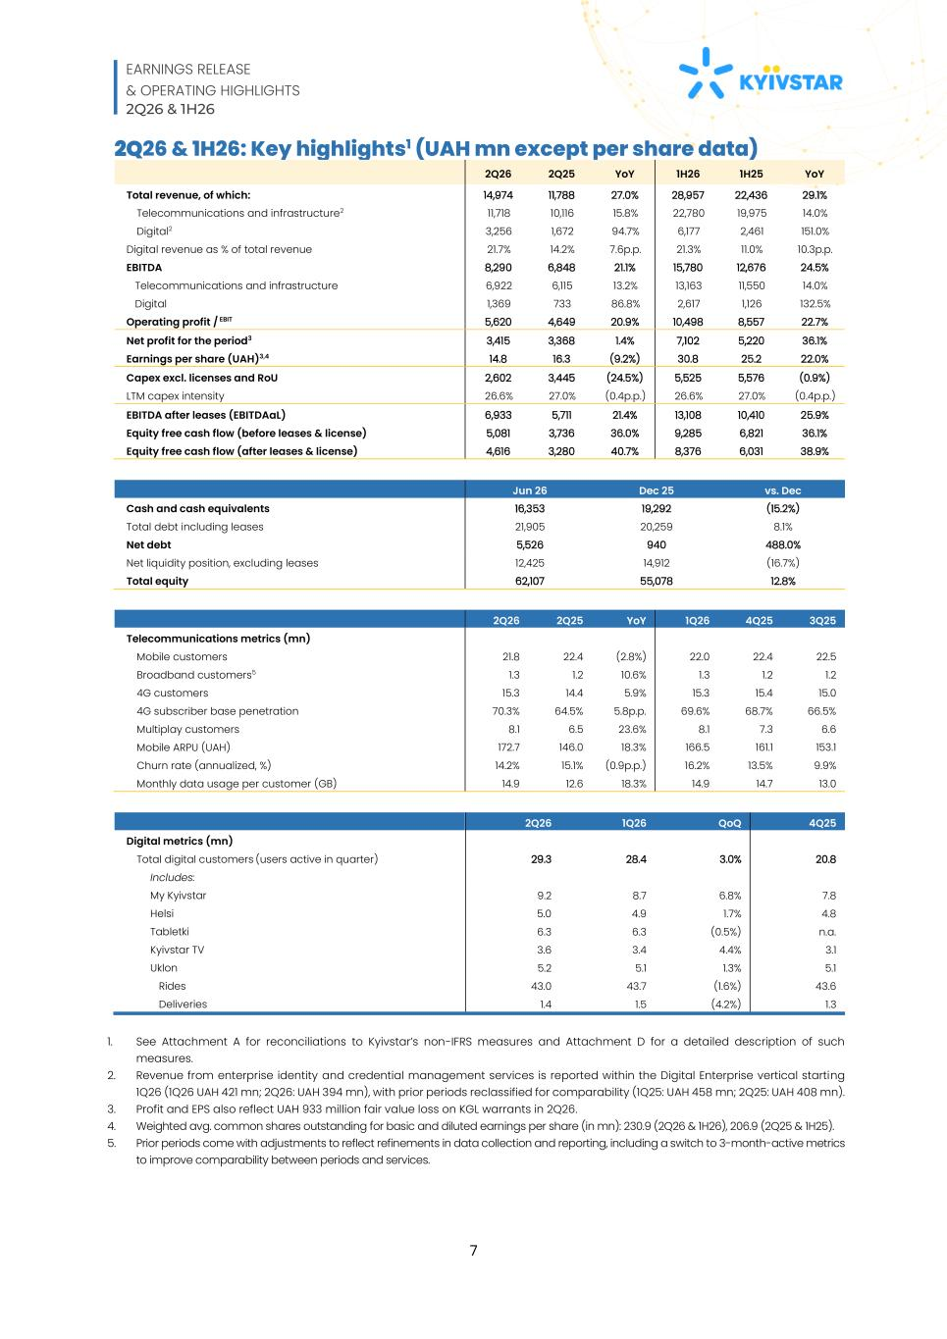
EARNINGS RELEASE & OPERATING HIGHLIGHTS 2Q26 & 1H26 7 2Q26 & 1H26: Key highlights1 (UAH mn except per share data) 2Q26 2Q25 YoY 1H26 1H25 YoY Total revenue, of which: 14,974 11,788 27.0% 28,957 22,436 29.1% Telecommunications and infrastructure2 11,718 10,116 15.8% 22,780 19,975 14.0% Digital2 3,256 1,672 94.7% 6,177 2,461 151.0% Digital revenue as % of total revenue 21.7% 14.2% 7.6p.p. 21.3% 11.0% 10.3p.p. EBITDA 8,290 6,848 21.1% 15,780 12,676 24.5% Telecommunications and infrastructure 6,922 6,115 13.2% 13,163 11,550 14.0% Digital 1,369 733 86.8% 2,617 1,126 132.5% Operating profit / EBIT 5,620 4,649 20.9% 10,498 8,557 22.7% Net profit for the period3 3,415 3,368 1.4% 7,102 5,220 36.1% Earnings per share (UAH)3,4 14.8 16.3 (9.2%) 30.8 25.2 22.0% Capex excl. licenses and RoU 2,602 3,445 (24.5%) 5,525 5,576 (0.9%) LTM capex intensity 26.6% 27.0% (0.4p.p.) 26.6% 27.0% (0.4p.p.) EBITDA after leases (EBITDAaL) 6,933 5,711 21.4% 13,108 10,410 25.9% Equity free cash flow (before leases & license) 5,081 3,736 36.0% 9,285 6,821 36.1% Equity free cash flow (after leases & license) 4,616 3,280 40.7% 8,376 6,031 38.9% Jun 26 Dec 25 vs. Dec Cash and cash equivalents 16,353 19,292 (15.2%) Total debt including leases 21,905 20,259 8.1% Net debt 5,526 940 488.0% Net liquidity position, excluding leases 12,425 14,912 (16.7%) Total equity 62,107 55,078 12.8% 2Q26 2Q25 YoY 1Q26 4Q25 3Q25 Telecommunications metrics (mn) Mobile customers 21.8 22.4 (2.8%) 22.0 22.4 22.5 Broadband customers5 1.3 1.2 10.6% 1.3 1.2 1.2 4G customers 15.3 14.4 5.9% 15.3 15.4 15.0 4G subscriber base penetration 70.3% 64.5% 5.8p.p. 69.6% 68.7% 66.5% Multiplay customers 8.1 6.5 23.6% 8.1 7.3 6.6 Mobile ARPU (UAH) 172.7 146.0 18.3% 166.5 161.1 153.1 Churn rate (annualized, %) 14.2% 15.1% (0.9p.p.) 16.2% 13.5% 9.9% Monthly data usage per customer (GB) 14.9 12.6 18.3% 14.9 14.7 13.0 2Q26 1Q26 QoQ 4Q25 Digital metrics (mn) Total digital customers (users active in quarter) 29.3 28.4 3.0% 20.8 Includes: My Kyivstar 9.2 8.7 6.8% 7.8 Helsi 5.0 4.9 1.7% 4.8 Tabletki 6.3 6.3 (0.5%) n.a. Kyivstar TV 3.6 3.4 4.4% 3.1 Uklon 5.2 5.1 1.3% 5.1 Rides 43.0 43.7 (1.6%) 43.6 Deliveries 1.4 1.5 (4.2%) 1.3 1. See Attachment A for reconciliations to Kyivstar’s non-IFRS measures and Attachment D for a detailed description of such measures. 2. Revenue from enterprise identity and credential management services is reported within the Digital Enterprise vertical starting 1Q26 (1Q26 UAH 421 mn; 2Q26: UAH 394 mn), with prior periods reclassified for comparability (1Q25: UAH 458 mn; 2Q25: UAH 408 mn). 3. Profit and EPS also reflect UAH 933 million fair value loss on KGL warrants in 2Q26. 4. Weighted avg. common shares outstanding for basic and diluted earnings per share (in mn): 230.9 (2Q26 & 1H26), 206.9 (2Q25 & 1H25). 5. Prior periods come with adjustments to reflect refinements in data collection and reporting, including a switch to 3-month-active metrics to improve comparability between periods and services.

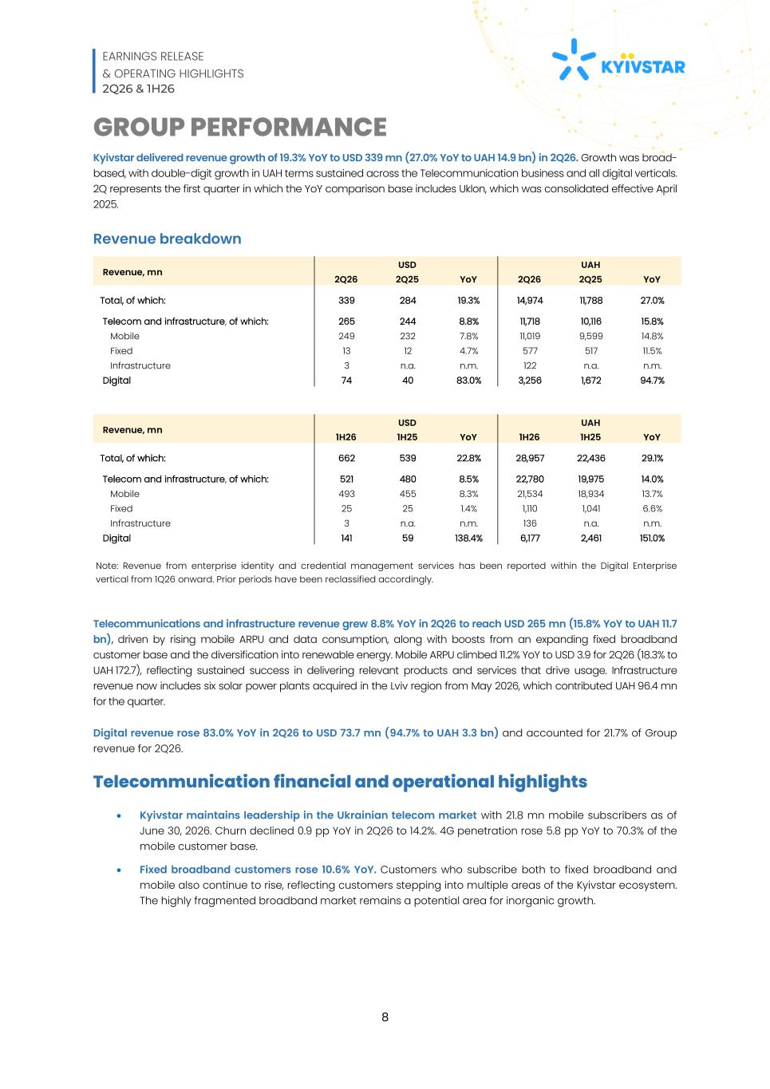
EARNINGS RELEASE & OPERATING HIGHLIGHTS 2Q26 & 1H26 8 GROUP PERFORMANCE Kyivstar delivered revenue growth of 19.3% YoY to USD 339 mn (27.0% YoY to UAH 14.9 bn) in 2Q26. Growth was broad- based, with double-digit growth in UAH terms sustained across the Telecommunication business and all digital verticals. 2Q represents the first quarter in which the YoY comparison base includes Uklon, which was consolidated effective April 2025. Revenue breakdown Revenue, mn USD UAH 2Q26 2Q25 YoY 2Q26 2Q25 YoY Total, of which: 339 284 19.3% 14,974 11,788 27.0% Telecom and infrastructure, of which: 265 244 8.8% 11,718 10,116 15.8% Mobile 249 232 7.8% 11,019 9,599 14.8% Fixed 13 12 4.7% 577 517 11.5% Infrastructure 3 n.a. n.m. 122 n.a. n.m. Digital 74 40 83.0% 3,256 1,672 94.7% Revenue, mn USD UAH 1H26 1H25 YoY 1H26 1H25 YoY Total, of which: 662 539 22.8% 28,957 22,436 29.1% Telecom and infrastructure, of which: 521 480 8.5% 22,780 19,975 14.0% Mobile 493 455 8.3% 21,534 18,934 13.7% Fixed 25 25 1.4% 1,110 1,041 6.6% Infrastructure 3 n.a. n.m. 136 n.a. n.m. Digital 141 59 138.4% 6,177 2,461 151.0% Note: Revenue from enterprise identity and credential management services has been reported within the Digital Enterprise vertical from 1Q26 onward. Prior periods have been reclassified accordingly. Telecommunications and infrastructure revenue grew 8.8% YoY in 2Q26 to reach USD 265 mn (15.8% YoY to UAH 11.7 bn), driven by rising mobile ARPU and data consumption, along with boosts from an expanding fixed broadband customer base and the diversification into renewable energy. Mobile ARPU climbed 11.2% YoY to USD 3.9 for 2Q26 (18.3% to UAH 172.7), reflecting sustained success in delivering relevant products and services that drive usage. Infrastructure revenue now includes six solar power plants acquired in the Lviv region from May 2026, which contributed UAH 96.4 mn for the quarter. Digital revenue rose 83.0% YoY in 2Q26 to USD 73.7 mn (94.7% to UAH 3.3 bn) and accounted for 21.7% of Group revenue for 2Q26. Telecommunication financial and operational highlights • Kyivstar maintains leadership in the Ukrainian telecom market with 21.8 mn mobile subscribers as of June 30, 2026. Churn declined 0.9 pp YoY in 2Q26 to 14.2%. 4G penetration rose 5.8 pp YoY to 70.3% of the mobile customer base. • Fixed broadband customers rose 10.6% YoY. Customers who subscribe both to fixed broadband and mobile also continue to rise, reflecting customers stepping into multiple areas of the Kyivstar ecosystem. The highly fragmented broadband market remains a potential area for inorganic growth.

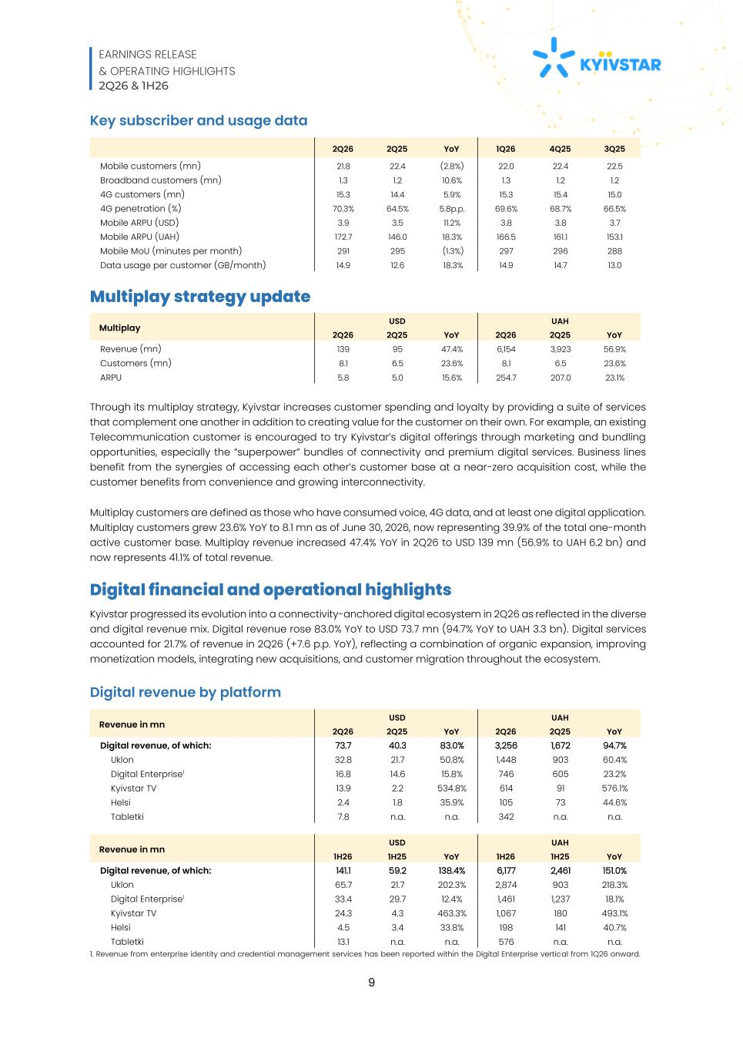
EARNINGS RELEASE & OPERATING HIGHLIGHTS 2Q26 & 1H26 9 Key subscriber and usage data 2Q26 2Q25 YoY 1Q26 4Q25 3Q25 Mobile customers (mn) 21.8 22.4 (2.8%) 22.0 22.4 22.5 Broadband customers (mn) 1.3 1.2 10.6% 1.3 1.2 1.2 4G customers (mn) 15.3 14.4 5.9% 15.3 15.4 15.0 4G penetration (%) 70.3% 64.5% 5.8p.p. 69.6% 68.7% 66.5% Mobile ARPU (USD) 3.9 3.5 11.2% 3.8 3.8 3.7 Mobile ARPU (UAH) 172.7 146.0 18.3% 166.5 161.1 153.1 Mobile MoU (minutes per month) 291 295 (1.3%) 297 296 288 Data usage per customer (GB/month) 14.9 12.6 18.3% 14.9 14.7 13.0 Multiplay strategy update Multiplay USD UAH 2Q26 2Q25 YoY 2Q26 2Q25 YoY Revenue (mn) 139 95 47.4% 6,154 3,923 56.9% Customers (mn) 8.1 6.5 23.6% 8.1 6.5 23.6% ARPU 5.8 5.0 15.6% 254.7 207.0 23.1% Through its multiplay strategy, Kyivstar increases customer spending and loyalty by providing a suite of services that complement one another in addition to creating value for the customer on their own. For example, an existing Telecommunication customer is encouraged to try Kyivstar’s digital offerings through marketing and bundling opportunities, especially the “superpower” bundles of connectivity and premium digital services. Business lines benefit from the synergies of accessing each other’s customer base at a near-zero acquisition cost, while the customer benefits from convenience and growing interconnectivity. Multiplay customers are defined as those who have consumed voice, 4G data, and at least one digital application. Multiplay customers grew 23.6% YoY to 8.1 mn as of June 30, 2026, now representing 39.9% of the total one-month active customer base. Multiplay revenue increased 47.4% YoY in 2Q26 to USD 139 mn (56.9% to UAH 6.2 bn) and now represents 41.1% of total revenue. Digital financial and operational highlights Kyivstar progressed its evolution into a connectivity-anchored digital ecosystem in 2Q26 as reflected in the diverse and digital revenue mix. Digital revenue rose 83.0% YoY to USD 73.7 mn (94.7% YoY to UAH 3.3 bn). Digital services accounted for 21.7% of revenue in 2Q26 (+7.6 p.p. YoY), reflecting a combination of organic expansion, improving monetization models, integrating new acquisitions, and customer migration throughout the ecosystem. Digital revenue by platform Revenue in mn USD UAH 2Q26 2Q25 YoY 2Q26 2Q25 YoY Digital revenue, of which: 73.7 40.3 83.0% 3,256 1,672 94.7% Uklon 32.8 21.7 50.8% 1,448 903 60.4% Digital Enterprise1 16.8 14.6 15.8% 746 605 23.2% Kyivstar TV 13.9 2.2 534.8% 614 91 576.1% Helsi 2.4 1.8 35.9% 105 73 44.6% Tabletki 7.8 n.a. n.a. 342 n.a. n.a. Revenue in mn USD UAH 1H26 1H25 YoY 1H26 1H25 YoY Digital revenue, of which: 141.1 59.2 138.4% 6,177 2,461 151.0% Uklon 65.7 21.7 202.3% 2,874 903 218.3% Digital Enterprise1 33.4 29.7 12.4% 1,461 1,237 18.1% Kyivstar TV 24.3 4.3 463.3% 1,067 180 493.1% Helsi 4.5 3.4 33.8% 198 141 40.7% Tabletki 13.1 n.a. n.a. 576 n.a. n.a. 1. Revenue from enterprise identity and credential management services has been reported within the Digital Enterprise vertical from 1Q26 onward.

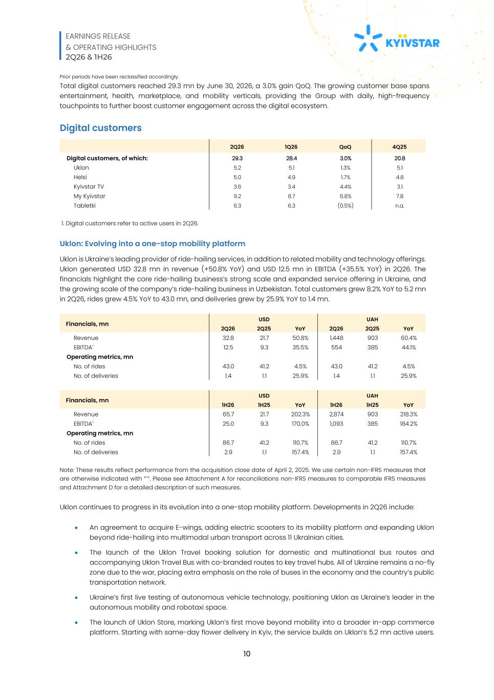
EARNINGS RELEASE & OPERATING HIGHLIGHTS 2Q26 & 1H26 10 Prior periods have been reclassified accordingly. Total digital customers reached 29.3 mn by June 30, 2026, a 3.0% gain QoQ. The growing customer base spans entertainment, health, marketplace, and mobility verticals, providing the Group with daily, high-frequency touchpoints to further boost customer engagement across the digital ecosystem. Digital customers 2Q26 1Q26 QoQ 4Q25 Digital customers, of which: 29.3 28.4 3.0% 20.8 Uklon 5.2 5.1 1.3% 5.1 Helsi 5.0 4.9 1.7% 4.8 Kyivstar TV 3.6 3.4 4.4% 3.1 My Kyivstar 9.2 8.7 6.8% 7.8 Tabletki 6.3 6.3 (0.5%) n.a. 1. Digital customers refer to active users in 2Q26. Uklon: Evolving into a one-stop mobility platform Uklon is Ukraine’s leading provider of ride-hailing services, in addition to related mobility and technology offerings. Uklon generated USD 32.8 mn in revenue (+50.8% YoY) and USD 12.5 mn in EBITDA (+35.5% YoY) in 2Q26. The financials highlight the core ride-hailing business’s strong scale and expanded service offering in Ukraine, and the growing scale of the company’s ride-hailing business in Uzbekistan. Total customers grew 8.2% YoY to 5.2 mn in 2Q26, rides grew 4.5% YoY to 43.0 mn, and deliveries grew by 25.9% YoY to 1.4 mn. Financials, mn USD UAH 2Q26 2Q25 YoY 2Q26 2Q25 YoY Revenue 32.8 21.7 50.8% 1,448 903 60.4% EBITDA* 12.5 9.3 35.5% 554 385 44.1% Operating metrics, mn No. of rides 43.0 41.2 4.5% 43.0 41.2 4.5% No. of deliveries 1.4 1.1 25.9% 1.4 1.1 25.9% Financials, mn USD UAH 1H26 1H25 YoY 1H26 1H25 YoY Revenue 65.7 21.7 202.3% 2,874 903 218.3% EBITDA* 25.0 9.3 170.0% 1,093 385 184.2% Operating metrics, mn No. of rides 86.7 41.2 110.7% 86.7 41.2 110.7% No. of deliveries 2.9 1.1 157.4% 2.9 1.1 157.4% Note: These results reflect performance from the acquisition close date of April 2, 2025. We use certain non-IFRS measures that are otherwise indicated with “*”. Please see Attachment A for reconciliations non-IFRS measures to comparable IFRS measures and Attachment D for a detailed description of such measures. Uklon continues to progress in its evolution into a one-stop mobility platform. Developments in 2Q26 include: • An agreement to acquire E-wings, adding electric scooters to its mobility platform and expanding Uklon beyond ride-hailing into multimodal urban transport across 11 Ukrainian cities. • The launch of the Uklon Travel booking solution for domestic and multinational bus routes and accompanying Uklon Travel Bus with co-branded routes to key travel hubs. All of Ukraine remains a no-fly zone due to the war, placing extra emphasis on the role of buses in the economy and the country’s public transportation network. • Ukraine’s first live testing of autonomous vehicle technology, positioning Uklon as Ukraine’s leader in the autonomous mobility and robotaxi space. • The launch of Uklon Store, marking Uklon’s first move beyond mobility into a broader in-app commerce platform. Starting with same-day flower delivery in Kyiv, the service builds on Uklon’s 5.2 mn active users.

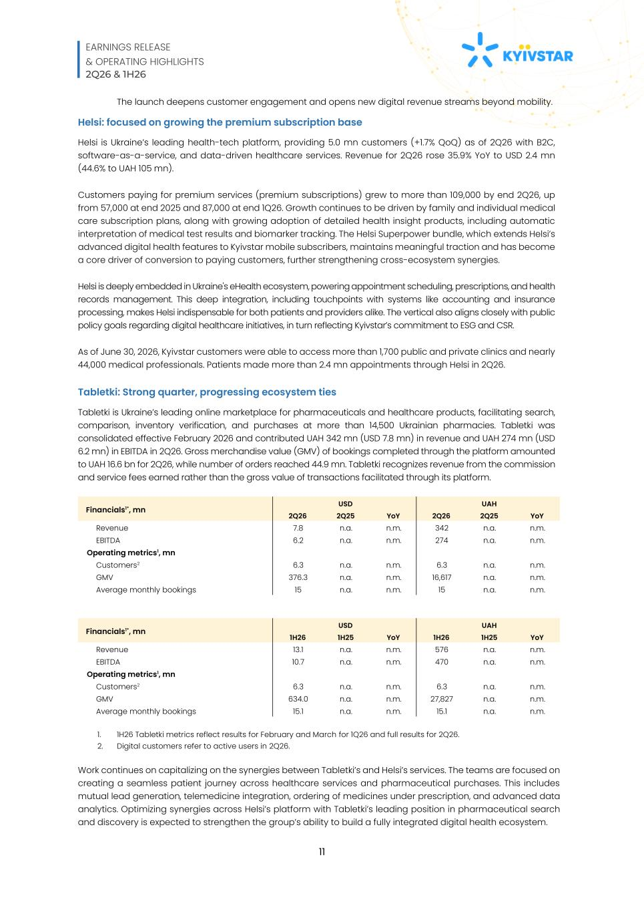
EARNINGS RELEASE & OPERATING HIGHLIGHTS 2Q26 & 1H26 11 The launch deepens customer engagement and opens new digital revenue streams beyond mobility. Helsi: focused on growing the premium subscription base Helsi is Ukraine’s leading health-tech platform, providing 5.0 mn customers (+1.7% QoQ) as of 2Q26 with B2C, software-as-a-service, and data-driven healthcare services. Revenue for 2Q26 rose 35.9% YoY to USD 2.4 mn (44.6% to UAH 105 mn). Customers paying for premium services (premium subscriptions) grew to more than 109,000 by end 2Q26, up from 57,000 at end 2025 and 87,000 at end 1Q26. Growth continues to be driven by family and individual medical care subscription plans, along with growing adoption of detailed health insight products, including automatic interpretation of medical test results and biomarker tracking. The Helsi Superpower bundle, which extends Helsi’s advanced digital health features to Kyivstar mobile subscribers, maintains meaningful traction and has become a core driver of conversion to paying customers, further strengthening cross-ecosystem synergies. Helsi is deeply embedded in Ukraine's eHealth ecosystem, powering appointment scheduling, prescriptions, and health records management. This deep integration, including touchpoints with systems like accounting and insurance processing, makes Helsi indispensable for both patients and providers alike. The vertical also aligns closely with public policy goals regarding digital healthcare initiatives, in turn reflecting Kyivstar’s commitment to ESG and CSR. As of June 30, 2026, Kyivstar customers were able to access more than 1,700 public and private clinics and nearly 44,000 medical professionals. Patients made more than 2.4 mn appointments through Helsi in 2Q26. Tabletki: Strong quarter, progressing ecosystem ties Tabletki is Ukraine’s leading online marketplace for pharmaceuticals and healthcare products, facilitating search, comparison, inventory verification, and purchases at more than 14,500 Ukrainian pharmacies. Tabletki was consolidated effective February 2026 and contributed UAH 342 mn (USD 7.8 mn) in revenue and UAH 274 mn (USD 6.2 mn) in EBITDA in 2Q26. Gross merchandise value (GMV) of bookings completed through the platform amounted to UAH 16.6 bn for 2Q26, while number of orders reached 44.9 mn. Tabletki recognizes revenue from the commission and service fees earned rather than the gross value of transactions facilitated through its platform. Financials1*, mn USD UAH 2Q26 2Q25 YoY 2Q26 2Q25 YoY Revenue 7.8 n.a. n.m. 342 n.a. n.m. EBITDA 6.2 n.a. n.m. 274 n.a. n.m. Operating metrics1, mn Customers2 6.3 n.a. n.m. 6.3 n.a. n.m. GMV 376.3 n.a. n.m. 16,617 n.a. n.m. Average monthly bookings 15 n.a. n.m. 15 n.a. n.m. Financials1*, mn USD UAH 1H26 1H25 YoY 1H26 1H25 YoY Revenue 13.1 n.a. n.m. 576 n.a. n.m. EBITDA 10.7 n.a. n.m. 470 n.a. n.m. Operating metrics1, mn Customers2 6.3 n.a. n.m. 6.3 n.a. n.m. GMV 634.0 n.a. n.m. 27,827 n.a. n.m. Average monthly bookings 15.1 n.a. n.m. 15.1 n.a. n.m. 1. 1H26 Tabletki metrics reflect results for February and March for 1Q26 and full results for 2Q26. 2. Digital customers refer to active users in 2Q26. Work continues on capitalizing on the synergies between Tabletki’s and Helsi’s services. The teams are focused on creating a seamless patient journey across healthcare services and pharmaceutical purchases. This includes mutual lead generation, telemedicine integration, ordering of medicines under prescription, and advanced data analytics. Optimizing synergies across Helsi’s platform with Tabletki’s leading position in pharmaceutical search and discovery is expected to strengthen the group’s ability to build a fully integrated digital health ecosystem.

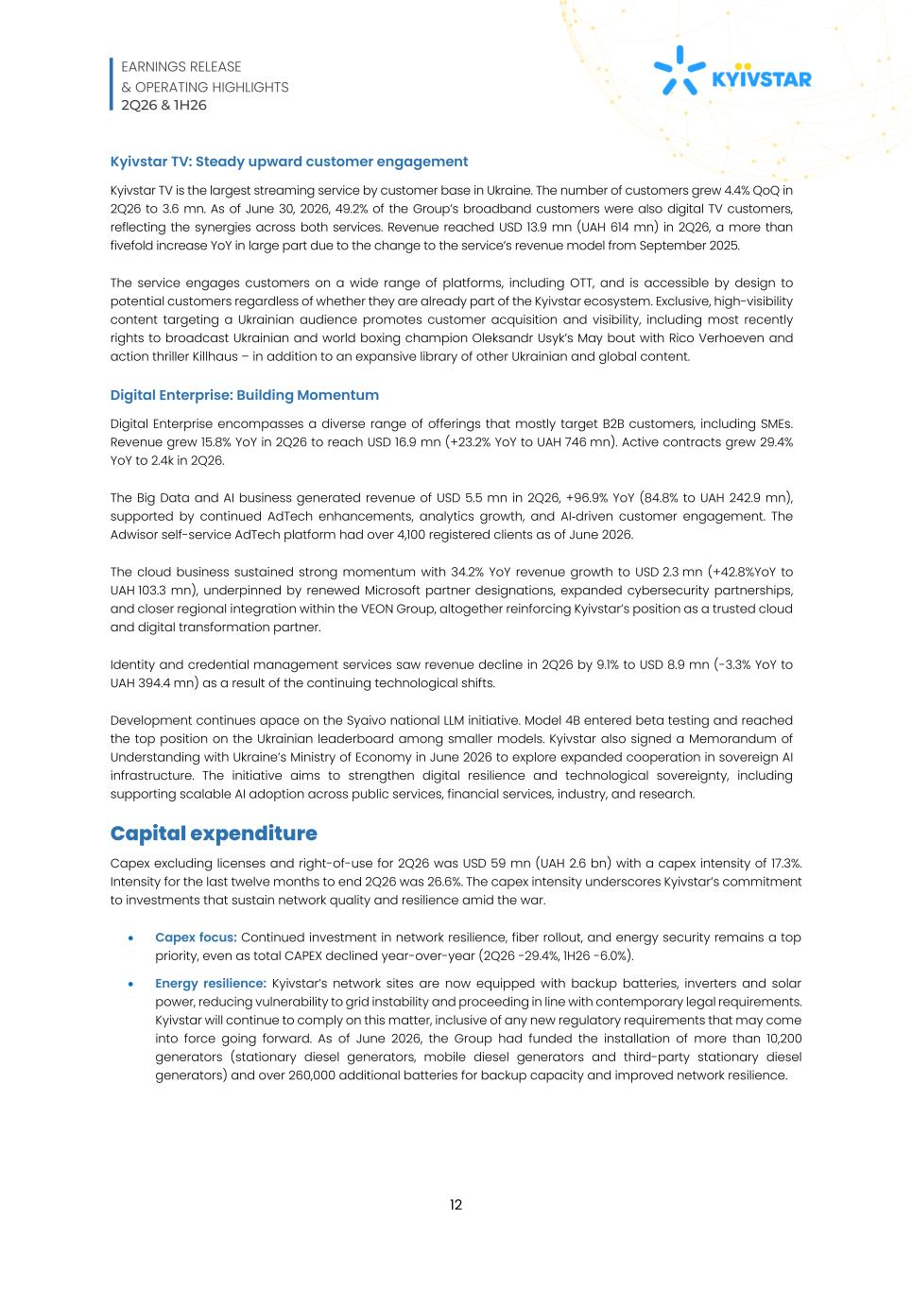
EARNINGS RELEASE & OPERATING HIGHLIGHTS 2Q26 & 1H26 12 Kyivstar TV: Steady upward customer engagement Kyivstar TV is the largest streaming service by customer base in Ukraine. The number of customers grew 4.4% QoQ in 2Q26 to 3.6 mn. As of June 30, 2026, 49.2% of the Group’s broadband customers were also digital TV customers, reflecting the synergies across both services. Revenue reached USD 13.9 mn (UAH 614 mn) in 2Q26, a more than fivefold increase YoY in large part due to the change to the service’s revenue model from September 2025. The service engages customers on a wide range of platforms, including OTT, and is accessible by design to potential customers regardless of whether they are already part of the Kyivstar ecosystem. Exclusive, high-visibility content targeting a Ukrainian audience promotes customer acquisition and visibility, including most recently rights to broadcast Ukrainian and world boxing champion Oleksandr Usyk’s May bout with Rico Verhoeven and action thriller Killhaus – in addition to an expansive library of other Ukrainian and global content. Digital Enterprise: Building Momentum Digital Enterprise encompasses a diverse range of offerings that mostly target B2B customers, including SMEs. Revenue grew 15.8% YoY in 2Q26 to reach USD 16.9 mn (+23.2% YoY to UAH 746 mn). Active contracts grew 29.4% YoY to 2.4k in 2Q26. The Big Data and AI business generated revenue of USD 5.5 mn in 2Q26, +96.9% YoY (84.8% to UAH 242.9 mn), supported by continued AdTech enhancements, analytics growth, and AI-driven customer engagement. The Adwisor self-service AdTech platform had over 4,100 registered clients as of June 2026. The cloud business sustained strong momentum with 34.2% YoY revenue growth to USD 2.3 mn (+42.8%YoY to UAH 103.3 mn), underpinned by renewed Microsoft partner designations, expanded cybersecurity partnerships, and closer regional integration within the VEON Group, altogether reinforcing Kyivstar’s position as a trusted cloud and digital transformation partner. Identity and credential management services saw revenue decline in 2Q26 by 9.1% to USD 8.9 mn (-3.3% YoY to UAH 394.4 mn) as a result of the continuing technological shifts. Development continues apace on the Syaivo national LLM initiative. Model 4B entered beta testing and reached the top position on the Ukrainian leaderboard among smaller models. Kyivstar also signed a Memorandum of Understanding with Ukraine’s Ministry of Economy in June 2026 to explore expanded cooperation in sovereign AI infrastructure. The initiative aims to strengthen digital resilience and technological sovereignty, including supporting scalable AI adoption across public services, financial services, industry, and research. Capital expenditure Capex excluding licenses and right-of-use for 2Q26 was USD 59 mn (UAH 2.6 bn) with a capex intensity of 17.3%. Intensity for the last twelve months to end 2Q26 was 26.6%. The capex intensity underscores Kyivstar’s commitment to investments that sustain network quality and resilience amid the war. • Capex focus: Continued investment in network resilience, fiber rollout, and energy security remains a top priority, even as total CAPEX declined year-over-year (2Q26 -29.4%, 1H26 -6.0%). • Energy resilience: Kyivstar’s network sites are now equipped with backup batteries, inverters and solar power, reducing vulnerability to grid instability and proceeding in line with contemporary legal requirements. Kyivstar will continue to comply on this matter, inclusive of any new regulatory requirements that may come into force going forward. As of June 2026, the Group had funded the installation of more than 10,200 generators (stationary diesel generators, mobile diesel generators and third-party stationary diesel generators) and over 260,000 additional batteries for backup capacity and improved network resilience.

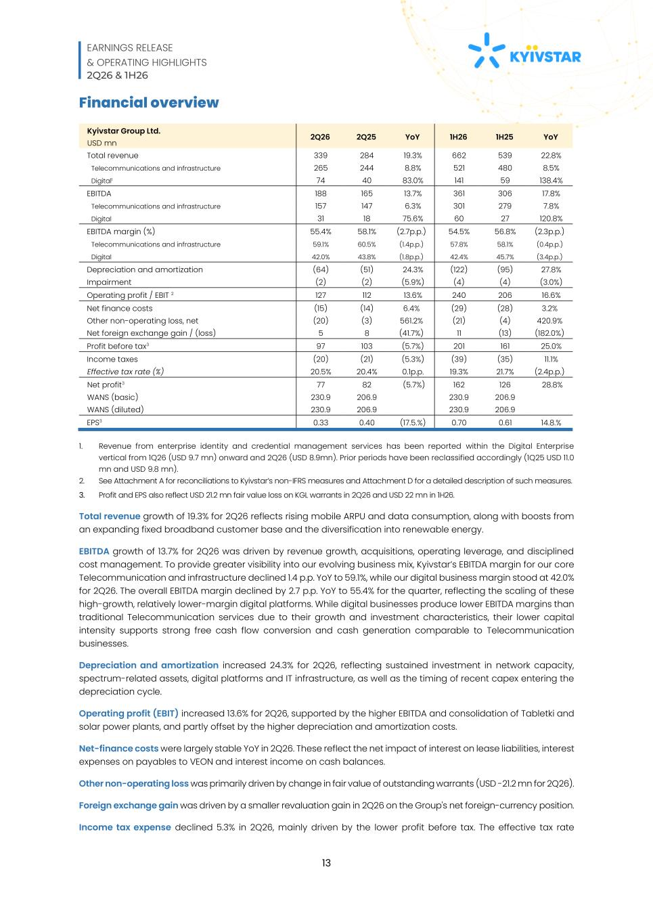
EARNINGS RELEASE & OPERATING HIGHLIGHTS 2Q26 & 1H26 13 Financial overview Kyivstar Group Ltd. USD mn 2Q26 2Q25 YoY 1H26 1H25 YoY Total revenue 339 284 19.3% 662 539 22.8% Telecommunications and infrastructure 265 244 8.8% 521 480 8.5% Digital1 74 40 83.0% 141 59 138.4% EBITDA 188 165 13.7% 361 306 17.8% Telecommunications and infrastructure 157 147 6.3% 301 279 7.8% Digital 31 18 75.6% 60 27 120.8% EBITDA margin (%) 55.4% 58.1% (2.7p.p.) 54.5% 56.8% (2.3p.p.) Telecommunications and infrastructure 59.1% 60.5% (1.4p.p.) 57.8% 58.1% (0.4p.p.) Digital 42.0% 43.8% (1.8p.p.) 42.4% 45.7% (3.4p.p.) Depreciation and amortization (64) (51) 24.3% (122) (95) 27.8% Impairment (2) (2) (5.9%) (4) (4) (3.0%) Operating profit / EBIT 2 127 112 13.6% 240 206 16.6% Net finance costs (15) (14) 6.4% (29) (28) 3.2% Other non-operating loss, net (20) (3) 561.2% (21) (4) 420.9% Net foreign exchange gain / (loss) 5 8 (41.7%) 11 (13) (182.0%) Profit before tax3 97 103 (5.7%) 201 161 25.0% Income taxes (20) (21) (5.3%) (39) (35) 11.1% Effective tax rate (%) 20.5% 20.4% 0.1p.p. 19.3% 21.7% (2.4p.p.) Net profit3 77 82 (5.7%) 162 126 28.8% WANS (basic) 230.9 206.9 230.9 206.9 WANS (diluted) 230.9 206.9 230.9 206.9 EPS3 0.33 0.40 (17.5.%) 0.70 0.61 14.8.% 1. Revenue from enterprise identity and credential management services has been reported within the Digital Enterprise vertical from 1Q26 (USD 9.7 mn) onward and 2Q26 (USD 8.9mn). Prior periods have been reclassified accordingly (1Q25 USD 11.0 mn and USD 9.8 mn). 2. See Attachment A for reconciliations to Kyivstar’s non-IFRS measures and Attachment D for a detailed description of such measures. 3. Profit and EPS also reflect USD 21.2 mn fair value loss on KGL warrants in 2Q26 and USD 22 mn in 1H26. Total revenue growth of 19.3% for 2Q26 reflects rising mobile ARPU and data consumption, along with boosts from an expanding fixed broadband customer base and the diversification into renewable energy. EBITDA growth of 13.7% for 2Q26 was driven by revenue growth, acquisitions, operating leverage, and disciplined cost management. To provide greater visibility into our evolving business mix, Kyivstar’s EBITDA margin for our core Telecommunication and infrastructure declined 1.4 p.p. YoY to 59.1%, while our digital business margin stood at 42.0% for 2Q26. The overall EBITDA margin declined by 2.7 p.p. YoY to 55.4% for the quarter, reflecting the scaling of these high-growth, relatively lower-margin digital platforms. While digital businesses produce lower EBITDA margins than traditional Telecommunication services due to their growth and investment characteristics, their lower capital intensity supports strong free cash flow conversion and cash generation comparable to Telecommunication businesses. Depreciation and amortization increased 24.3% for 2Q26, reflecting sustained investment in network capacity, spectrum-related assets, digital platforms and IT infrastructure, as well as the timing of recent capex entering the depreciation cycle. Operating profit (EBIT) increased 13.6% for 2Q26, supported by the higher EBITDA and consolidation of Tabletki and solar power plants, and partly offset by the higher depreciation and amortization costs. Net-finance costs were largely stable YoY in 2Q26. These reflect the net impact of interest on lease liabilities, interest expenses on payables to VEON and interest income on cash balances. Other non-operating loss was primarily driven by change in fair value of outstanding warrants (USD -21.2 mn for 2Q26). Foreign exchange gain was driven by a smaller revaluation gain in 2Q26 on the Group's net foreign-currency position. Income tax expense declined 5.3% in 2Q26, mainly driven by the lower profit before tax. The effective tax rate

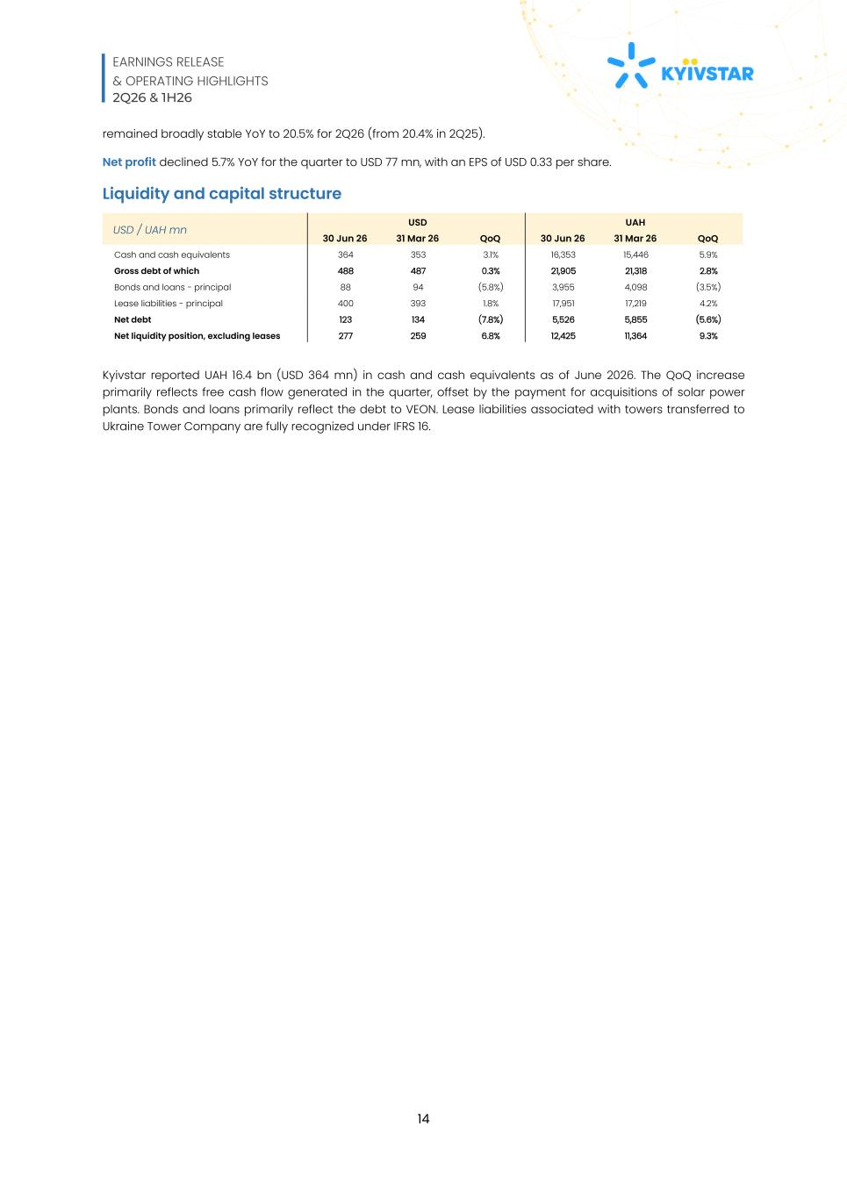
EARNINGS RELEASE & OPERATING HIGHLIGHTS 2Q26 & 1H26 14 remained broadly stable YoY to 20.5% for 2Q26 (from 20.4% in 2Q25). Net profit declined 5.7% YoY for the quarter to USD 77 mn, with an EPS of USD 0.33 per share. Liquidity and capital structure USD / UAH mn USD UAH 30 Jun 26 31 Mar 26 QoQ 30 Jun 26 31 Mar 26 QoQ Cash and cash equivalents 364 353 3.1% 16,353 15,446 5.9% Gross debt of which 488 487 0.3% 21,905 21,318 2.8% Bonds and loans - principal 88 94 (5.8%) 3,955 4,098 (3.5%) Lease liabilities - principal 400 393 1.8% 17,951 17,219 4.2% Net debt 123 134 (7.8%) 5,526 5,855 (5.6%) Net liquidity position, excluding leases 277 259 6.8% 12,425 11,364 9.3% Kyivstar reported UAH 16.4 bn (USD 364 mn) in cash and cash equivalents as of June 2026. The QoQ increase primarily reflects free cash flow generated in the quarter, offset by the payment for acquisitions of solar power plants. Bonds and loans primarily reflect the debt to VEON. Lease liabilities associated with towers transferred to Ukraine Tower Company are fully recognized under IFRS 16.

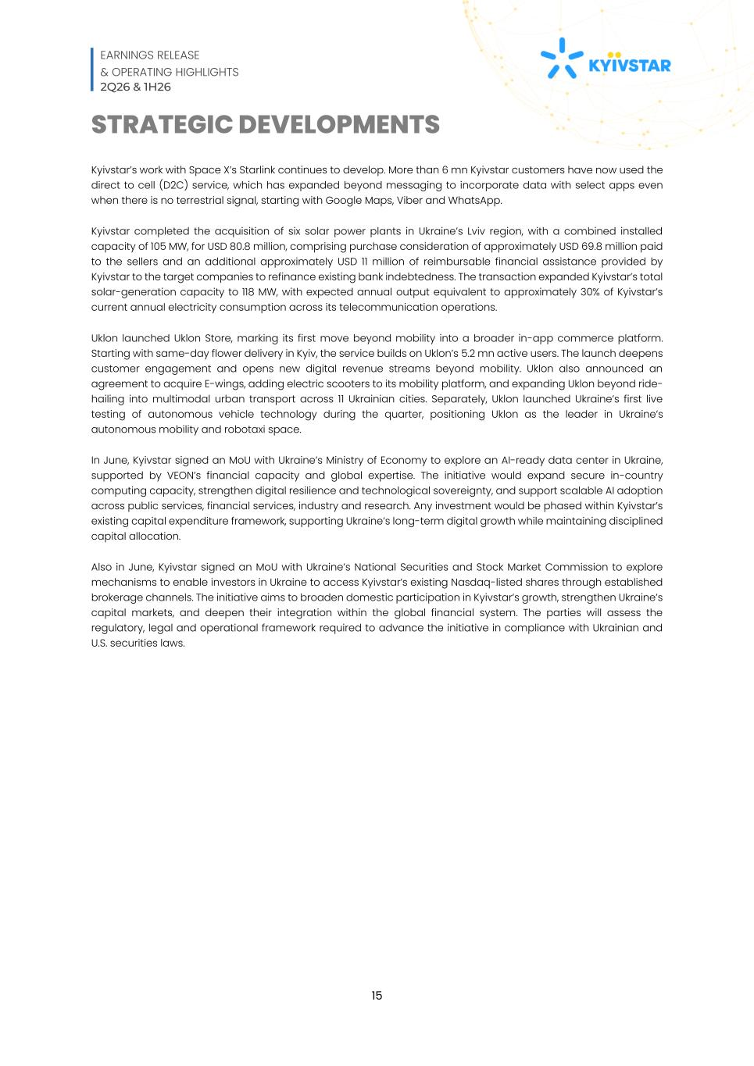
EARNINGS RELEASE & OPERATING HIGHLIGHTS 2Q26 & 1H26 15 STRATEGIC DEVELOPMENTS Kyivstar’s work with Space X’s Starlink continues to develop. More than 6 mn Kyivstar customers have now used the direct to cell (D2C) service, which has expanded beyond messaging to incorporate data with select apps even when there is no terrestrial signal, starting with Google Maps, Viber and WhatsApp. Kyivstar completed the acquisition of six solar power plants in Ukraine’s Lviv region, with a combined installed capacity of 105 MW, for USD 80.8 million, comprising purchase consideration of approximately USD 69.8 million paid to the sellers and an additional approximately USD 11 million of reimbursable financial assistance provided by Kyivstar to the target companies to refinance existing bank indebtedness. The transaction expanded Kyivstar’s total solar-generation capacity to 118 MW, with expected annual output equivalent to approximately 30% of Kyivstar’s current annual electricity consumption across its telecommunication operations. Uklon launched Uklon Store, marking its first move beyond mobility into a broader in-app commerce platform. Starting with same-day flower delivery in Kyiv, the service builds on Uklon’s 5.2 mn active users. The launch deepens customer engagement and opens new digital revenue streams beyond mobility. Uklon also announced an agreement to acquire E-wings, adding electric scooters to its mobility platform, and expanding Uklon beyond ride- hailing into multimodal urban transport across 11 Ukrainian cities. Separately, Uklon launched Ukraine’s first live testing of autonomous vehicle technology during the quarter, positioning Uklon as the leader in Ukraine’s autonomous mobility and robotaxi space. In June, Kyivstar signed an MoU with Ukraine’s Ministry of Economy to explore an AI-ready data center in Ukraine, supported by VEON’s financial capacity and global expertise. The initiative would expand secure in-country computing capacity, strengthen digital resilience and technological sovereignty, and support scalable AI adoption across public services, financial services, industry and research. Any investment would be phased within Kyivstar’s existing capital expenditure framework, supporting Ukraine’s long-term digital growth while maintaining disciplined capital allocation. Also in June, Kyivstar signed an MoU with Ukraine’s National Securities and Stock Market Commission to explore mechanisms to enable investors in Ukraine to access Kyivstar’s existing Nasdaq-listed shares through established brokerage channels. The initiative aims to broaden domestic participation in Kyivstar’s growth, strengthen Ukraine’s capital markets, and deepen their integration within the global financial system. The parties will assess the regulatory, legal and operational framework required to advance the initiative in compliance with Ukrainian and U.S. securities laws.

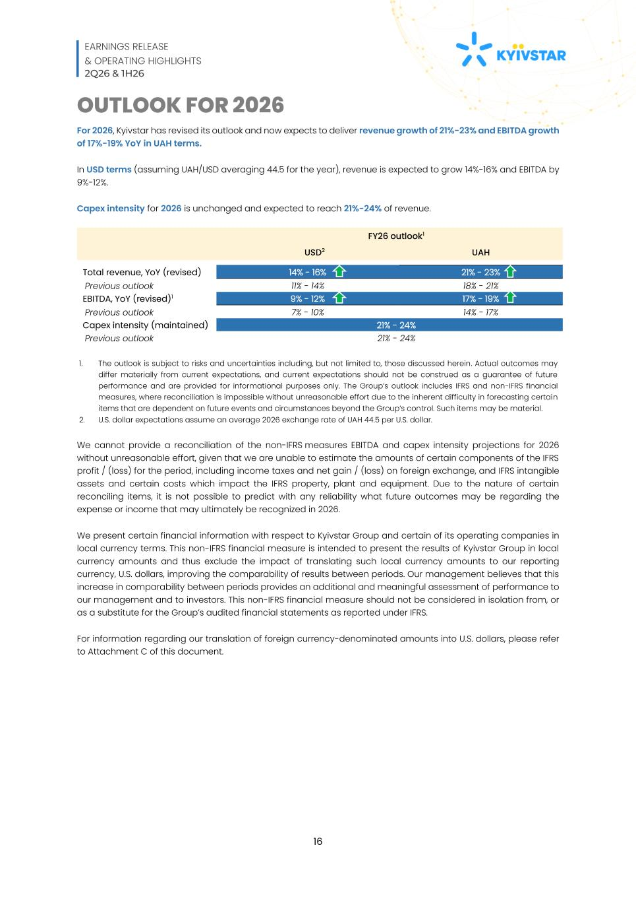
EARNINGS RELEASE & OPERATING HIGHLIGHTS 2Q26 & 1H26 16 OUTLOOK FOR 2026 For 2026, Kyivstar has revised its outlook and now expects to deliver revenue growth of 21%-23% and EBITDA growth of 17%-19% YoY in UAH terms. In USD terms (assuming UAH/USD averaging 44.5 for the year), revenue is expected to grow 14%-16% and EBITDA by 9%-12%. Capex intensity for 2026 is unchanged and expected to reach 21%-24% of revenue. FY26 outlook1 USD2 UAH Total revenue, YoY (revised) 14% - 16% 21% - 23% Previous outlook 11% - 14% 18% - 21% EBITDA, YoY (revised)1 9% - 12% 17% - 19% Previous outlook 7% - 10% 14% - 17% Capex intensity (maintained) 21% - 24% Previous outlook 21% - 24% 1. The outlook is subject to risks and uncertainties including, but not limited to, those discussed herein. Actual outcomes may differ materially from current expectations, and current expectations should not be construed as a guarantee of future performance and are provided for informational purposes only. The Group’s outlook includes IFRS and non-IFRS financial measures, where reconciliation is impossible without unreasonable effort due to the inherent difficulty in forecasting certain items that are dependent on future events and circumstances beyond the Group’s control. Such items may be material. 2. U.S. dollar expectations assume an average 2026 exchange rate of UAH 44.5 per U.S. dollar. We cannot provide a reconciliation of the non-IFRS measures EBITDA and capex intensity projections for 2026 without unreasonable effort, given that we are unable to estimate the amounts of certain components of the IFRS profit / (loss) for the period, including income taxes and net gain / (loss) on foreign exchange, and IFRS intangible assets and certain costs which impact the IFRS property, plant and equipment. Due to the nature of certain reconciling items, it is not possible to predict with any reliability what future outcomes may be regarding the expense or income that may ultimately be recognized in 2026. We present certain financial information with respect to Kyivstar Group and certain of its operating companies in local currency terms. This non-IFRS financial measure is intended to present the results of Kyivstar Group in local currency amounts and thus exclude the impact of translating such local currency amounts to our reporting currency, U.S. dollars, improving the comparability of results between periods. Our management believes that this increase in comparability between periods provides an additional and meaningful assessment of performance to our management and to investors. This non-IFRS financial measure should not be considered in isolation from, or as a substitute for the Group’s audited financial statements as reported under IFRS. For information regarding our translation of foreign currency-denominated amounts into U.S. dollars, please refer to Attachment C of this document.

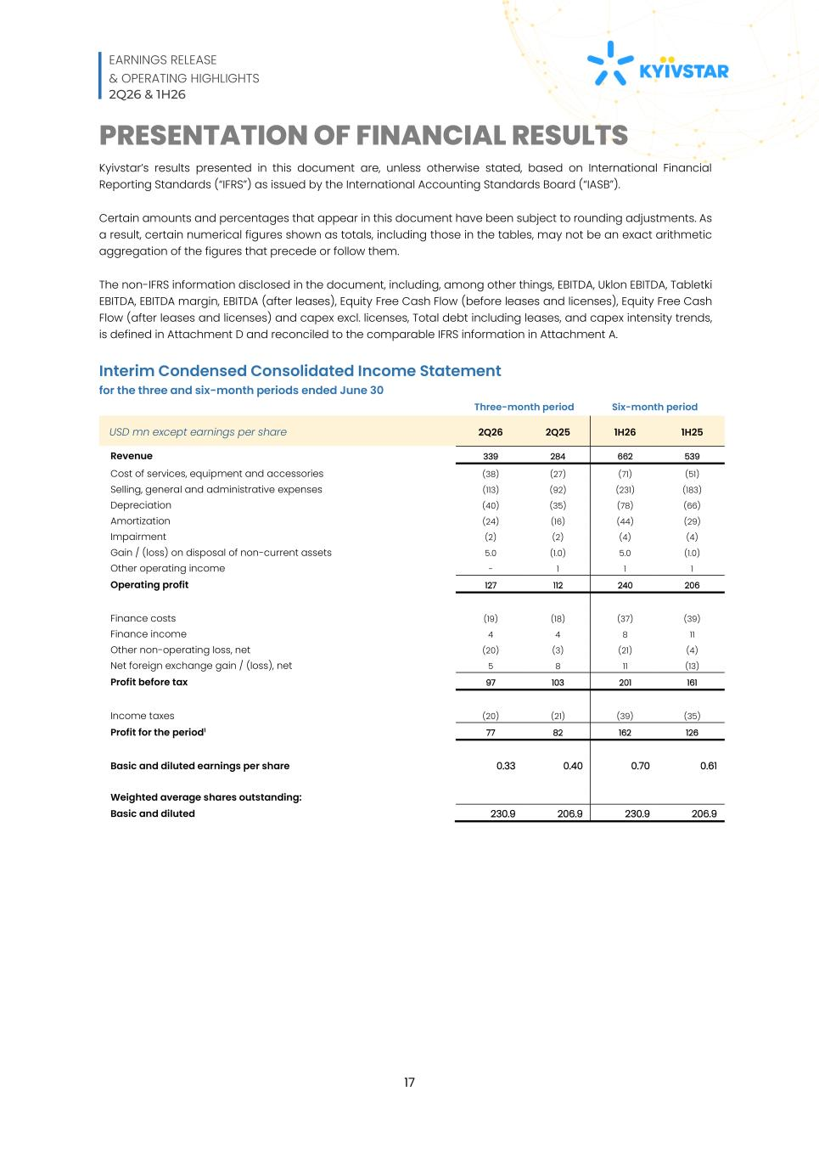
EARNINGS RELEASE & OPERATING HIGHLIGHTS 2Q26 & 1H26 17 PRESENTATION OF FINANCIAL RESULTS Kyivstar’s results presented in this document are, unless otherwise stated, based on International Financial Reporting Standards (“IFRS”) as issued by the International Accounting Standards Board (“IASB”). Certain amounts and percentages that appear in this document have been subject to rounding adjustments. As a result, certain numerical figures shown as totals, including those in the tables, may not be an exact arithmetic aggregation of the figures that precede or follow them. The non-IFRS information disclosed in the document, including, among other things, EBITDA, Uklon EBITDA, Tabletki EBITDA, EBITDA margin, EBITDA (after leases), Equity Free Cash Flow (before leases and licenses), Equity Free Cash Flow (after leases and licenses) and capex excl. licenses, Total debt including leases, and capex intensity trends, is defined in Attachment D and reconciled to the comparable IFRS information in Attachment A. Interim Condensed Consolidated Income Statement for the three and six-month periods ended June 30 Three-month period Six-month period USD mn except earnings per share 2Q26 2Q25 1H26 1H25 Revenue 339 284 662 539 Cost of services, equipment and accessories (38) (27) (71) (51) Selling, general and administrative expenses (113) (92) (231) (183) Depreciation (40) (35) (78) (66) Amortization (24) (16) (44) (29) Impairment (2) (2) (4) (4) Gain / (loss) on disposal of non-current assets 5.0 (1.0) 5.0 (1.0) Other operating income - 1 1 1 Operating profit 127 112 240 206 Finance costs (19) (18) (37) (39) Finance income 4 4 8 11 Other non-operating loss, net (20) (3) (21) (4) Net foreign exchange gain / (loss), net 5 8 11 (13) Profit before tax 97 103 201 161 Income taxes (20) (21) (39) (35) Profit for the period1 77 82 162 126 Basic and diluted earnings per share 0.33 0.40 0.70 0.61 Weighted average shares outstanding: Basic and diluted 230.9 206.9 230.9 206.9

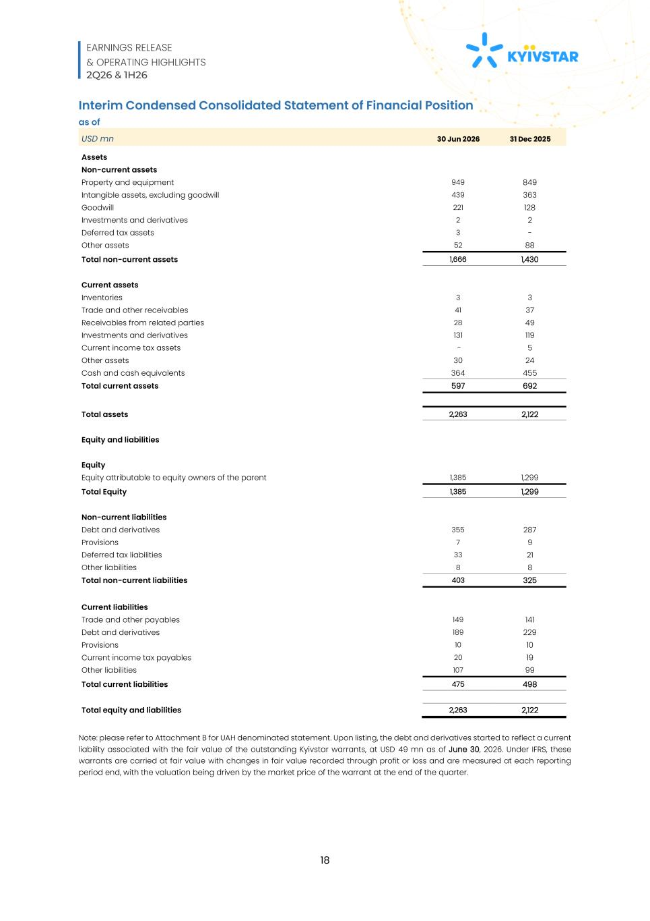
EARNINGS RELEASE & OPERATING HIGHLIGHTS 2Q26 & 1H26 18 Interim Condensed Consolidated Statement of Financial Position as of USD mn 30 Jun 2026 31 Dec 2025 Assets Non-current assets Property and equipment 949 849 Intangible assets, excluding goodwill 439 363 Goodwill 221 128 Investments and derivatives 2 2 Deferred tax assets 3 - Other assets 52 88 Total non-current assets 1,666 1,430 Current assets Inventories 3 3 Trade and other receivables 41 37 Receivables from related parties 28 49 Investments and derivatives 131 119 Current income tax assets - 5 Other assets 30 24 Cash and cash equivalents 364 455 Total current assets 597 692 Total assets 2,263 2,122 Equity and liabilities Equity Equity attributable to equity owners of the parent 1,385 1,299 Total Equity 1,385 1,299 Non-current liabilities Debt and derivatives 355 287 Provisions 7 9 Deferred tax liabilities 33 21 Other liabilities 8 8 Total non-current liabilities 403 325 Current liabilities Trade and other payables 149 141 Debt and derivatives 189 229 Provisions 10 10 Current income tax payables 20 19 Other liabilities 107 99 Total current liabilities 475 498 Total equity and liabilities 2,263 2,122 Note: please refer to Attachment B for UAH denominated statement. Upon listing, the debt and derivatives started to reflect a current liability associated with the fair value of the outstanding Kyivstar warrants, at USD 49 mn as of June 30, 2026. Under IFRS, these warrants are carried at fair value with changes in fair value recorded through profit or loss and are measured at each reporting period end, with the valuation being driven by the market price of the warrant at the end of the quarter.

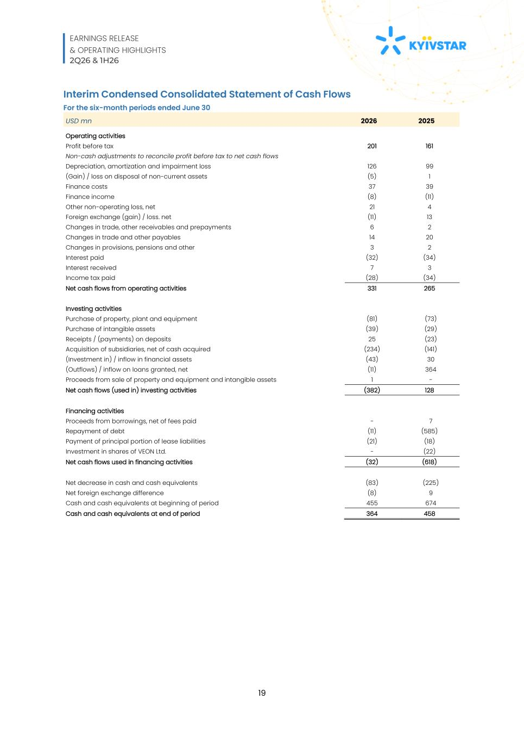
EARNINGS RELEASE & OPERATING HIGHLIGHTS 2Q26 & 1H26 19 Interim Condensed Consolidated Statement of Cash Flows For the six-month periods ended June 30 USD mn 2026 2025 Operating activities Profit before tax 201 161 Non-cash adjustments to reconcile profit before tax to net cash flows Depreciation, amortization and impairment loss 126 99 (Gain) / loss on disposal of non-current assets (5) 1 Finance costs 37 39 Finance income (8) (11) Other non-operating loss, net 21 4 Foreign exchange (gain) / loss. net (11) 13 Changes in trade, other receivables and prepayments 6 2 Changes in trade and other payables 14 20 Changes in provisions, pensions and other 3 2 Interest paid (32) (34) Interest received 7 3 Income tax paid (28) (34) Net cash flows from operating activities 331 265 Investing activities Purchase of property, plant and equipment (81) (73) Purchase of intangible assets (39) (29) Receipts / (payments) on deposits 25 (23) Acquisition of subsidiaries, net of cash acquired (234) (141) (Investment in) / inflow in financial assets (43) 30 (Outflows) / inflow on loans granted, net (11) 364 Proceeds from sale of property and equipment and intangible assets 1 - Net cash flows (used in) investing activities (382) 128 Financing activities Proceeds from borrowings, net of fees paid - 7 Repayment of debt (11) (585) Payment of principal portion of lease liabilities (21) (18) Investment in shares of VEON Ltd. - (22) Net cash flows used in financing activities (32) (618) Net decrease in cash and cash equivalents (83) (225) Net foreign exchange difference (8) 9 Cash and cash equivalents at beginning of period 455 674 Cash and cash equivalents at end of period 364 458

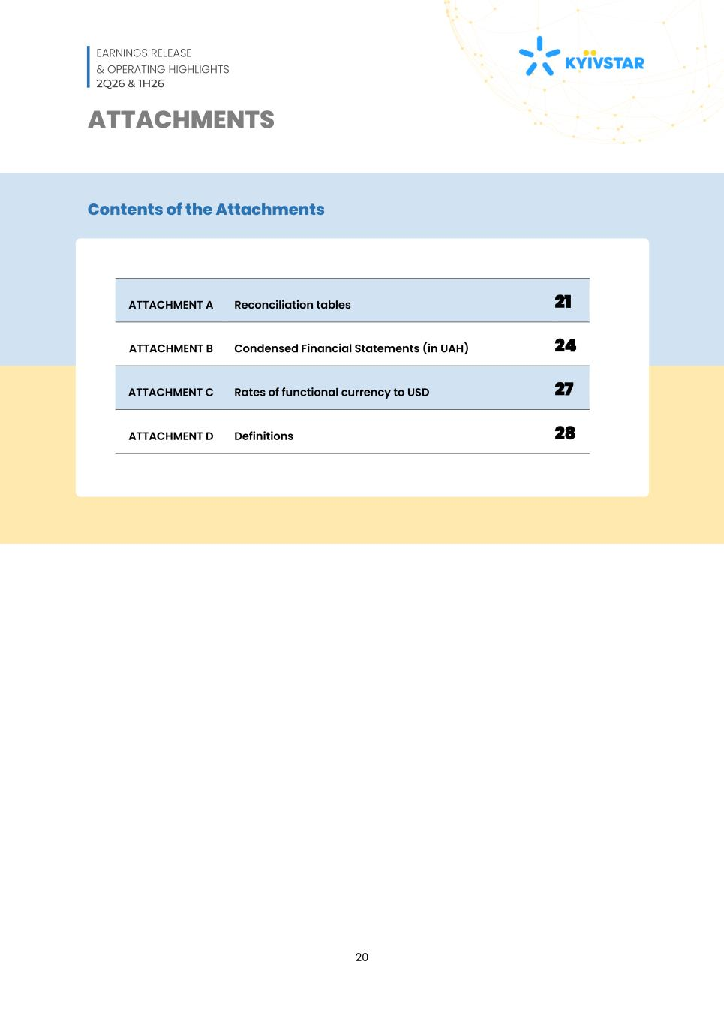
EARNINGS RELEASE & OPERATING HIGHLIGHTS 2Q26 & 1H26 20 ATTACHMENTS Contents of the Attachments ATTACHMENT A Reconciliation tables 21 ATTACHMENT B Condensed Financial Statements (in UAH) 24 ATTACHMENT C Rates of functional currency to USD 27 ATTACHMENT D Definitions 28

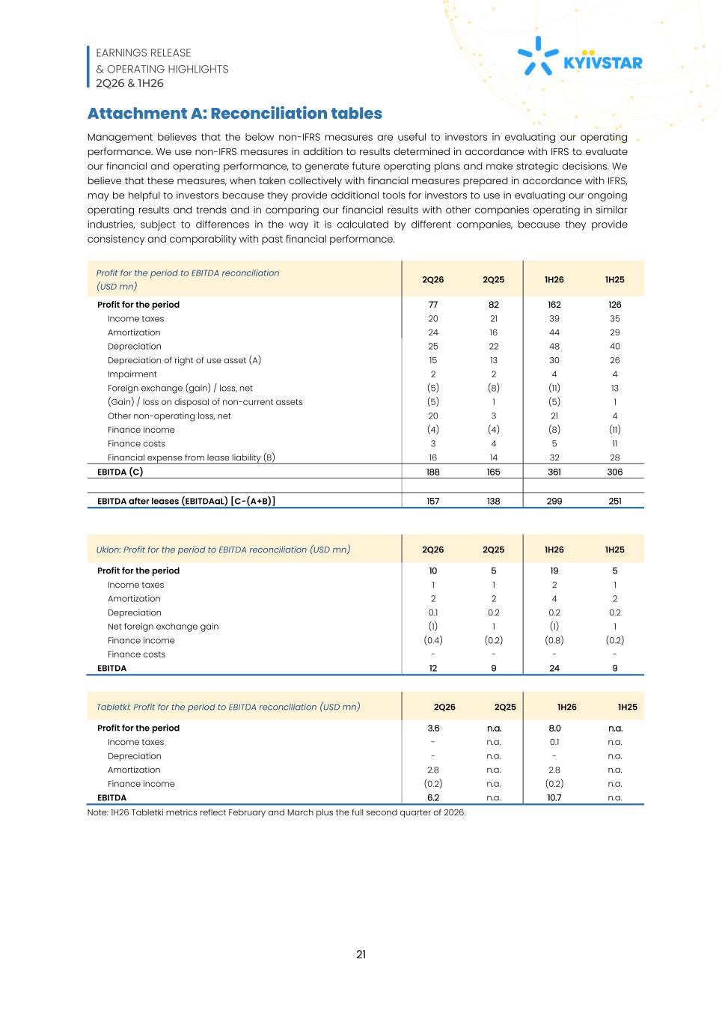
EARNINGS RELEASE & OPERATING HIGHLIGHTS 2Q26 & 1H26 21 Attachment A: Reconciliation tables Management believes that the below non-IFRS measures are useful to investors in evaluating our operating performance. We use non-IFRS measures in addition to results determined in accordance with IFRS to evaluate our financial and operating performance, to generate future operating plans and make strategic decisions. We believe that these measures, when taken collectively with financial measures prepared in accordance with IFRS, may be helpful to investors because they provide additional tools for investors to use in evaluating our ongoing operating results and trends and in comparing our financial results with other companies operating in similar industries, subject to differences in the way it is calculated by different companies, because they provide consistency and comparability with past financial performance. Profit for the period to EBITDA reconciliation (USD mn) 2Q26 2Q25 1H26 1H25 Profit for the period 77 82 162 126 Income taxes 20 21 39 35 Amortization 24 16 44 29 Depreciation 25 22 48 40 Depreciation of right of use asset (A) 15 13 30 26 Impairment 2 2 4 4 Foreign exchange (gain) / loss, net (5) (8) (11) 13 (Gain) / loss on disposal of non-current assets (5) 1 (5) 1 Other non-operating loss, net 20 3 21 4 Finance income (4) (4) (8) (11) Finance costs 3 4 5 11 Financial expense from lease liability (B) 16 14 32 28 EBITDA (C) 188 165 361 306 EBITDA after leases (EBITDAaL) [C-(A+B)] 157 138 299 251 Uklon: Profit for the period to EBITDA reconciliation (USD mn) 2Q26 2Q25 1H26 1H25 Profit for the period 10 5 19 5 Income taxes 1 1 2 1 Amortization 2 2 4 2 Depreciation 0.1 0.2 0.2 0.2 Net foreign exchange gain (1) 1 (1) 1 Finance income (0.4) (0.2) (0.8) (0.2) Finance costs - - - - EBITDA 12 9 24 9 Tabletki: Profit for the period to EBITDA reconciliation (USD mn) 2Q26 2Q25 1H26 1H25 Profit for the period 3.6 n.a. 8.0 n.a. Income taxes - n.a. 0.1 n.a. Depreciation - n.a. - n.a. Amortization 2.8 n.a. 2.8 n.a. Finance income (0.2) n.a. (0.2) n.a. EBITDA 6.2 n.a. 10.7 n.a. Note: 1H26 Tabletki metrics reflect February and March plus the full second quarter of 2026.

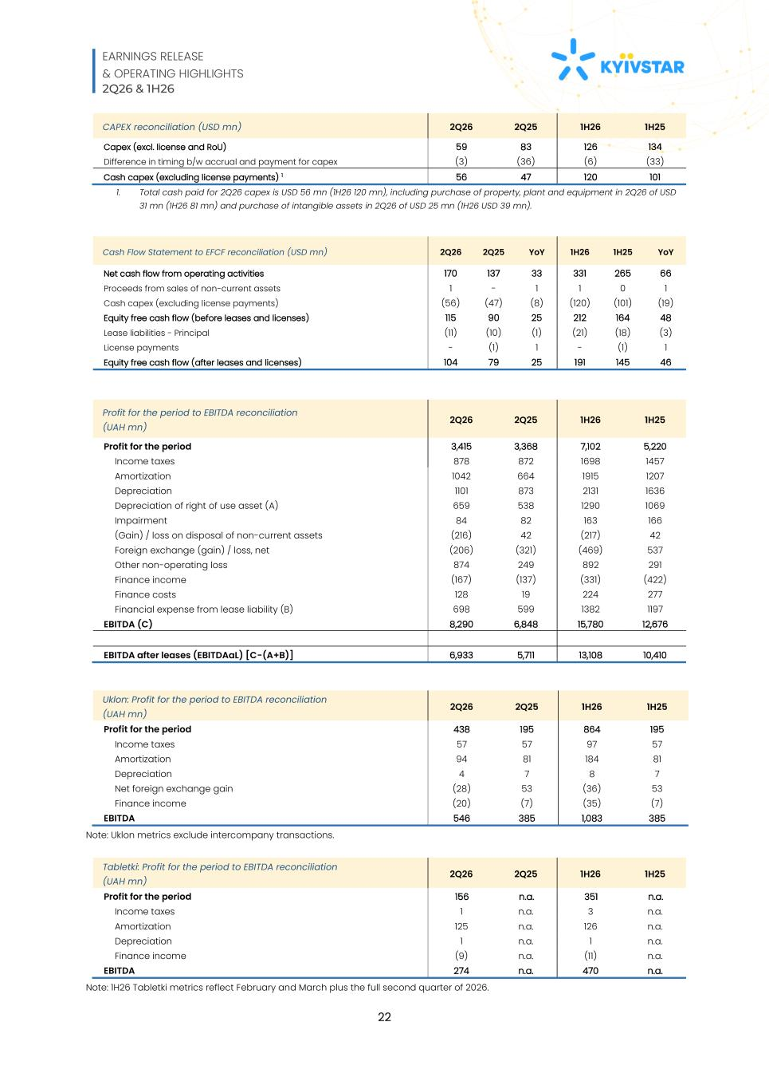
EARNINGS RELEASE & OPERATING HIGHLIGHTS 2Q26 & 1H26 22 CAPEX reconciliation (USD mn) 2Q26 2Q25 1H26 1H25 Capex (excl. license and RoU) 59 83 126 134 Difference in timing b/w accrual and payment for capex (3) (36) (6) (33) Cash capex (excluding license payments) 1 56 47 120 101 1. Total cash paid for 2Q26 capex is USD 56 mn (1H26 120 mn), including purchase of property, plant and equipment in 2Q26 of USD 31 mn (1H26 81 mn) and purchase of intangible assets in 2Q26 of USD 25 mn (1H26 USD 39 mn). Cash Flow Statement to EFCF reconciliation (USD mn) 2Q26 2Q25 YoY 1H26 1H25 YoY Net cash flow from operating activities 170 137 33 331 265 66 Proceeds from sales of non-current assets 1 - 1 1 0 1 Cash capex (excluding license payments) (56) (47) (8) (120) (101) (19) Equity free cash flow (before leases and licenses) 115 90 25 212 164 48 Lease liabilities - Principal (11) (10) (1) (21) (18) (3) License payments - (1) 1 - (1) 1 Equity free cash flow (after leases and licenses) 104 79 25 191 145 46 Profit for the period to EBITDA reconciliation (UAH mn) 2Q26 2Q25 1H26 1H25 Profit for the period 3,415 3,368 7,102 5,220 Income taxes 878 872 1698 1457 Amortization 1042 664 1915 1207 Depreciation 1101 873 2131 1636 Depreciation of right of use asset (A) 659 538 1290 1069 Impairment 84 82 163 166 (Gain) / loss on disposal of non-current assets (216) 42 (217) 42 Foreign exchange (gain) / loss, net (206) (321) (469) 537 Other non-operating loss 874 249 892 291 Finance income (167) (137) (331) (422) Finance costs 128 19 224 277 Financial expense from lease liability (B) 698 599 1382 1197 EBITDA (C) 8,290 6,848 15,780 12,676 EBITDA after leases (EBITDAaL) [C-(A+B)] 6,933 5,711 13,108 10,410 Uklon: Profit for the period to EBITDA reconciliation (UAH mn) 2Q26 2Q25 1H26 1H25 Profit for the period 438 195 864 195 Income taxes 57 57 97 57 Amortization 94 81 184 81 Depreciation 4 7 8 7 Net foreign exchange gain (28) 53 (36) 53 Finance income (20) (7) (35) (7) EBITDA 546 385 1,083 385 Note: Uklon metrics exclude intercompany transactions. Tabletki: Profit for the period to EBITDA reconciliation (UAH mn) 2Q26 2Q25 1H26 1H25 Profit for the period 156 n.a. 351 n.a. Income taxes 1 n.a. 3 n.a. Amortization 125 n.a. 126 n.a. Depreciation 1 n.a. 1 n.a. Finance income (9) n.a. (11) n.a. EBITDA 274 n.a. 470 n.a. Note: 1H26 Tabletki metrics reflect February and March plus the full second quarter of 2026.

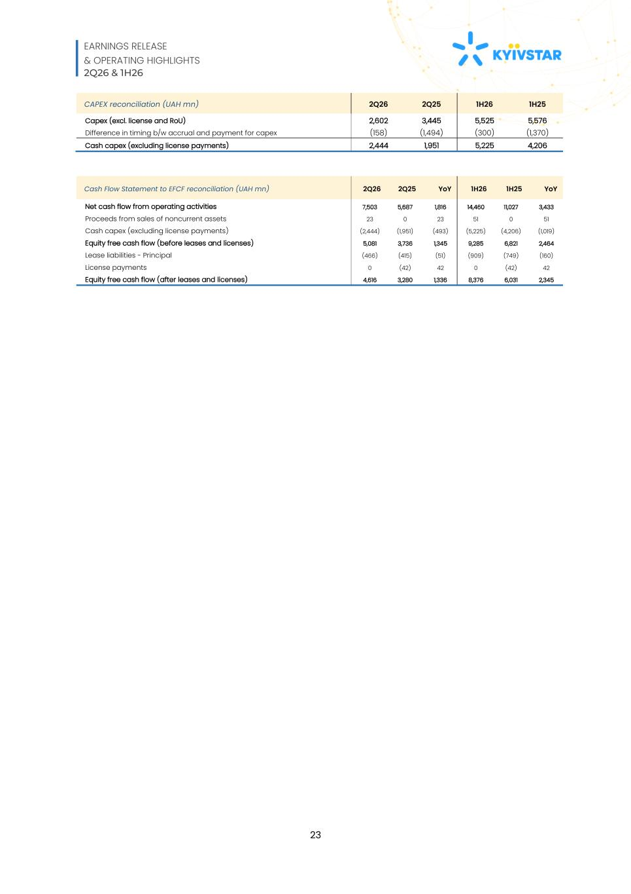
EARNINGS RELEASE & OPERATING HIGHLIGHTS 2Q26 & 1H26 23 CAPEX reconciliation (UAH mn) 2Q26 2Q25 1H26 1H25 Capex (excl. license and RoU) 2,602 3,445 5,525 5,576 Difference in timing b/w accrual and payment for capex (158) (1,494) (300) (1,370) Cash capex (excluding license payments) 2,444 1,951 5,225 4,206 Cash Flow Statement to EFCF reconciliation (UAH mn) 2Q26 2Q25 YoY 1H26 1H25 YoY Net cash flow from operating activities 7,503 5,687 1,816 14,460 11,027 3,433 Proceeds from sales of noncurrent assets 23 0 23 51 0 51 Cash capex (excluding license payments) (2,444) (1,951) (493) (5,225) (4,206) (1,019) Equity free cash flow (before leases and licenses) 5,081 3,736 1,345 9,285 6,821 2,464 Lease liabilities - Principal (466) (415) (51) (909) (749) (160) License payments 0 (42) 42 0 (42) 42 Equity free cash flow (after leases and licenses) 4,616 3,280 1,336 8,376 6,031 2,345

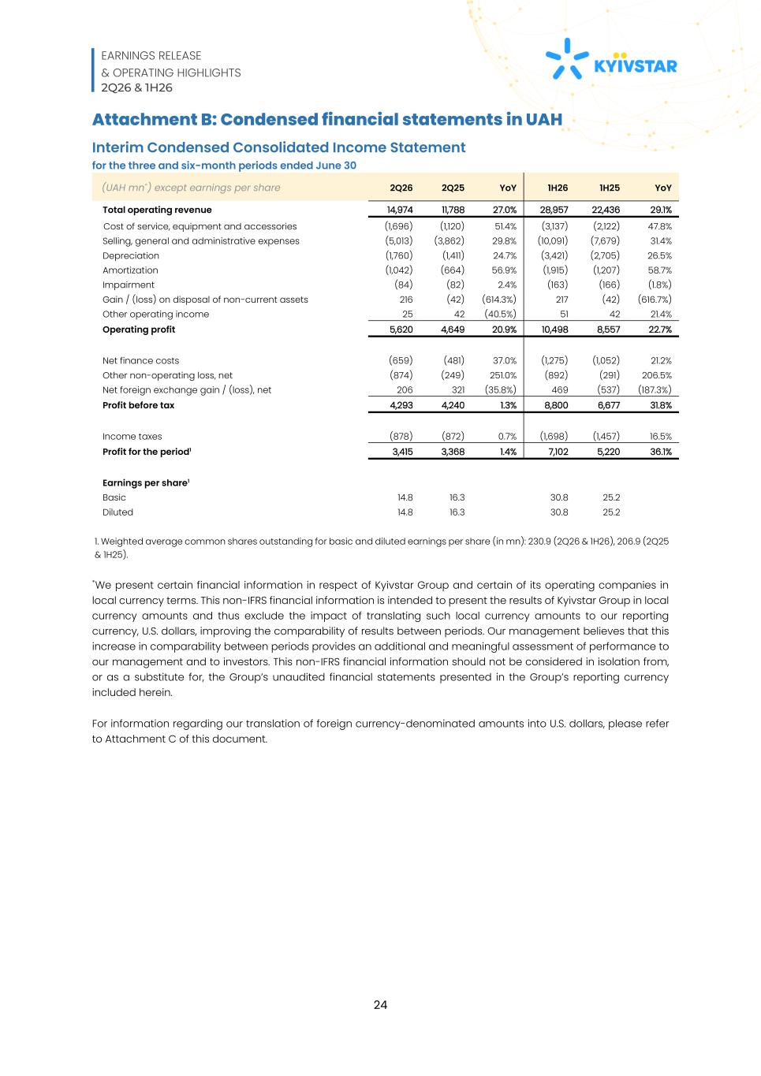
EARNINGS RELEASE & OPERATING HIGHLIGHTS 2Q26 & 1H26 24 Attachment B: Condensed financial statements in UAH Interim Condensed Consolidated Income Statement for the three and six-month periods ended June 30 (UAH mn*) except earnings per share 2Q26 2Q25 YoY 1H26 1H25 YoY Total operating revenue 14,974 11,788 27.0% 28,957 22,436 29.1% Cost of service, equipment and accessories (1,696) (1,120) 51.4% (3,137) (2,122) 47.8% Selling, general and administrative expenses (5,013) (3,862) 29.8% (10,091) (7,679) 31.4% Depreciation (1,760) (1,411) 24.7% (3,421) (2,705) 26.5% Amortization (1,042) (664) 56.9% (1,915) (1,207) 58.7% Impairment (84) (82) 2.4% (163) (166) (1.8%) Gain / (loss) on disposal of non-current assets 216 (42) (614.3%) 217 (42) (616.7%) Other operating income 25 42 (40.5%) 51 42 21.4% Operating profit 5,620 4,649 20.9% 10,498 8,557 22.7% Net finance costs (659) (481) 37.0% (1,275) (1,052) 21.2% Other non-operating loss, net (874) (249) 251.0% (892) (291) 206.5% Net foreign exchange gain / (loss), net 206 321 (35.8%) 469 (537) (187.3%) Profit before tax 4,293 4,240 1.3% 8,800 6,677 31.8% Income taxes (878) (872) 0.7% (1,698) (1,457) 16.5% Profit for the period1 3,415 3,368 1.4% 7,102 5,220 36.1% Earnings per share1 Basic 14.8 16.3 30.8 25.2 Diluted 14.8 16.3 30.8 25.2 1. Weighted average common shares outstanding for basic and diluted earnings per share (in mn): 230.9 (2Q26 & 1H26), 206.9 (2Q25 & 1H25). *We present certain financial information in respect of Kyivstar Group and certain of its operating companies in local currency terms. This non-IFRS financial information is intended to present the results of Kyivstar Group in local currency amounts and thus exclude the impact of translating such local currency amounts to our reporting currency, U.S. dollars, improving the comparability of results between periods. Our management believes that this increase in comparability between periods provides an additional and meaningful assessment of performance to our management and to investors. This non-IFRS financial information should not be considered in isolation from, or as a substitute for, the Group’s unaudited financial statements presented in the Group’s reporting currency included herein. For information regarding our translation of foreign currency-denominated amounts into U.S. dollars, please refer to Attachment C of this document.

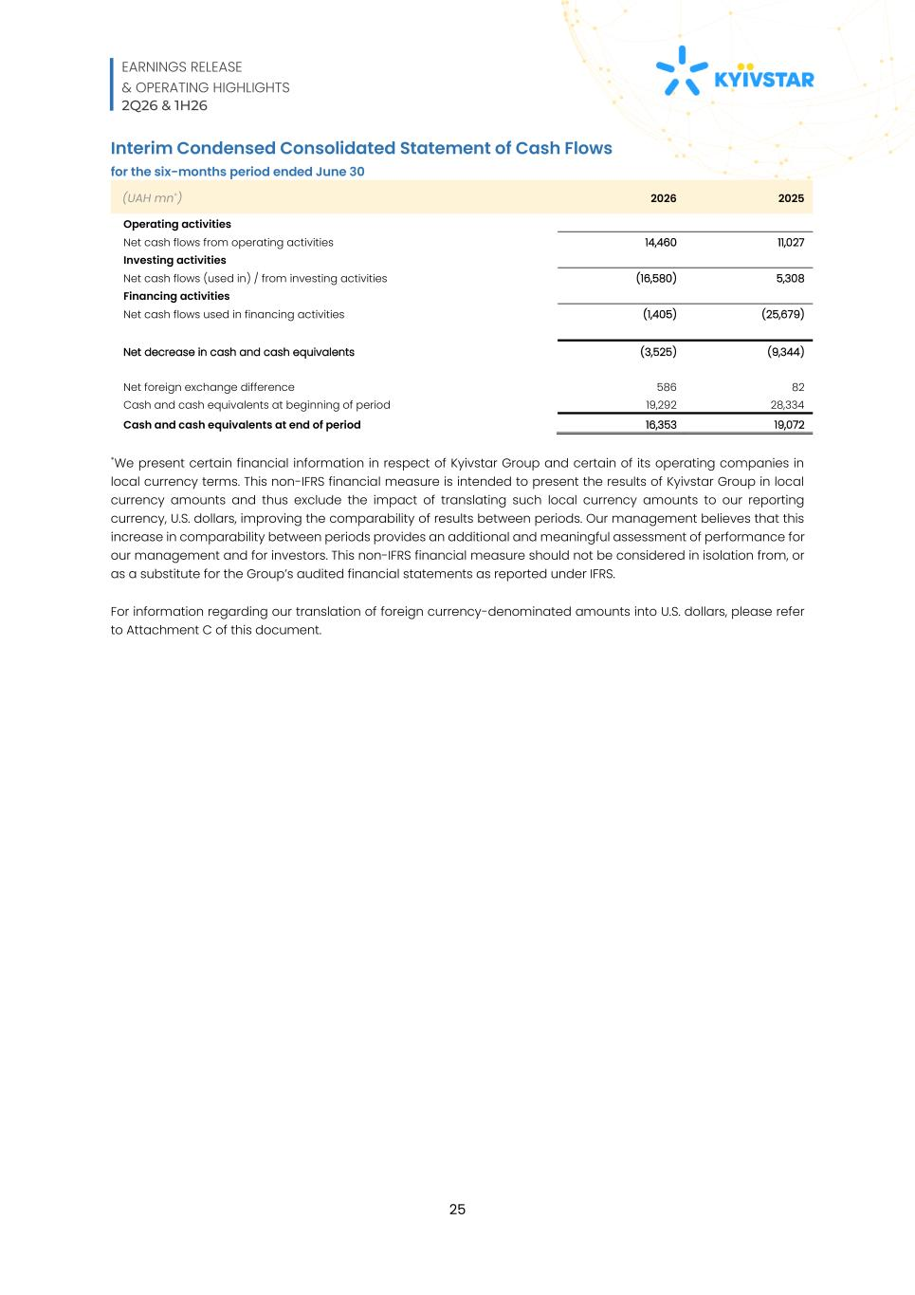
EARNINGS RELEASE & OPERATING HIGHLIGHTS 2Q26 & 1H26 25 Interim Condensed Consolidated Statement of Cash Flows for the six-months period ended June 30 (UAH mn*) 2026 2025 Operating activities Net cash flows from operating activities 14,460 11,027 Investing activities Net cash flows (used in) / from investing activities (16,580) 5,308 Financing activities Net cash flows used in financing activities (1,405) (25,679) Net decrease in cash and cash equivalents (3,525) (9,344) Net foreign exchange difference 586 82 Cash and cash equivalents at beginning of period 19,292 28,334 Cash and cash equivalents at end of period 16,353 19,072 *We present certain financial information in respect of Kyivstar Group and certain of its operating companies in local currency terms. This non-IFRS financial measure is intended to present the results of Kyivstar Group in local currency amounts and thus exclude the impact of translating such local currency amounts to our reporting currency, U.S. dollars, improving the comparability of results between periods. Our management believes that this increase in comparability between periods provides an additional and meaningful assessment of performance for our management and for investors. This non-IFRS financial measure should not be considered in isolation from, or as a substitute for the Group’s audited financial statements as reported under IFRS. For information regarding our translation of foreign currency-denominated amounts into U.S. dollars, please refer to Attachment C of this document.

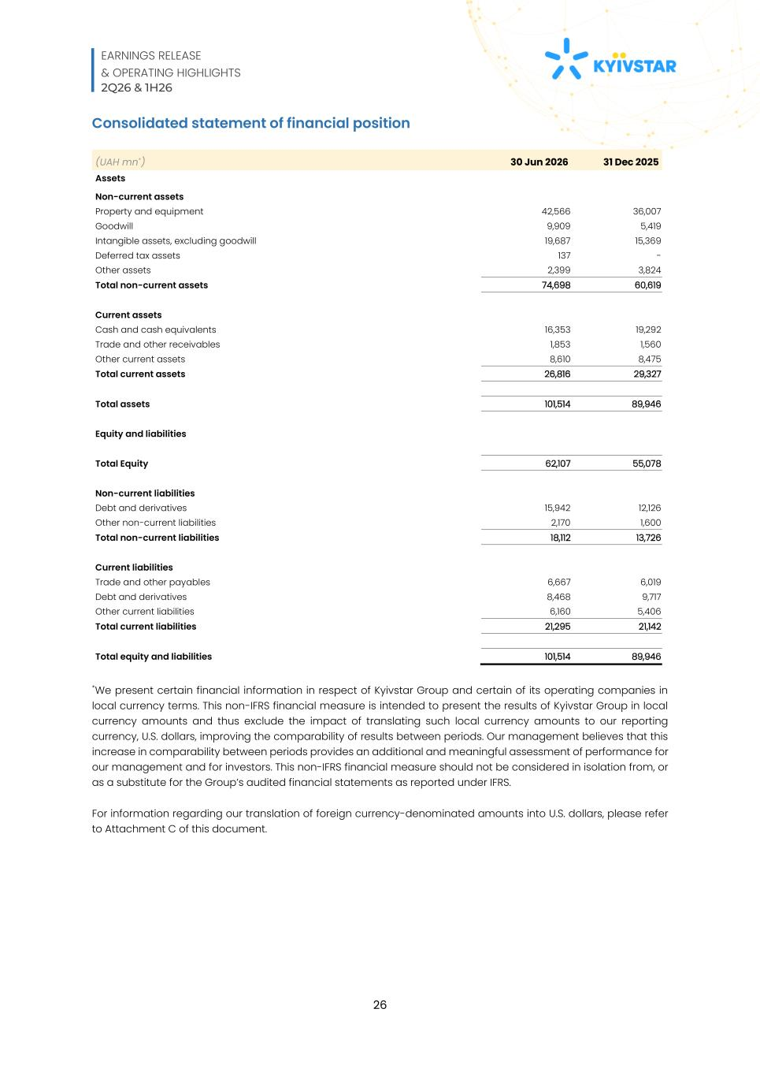
EARNINGS RELEASE & OPERATING HIGHLIGHTS 2Q26 & 1H26 26 Consolidated statement of financial position (UAH mn*) 30 Jun 2026 31 Dec 2025 Assets Non-current assets Property and equipment 42,566 36,007 Goodwill 9,909 5,419 Intangible assets, excluding goodwill 19,687 15,369 Deferred tax assets 137 - Other assets 2,399 3,824 Total non-current assets 74,698 60,619 Current assets Cash and cash equivalents 16,353 19,292 Trade and other receivables 1,853 1,560 Other current assets 8,610 8,475 Total current assets 26,816 29,327 Total assets 101,514 89,946 Equity and liabilities Total Equity 62,107 55,078 Non-current liabilities Debt and derivatives 15,942 12,126 Other non-current liabilities 2,170 1,600 Total non-current liabilities 18,112 13,726 Current liabilities Trade and other payables 6,667 6,019 Debt and derivatives 8,468 9,717 Other current liabilities 6,160 5,406 Total current liabilities 21,295 21,142 Total equity and liabilities 101,514 89,946 *We present certain financial information in respect of Kyivstar Group and certain of its operating companies in local currency terms. This non-IFRS financial measure is intended to present the results of Kyivstar Group in local currency amounts and thus exclude the impact of translating such local currency amounts to our reporting currency, U.S. dollars, improving the comparability of results between periods. Our management believes that this increase in comparability between periods provides an additional and meaningful assessment of performance for our management and for investors. This non-IFRS financial measure should not be considered in isolation from, or as a substitute for the Group’s audited financial statements as reported under IFRS. For information regarding our translation of foreign currency-denominated amounts into U.S. dollars, please refer to Attachment C of this document.

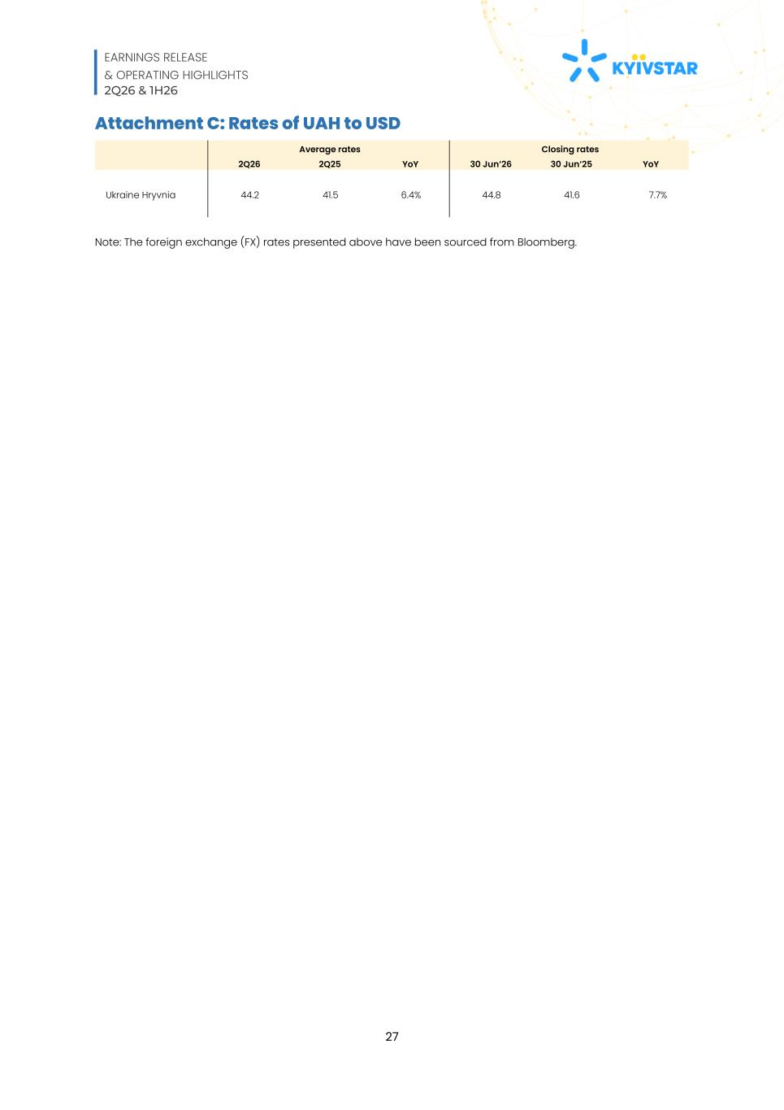
EARNINGS RELEASE & OPERATING HIGHLIGHTS 2Q26 & 1H26 27 Attachment C: Rates of UAH to USD Average rates Closing rates 2Q26 2Q25 YoY 30 Jun’26 30 Jun’25 YoY Ukraine Hryvnia 44.2 41.5 6.4% 44.8 41.6 7.7% Note: The foreign exchange (FX) rates presented above have been sourced from Bloomberg.

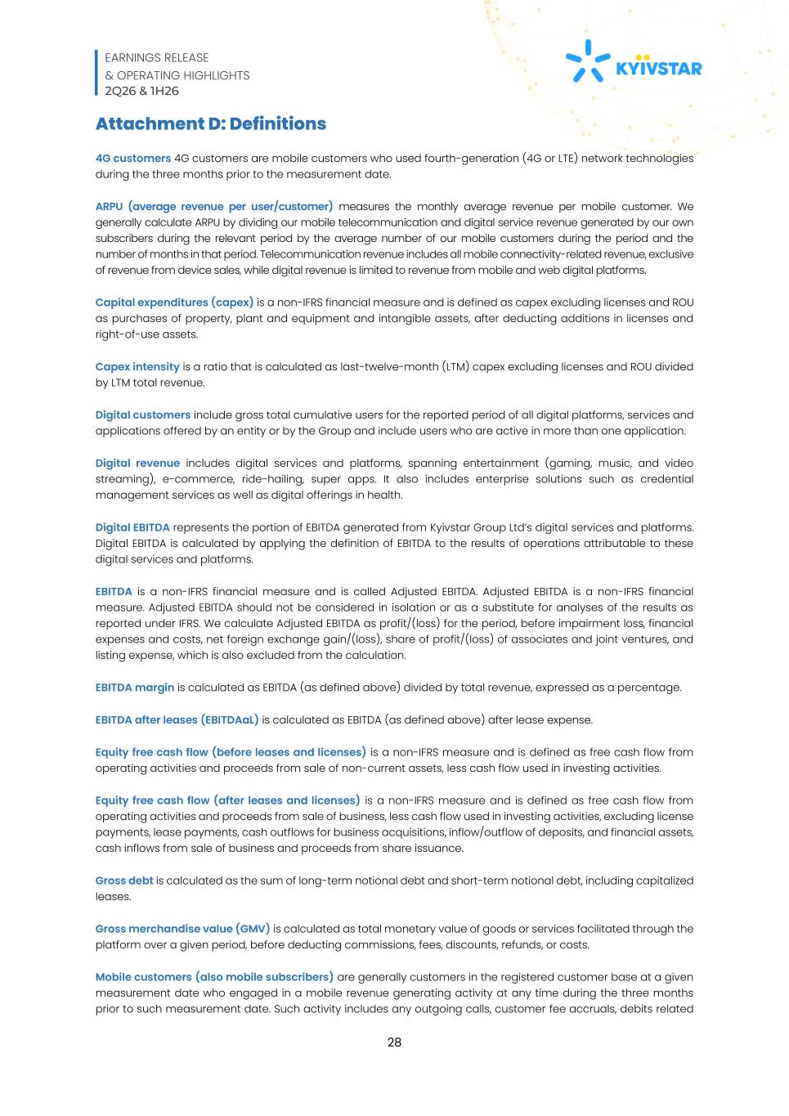
EARNINGS RELEASE & OPERATING HIGHLIGHTS 2Q26 & 1H26 28 Attachment D: Definitions 4G customers 4G customers are mobile customers who used fourth-generation (4G or LTE) network technologies during the three months prior to the measurement date. ARPU (average revenue per user/customer) measures the monthly average revenue per mobile customer. We generally calculate ARPU by dividing our mobile telecommunication and digital service revenue generated by our own subscribers during the relevant period by the average number of our mobile customers during the period and the number of months in that period. Telecommunication revenue includes all mobile connectivity-related revenue, exclusive of revenue from device sales, while digital revenue is limited to revenue from mobile and web digital platforms. Capital expenditures (capex) is a non-IFRS financial measure and is defined as capex excluding licenses and ROU as purchases of property, plant and equipment and intangible assets, after deducting additions in licenses and right-of-use assets. Capex intensity is a ratio that is calculated as last-twelve-month (LTM) capex excluding licenses and ROU divided by LTM total revenue. Digital customers include gross total cumulative users for the reported period of all digital platforms, services and applications offered by an entity or by the Group and include users who are active in more than one application. Digital revenue includes digital services and platforms, spanning entertainment (gaming, music, and video streaming), e-commerce, ride-hailing, super apps. It also includes enterprise solutions such as credential management services as well as digital offerings in health. Digital EBITDA represents the portion of EBITDA generated from Kyivstar Group Ltd’s digital services and platforms. Digital EBITDA is calculated by applying the definition of EBITDA to the results of operations attributable to these digital services and platforms. EBITDA is a non-IFRS financial measure and is called Adjusted EBITDA. Adjusted EBITDA is a non-IFRS financial measure. Adjusted EBITDA should not be considered in isolation or as a substitute for analyses of the results as reported under IFRS. We calculate Adjusted EBITDA as profit/(loss) for the period, before impairment loss, financial expenses and costs, net foreign exchange gain/(loss), share of profit/(loss) of associates and joint ventures, and listing expense, which is also excluded from the calculation. EBITDA margin is calculated as EBITDA (as defined above) divided by total revenue, expressed as a percentage. EBITDA after leases (EBITDAaL) is calculated as EBITDA (as defined above) after lease expense. Equity free cash flow (before leases and licenses) is a non-IFRS measure and is defined as free cash flow from operating activities and proceeds from sale of non-current assets, less cash flow used in investing activities. Equity free cash flow (after leases and licenses) is a non-IFRS measure and is defined as free cash flow from operating activities and proceeds from sale of business, less cash flow used in investing activities, excluding license payments, lease payments, cash outflows for business acquisitions, inflow/outflow of deposits, and financial assets, cash inflows from sale of business and proceeds from share issuance. Gross debt is calculated as the sum of long-term notional debt and short-term notional debt, including capitalized leases. Gross merchandise value (GMV) is calculated as total monetary value of goods or services facilitated through the platform over a given period, before deducting commissions, fees, discounts, refunds, or costs. Mobile customers (also mobile subscribers) are generally customers in the registered customer base at a given measurement date who engaged in a mobile revenue generating activity at any time during the three months prior to such measurement date. Such activity includes any outgoing calls, customer fee accruals, debits related

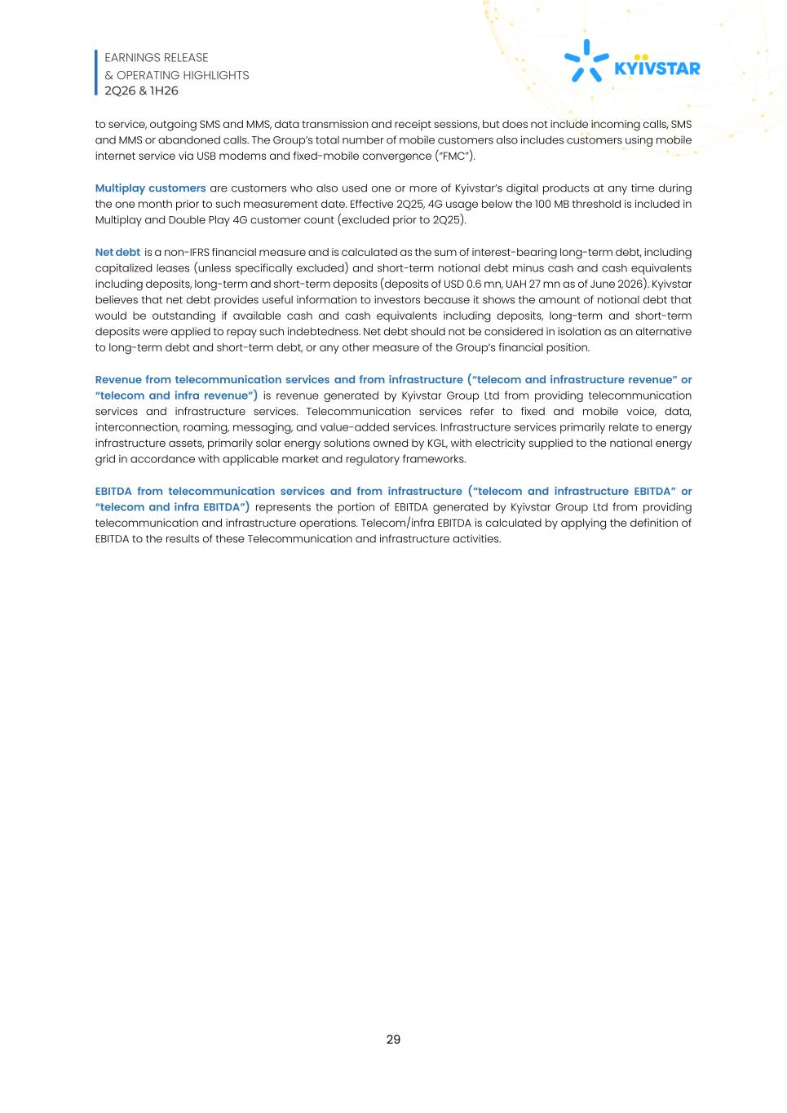
EARNINGS RELEASE & OPERATING HIGHLIGHTS 2Q26 & 1H26 29 to service, outgoing SMS and MMS, data transmission and receipt sessions, but does not include incoming calls, SMS and MMS or abandoned calls. The Group’s total number of mobile customers also includes customers using mobile internet service via USB modems and fixed-mobile convergence (“FMC”). Multiplay customers are customers who also used one or more of Kyivstar’s digital products at any time during the one month prior to such measurement date. Effective 2Q25, 4G usage below the 100 MB threshold is included in Multiplay and Double Play 4G customer count (excluded prior to 2Q25). Net debt is a non-IFRS financial measure and is calculated as the sum of interest-bearing long-term debt, including capitalized leases (unless specifically excluded) and short-term notional debt minus cash and cash equivalents including deposits, long-term and short-term deposits (deposits of USD 0.6 mn, UAH 27 mn as of June 2026). Kyivstar believes that net debt provides useful information to investors because it shows the amount of notional debt that would be outstanding if available cash and cash equivalents including deposits, long-term and short-term deposits were applied to repay such indebtedness. Net debt should not be considered in isolation as an alternative to long-term debt and short-term debt, or any other measure of the Group’s financial position. Revenue from telecommunication services and from infrastructure (“telecom and infrastructure revenue” or “telecom and infra revenue”) is revenue generated by Kyivstar Group Ltd from providing telecommunication services and infrastructure services. Telecommunication services refer to fixed and mobile voice, data, interconnection, roaming, messaging, and value-added services. Infrastructure services primarily relate to energy infrastructure assets, primarily solar energy solutions owned by KGL, with electricity supplied to the national energy grid in accordance with applicable market and regulatory frameworks. EBITDA from telecommunication services and from infrastructure (“telecom and infrastructure EBITDA” or “telecom and infra EBITDA”) represents the portion of EBITDA generated by Kyivstar Group Ltd from providing telecommunication and infrastructure operations. Telecom/infra EBITDA is calculated by applying the definition of EBITDA to the results of these Telecommunication and infrastructure activities.

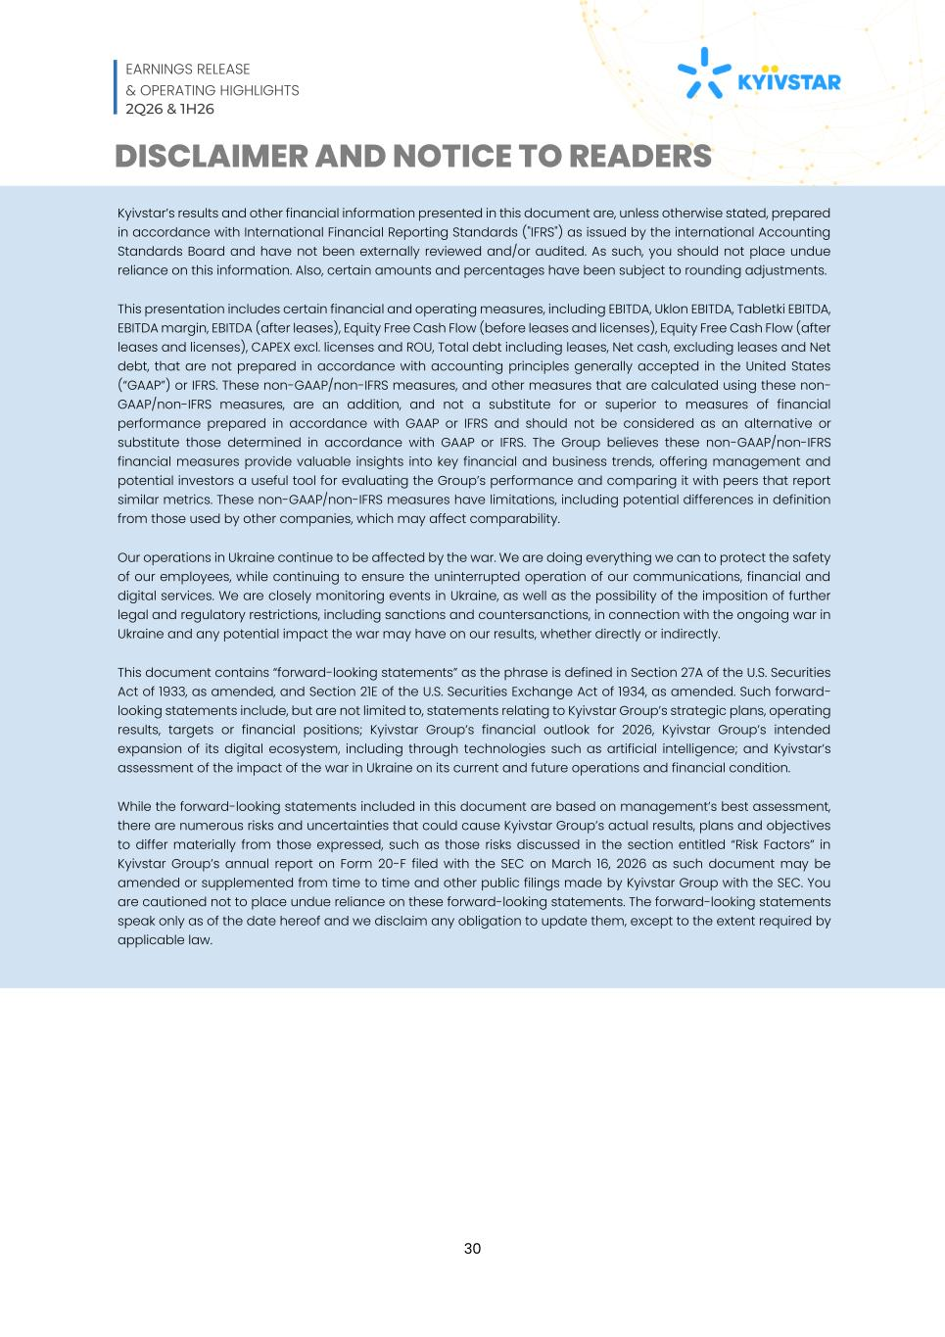
EARNINGS RELEASE & OPERATING HIGHLIGHTS 2Q26 & 1H26 30 DISCLAIMER AND NOTICE TO READERS Kyivstar’s results and other financial information presented in this document are, unless otherwise stated, prepared in accordance with International Financial Reporting Standards ("IFRS") as issued by the international Accounting Standards Board and have not been externally reviewed and/or audited. As such, you should not place undue reliance on this information. Also, certain amounts and percentages have been subject to rounding adjustments. This presentation includes certain financial and operating measures, including EBITDA, Uklon EBITDA, Tabletki EBITDA, EBITDA margin, EBITDA (after leases), Equity Free Cash Flow (before leases and licenses), Equity Free Cash Flow (after leases and licenses), CAPEX excl. licenses and ROU, Total debt including leases, Net cash, excluding leases and Net debt, that are not prepared in accordance with accounting principles generally accepted in the United States (“GAAP”) or IFRS. These non-GAAP/non-IFRS measures, and other measures that are calculated using these non- GAAP/non-IFRS measures, are an addition, and not a substitute for or superior to measures of financial performance prepared in accordance with GAAP or IFRS and should not be considered as an alternative or substitute those determined in accordance with GAAP or IFRS. The Group believes these non-GAAP/non-IFRS financial measures provide valuable insights into key financial and business trends, offering management and potential investors a useful tool for evaluating the Group’s performance and comparing it with peers that report similar metrics. These non-GAAP/non-IFRS measures have limitations, including potential differences in definition from those used by other companies, which may affect comparability. Our operations in Ukraine continue to be affected by the war. We are doing everything we can to protect the safety of our employees, while continuing to ensure the uninterrupted operation of our communications, financial and digital services. We are closely monitoring events in Ukraine, as well as the possibility of the imposition of further legal and regulatory restrictions, including sanctions and countersanctions, in connection with the ongoing war in Ukraine and any potential impact the war may have on our results, whether directly or indirectly. This document contains “forward-looking statements” as the phrase is defined in Section 27A of the U.S. Securities Act of 1933, as amended, and Section 21E of the U.S. Securities Exchange Act of 1934, as amended. Such forward- looking statements include, but are not limited to, statements relating to Kyivstar Group’s strategic plans, operating results, targets or financial positions; Kyivstar Group’s financial outlook for 2026, Kyivstar Group’s intended expansion of its digital ecosystem, including through technologies such as artificial intelligence; and Kyivstar’s assessment of the impact of the war in Ukraine on its current and future operations and financial condition. While the forward-looking statements included in this document are based on management’s best assessment, there are numerous risks and uncertainties that could cause Kyivstar Group’s actual results, plans and objectives to differ materially from those expressed, such as those risks discussed in the section entitled “Risk Factors” in Kyivstar Group’s annual report on Form 20-F filed with the SEC on March 16, 2026 as such document may be amended or supplemented from time to time and other public filings made by Kyivstar Group with the SEC. You are cautioned not to place undue reliance on these forward-looking statements. The forward-looking statements speak only as of the date hereof and we disclaim any obligation to update them, except to the extent required by applicable law.


EARNINGS RELEASE & OPERATING HIGHLIGHTS 2Q26 & 1H26 31 Kyivstar Group Ltd. Index Tower, Unit 517, Level 5 Dubai International Financial Centre Dubai, United Arab Emirates ir@kyivstargroup.com

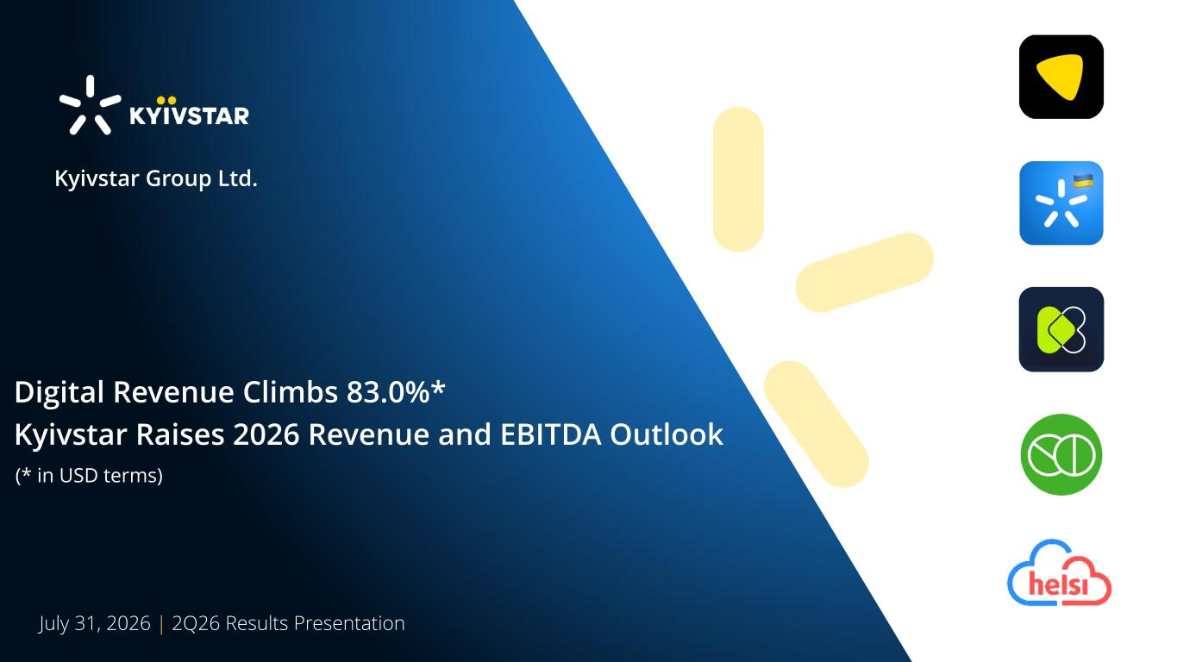
26CF7F EC2BF72C2C2C text 874BA1 FFC836 numbers F41C3A F7AB08 CE9F11 E5E5E5 F7F7F7 2638902AC2B5 FFFFFF D9D9D9 fill FFFFFF 90% opacity 592C70 0F1F59177769 994AA5 6D307A main pallete 00061A AA6ACC 5C73C667E8D9C382D1 D4ABEF 9BB0EABDFFF5F1D7F7 21E8CF 2949C1EC2BF7 July 31, 2026 | 2Q26 Results Presentation Kyivstar Group Ltd. Digital Revenue Climbs 83.0%* Kyivstar Raises 2026 Revenue and EBITDA Outlook (* in USD terms)

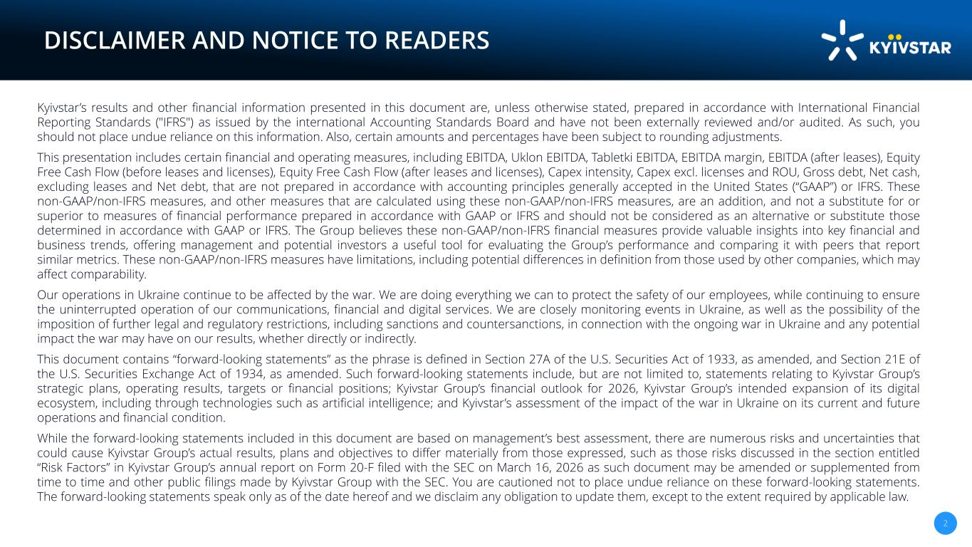
26CF7F EC2BF72C2C2C text 874BA1 FFC836 numbers F41C3A F7AB08 CE9F11 E5E5E5 F7F7F7 2638902AC2B5 FFFFFF D9D9D9 fill FFFFFF 90% opacity 592C70 0F1F59177769 994AA5 6D307A main pallete 00061A AA6ACC 5C73C667E8D9C382D1 D4ABEF 9BB0EABDFFF5F1D7F7 21E8CF 2949C1EC2BF7 2 DISCLAIMER AND NOTICE TO READERS Kyivstar’s results and other financial information presented in this document are, unless otherwise stated, prepared in accordance with International Financial Reporting Standards ("IFRS") as issued by the international Accounting Standards Board and have not been externally reviewed and/or audited. As such, you should not place undue reliance on this information. Also, certain amounts and percentages have been subject to rounding adjustments. This presentation includes certain financial and operating measures, including EBITDA, Uklon EBITDA, Tabletki EBITDA, EBITDA margin, EBITDA (after leases), Equity Free Cash Flow (before leases and licenses), Equity Free Cash Flow (after leases and licenses), Capex intensity, Capex excl. licenses and ROU, Gross debt, Net cash, excluding leases and Net debt, that are not prepared in accordance with accounting principles generally accepted in the United States (“GAAP”) or IFRS. These non-GAAP/non-IFRS measures, and other measures that are calculated using these non-GAAP/non-IFRS measures, are an addition, and not a substitute for or superior to measures of financial performance prepared in accordance with GAAP or IFRS and should not be considered as an alternative or substitute those determined in accordance with GAAP or IFRS. The Group believes these non-GAAP/non-IFRS financial measures provide valuable insights into key financial and business trends, offering management and potential investors a useful tool for evaluating the Group’s performance and comparing it with peers that report similar metrics. These non-GAAP/non-IFRS measures have limitations, including potential differences in definition from those used by other companies, which may affect comparability. Our operations in Ukraine continue to be affected by the war. We are doing everything we can to protect the safety of our employees, while continuing to ensure the uninterrupted operation of our communications, financial and digital services. We are closely monitoring events in Ukraine, as well as the possibility of the imposition of further legal and regulatory restrictions, including sanctions and countersanctions, in connection with the ongoing war in Ukraine and any potential impact the war may have on our results, whether directly or indirectly. This document contains “forward-looking statements” as the phrase is defined in Section 27A of the U.S. Securities Act of 1933, as amended, and Section 21E of the U.S. Securities Exchange Act of 1934, as amended. Such forward-looking statements include, but are not limited to, statements relating to Kyivstar Group’s strategic plans, operating results, targets or financial positions; Kyivstar Group’s financial outlook for 2026, Kyivstar Group’s intended expansion of its digital ecosystem, including through technologies such as artificial intelligence; and Kyivstar’s assessment of the impact of the war in Ukraine on its current and future operations and financial condition. While the forward-looking statements included in this document are based on management’s best assessment, there are numerous risks and uncertainties that could cause Kyivstar Group’s actual results, plans and objectives to differ materially from those expressed, such as those risks discussed in the section entitled “Risk Factors” in Kyivstar Group’s annual report on Form 20-F filed with the SEC on March 16, 2026 as such document may be amended or supplemented from time to time and other public filings made by Kyivstar Group with the SEC. You are cautioned not to place undue reliance on these forward-looking statements. The forward-looking statements speak only as of the date hereof and we disclaim any obligation to update them, except to the extent required by applicable law.

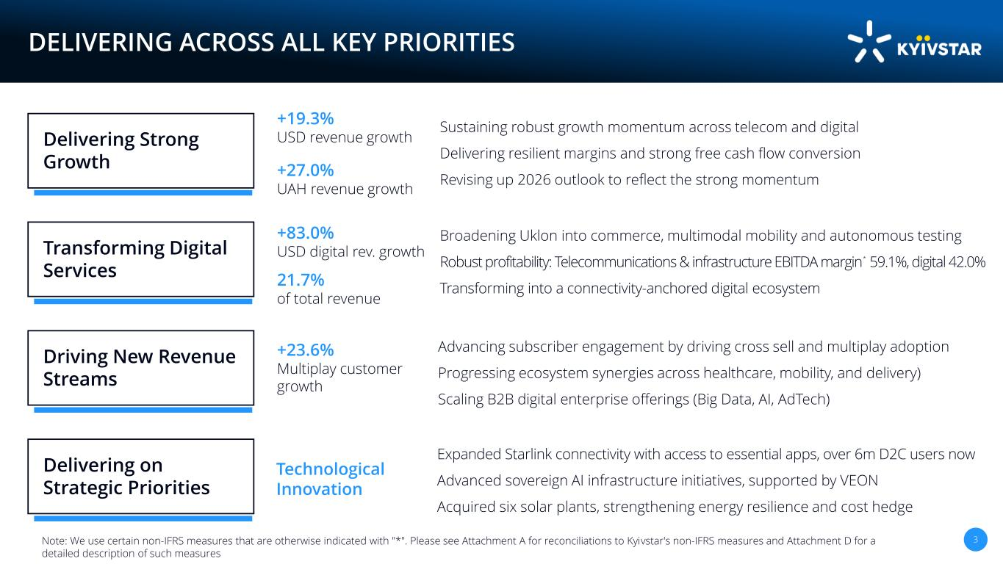
26CF7F EC2BF72C2C2C text 874BA1 FFC836 numbers F41C3A F7AB08 CE9F11 E5E5E5 F7F7F7 2638902AC2B5 FFFFFF D9D9D9 fill FFFFFF 90% opacity 592C70 0F1F59177769 994AA5 6D307A main pallete 00061A AA6ACC 5C73C667E8D9C382D1 D4ABEF 9BB0EABDFFF5F1D7F7 21E8CF 2949C1EC2BF7 +19.3% USD revenue growth 3 DELIVERING ACROSS ALL KEY PRIORITIES Sustaining robust growth momentum across telecom and digital Delivering resilient margins and strong free cash flow conversion Revising up 2026 outlook to reflect the strong momentum Delivering Strong Growth Broadening Uklon into commerce, multimodal mobility and autonomous testing Robust profitability: Telecommunications & infrastructure EBITDA margin * 59.1%, digital 42.0% Transforming into a connectivity-anchored digital ecosystem Transforming Digital Services +83.0% USD digital rev. growth Advancing subscriber engagement by driving cross sell and multiplay adoption Progressing ecosystem synergies across healthcare, mobility, and delivery) Scaling B2B digital enterprise offerings (Big Data, AI, AdTech) Driving New Revenue Streams +23.6% Multiplay customer growth Expanded Starlink connectivity with access to essential apps, over 6m D2C users now Advanced sovereign AI infrastructure initiatives, supported by VEON Acquired six solar plants, strengthening energy resilience and cost hedge Delivering on Strategic Priorities Technological Innovation +27.0% UAH revenue growth 21.7% of total revenue Note: We use certain non-IFRS measures that are otherwise indicated with "*". Please see Attachment A for reconciliations to Kyivstar's non-IFRS measures and Attachment D for a detailed description of such measures

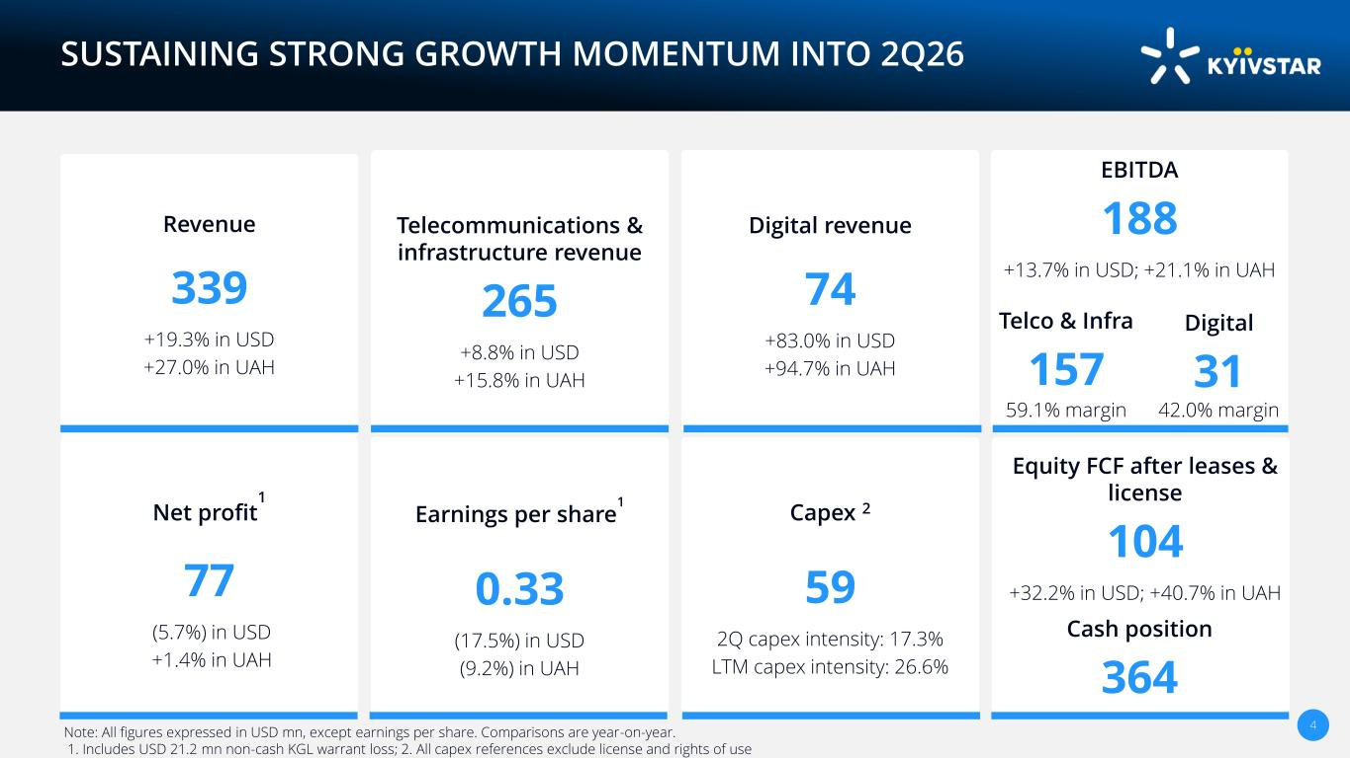
26CF7F EC2BF72C2C2C text 874BA1 FFC836 numbers F41C3A F7AB08 CE9F11 E5E5E5 F7F7F7 2638902AC2B5 FFFFFF D9D9D9 fill FFFFFF 90% opacity 592C70 0F1F59177769 994AA5 6D307A main pallete 00061A AA6ACC 5C73C667E8D9C382D1 D4ABEF 9BB0EABDFFF5F1D7F7 21E8CF 2949C1EC2BF7 4 SUSTAINING STRONG GROWTH MOMENTUM INTO 2Q26 Revenue 339 +19.3% in USD +27.0% in UAH Telecommunications & infrastructure revenue 265 +8.8% in USD +15.8% in UAH Digital revenue 74 +83.0% in USD +94.7% in UAH EBITDA 188 +13.7% in USD; +21.1% in UAH Net profit 1 77 (5.7%) in USD +1.4% in UAH Earnings per share 1 0.33 (17.5%) in USD (9.2%) in UAH Capex 2 59 2Q capex intensity: 17.3% LTM capex intensity: 26.6% Equity FCF after leases & license 104 +32.2% in USD; +40.7% in UAH Note: All figures expressed in USD mn, except earnings per share. Comparisons are year-on-year. 1. Includes USD 21.2 mn non-cash KGL warrant loss; 2. All capex references exclude license and rights of use Digital 31 Cash position 364 Telco & Infra 157 42.0% margin59.1% margin

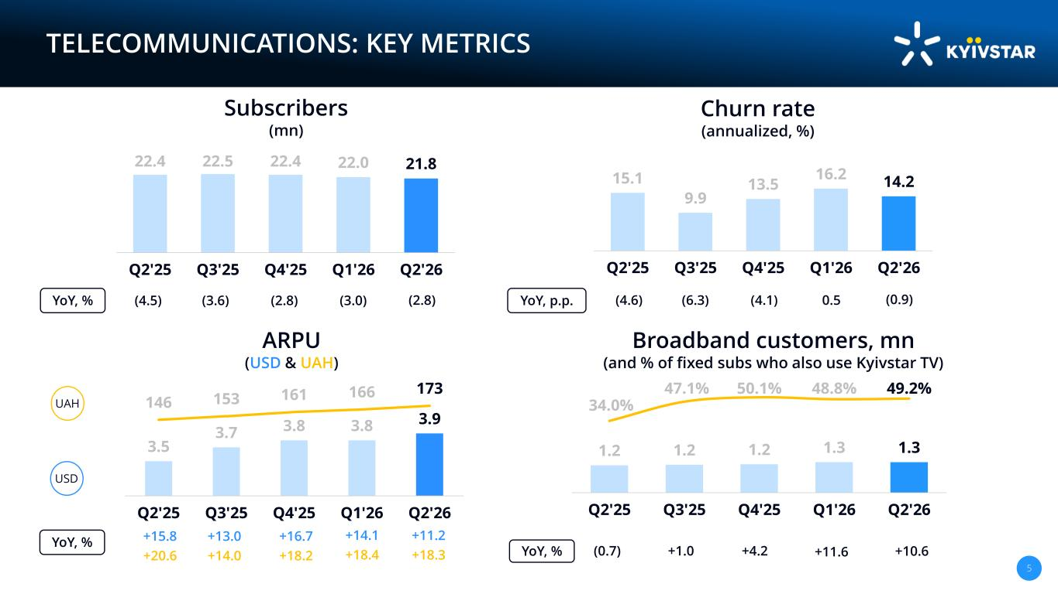
26CF7F EC2BF72C2C2C text 874BA1 FFC836 numbers F41C3A F7AB08 CE9F11 E5E5E5 F7F7F7 2638902AC2B5 FFFFFF D9D9D9 fill FFFFFF 90% opacity 592C70 0F1F59177769 994AA5 6D307A main pallete 00061A AA6ACC 5C73C667E8D9C382D1 D4ABEF 9BB0EABDFFF5F1D7F7 21E8CF 2949C1EC2BF7 5 TELECOMMUNICATIONS: KEY METRICS Subscribers (mn) Churn rate (annualized, %) 22.4 22.5 22.4 22.0 21.8 Q2'25 Q3'25 Q4'25 Q1'26 Q2'26 (4.5) (3.6) (2.8)YoY, % ARPU (USD & UAH) 15.1 9.9 13.5 16.2 14.2 Q2'25 Q3'25 Q4'25 Q1'26 Q2'26 (4.6) (6.3) (4.1) 3.5 3.7 3.8 3.8 3.9 146 153 161 166 173 Q2'25 Q3'25 Q4'25 Q1'26 Q2'26 +20.6 +14.0 +18.2 +15.8 +13.0 +16.7 UAH USD YoY, % YoY, p.p. 1.2 1.2 1.2 1.3 1.3 34.0% 47.1% 50.1% 48.8% 49.2% Q2'25 Q3'25 Q4'25 Q1'26 Q2'26 (0.7) +1.0 +4.2YoY, % (3.0) 0.5 +18.4 +14.1 +11.6 Broadband customers, mn (and % of fixed subs who also use Kyivstar TV) (2.8) (0.9) +18.3 +11.2 +10.6

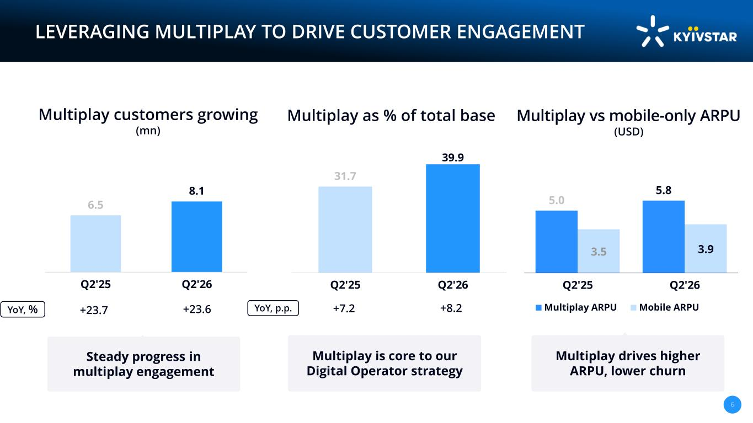
26CF7F EC2BF72C2C2C text 874BA1 FFC836 numbers F41C3A F7AB08 CE9F11 E5E5E5 F7F7F7 2638902AC2B5 FFFFFF D9D9D9 fill FFFFFF 90% opacity 592C70 0F1F59177769 994AA5 6D307A main pallete 00061A AA6ACC 5C73C667E8D9C382D1 D4ABEF 9BB0EABDFFF5F1D7F7 21E8CF 2949C1EC2BF7 6 LEVERAGING MULTIPLAY TO DRIVE CUSTOMER ENGAGEMENT Multiplay vs mobile-only ARPU (USD) YoY, % Multiplay customers growing (mn) Multiplay as % of total base 31.7 39.9 Q2'25 Q2'26 +7.2 6.5 8.1 Q2'25 Q2'26 Multiplay drives higher ARPU, lower churn Steady progress in multiplay engagement Multiplay is core to our Digital Operator strategy YoY, p.p. 5.0 5.8 3.5 3.9 Q2'25 Q2'26 Multiplay ARPU Mobile ARPU 3.8x +23.7 +23.6 +8.2

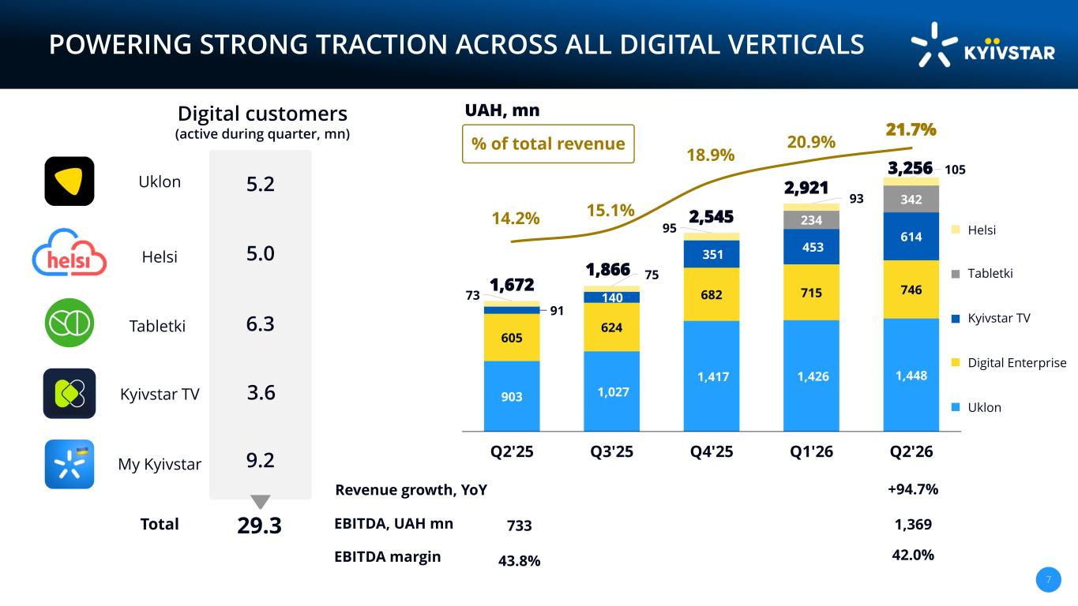
26CF7F EC2BF72C2C2C text 874BA1 FFC836 numbers F41C3A F7AB08 CE9F11 E5E5E5 F7F7F7 2638902AC2B5 FFFFFF D9D9D9 fill FFFFFF 90% opacity 592C70 0F1F59177769 994AA5 6D307A main pallete 00061A AA6ACC 5C73C667E8D9C382D1 D4ABEF 9BB0EABDFFF5F1D7F7 21E8CF 2949C1EC2BF7 POWERING STRONG TRACTION ACROSS ALL DIGITAL VERTICALS 7 903 1,027 1,417 1,426 1,448 605 624 682 715 746 91 140 351 453 614 234 342 73 75 95 93 105 14.2% 15.1% 18.9% 20.9% 21.7% Q2'25 Q3'25 Q4'25 Q1'26 Q2'26 % of total revenue 2,545 3,256 1,672 1,866 UAH, mn +94.7%Revenue growth, YoY EBITDA, UAH mn EBITDA margin 1,369 42.0%43.8% 733 2,9215.2 3.6 5.0 6.3 Digital customers (active during quarter, mn) 29.3 Uklon Kyivstar TV Helsi My Kyivstar Tabletki 9.2 Helsi Tabletki Kyivstar TV Digital Enterprise Uklon Total

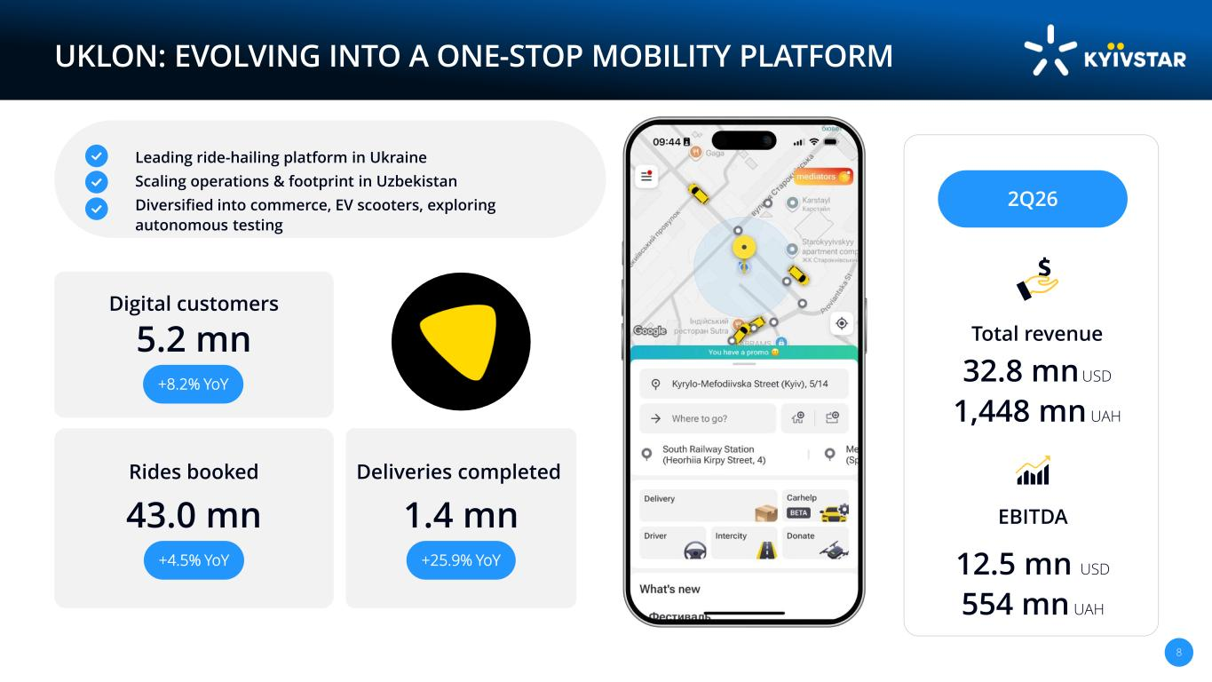
26CF7F EC2BF72C2C2C text 874BA1 FFC836 numbers F41C3A F7AB08 CE9F11 E5E5E5 F7F7F7 2638902AC2B5 FFFFFF D9D9D9 fill FFFFFF 90% opacity 592C70 0F1F59177769 994AA5 6D307A main pallete 00061A AA6ACC 5C73C667E8D9C382D1 D4ABEF 9BB0EABDFFF5F1D7F7 21E8CF 2949C1EC2BF7 8 UKLON: EVOLVING INTO A ONE-STOP MOBILITY PLATFORM Leading ride-hailing platform in Ukraine Scaling operations & footprint in Uzbekistan Diversified into commerce, EV scooters, exploring autonomous testing 32.8 mn USD 1,448 mn UAH Total revenue EBITDA 2Q26 5.2 mn Digital customers 43.0 mn Rides booked +4.5% YoY 1.4 mn Deliveries completed +25.9% YoY +8.2% YoY 12.5 mn USD 554 mn UAH

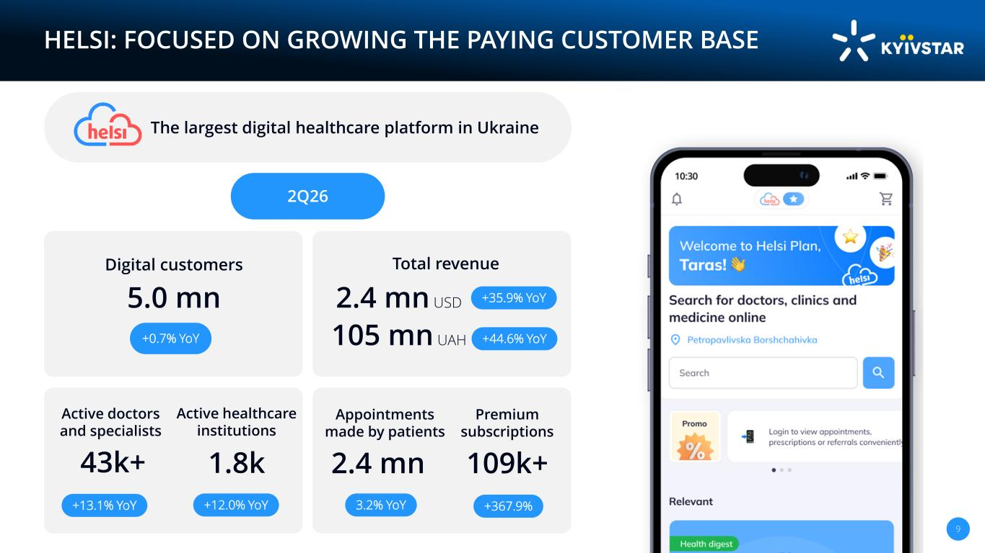
26CF7F EC2BF72C2C2C text 874BA1 FFC836 numbers F41C3A F7AB08 CE9F11 E5E5E5 F7F7F7 2638902AC2B5 FFFFFF D9D9D9 fill FFFFFF 90% opacity 592C70 0F1F59177769 994AA5 6D307A main pallete 00061A AA6ACC 5C73C667E8D9C382D1 D4ABEF 9BB0EABDFFF5F1D7F7 21E8CF 2949C1EC2BF7 9 HELSI: FOCUSED ON GROWING THE PAYING CUSTOMER BASE The largest digital healthcare platform in Ukraine Active doctors and specialists 2.4 mn Appointments made by patients 1.8k Active healthcare institutions +13.1% YoY +12.0% YoY 3.2% YoY 109k+ Premium subscriptions +367.9% 5.0 mn Digital customers +0.7% YoY 2.4 mn USD 105 mn UAH Total revenue +35.9% YoY +44.6% YoY 2Q26 43k+

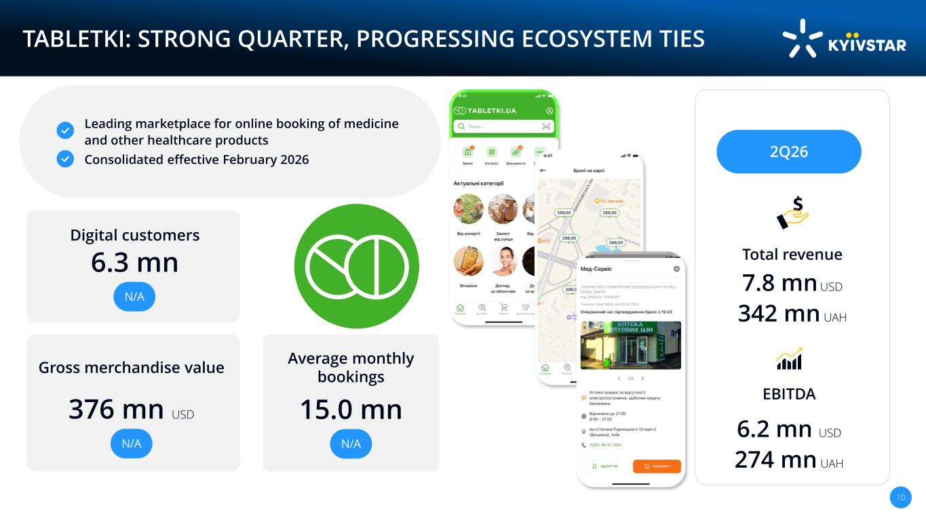
26CF7F EC2BF72C2C2C text 874BA1 FFC836 numbers F41C3A F7AB08 CE9F11 E5E5E5 F7F7F7 2638902AC2B5 FFFFFF D9D9D9 fill FFFFFF 90% opacity 592C70 0F1F59177769 994AA5 6D307A main pallete 00061A AA6ACC 5C73C667E8D9C382D1 D4ABEF 9BB0EABDFFF5F1D7F7 21E8CF 2949C1EC2BF7 10 TABLETKI: STRONG QUARTER, PROGRESSING ECOSYSTEM TIES 7.8 mn USD 342 mn UAH Total revenue 6.2 mn USD 274 mn UAH EBITDA 2Q26 Leading marketplace for online booking of medicine and other healthcare products Consolidated effective February 2026 6.3 mn Digital customers 376 mn USD Gross merchandise value N/A 15.0 mn Average monthly bookings N/A N/A

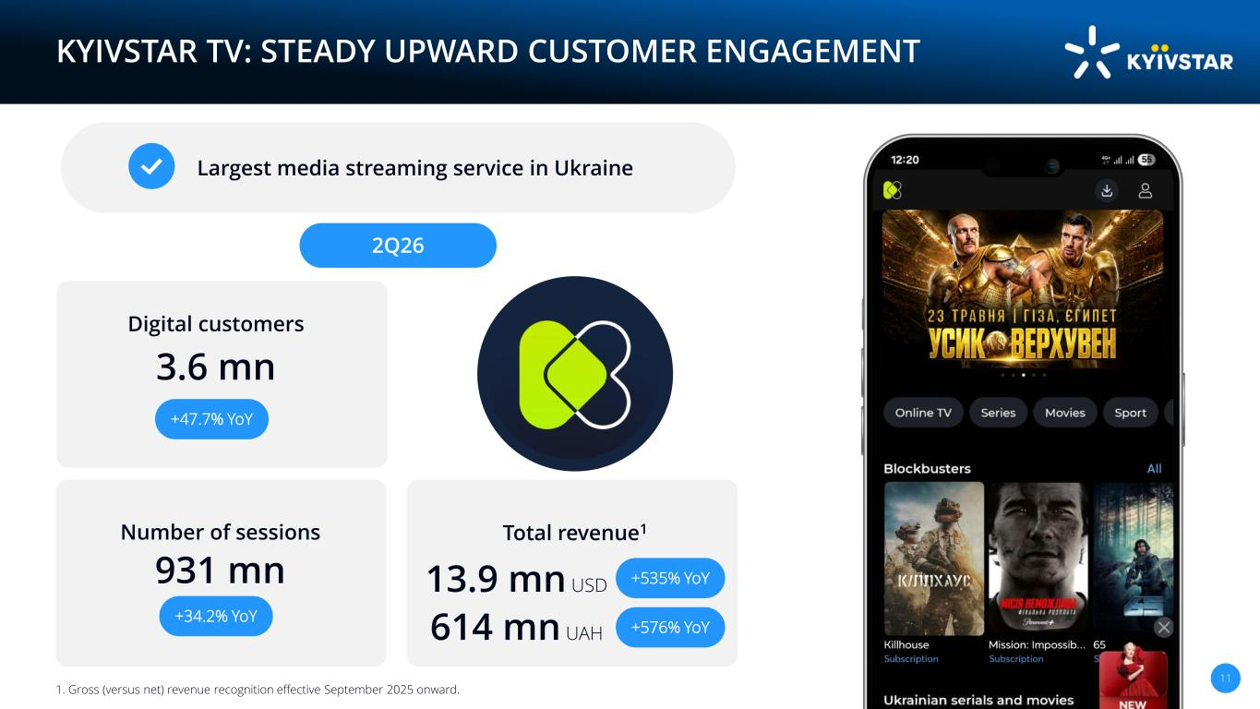
26CF7F EC2BF72C2C2C text 874BA1 FFC836 numbers F41C3A F7AB08 CE9F11 E5E5E5 F7F7F7 2638902AC2B5 FFFFFF D9D9D9 fill FFFFFF 90% opacity 592C70 0F1F59177769 994AA5 6D307A main pallete 00061A AA6ACC 5C73C667E8D9C382D1 D4ABEF 9BB0EABDFFF5F1D7F7 21E8CF 2949C1EC2BF7 11 KYIVSTAR TV: STEADY UPWARD CUSTOMER ENGAGEMENT Largest media streaming service in Ukraine 3.6 mn Digital customers 931 mn Number of sessions +34.2% YoY +47.7% YoY 13.9 mn USD 614 mn UAH Total revenue1 +535% YoY +576% YoY 1. Gross (versus net) revenue recognition effective September 2025 onward. 2Q26

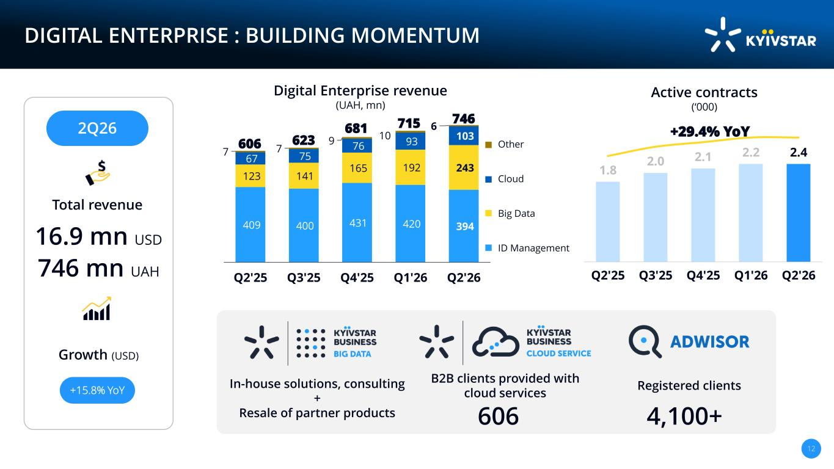
26CF7F EC2BF72C2C2C text 874BA1 FFC836 numbers F41C3A F7AB08 CE9F11 E5E5E5 F7F7F7 2638902AC2B5 FFFFFF D9D9D9 fill FFFFFF 90% opacity 592C70 0F1F59177769 994AA5 6D307A main pallete 00061A AA6ACC 5C73C667E8D9C382D1 D4ABEF 9BB0EABDFFF5F1D7F7 21E8CF 2949C1EC2BF7 12 DIGITAL ENTERPRISE : BUILDING MOMENTUM Digital Enterprise revenue (UAH, mn) Active contracts (‘000) 2Q26 Total revenue 16.9 mn USD 746 mn UAH Growth (USD) 606 B2B clients provided with cloud services 4,100+ Registered clientsIn-house solutions, consulting + Resale of partner products 409 400 431 420 394 123 141 165 192 243 67 75 76 93 103 7 7 9 10 6 Q2'25 Q3'25 Q4'25 Q1'26 Q2'26 Other Cloud Big Data ID Management 715681 623606 1.8 2.0 2.1 2.2 2.4 Q2'25 Q3'25 Q4'25 Q1'26 Q2'26 +29.4% YoY +15.8% YoY 746

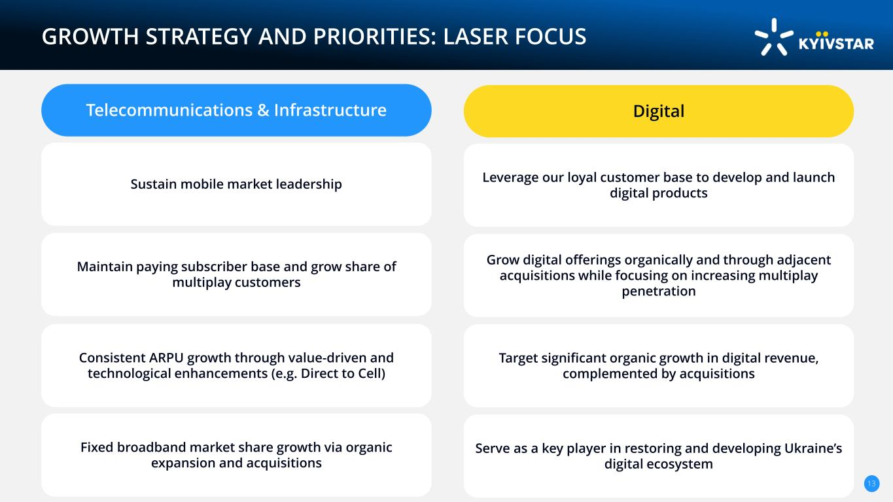
26CF7F EC2BF72C2C2C text 874BA1 FFC836 numbers F41C3A F7AB08 CE9F11 E5E5E5 F7F7F7 2638902AC2B5 FFFFFF D9D9D9 fill FFFFFF 90% opacity 592C70 0F1F59177769 994AA5 6D307A main pallete 00061A AA6ACC 5C73C667E8D9C382D1 D4ABEF 9BB0EABDFFF5F1D7F7 21E8CF 2949C1EC2BF7 Sustain mobile market leadership GROWTH STRATEGY AND PRIORITIES: LASER FOCUS Telecommunications & Infrastructure Leverage our loyal customer base to develop and launch digital products Digital Maintain paying subscriber base and grow share of multiplay customers Grow digital offerings organically and through adjacent acquisitions while focusing on increasing multiplay penetration Consistent ARPU growth through value-driven and technological enhancements (e.g. Direct to Cell) Target significant organic growth in digital revenue, complemented by acquisitions Fixed broadband market share growth via organic expansion and acquisitions Serve as a key player in restoring and developing Ukraine’s digital ecosystem 13

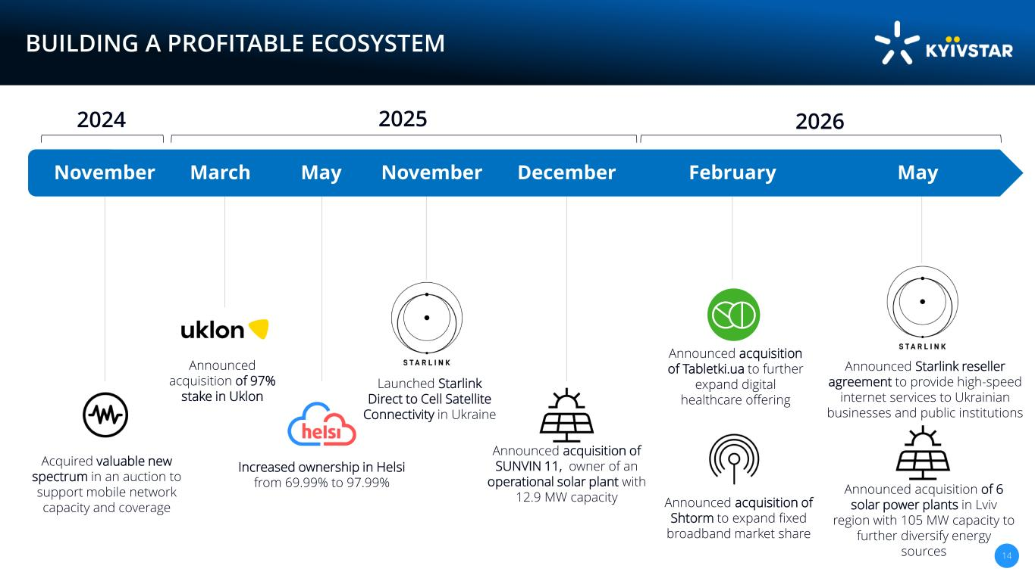
26CF7F EC2BF72C2C2C text 874BA1 FFC836 numbers F41C3A F7AB08 CE9F11 E5E5E5 F7F7F7 2638902AC2B5 FFFFFF D9D9D9 fill FFFFFF 90% opacity 592C70 0F1F59177769 994AA5 6D307A main pallete 00061A AA6ACC 5C73C667E8D9C382D1 D4ABEF 9BB0EABDFFF5F1D7F7 21E8CF 2949C1EC2BF7 14 BUILDING A PROFITABLE ECOSYSTEM Increased ownership in Helsi from 69.99% to 97.99% Announced acquisition of 97% stake in Uklon Launched Starlink Direct to Cell Satellite Connectivity in Ukraine November March May November Announced acquisition of Tabletki.ua to further expand digital healthcare offering February Acquired valuable new spectrum in an auction to support mobile network capacity and coverage Announced acquisition of SUNVIN 11, owner of an operational solar plant with 12.9 MW capacity December 2024 2025 2026 Announced acquisition of Shtorm to expand fixed broadband market share May Announced Starlink reseller agreement to provide high-speed internet services to Ukrainian businesses and public institutions Announced acquisition of 6 solar power plants in Lviv region with 105 MW capacity to further diversify energy sources

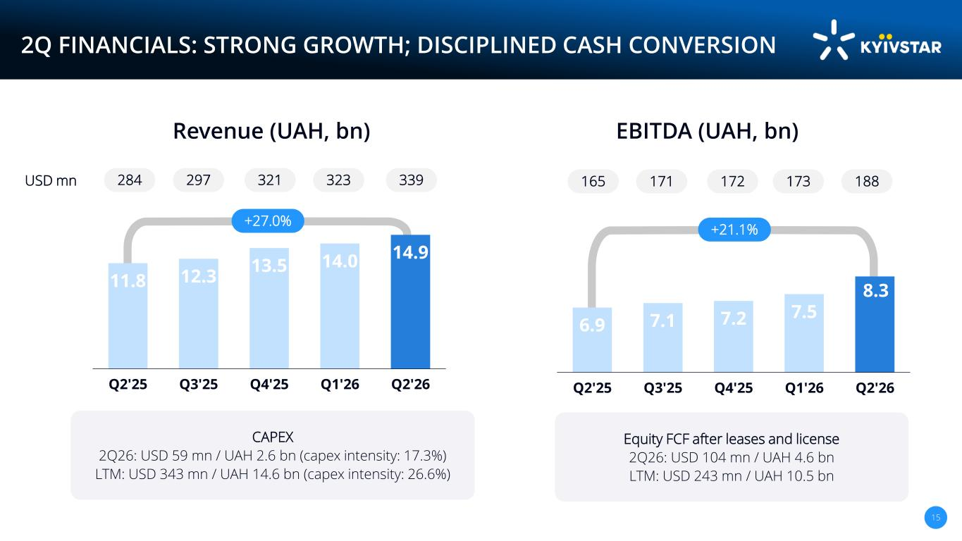
26CF7F EC2BF72C2C2C text 874BA1 FFC836 numbers F41C3A F7AB08 CE9F11 E5E5E5 F7F7F7 2638902AC2B5 FFFFFF D9D9D9 fill FFFFFF 90% opacity 592C70 0F1F59177769 994AA5 6D307A main pallete 00061A AA6ACC 5C73C667E8D9C382D1 D4ABEF 9BB0EABDFFF5F1D7F7 21E8CF 2949C1EC2BF7 6.9 7.1 7.2 7.5 8.3 Q2'25 Q3'25 Q4'25 Q1'26 Q2'26 15 2Q FINANCIALS: STRONG GROWTH; DISCIPLINED CASH CONVERSION Revenue (UAH, bn) 11.8 12.3 13.5 14.0 14.9 Q2'25 Q3'25 Q4'25 Q1'26 Q2'26 +27.0% CAPEX 2Q26: USD 59 mn / UAH 2.6 bn (capex intensity: 17.3%) LTM: USD 343 mn / UAH 14.6 bn (capex intensity: 26.6%) 339USD mn EBITDA (UAH, bn) Equity FCF after leases and license 2Q26: USD 104 mn / UAH 4.6 bn LTM: USD 243 mn / UAH 10.5 bn 321297284 +21.1% 188173172165323 171

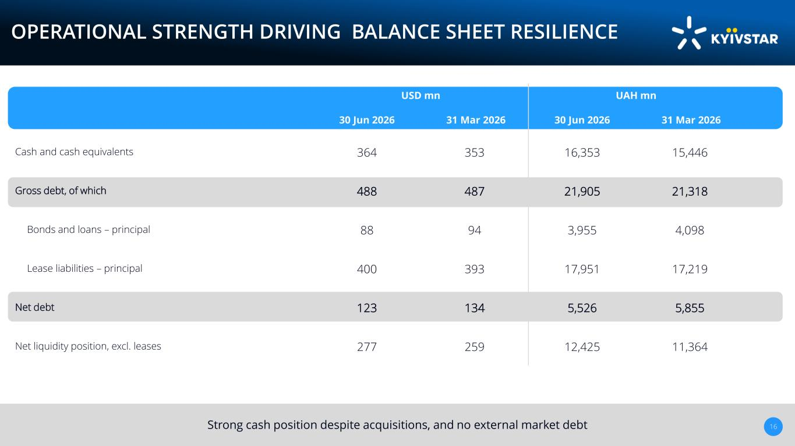
26CF7F EC2BF72C2C2C text 874BA1 FFC836 numbers F41C3A F7AB08 CE9F11 E5E5E5 F7F7F7 2638902AC2B5 FFFFFF D9D9D9 fill FFFFFF 90% opacity 592C70 0F1F59177769 994AA5 6D307A main pallete 00061A AA6ACC 5C73C667E8D9C382D1 D4ABEF 9BB0EABDFFF5F1D7F7 21E8CF 2949C1EC2BF7 Strong cash position despite acquisitions, and no external market debt 16 OPERATIONAL STRENGTH DRIVING BALANCE SHEET RESILIENCE USD mn UAH mn 30 Jun 2026 31 Mar 2026 30 Jun 2026 31 Mar 2026 Cash and cash equivalents 364 353 16,353 15,446 Gross debt, of which 488 487 21,905 21,318 Bonds and loans – principal 88 94 3,955 4,098 Lease liabilities – principal 400 393 17,951 17,219 Net debt 123 134 5,526 5,855 Net liquidity position, excl. leases 277 259 12,425 11,364

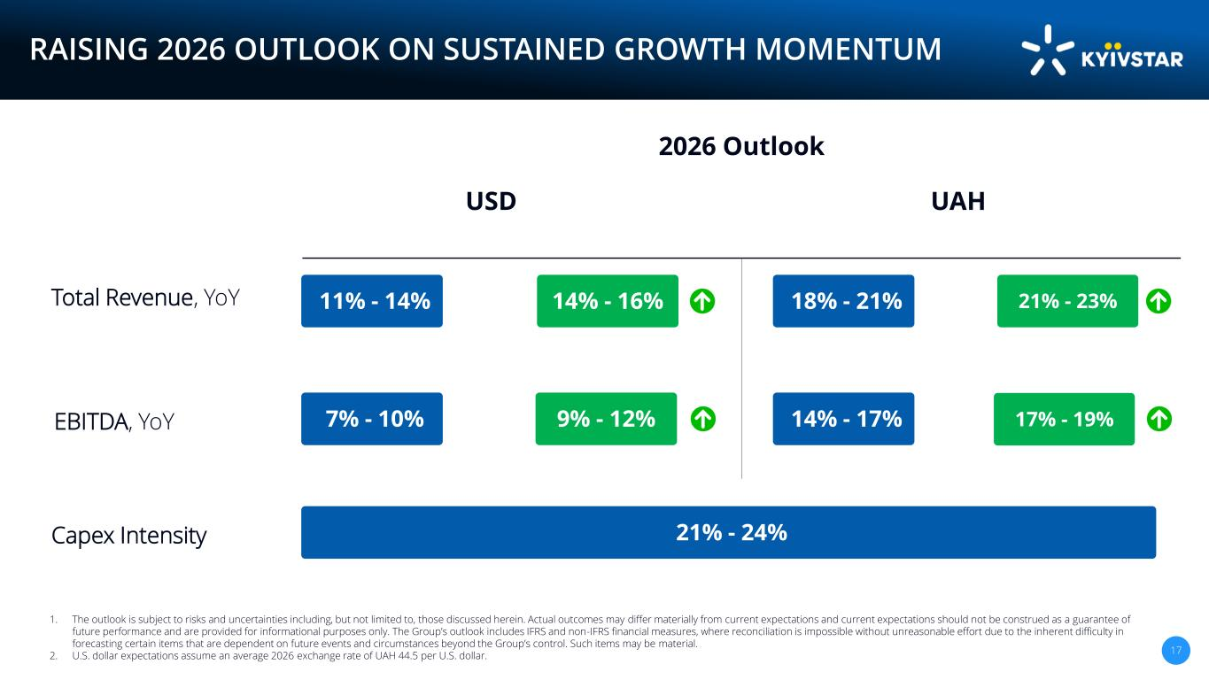
26CF7F EC2BF72C2C2C text 874BA1 FFC836 numbers F41C3A F7AB08 CE9F11 E5E5E5 F7F7F7 2638902AC2B5 FFFFFF D9D9D9 fill FFFFFF 90% opacity 592C70 0F1F59177769 994AA5 6D307A main pallete 00061A AA6ACC 5C73C667E8D9C382D1 D4ABEF 9BB0EABDFFF5F1D7F7 21E8CF 2949C1EC2BF7 RAISING 2026 OUTLOOK ON SUSTAINED GROWTH MOMENTUM 1. The outlook is subject to risks and uncertainties including, but not limited to, those discussed herein. Actual outcomes may differ materially from current expectations and current expectations should not be construed as a guarantee of future performance and are provided for informational purposes only. The Group’s outlook includes IFRS and non-IFRS financial measures, where reconciliation is impossible without unreasonable effort due to the inherent difficulty in forecasting certain items that are dependent on future events and circumstances beyond the Group’s control. Such items may be material. 2. U.S. dollar expectations assume an average 2026 exchange rate of UAH 44.5 per U.S. dollar. 17 17% - 19% 11% - 14% 14% - 16% 18% - 21% 21% - 23% 7% - 10% 9% - 12% 14% - 17% 21% - 24% Total Revenue, YoY EBITDA, YoY Capex Intensity USD UAH 2026 Outlook


26CF7F EC2BF72C2C2C text 874BA1 FFC836 numbers F41C3A F7AB08 CE9F11 E5E5E5 F7F7F7 2638902AC2B5 FFFFFF D9D9D9 fill FFFFFF 90% opacity 592C70 0F1F59177769 994AA5 6D307A main pallete 00061A AA6ACC 5C73C667E8D9C382D1 D4ABEF 9BB0EABDFFF5F1D7F7 21E8CF 2949C1EC2BF7 SAVE THE DATE Capital Markets Day 16 November 2026 New York City Further details will be shared in due course


26CF7F EC2BF72C2C2C text 874BA1 FFC836 numbers F41C3A F7AB08 CE9F11 E5E5E5 F7F7F7 2638902AC2B5 FFFFFF D9D9D9 fill FFFFFF 90% opacity 592C70 0F1F59177769 994AA5 6D307A main pallete 00061A AA6ACC 5C73C667E8D9C382D1 D4ABEF 9BB0EABDFFF5F1D7F7 21E8CF 2949C1EC2BF7 19 Appendix

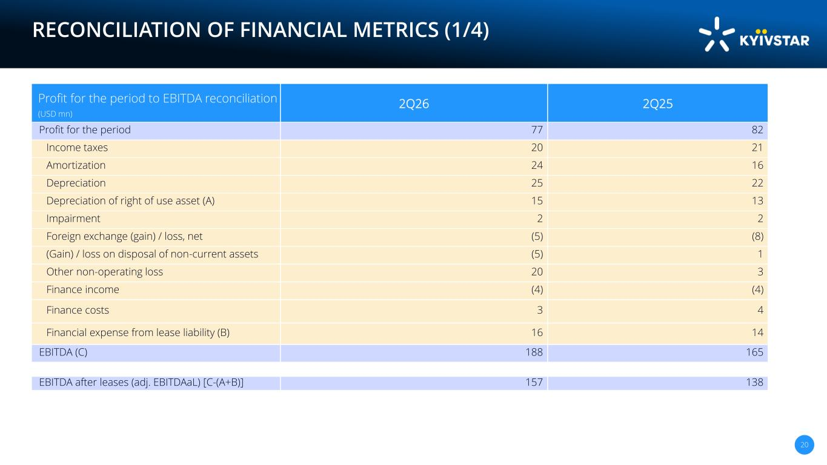
26CF7F EC2BF72C2C2C text 874BA1 FFC836 numbers F41C3A F7AB08 CE9F11 E5E5E5 F7F7F7 2638902AC2B5 FFFFFF D9D9D9 fill FFFFFF 90% opacity 592C70 0F1F59177769 994AA5 6D307A main pallete 00061A AA6ACC 5C73C667E8D9C382D1 D4ABEF 9BB0EABDFFF5F1D7F7 21E8CF 2949C1EC2BF7 RECONCILIATION OF FINANCIAL METRICS (1/4) 20 Profit for the period to EBITDA reconciliation (USD mn) 2Q26 2Q25 Profit for the period 77 82 Income taxes 20 21 Amortization 24 16 Depreciation 25 22 Depreciation of right of use asset (A) 15 13 Impairment 2 2 Foreign exchange (gain) / loss, net (5) (8) (Gain) / loss on disposal of non-current assets (5) 1 Other non-operating loss 20 3 Finance income (4) (4) Finance costs 3 4 Financial expense from lease liability (B) 16 14 EBITDA (C) 188 165 EBITDA after leases (adj. EBITDAaL) [C-(A+B)] 157 138

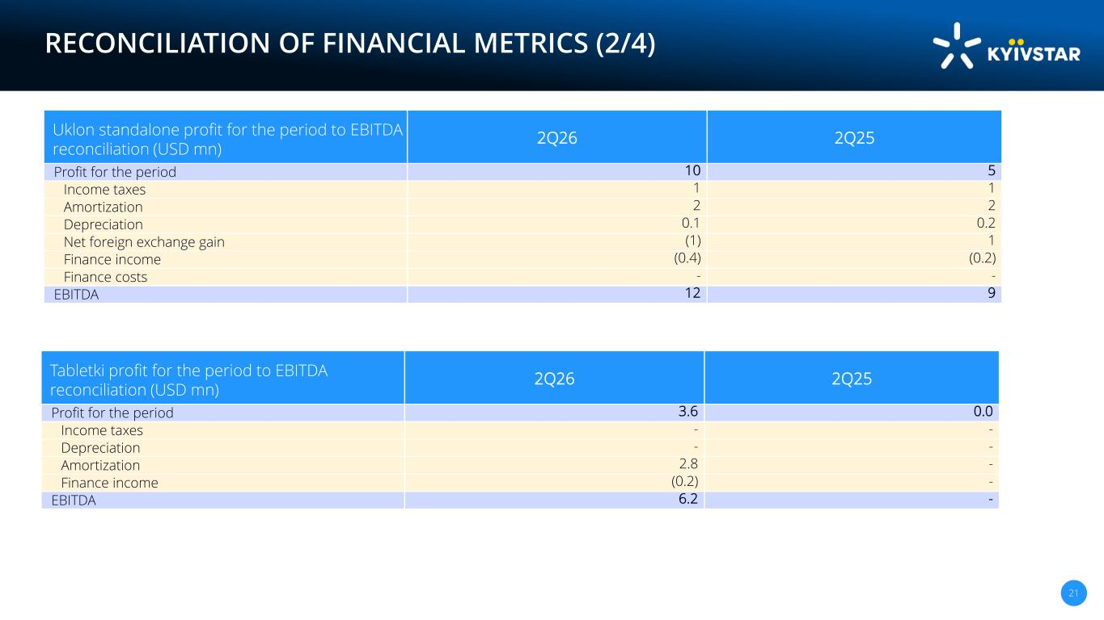
26CF7F EC2BF72C2C2C text 874BA1 FFC836 numbers F41C3A F7AB08 CE9F11 E5E5E5 F7F7F7 2638902AC2B5 FFFFFF D9D9D9 fill FFFFFF 90% opacity 592C70 0F1F59177769 994AA5 6D307A main pallete 00061A AA6ACC 5C73C667E8D9C382D1 D4ABEF 9BB0EABDFFF5F1D7F7 21E8CF 2949C1EC2BF7 RECONCILIATION OF FINANCIAL METRICS (2/4) 21 Uklon standalone profit for the period to EBITDA reconciliation (USD mn) 2Q26 2Q25 Profit for the period 10 5 Income taxes 1 1 Amortization 2 2 Depreciation 0.1 0.2 Net foreign exchange gain (1) 1 Finance income (0.4) (0.2) Finance costs - - EBITDA 12 9 Tabletki profit for the period to EBITDA reconciliation (USD mn) 2Q26 2Q25 Profit for the period 3.6 0.0 Income taxes - - Depreciation - - Amortization 2.8 - Finance income (0.2) - EBITDA 6.2 -

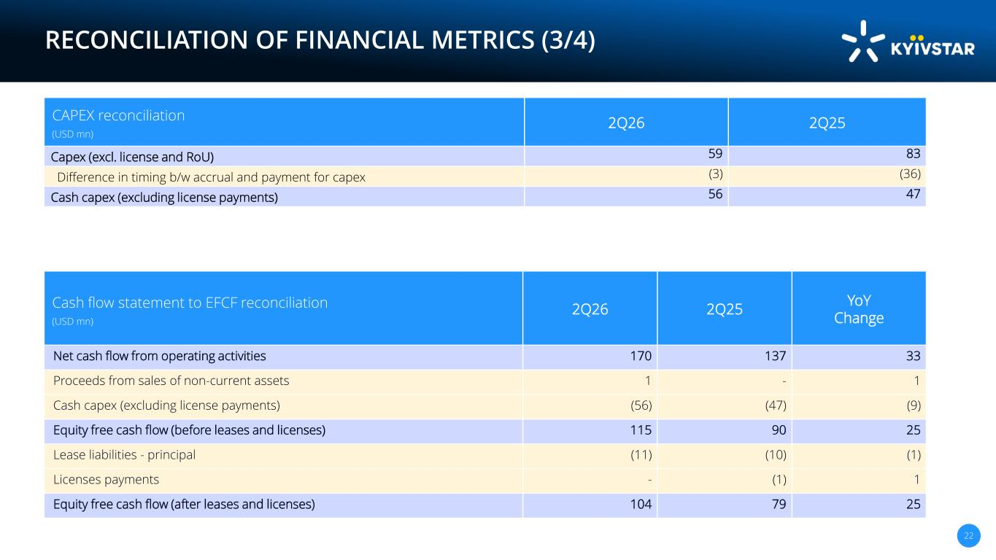
26CF7F EC2BF72C2C2C text 874BA1 FFC836 numbers F41C3A F7AB08 CE9F11 E5E5E5 F7F7F7 2638902AC2B5 FFFFFF D9D9D9 fill FFFFFF 90% opacity 592C70 0F1F59177769 994AA5 6D307A main pallete 00061A AA6ACC 5C73C667E8D9C382D1 D4ABEF 9BB0EABDFFF5F1D7F7 21E8CF 2949C1EC2BF7 RECONCILIATION OF FINANCIAL METRICS (3/4) 22 CAPEX reconciliation (USD mn) 2Q26 2Q25 Capex (excl. license and RoU) 59 83 Difference in timing b/w accrual and payment for capex (3) (36) Cash capex (excluding license payments) 56 47 Cash flow statement to EFCF reconciliation (USD mn) 2Q26 2Q25 YoY Change Net cash flow from operating activities 170 137 33 Proceeds from sales of non-current assets 1 - 1 Cash capex (excluding license payments) (56) (47) (9) Equity free cash flow (before leases and licenses) 115 90 25 Lease liabilities - principal (11) (10) (1) Licenses payments - (1) 1 Equity free cash flow (after leases and licenses) 104 79 25

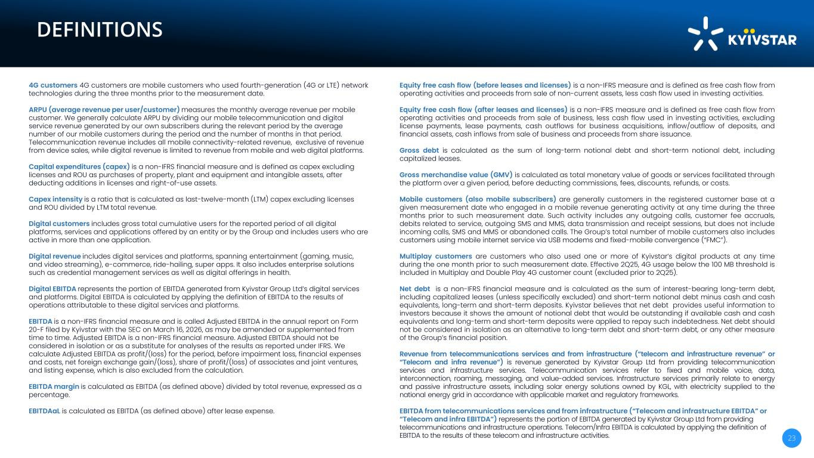
26CF7F EC2BF72C2C2C text 874BA1 FFC836 numbers F41C3A F7AB08 CE9F11 E5E5E5 F7F7F7 2638902AC2B5 FFFFFF D9D9D9 fill FFFFFF 90% opacity 592C70 0F1F59177769 994AA5 6D307A main pallete 00061A AA6ACC 5C73C667E8D9C382D1 D4ABEF 9BB0EABDFFF5F1D7F7 21E8CF 2949C1EC2BF7 DEFINITIONS 23 4G customers 4G customers are mobile customers who used fourth-generation (4G or LTE) network technologies during the three months prior to the measurement date. ARPU (average revenue per user/customer) measures the monthly average revenue per mobile customer. We generally calculate ARPU by dividing our mobile telecommunication and digital service revenue generated by our own subscribers during the relevant period by the average number of our mobile customers during the period and the number of months in that period. Telecommunication revenue includes all mobile connectivity-related revenue, exclusive of revenue from device sales, while digital revenue is limited to revenue from mobile and web digital platforms. Capital expenditures (capex) is a non-IFRS financial measure and is defined as capex excluding licenses and ROU as purchases of property, plant and equipment and intangible assets, after deducting additions in licenses and right-of-use assets. Capex intensity is a ratio that is calculated as last-twelve-month (LTM) capex excluding licenses and ROU divided by LTM total revenue. Digital customers includes gross total cumulative users for the reported period of all digital platforms, services and applications offered by an entity or by the Group and includes users who are active in more than one application. Digital revenue includes digital services and platforms, spanning entertainment (gaming, music, and video streaming), e-commerce, ride-hailing, super apps. It also includes enterprise solutions such as credential management services as well as digital offerings in health. Digital EBITDA represents the portion of EBITDA generated from Kyivstar Group Ltd’s digital services and platforms. Digital EBITDA is calculated by applying the definition of EBITDA to the results of operations attributable to these digital services and platforms. EBITDA is a non-IFRS financial measure and is called Adjusted EBITDA in the annual report on Form 20-F filed by Kyivstar with the SEC on March 16, 2026, as may be amended or supplemented from time to time. Adjusted EBITDA is a non-IFRS financial measure. Adjusted EBITDA should not be considered in isolation or as a substitute for analyses of the results as reported under IFRS. We calculate Adjusted EBITDA as profit/(loss) for the period, before impairment loss, financial expenses and costs, net foreign exchange gain/(loss), share of profit/(loss) of associates and joint ventures, and listing expense, which is also excluded from the calculation. EBITDA margin is calculated as EBITDA (as defined above) divided by total revenue, expressed as a percentage. EBITDAaL is calculated as EBITDA (as defined above) after lease expense. Equity free cash flow (before leases and licenses) is a non-IFRS measure and is defined as free cash flow from operating activities and proceeds from sale of non-current assets, less cash flow used in investing activities. Equity free cash flow (after leases and licenses) is a non-IFRS measure and is defined as free cash flow from operating activities and proceeds from sale of business, less cash flow used in investing activities, excluding license payments, lease payments, cash outflows for business acquisitions, inflow/outflow of deposits, and financial assets, cash inflows from sale of business and proceeds from share issuance. Gross debt is calculated as the sum of long-term notional debt and short-term notional debt, including capitalized leases. Gross merchandise value (GMV) is calculated as total monetary value of goods or services facilitated through the platform over a given period, before deducting commissions, fees, discounts, refunds, or costs. Mobile customers (also mobile subscribers) are generally customers in the registered customer base at a given measurement date who engaged in a mobile revenue generating activity at any time during the three months prior to such measurement date. Such activity includes any outgoing calls, customer fee accruals, debits related to service, outgoing SMS and MMS, data transmission and receipt sessions, but does not include incoming calls, SMS and MMS or abandoned calls. The Group’s total number of mobile customers also includes customers using mobile internet service via USB modems and fixed-mobile convergence (“FMC”). Multiplay customers are customers who also used one or more of Kyivstar’s digital products at any time during the one month prior to such measurement date. Effective 2Q25, 4G usage below the 100 MB threshold is included in Multiplay and Double Play 4G customer count (excluded prior to 2Q25). Net debt is a non-IFRS financial measure and is calculated as the sum of interest-bearing long-term debt, including capitalized leases (unless specifically excluded) and short-term notional debt minus cash and cash equivalents, long-term and short-term deposits. Kyivstar believes that net debt provides useful information to investors because it shows the amount of notional debt that would be outstanding if available cash and cash equivalents and long-term and short-term deposits were applied to repay such indebtedness. Net debt should not be considered in isolation as an alternative to long-term debt and short-term debt, or any other measure of the Group’s financial position. Revenue from telecommunications services and from infrastructure (“telecom and infrastructure revenue” or “Telecom and infra revenue”) is revenue generated by Kyivstar Group Ltd from providing telecommunication services and infrastructure services. Telecommunication services refer to fixed and mobile voice, data, interconnection, roaming, messaging, and value-added services. Infrastructure services primarily relate to energy and passive infrastructure assets, including solar energy solutions owned by KGL, with electricity supplied to the national energy grid in accordance with applicable market and regulatory frameworks. EBITDA from telecommunications services and from infrastructure (“Telecom and infrastructure EBITDA” or “Telecom and infra EBITDA”) represents the portion of EBITDA generated by Kyivstar Group Ltd from providing telecommunications and infrastructure operations. Telecom/Infra EBITDA is calculated by applying the definition of EBITDA to the results of these telecom and infrastructure activities.


26CF7F EC2BF72C2C2C text 874BA1 FFC836 numbers F41C3A F7AB08 CE9F11 E5E5E5 F7F7F7 2638902AC2B5 FFFFFF D9D9D9 fill FFFFFF 90% opacity 592C70 0F1F59177769 994AA5 6D307A main pallete 00061A AA6ACC 5C73C667E8D9C382D1 D4ABEF 9BB0EABDFFF5F1D7F7 21E8CF 2949C1EC2BF7 24 ir@kyivstargroup.com

